Lab Report No: 03
Lab Report On: Socket program with Phython.
Name: Md. Aminul Islam
ID: IT-17025

Objective: Socket programming shows how to use socket APIs to establish communication links between remote and local processes. Sockets are useful for both stand-alone and network applications. The processes that use a socket can reside on the same system or different systems on different networks.

Server side : Server-side network programming involves designing and implementing programs to be run on a server. Server-side applications receive requests from the clients and perform tasks as requested by the clients. Server-side applications run as processes on a dedicated physical machine, virtual machine, or cloud infrastructure.

Server side code:

import socket # for socket

import sys

try:

- = socket.socket(socket.AF_INET, socket.SOCK_STREAM) print "Socket successfully created"

except socket.error as err:

print "socket creation failed with error %s" %(err)

port = 80

try:

host_ip = socket.gethostbyname('www.google.com')

except socket.gaierror:

print "there was an error resolving the host"

sys.exit()

s.connect((host_ip, port))

print "the socket has successfully connected to google \on port == %s" %(host_ip)

Client side: In a client environment, each computer still holds its resources and files. A computer, the server, can hold them and other computers can access them. Since the server is always ON, the client machines can access the files and resources without caring whether a certain computer is ON. Other computers can also access the resources stored in a computer, as in a peer-to-peer scenario

Client side code:

# standard Python

sio = socketio.Client()

# asyncio

sio = socketio.AsyncClient()

sio.connect('http://localhost:127.0.0.1')

await sio.connect('http://localhost:127.0.0.1'
sio.event(namespace='/chat')

def my_custom_event(sid, data):

pass

@sio.on('connect', namespace='/chat')

def on_connect():

tracert( 172.18.4.1)

Output : Socket successfully created the socket has successfully connected to google on port == 80 to IP 172.18.4.1

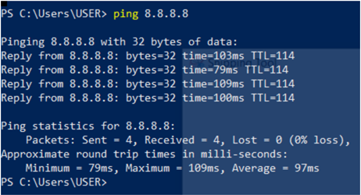

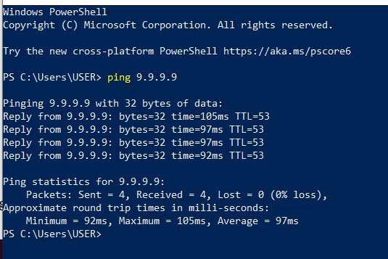

Conclusion: Sockets are the endpoints of a bidirectional communications channel. Sockets may communicate within a process, between processes on the same machine, or between processes on different continents.

