Amanda Minutello

CEE 598 – Traffic Simulation and Modelling

Dr. Zhou

Assignment 3 – VISSIM Tutorial

***Please use the following Vissim network.***

***PTV Vissim 2021\Tutorials & Guides\Tutorial First Steps\Vissim Files\Headquarters 10.inpx***

1. ***Please show the information using snapshot for the required operations, such as, links, desirable speed decisions, reduced speed areas, conflict areas, priority rules (if any), connectors, vehicle inputs, vehicle route, so that you can be familiar with this network. Please list the numbers of each types of modeling objects. Please use one sentence to describe the first object at each object type.***
2. ***Please choose three paths defined by yourself and check their travel time measures following the instructions. Then run the simulation and make sure the simulation is finished.***
3. ***After that, go to “Evaluation” in the menu to “Result Lists” “Vehicle Travel Time Result”, to show your result.***

Highway 10 Network:

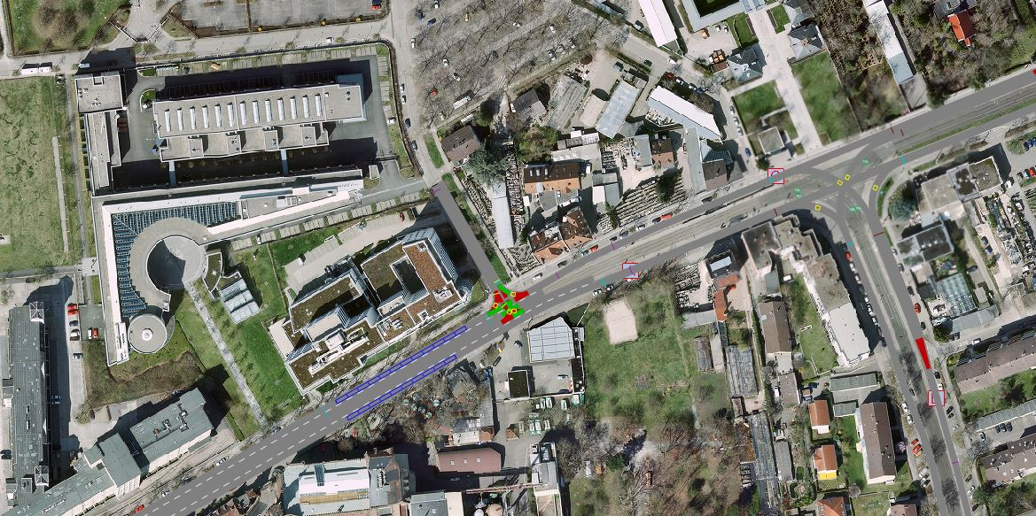

*Table 1: Link Attributes*

The first link has a length of 313m and allows motorized vehicles to drive on it.

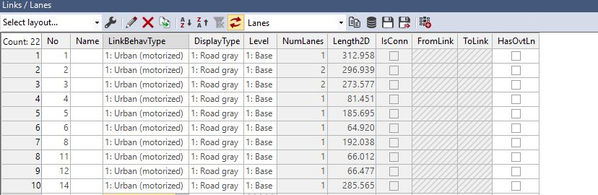

*Table 2: Desirable Speeds*

The first speed decision has a maximum of 30 km/hr

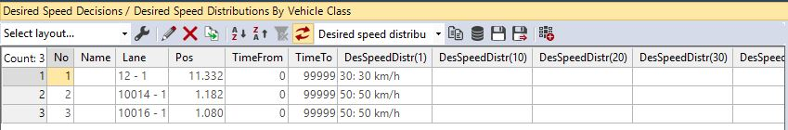

*Table 3: Reduced Speed Areas*

The first reduced speed area prevents vehicles from traveling faster than 25 km/hr over it. This occurs at a turn.

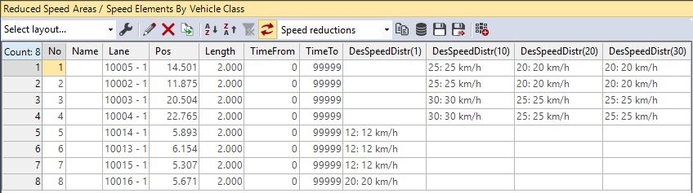

*Table 4: Conflict Areas*

Conflict areas are created where there is a possibility of an accident or queue occurring.

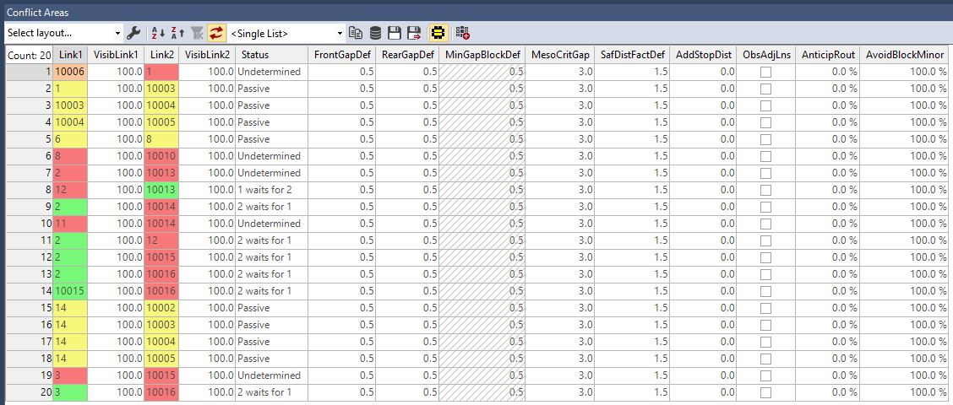

*Table 5: Connectors*

The first connector is created to allow vehicles to travel from link 1 to link 2.

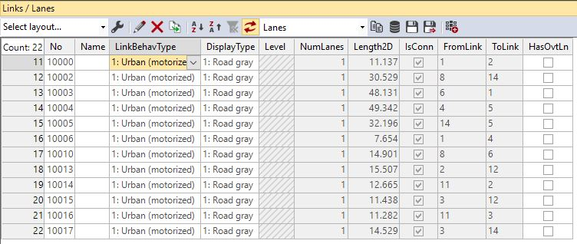

*Table 6: Vehicle Inputs*

The amount of vehicles allowed to enter link 1 per a given period of time is 600 vehicles.

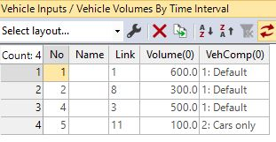

*Table 7: Vehicle Routes*

The first vehicle route allows vehicles to travel from link 1 to link 14

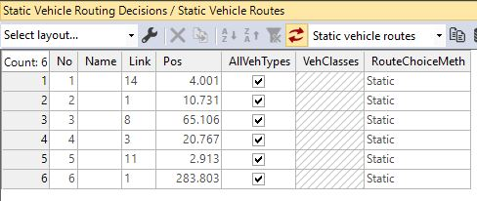

**Network Overview:**

* Links: 10
* Connectors: 10
* This network does not have any coded priority rules.

**Chosen Routes for Vehicle Travel Times:**

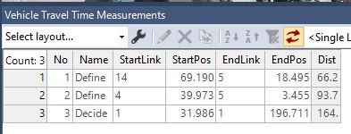

**Evaluation:**

