Amanda Minutello

CEE 598 – Traffic Simulation and Modelling

Dr. Zhou

Assignment 3 – VISSIM Tutorial

***Please use the following Vissim network.***

***PTV Vissim 2021\Tutorials & Guides\Tutorial First Steps\Vissim Files\Headquarters 10.inpx***

1. ***Please show the information using snapshot for the required operations, such as, links, desirable speed decisions, reduced speed areas, conflict areas, priority rules (if any), connectors, vehicle inputs, vehicle route, so that you can be familiar with this network. Please list the numbers of each types of modeling objects. Please use one sentence to describe the first object at each object type.***
2. ***Please choose three paths defined by yourself and check their travel time measures following the instructions. Then run the simulation and make sure the simulation is finished.***
3. ***After that, go to “Evaluation” in the menu to “Result Lists” “Vehicle Travel Time Result”, to show your result.***

Highway 10 Network:

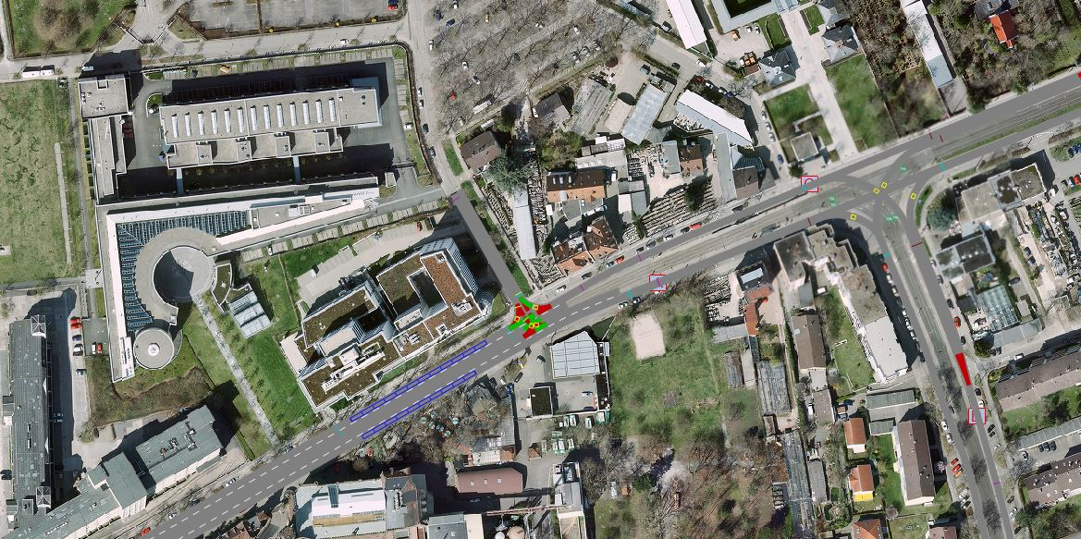

*Table 1: Link Attributes*

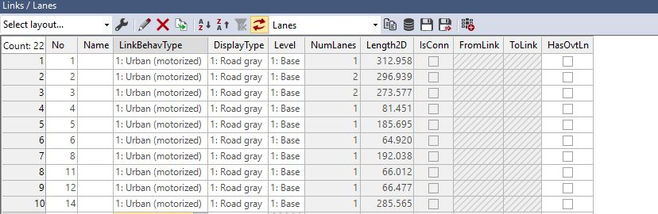

*Table 2: Desirable Speeds*

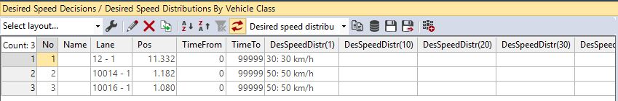

*Table 3: Reduced Speed Areas*

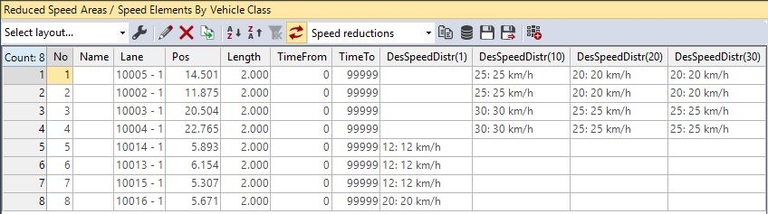

*Table 4: Conflict Areas*

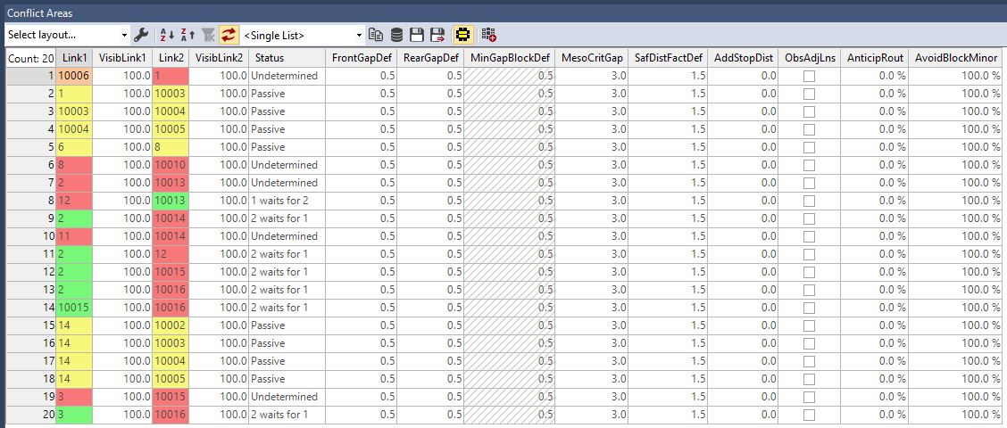

*Table 5: Connectors*

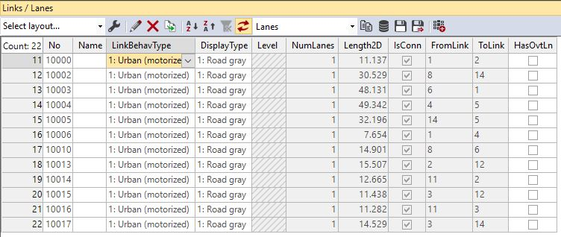

*Table 6: Vehicle Inputs*

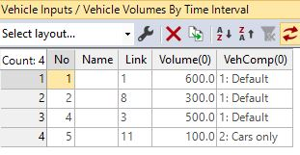

*Table 7: Vehicle Routes*

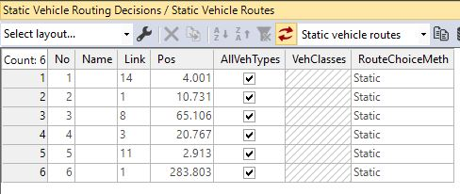

**Network Overview:**

* Links: 10
* Connectors: 10
* This network does not have any coded priority rules.

**Chosen Routes:**

**Evaluation**