**Practice :-**

After a opensearch dashboard create a index pattern :-

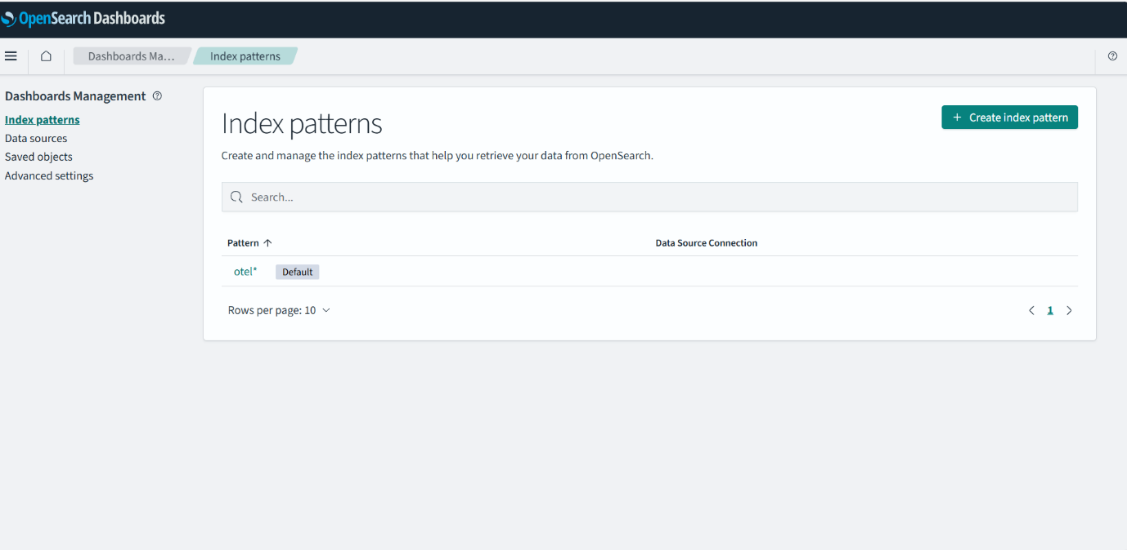

And then create a dashboard :-

