PROJECT REPORT
ANONYMITY TOOLKIT
A Python-Based Network Privacy and VPN/Proxy Learning Application

Submitted by | Ami Parekh
Trainer | Akshar Ratnani
Course | Cybersecurity
Institution | Adani Skill Development Center
Submission date | 04 October 2026
Submitted as part of cybersecurity learning and project work.

Table of Contents
1. Abstract
2. Introduction
3. Problem Statement
4. Objectives
5. Scope
6. Concepts and Background
7. Technology Stack and Requirements
8. System Architecture and Modules
9. Working Methodology
10. Testing and Validation
11. Results and Discussion
12. Application Screenshots
13. Limitations
14. Ethical and Privacy Considerations
15. Future Enhancements
16. Conclusion
17. References

1. Abstract
Anonymity Toolkit is a Python desktop application developed as an educational cybersecurity project. It helps users explore network privacy, public IP observations, HTTP/HTTPS proxy testing, VPN/proxy comparison, privacy review, and common online privacy concepts. The interface is built with CustomTkinter. The application includes an online/offline mode, an offline learning simulator, local JSON-based history, and TXT/HTML report generation with an option to redact IP addresses. Its purpose is to support learning and basic diagnostics rather than to provide or guarantee anonymity. The tool distinguishes observed information, user-reported checklist answers, and simulated scenarios. External services, network configuration, and the limits of the implemented checks affect the results.

2. Introduction
Online privacy depends on more than changing an IP address. A VPN can create an encrypted tunnel between a device and a VPN server, while a proxy relays selected traffic through another server. These tools have different trust assumptions and do not automatically prevent browser tracking, account-based identification, or every type of network leak. Anonymity Toolkit provides a beginner-friendly desktop interface to observe a public IP lookup, test an authorised proxy endpoint, compare saved observations, and learn through offline scenarios.

3. Problem Statement
Users may assume that enabling a VPN or proxy makes all online activity anonymous. This is an inaccurate generalisation. A public IP lookup provides one view at a particular time, and a changed address alone cannot confirm that all traffic is routed through a VPN or that DNS, IPv6, WebRTC, browser fingerprinting, and other privacy risks are controlled. The project addresses this knowledge gap through transparent, limited diagnostics and educational explanations.

4. Objectives
- Observe the public IP address reported by an external lookup service.
- Validate and test an HTTP/HTTPS proxy endpoint that the user owns or is authorised to test.
- Compare two saved network observations and explain what the difference can and cannot demonstrate.
- Provide a manual privacy checklist without presenting user answers as automatically verified facts.
- Teach VPN, proxy, and traffic-visibility concepts through offline simulated scenarios.
- Generate local TXT or HTML reports, with optional IP-address redaction.
- Use safe implementation practices such as timeouts, input validation, secret redaction, and an offline-by-default mode.

5. Scope
The application is intended for learning and basic, user-initiated diagnostics. Its main pages include Dashboard, IP Information, Proxy Tester, Network Comparison, Privacy Checklist, Learning Simulator, Reports, and About/Help. The tool does not discover proxies, scan networks, guess credentials, or claim to certify a user's anonymity.

6. Concepts and Background

6.1 Public IP address
A public IP address is the address an external service may observe for a connection. This project uses the ipify service for a user-requested lookup and validates the returned address using Python's ipaddress module. The result reflects that service's observation at that time; it is not a complete network audit.

6.2 VPN and proxy
A VPN typically routes configured device traffic through an encrypted tunnel to a VPN server. A proxy generally relays requests for an application or configured traffic. A website may observe the VPN or proxy exit address, but the provider or proxy operator may have visibility into some connection metadata. The exact protection depends on configuration, protocols, encryption, and the service provider.

6.3 Privacy and anonymity
Privacy concerns control over information and who can access it. Anonymity concerns whether activity can be linked to a particular identity. A VPN or proxy can affect some network observations but does not by itself prevent identification through accounts, cookies, tracking, or browser fingerprinting.

7. Technology Stack and Requirements
Component | Use
Python 3.11+ | Core application logic and standard-library utilities
CustomTkinter 5.2.2 | Desktop graphical interface
Requests (2.31 or later, below 3) | HTTP/HTTPS lookup and proxy test requests
Python standard library | JSON storage, IP validation, threading/queue, logging, HTML handling, and unittest
Operating system | Windows or Linux with Python Tk support

8. System Architecture and Modules
The application uses a modular design. main.py starts the desktop application. The app package manages the main window, navigation, controller, background tasks, theme, and logging. The ui package contains the pages and reusable widgets. The services package contains IP lookup, proxy testing, comparison, privacy checklist, and redaction logic. The simulator loads seven offline scenarios from data/scenarios.json. The storage module validates and writes local JSON data, while the report generator creates TXT and HTML exports. Network-related work is kept out of GUI page code.
- Dashboard: shows mode, latest saved observation, diagnostic time, saved counts, and quick actions.
- IP Information: requests a public IP lookup in Online mode and records a successful observation.
- Proxy Tester: validates an HTTP/HTTPS proxy URL and makes one test request; credentials are kept in memory for that test.
- Network Comparison: compares two saved observations and provides qualified explanations, including limitations.
- Privacy Checklist: presents seven manual review items with statuses and follow-up guidance; it does not calculate a score.
- Learning Simulator: presents seven offline simulated scenarios with simplified traffic-flow explanations.
- Reports: previews and exports TXT/HTML reports, with optional IP redaction.
- Storage and logging: stores local history as JSON and applies secret-redaction measures to logs.

9. Working Methodology
- Launch the application using Python and select Online or Offline mode. Offline is the default and does not make network requests.
- In Online mode, request a public IP lookup. The application validates the response and displays an error if the request fails or the returned value is invalid.
- To test a proxy, enter an HTTP/HTTPS proxy endpoint that you own or are authorised to test. The application performs one request and reports the outcome.
- Connect or disconnect a VPN manually using its own application, then collect another public IP observation if appropriate.
- Select two saved observations in Network Comparison. Review the explanation and remember that an IP change does not prove all traffic is protected.
- Review the manual privacy checklist and explore the Learning Simulator, which works offline.
- Preview a report and save it as TXT or HTML. Consider IP redaction before sharing the report.

10. Testing and Validation
The project includes a unittest-based test suite covering IP lookup, proxy testing, comparison logic, privacy findings, redaction, JSON storage, background tasks, simulator scenarios, report generation, integration behaviour, and a GUI smoke test where a display is available. The README states that HTTP interactions are mocked in automated tests so the suite can run offline and does not require a live VPN or paid service. Manual GUI checks are documented separately in docs/MANUAL_TESTING.md. The presence of tests does not itself establish that every test passed in the submission environment; results should be recorded after running the test command.
Recommended test command: python -m unittest discover -s tests -v

11. Results and Discussion
The implementation brings several learning tasks into one desktop interface: public IP observation, a single-request HTTP/HTTPS proxy test, comparison of saved observations, a manual checklist, offline simulation, and local report export. Its design separates observed results from user-reported answers and simulated explanations. The tool is best understood as a learning and diagnostic aid, not a security certification or a guarantee that a VPN is correctly configured.

12. Application Screenshots
The uploaded ZIP does not contain actual application screenshots; its screenshot directory contains only a placeholder file. To avoid misrepresenting illustrative images as evidence, the following spaces are reserved for genuine captures from the running application. Insert screenshots before final submission.
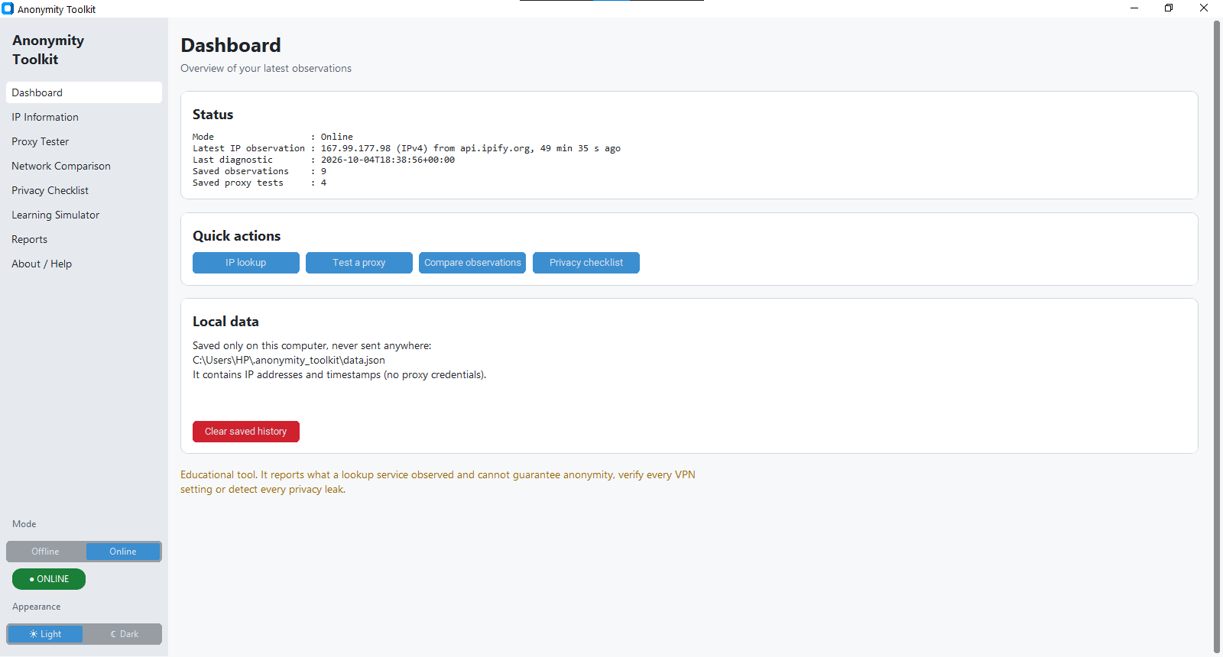
Figure 1. Dashboard

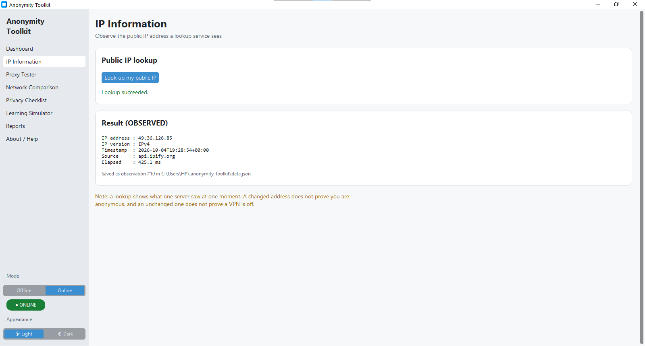
Figure 2. IP Information

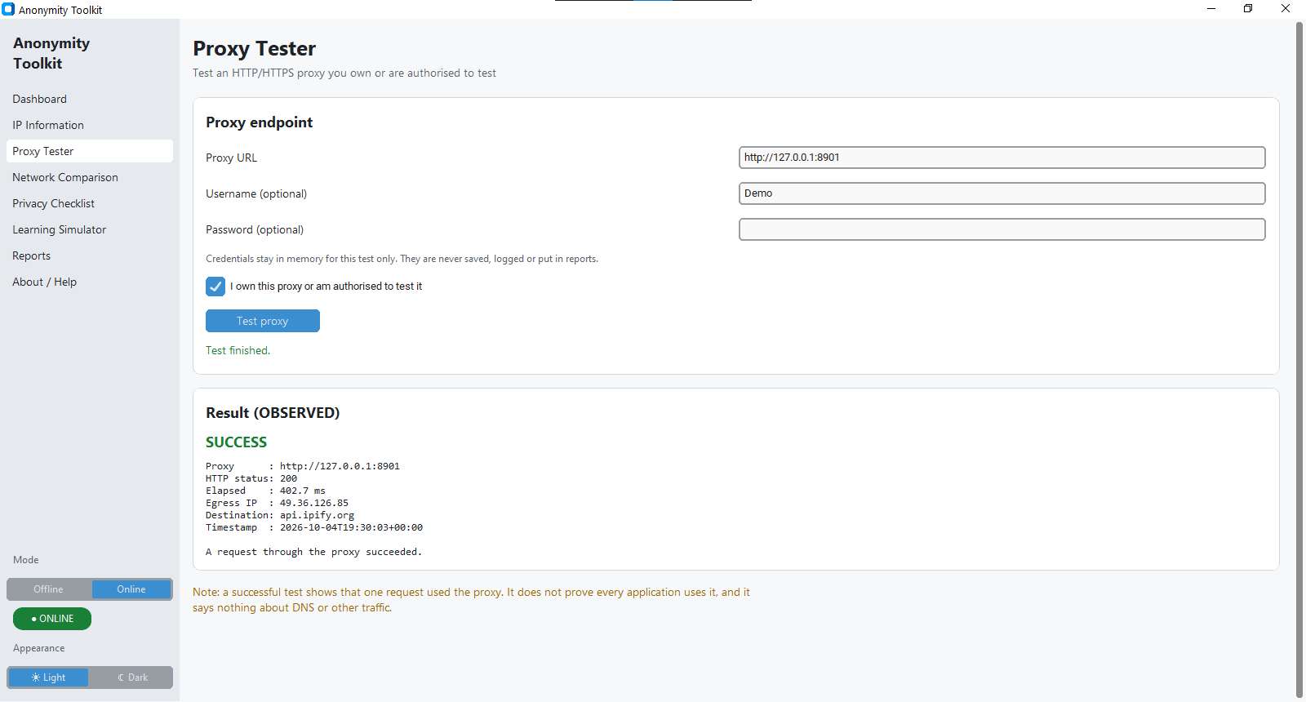
Figure 3. Proxy Tester

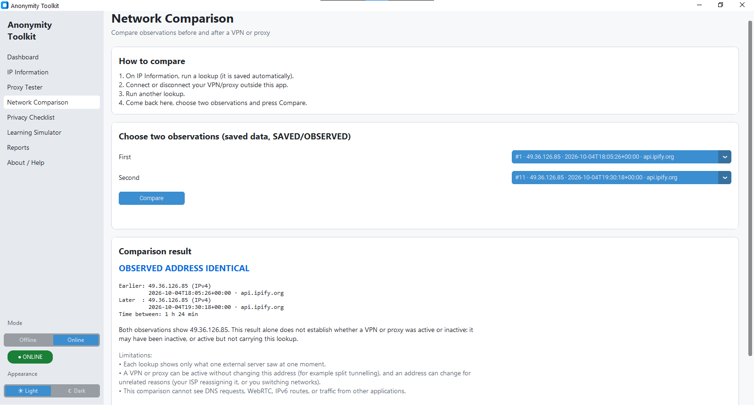
Figure 4. Network Comparison

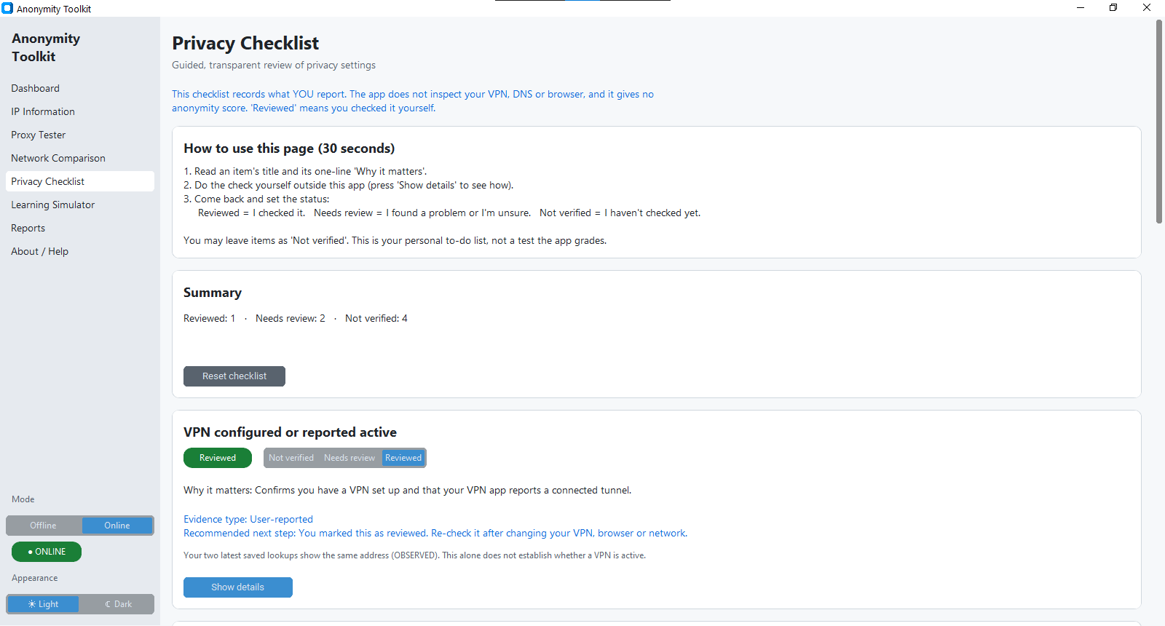
Figure 5. Privacy Checklist

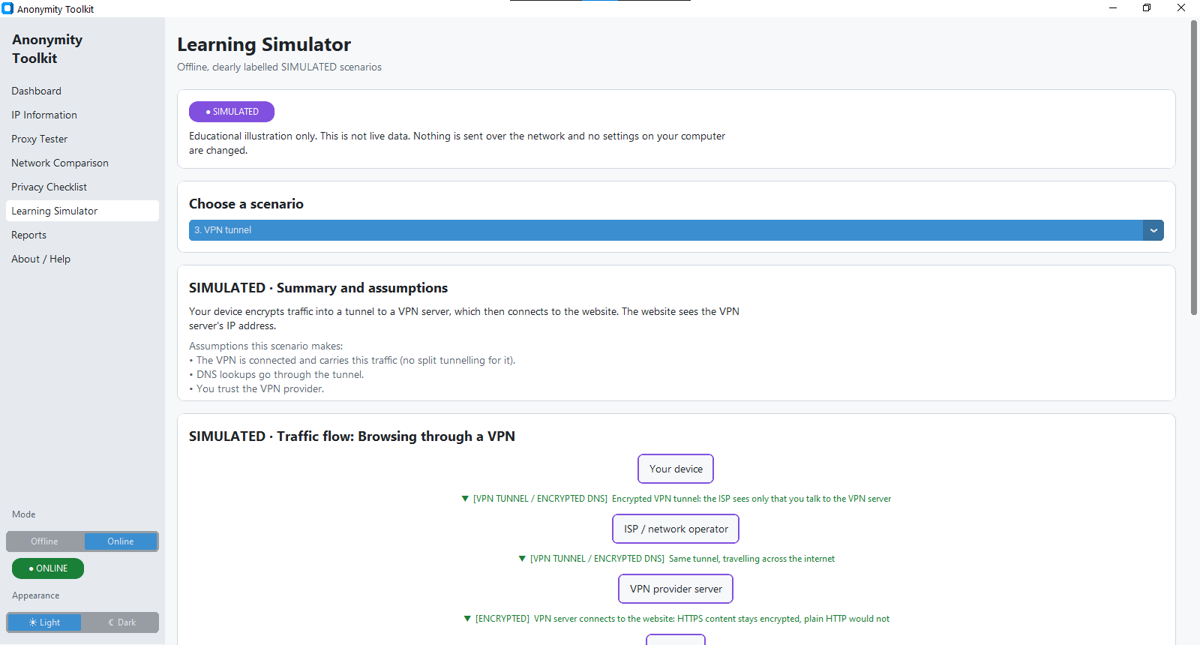
Figure 6. Learning Simulator

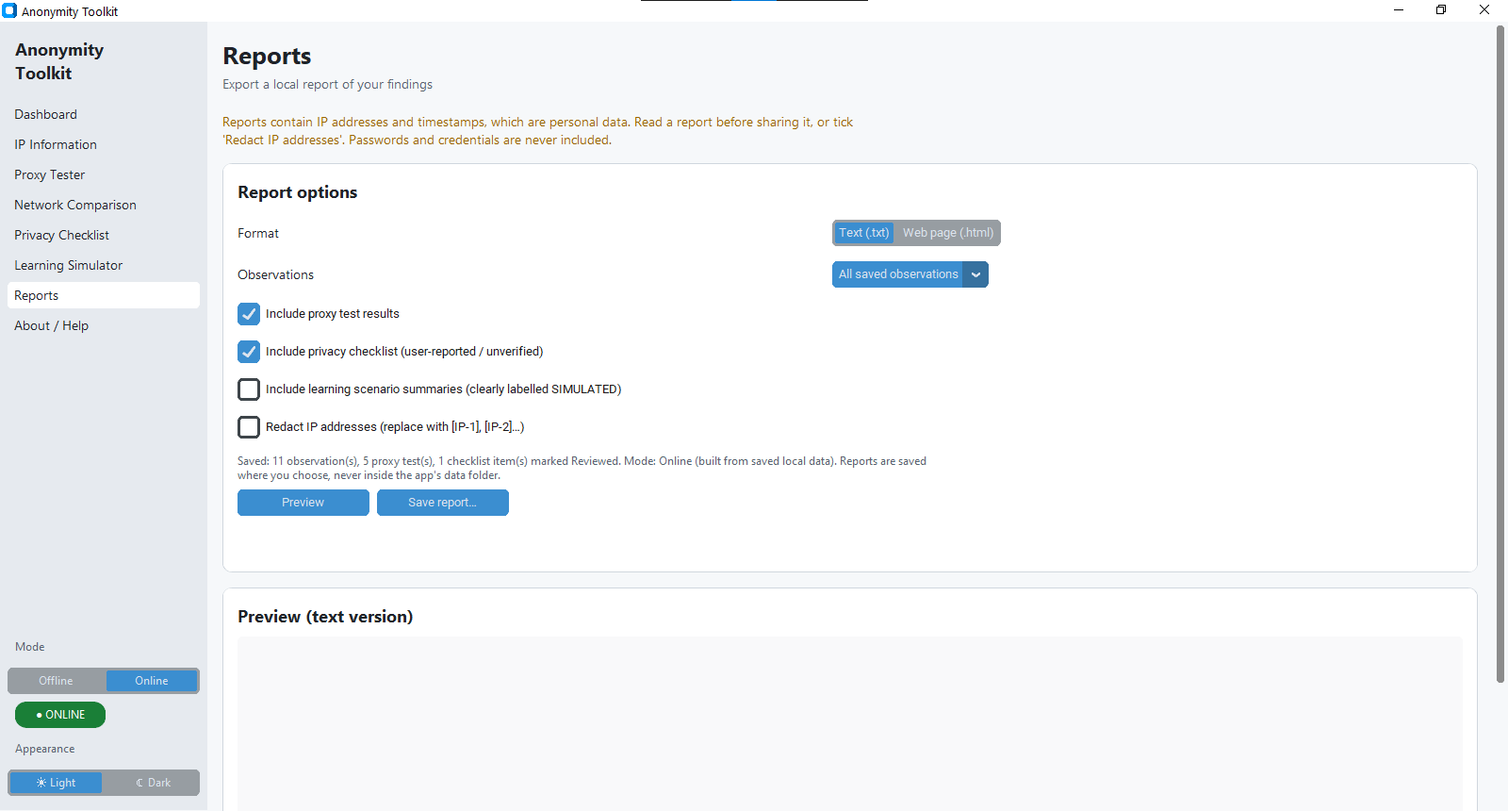
Figure 7. Reports

13. Limitations
- The public IP result reflects one third-party lookup service at one moment and depends on network availability.
- The application does not automatically test DNS leaks, WebRTC leaks, IPv6 routing, kill-switch behaviour, or every aspect of VPN routing.
- The privacy checklist is manual and depends on user input; it does not independently verify configuration.
- Proxy testing supports HTTP/HTTPS proxies only, performs one request per test, and does not support SOCKS proxies.
- Local history is stored as JSON and is not encrypted. Reports and saved observations may contain IP addresses and should be handled carefully.
- The seven simulator scenarios are simplified educational models and may not represent every VPN, proxy, or network configuration.
- Automated tests do not fully exercise all GUI interactions; manual testing is also required.

14. Ethical and Privacy Considerations
The tool should be used only with networks, proxy endpoints, and accounts that the user owns or is authorised to test. It does not include proxy discovery, network scanning, or credential guessing. Network requests are initiated by the user in Online mode; Offline mode is intended for local learning without network requests. Proxy passwords are kept in memory for a single test and are not intended to be saved, logged, or included in reports. Because saved observations and reports may contain IP addresses, users should redact sensitive information before sharing them.

15. Future Enhancements
- Add SOCKS proxy support with suitable validation and tests.
- Provide optional guided DNS-leak checks based on user-supplied evidence.
- Add CSV export of observation history.
- Offer encrypted local storage and configurable lookup services.
- Expand simulator scenarios and provide a screenshot-based user guide.

16. Conclusion
Anonymity Toolkit demonstrates how Python can be used to build a modular desktop application for cybersecurity education. It combines basic network observations with proxy testing, comparison, a privacy checklist, offline scenarios, and report export. The project reinforces an important principle: changing a public IP address is only one observation and is not proof of anonymity. The application's transparent limitations, offline learning mode, input validation, and separation of GUI and service logic make it a useful foundation for further learning.

17. References
- Python Documentation: https://docs.python.org/3/
- CustomTkinter Documentation: https://customtkinter.tomschimansky.com/
- Requests Documentation: https://requests.readthedocs.io/en/latest/
- ipify — Public IP API: https://www.ipify.org/
- Python ipaddress module: https://docs.python.org/3/library/ipaddress.html
- Python unittest documentation: https://docs.python.org/3/library/unittest.html
- Electronic Frontier Foundation — Surveillance Self-Defense: https://ssd.eff.org/
- Cybersecurity and Infrastructure Security Agency (CISA): https://www.cisa.gov/

