THE EVENT MANAGEMENT SYSTEM

Certificate page

Acknowledgement
I would like to express my sincere gratitude to all those who have supported and guided me during the successful completion of my internship project titled “The Event Management System.”
First and foremost, I would like to thank my project guide (Dr.D.B.Choksi Sir) for their valuable guidance, continuous support, and encouragement throughout the development of this project. Their suggestions and feedback helped me improve my knowledge and complete the project successfully.
I would also like to express my heartfelt thanks to the faculty members of the MCA department for providing me with the necessary knowledge and technical skills required to carry out this project.
I am grateful to my internship organization for giving me the opportunity to work on this project and gain practical experience in real-world application development.
I would also like to thank my friends and classmates for their support, cooperation, and motivation during the project development.
Finally, I would like to thank my family for their constant encouragement, understanding, and support throughout my academic journey.

Organization Overview
- Name of the organization: 7Sisters Tech
- Organization Address: Skywalk the element,511,Jagatpur Rd,Gota,Ahemedabad,Gujarat 382481
- Website: https://7sisterstech.com
- Working on Platforms and Technologies: Mobile App Development, Web Development
- Project Guide name: Hiten Movaliya(Co-founder, technical lead)
- Contact:
- Email:

Hardware and Software Configuration

Hardware Configuration
- Processor: Intel Core i3
- RAM: 12 GB
- System Type: 64-bit Operating System
- Input Devices: Keyboard, Mouse
- Output Devices: Monitor

Software Configuration
- Operating System: Windows 11
- Frontend: ReactJS
- Backend: PHP
- Database: MySQL
- Server: XAMPP,Localhost,Apache
- Browser: Google Chrome / Edge
- Payment Gateway: Razorpay
- Notification Service: Firebase Cloud Messaging (FCM)
- Version Control: Git & Github

Features of Tools used

ReactJS (Frontend)
- Component-based architecture
- Fast rendering using Virtual DOM
- Reusable components
- Responsive UI development
- Easy state and props management

PHP (Backend)
- Handles server-side logic
- API development and routing
- Fast data processing
- Integration with database
- Supports authentication and authorization

MySQL (Database)
- Structured data storage
- Supports relational data
- Fast query execution
- Data integrity and security
- Easy data management

Razorpay (Payment Gateway)
- Secure online transactions
- Easy integration
- Supports multiple payment methods
- Real-time payment verification
- Handles currency in paise (converted in UI)

Firebase Cloud Messaging (FCM)
- Real-time push notifications
- Cross-platform support
- Reliable message delivery
- Supports event reminders and alerts
- Improves user engagement

Bootstrap / CSS
- Responsive design
- Predefined UI components
- Easy styling and layout design
- Mobile-friendly interface

Git & Github
- Version control system
- Tracks code changes
- Collaboration support
- Backup and code management

Web Browser
- Runs the application
- Supports debugging tools
- Compatible with modern web technologies

Project Profile
Project Title | The Event Management System
Objective | The objective of this project is to create a system that simplifies event creation, management, and booking through an online platform
Technologies | Frontend & Styling: React JS, HTML5,CSS3,Axios,React Router, Bootstrap  Backend: PHP (for server-side logic and database connectivity)  Database: MySQL,phpMyAdmin
Tools | Visual Studio Code, XAMPP(server)
Project Guide | Dr.D.B.Choksi
Submitted To | Sardar Patel University

Project Definition
The Event Management System is a web-based application designed to manage and organize events in a digital and efficient way. The system allows organizers to create and manage events, administrators to monitor and approve events, and users to browse and register for events through an online platform.
The main purpose of this system is to simplify the entire event management process by reducing manual work and providing a centralized platform where all event-related activities can be handled. The system stores event information, user details, registrations, and other important data in a structured database, making it easy to access and manage.
In this system, different users have different roles and permissions. Organizers can create and manage their events, administrators have the authority to approve or reject events and manage the system, and customers can view available events and register for them. The system also helps track seat availability, manage event bookings, and generate tickets for registered users.
By using this system, event organizers can efficiently handle large numbers of participants, users can easily find and register for events, and administrators can maintain proper control over the entire system. The Event Management System provides a reliable, organized, and user-friendly solution for managing events online.
It provides role-based access for:
- Admin
- Organizer
- Customer/User

Introduction
Event management plays an important role in organizing different types of activities such as conferences, workshops, cultural programs, seminars, exhibitions, and social gatherings. Managing these events manually can be time-consuming and difficult, especially when dealing with large numbers of participants and multiple events at the same time.
Traditionally, event management involves manual registrations, paperwork, physical ticket distribution, and direct communication between organizers and participants. This process often leads to problems such as data errors, lack of proper coordination, difficulty in tracking registrations, and inefficient management of event information.
To overcome these problems, the Event Management System has been developed as a web-based solution that automates and simplifies the process of managing events. This system provides a digital platform where event organizers can create events, users can browse and register for events, and administrators can monitor and control all activities.
The system is designed with a user-friendly interface that makes it easy for users to interact with the platform. Organizers can add event details such as event name, description, date, location, number of seats, and ticket price. Administrators review and approve these events to ensure that only valid events are available to users. Customers can view available events and register for them based on their interests.
The Event Management System also includes features such as seat availability management, event registration tracking, payment handling for paid events, and ticket generation for successful registrations. These features help create a smooth and organized process for both organizers and users.
The system is developed using modern web technologies such as React for the frontend, PHP for backend processing, and MySQL for database management. These technologies provide flexibility, scalability, and efficient data handling for the application.
Overall, the Event Management System helps improve the efficiency, reliability, and accessibility of event management by providing an organized digital platform for all users involved in the event process.

Aim of the Project
The main aim of the Event Management System project is to develop a web-based application that simplifies the process of creating, managing, and booking events through an online platform. The system is designed to reduce manual work and provide a centralized solution where administrators, organizers, and users can interact efficiently.
The project focuses on creating a structured system where event organizers can create events, administrators can monitor and control the activities of the system, and users can easily browse and register for events. By using this system, the entire process of event management becomes faster, more organized, and more reliable.
Another important aim of this project is to improve communication between organizers and participants by providing a platform where event information is easily accessible. Users can view event details such as date, location, category, seat availability, and ticket price before registering.
The system also aims to provide secure data storage using a database so that all information related to users, events, and registrations can be stored and managed properly. By implementing role-based access control, the system ensures that each user performs only the tasks assigned to their role.
Overall, the aim of this project is to create a user-friendly, secure, and efficient event management platform that helps organizations manage events in a systematic and digital way.

Objectives:
- To develop a platform where organizers can easily create and manage events.
- To allow organizers to provide complete event details and manage participant registrations efficiently.
- To implement a role-based system with different users such as Admin, Organizer, and Customer having specific permissions.
- To ensure proper control and organized execution of system operations through role management.
- To provide users with an easy way to search, view, and explore events based on their interests.
- To enable users to browse events by categories and select events according to their preferences.
- To automate event registration and manage seat availability to prevent overbooking.
- To maintain a centralized database for storing and managing all event-related data.
- To improve data accessibility, updating, and management processes.
- To provide secure login and authentication to restrict unauthorized access.
- To enhance overall efficiency and reduce manual work in event management.
- To build a reliable, user-friendly, and efficient event management platform.

System Features
- User Authentication System
- Signup, login, and logout functionality
- Secure password handling (bcrypt)

- Role-Based Access Control
- Separate modules for Admin, Organizer, and User
- Different dashboards and permissions

- Dynamic Navbar
- Links: Home, About, Contact, Dashboard
- Role-based navigation
- Light/Dark mode toggle

- City-Based Event Filtering
- Dropdown to select city
- Events displayed based on selected location

- Event Management Module (Organizer)
- Add, update, delete events
- Manage event details like date, time, price, category

- Event Browsing (User Side)
- View all events
- Categories section
- Upcoming events & today’s events

- Search Functionality
- Search events using keywords
- Improves user experience

- Payment Integration (Razorpay)
- Secure online payment
- Stores payment details (order ID, payment ID, signature)
- Handles amount in paise and displays correct value

- Booking & Order Management
- Store booking records
- Track payment status
- Refund handling

- Reports Generation
- Monthly reports
- Yearly reports
- Based on booking data

- User Profile Management
- Fetch and display logged-in user details
- Profile icon in Navbar

- Responsive Web Design
- Clean UI using Bootstrap/CSS

- Contact & About Pages
- Static information pages
- Contact form

Project Activities
Project activities describe the step-by-step process followed during the development of the system.

Requirement Gathering
- Collected requirements from users and organizers
- Identified system needs like event creation, booking, and payment
- Defined project scope and objectives

System Analysis
- Analyzed the existing manual system and its drawbacks
- Studied feasibility (technical, economic, operational)
- Finalized system requirements

System Design
- Designed system architecture (frontend, backend, database)
- Created database schema (tables like users, events, bookings, payments)
- Prepared UI/UX design (Navbar, dashboard, forms)
- Designed diagrams (DFD, UML, ER diagram)

System Testing
- Performed unit testing for individual modules
- Conducted integration testing
- Checked login, booking, and payment functionality
- Fixed bugs and errors

Requirement Analysis
Requirement analysis defines the needs and functionalities of the system. It is divided into Functional Requirements and Non-Functional Requirements.

Functional Requirements

1. User (Customer)
- Register and login
- View and search events
- Filter events by city and category
- View event details
- Book tickets
- Make online payment
- View booking history

2. Organizer
- Login to organizer dashboard
- Create new events
- Update event details
- Delete events
- View participant details

3. Admin
- Login to admin panel
- Manage users
- Monitor all events
- Manage event registrations
- View bookings
- Generate reports (monthly/yearly)

4. System
- Authenticate users securely
- Manage role-based access
- Store and retrieve data from database
- Handle booking process
- Process online payments (Razorpay)
- Update seat availability automatically
- Generate reports

Non Functional Requirements
- Fast system performance
- Secure authentication and payment
- User-friendly interface
- Responsive design (desktop)
- Reliable and error-free operation
- Scalable for future expansion
- Easy maintenance and updates

Feasibility Study:
The feasibility study evaluates whether the proposed Event Management System is practical, beneficial, and achievable. It analyzes different aspects to determine the success of the system.

Technical Feasibility
This project is technically feasible as it uses widely available and reliable technologies.
- Frontend developed using ReactJS with responsive UI
- Backend implemented using PHP
- Database managed using MySQL
- Integration with Razorpay for online payment
- System can run on standard computers with internet access
These technologies are easy to implement, maintain, and scale, making the system technically viable.

Economic Feasibility
The system is cost-effective and affordable.
- Uses open-source technologies (React, MySQL,PHP)
- No need for expensive hardware
- Development cost is minimal
- Reduces manual labor and paperwork costs
- Long-term savings due to automation
Hence, the project is economically feasible.

Operational Feasibility
The system is easy to use and operate.
- User-friendly interface for all users
- Role-based dashboards (Admin, Organizer, User)
- Easy navigation with Navbar and filters
- Minimal training required
The system fits well into real-world usage, making it operationally feasible.

System Testing

Integration Testing

Acceptance Testing

System Testing

Functional Testing

Modules of Project:
The Event Management System is divided into three main modules based on user roles: Admin Module, Organizer Module, and Customer Module.

Admin Module
The Admin Module is responsible for managing the entire system. The administrator has full control over system activities and ensures that all processes run smoothly.
The admin can review events created by organizers and decide whether to approve or reject them. This helps maintain quality and prevents unauthorized events from being displayed on the platform.
The admin can also manage users, view event registrations, monitor system activities, and maintain event categories. By having full control over the system, the administrator ensures proper operation and security.

Organizer Module
The Organizer Module allows event organizers to create and manage events. Organizers can add event details such as event title, description, location, date, and ticket price.
They can also monitor the number of participants registered for their events and update event details if necessary. This module helps organizers efficiently manage their events without relying on manual processes.

Customer Module
The Customer Module is designed for users who want to explore and participate in events. Customers can register on the platform, browse available events, and view event details.
Users can register for events directly through the system. For paid events, the system allows them to complete the payment process and receive confirmation.
This module ensures that users have a simple and convenient way to discover and participate in events.

Data Dictionary:
Data dictionary includes information such as the number of record in file, the frequency of a process to run, security factor like password which user must enter to get access to the information. The major elements are data flows, data stores and processes. The data dictionary stores details and description.

users table

Sr .no | Field Name | Data Type | Size | Constraints | Description
1 | Id | Int | 11 | PK,Auto_Increment,Not null | Unique User identifier
2 | Name | Varchar | 100 | Not null | Full name of user
3 | Email | Varchar | 100 | Not null | Email of user
4 | Phone | Number | 20 | Not null | Phone number of user
5 | Password | Varchar | 255 | Not null | Encrypted user password
6 | Role | Enum | customer, organizer  ,admin | Not null, Default ‘customer’ | Role of user
7 | Status | Enum | Active, blocked | Not null, Default ‘active’ | Account status
8 | created_at | Timestamp |  | Not null , Default Current_timestamp | Account creation date

categories table

Sr .no | Field Name | Data Type | Size | Constraints | Description
1 | Id | Int | 11 | PK,Auto_Increment,Not null | Unique category identifier
2 | category_name | Varchar | 100 | Not null | Name of event category

events table

Sr .no | Field Name | Data Type | Size | Constraints | Description
1 | Id | Int | 11 | PK,Auto_Increment,Not null | Unique event identifier
2 | organizer_id | Int | 11 | FK(users),Not null | Organizer user id
3 | category_id | Int | 11 | FK(categories),Not null | Event category id
4 | Title | Varchar | 255 | Not null | Event title
5 | date_time | Datetime |  | Not null | Event date & time
6 | Location | Varchar | 255 | Not null | Event location
7 | City | Varchar | 100 | Not null | City of event
8 | Description | Text |  | Not null | Event Description
9 | Poster | Varchar | 255 | Not null | Event poster
10 | Status | Enum | pending, approved,  rejected, cancelled | Not null, Default ‘pending’ | Event status
11 | event_type | Enum | Free, paid | Not null, Default ‘free’ | Event payment type
12 | Price | Decimal | 10,2 | Not null, Default 0.00 | Price of ticket
13 | total_seats | Int | 11 | Not null | Total available seats
14 | available_seats | Int | 11 | Not null | Remaining available seats
15 | reminder_sent | Tinyint | 1 | Not null, Default 0 | Notification reminder
16 | created_at | timestamp |  | Not null, Default Current_timestamp | Event creation date

event_registrations table

Sr .no | Field Name | Data Type | Size | Constraints | Description
1 | Id | Int | 11 | PK, Auto_Increment  ,Not null | Unique Registration id
2 | user_id | Int | 11 | FK(users),Not null | User id for identify user
3 | event_id | Int | 11 | FK(events),Not null | Event id for identify event
4 | ticket_id | Varchar | 255 | Not null | Ticket id for users
5 | Status | Enum | Pending, confirmed,  rejected,pending_payment  ,cancelled_by_admin | Not null, Default pending | Event Registration status
6 | registered_at | timestamp |  | Not null, Default Current_timestamp | Registration date and time

notification table

Sr .no | Field Name | Data Type | Size | Constraints | Description
1 | Id | Int | 11 | PK, Auto_Increment  ,Not null | Unique notification id
2 | user_id | Int | 11 | FK(users),Not null | User id for identify user
3 | Message | Text |  | Not null | Notification messages
4 | is_read | Tinyint | 1 | Not null | Notification readable or not
5 | created_at | timestamp |  | Not null, Default Current_timestamp | Notification creation date and time

contact_messages table

Sr .no | Field Name | Data Type | Size | Constraints | Description
1 | Id | Int | 11 | PK, Auto_Increment  ,Not null | Unique contact id
2 | Name | Varchar | 100 | Not null | Name of the user(sender)
3 | Email | Varchar | 100 | Not null | Email of the user(sender)
4 | Message | Text |  | Not null | Message content
5 | Reply | Text |  | Not null | Admin reply
6 | Status | Enum | New,read,replied | Not null, Default new | Message status
7 | created_at | timestamp |  | Not null, Default Current_timestamp | Message creation date

event_reviews table

Sr .no | Field Name | Data Type | Size | Constraints | Description
1 | Id | Int | 11 | PK, Auto_Increment  ,Not null | Unique review id
2 | user_id | Int | 11 | FK(users),Not null | User id for identify user
3 | event_id | Int | 11 | FK(events),Not null | Event id for identify event
4 | Rating | Int | 11 | Not null, check(between 1 to 5) | Rating given between 1 to 5
5 | Review | Text |  | Not null | Review comment
6 | created_at | timestamp |  | Not null, Default Current_timestamp | Review date

bookings table

Sr .no | Field Name | Data Type | Size | Constraints | Description
1 | Id | Int | 11 | PK, Auto_Increment  ,Not null | Unique booking id
2 | registration_id | Int | 11 | FK(event_registrations),Not null | Registration id
3 | ticket_id | Varchar | 255 | FK(event_registrations),Not null | Ticket id
4 | razorpay_order_id | Varchar | 100 | Not null | Razorpay order id
5 | razorpay_payment_id | Varchar | 100 |  | Razorpay payment id
6 | razorpay_signature | Varchar | 255 |  | Razorpay signature
7 | Amount | Int | 11 | Not null | Booking amount
8 | payment_status | Enum | Pending, paid,  failed, refunded | Not null, Default pending | Payment status
9 | booking_date | timestamp |  | Not null, Default Current_timestamp | Booking date and time
10 | razorpay_refund_id | Varchar | 100 |  | Razorpay refund id
11 | refund_amount | Int | 11 |  | Refund amount
12 | refunded_at | datetime |  | Not null, Default Current_timestamp | Refund fate and time

user_tokens table

Sr .no | Field Name | Data Type | Size | Constraints | Description
1 | Id | Int | 11 | PK, Auto_Increment  ,Not null | Unique user token id
2 | user_id | Int | 11 | FK(users),Not null | User id for identify user
3 | Token | Varchar | 255 | Not null | Generated token from Google
4 | created_at | Timestamp |  | Not null, Default Current_timestamp | Token creation date and time

Data Flow Diagram

Context Level DFD
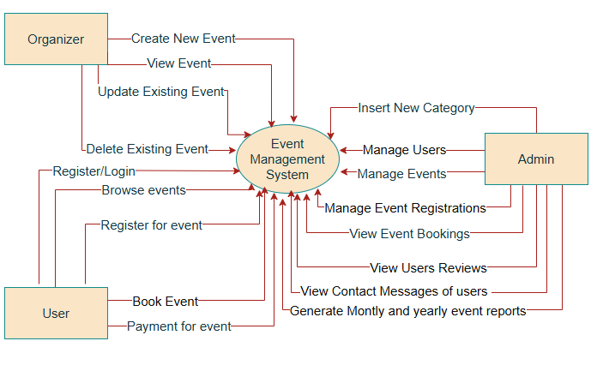
[Figure 12.1 Context Level DFD]

Level 1 DFD for users
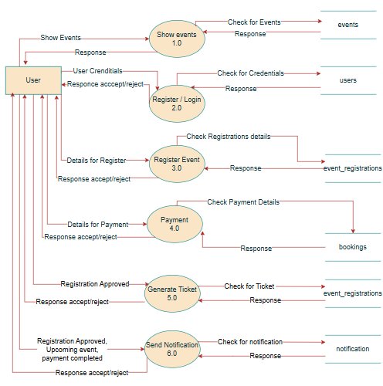
[Figure 12.2 Level 1 DFD for Users]

Level 1 DFD for Organizers
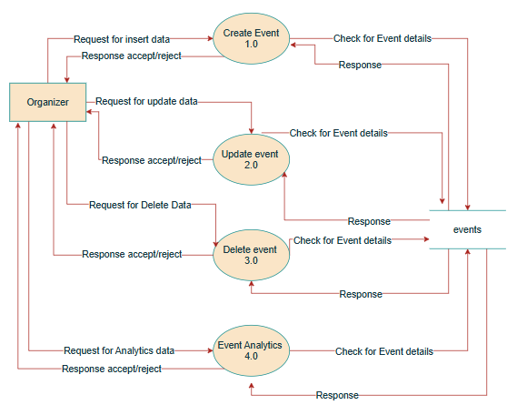
[Figure 12.3 Level 1 DFD for Organizers]

Level 1 DFD for Admin
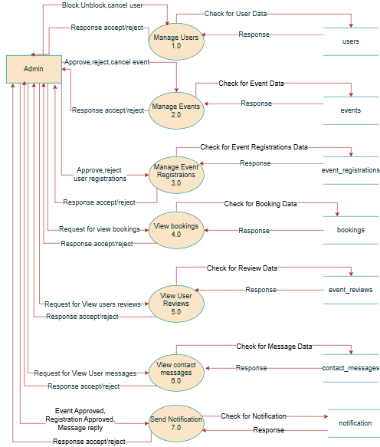

[Figure 12.4 Level 1 DFD for Admin]

Level 2 DFD for Manage users
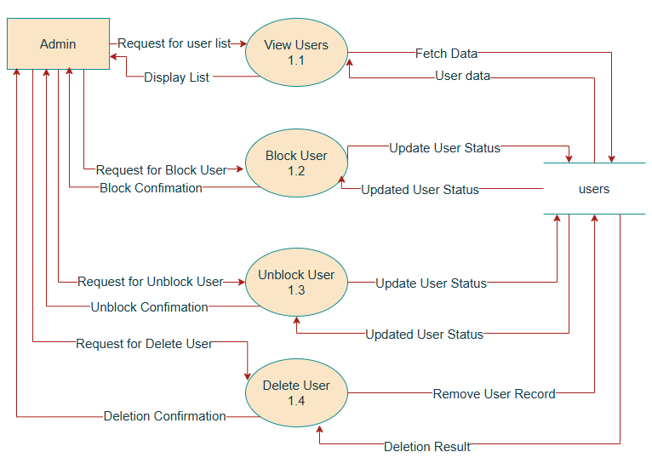
[Figure 12.4.1 Level 2 DFD for Manage Users]

Level 2 DFD for Manage Events
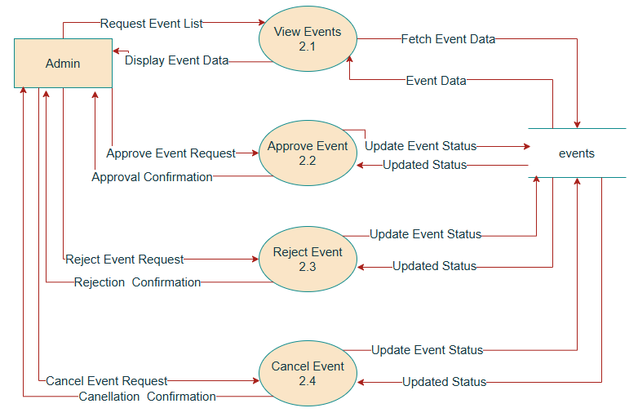[Figure 12.4.2 Level 2 DFD for Manage Events]

Entity-Relationship [ER] Diagram

UML Class Diagram

Activity Diagram

Sequence Diagram

Web interface

Register Page
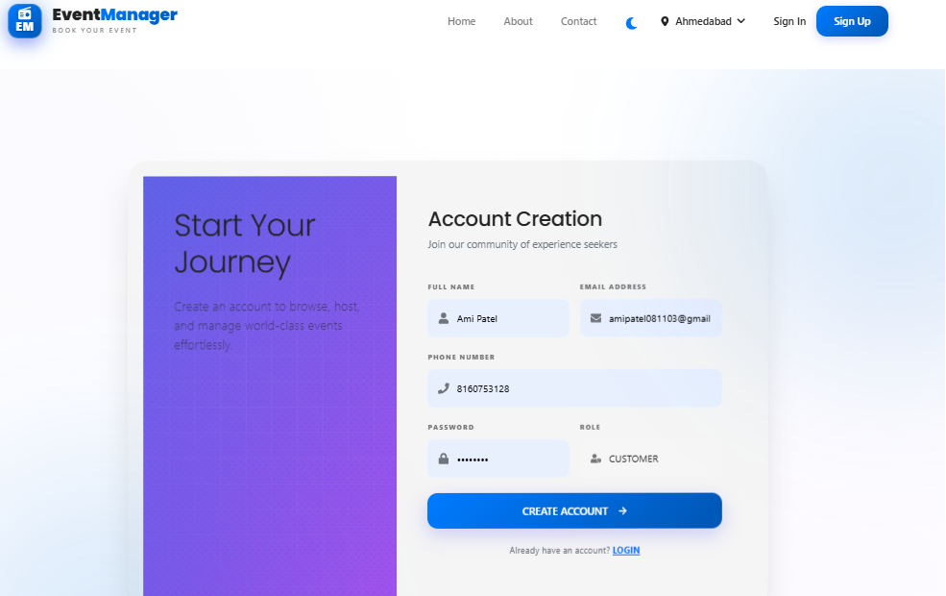

Login Page
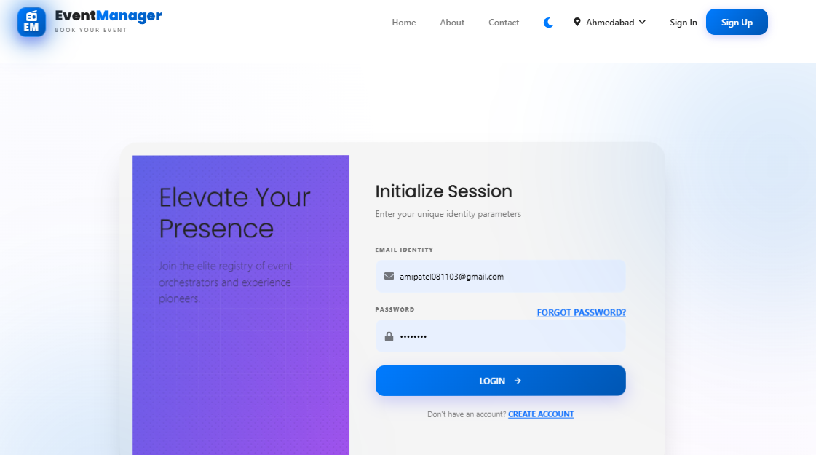

Home Page

Event Details Page

Customer Dashboard

Booking Page

Payment Page

Ticket Page

Download PDF Page

Admin Dashboard

Add categories Page

Manage users Page

Manage events Page

Manage event registrations Page

View Bookings Page

View event review Page

Monthly Report Page

Yearly Report Page

Organizer Dashboard

Create Event Page

All Events List

Update Event Page

Analytics Page

Contact Page

About Page

Limitations
- Requires a stable internet connection
- Limited payment gateway support (only Razorpay)
- No mobile application (only web-based system)
- Limited scalability for very large number of users/events
- Basic security features (can be enhanced further)
- Dependency on server and notification service availability (FCM)

Future Expansions
- Develop a mobile application (Android/iOS)
- Add multiple payment gateways (UPI, PayPal, etc.)
- Implement real-time notifications (Email/SMS)
- Add AI-based event recommendations
- Introduce live chat support
- Enhance security features (OTP, 2FA authentication)
- Add advanced analytics dashboard
- Enable multi-language support
- Improve scalability using cloud deployment

Conclusion
The Event Management System provides a complete digital solution for managing events efficiently. It includes features such as event creation, booking, secure payment integration, and real-time notifications using FCM, which enhance user engagement and communication. The system reduces manual effort, improves accuracy, and provides a user-friendly experience. Overall, it is a reliable, scalable, and modern platform for event management.

References
- ReactJS Official Documentation
- PHP Documentation
- FPDF Documentation for PDF generate
- Razorpay Payment Gateway Documentation
- Firebase Cloud Messaging (FCM) Documentation
- Online tutorials and learning resources
- www.w3schools.com
- https://getbootstrap.com

