PROJECT1 – WIRESHARK ESSENTIALS
Student Name: Amir ali Ansari
Date:03/03/2026

Screenshot 1: Wireshark Download Page

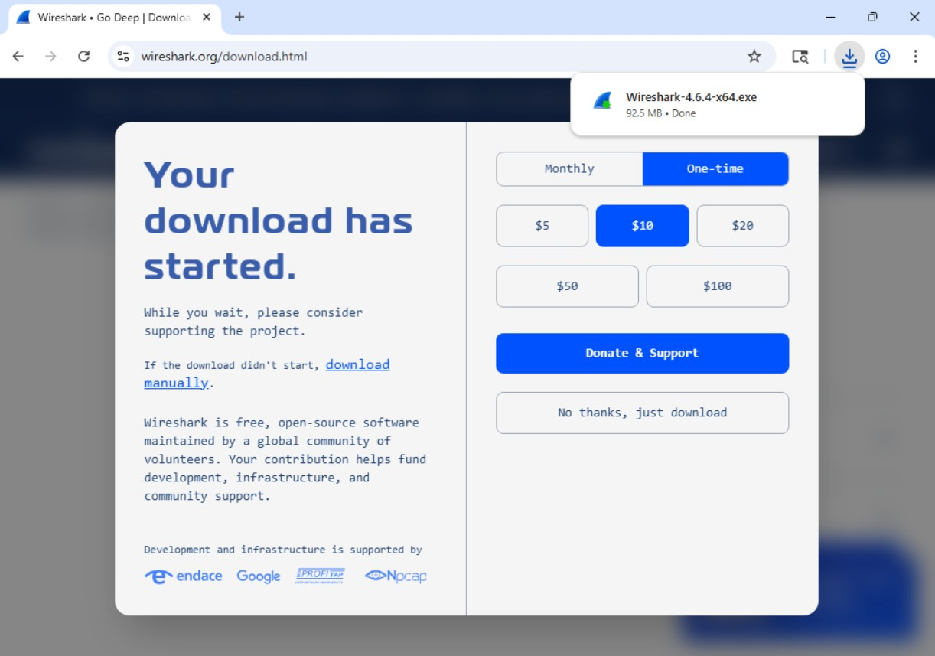

Screenshot 2: Wireshark Installation Completed

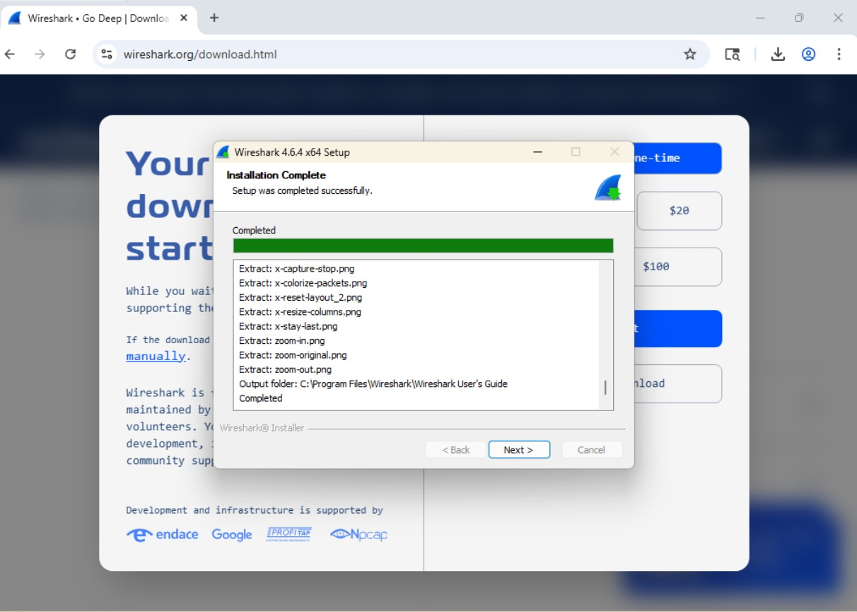

Screenshot 3: Interface Selection Screen
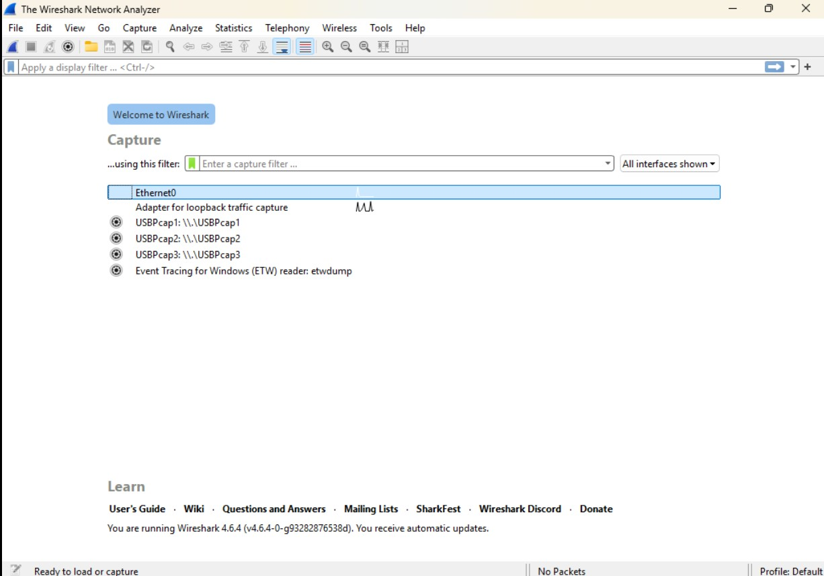

Screenshot 4: Live Packet Capture

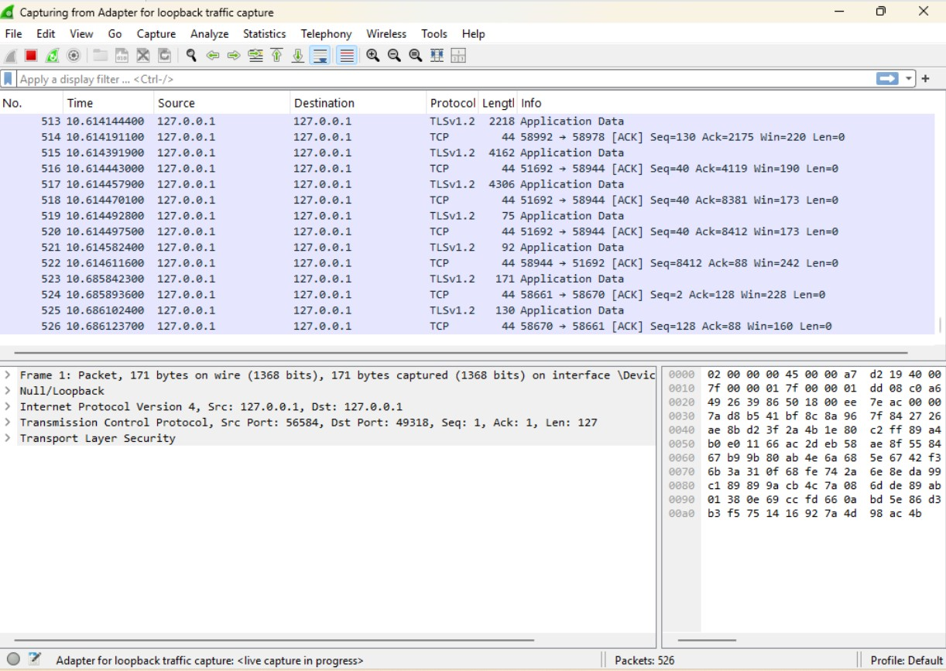Screenshot 5: Stopped Capture

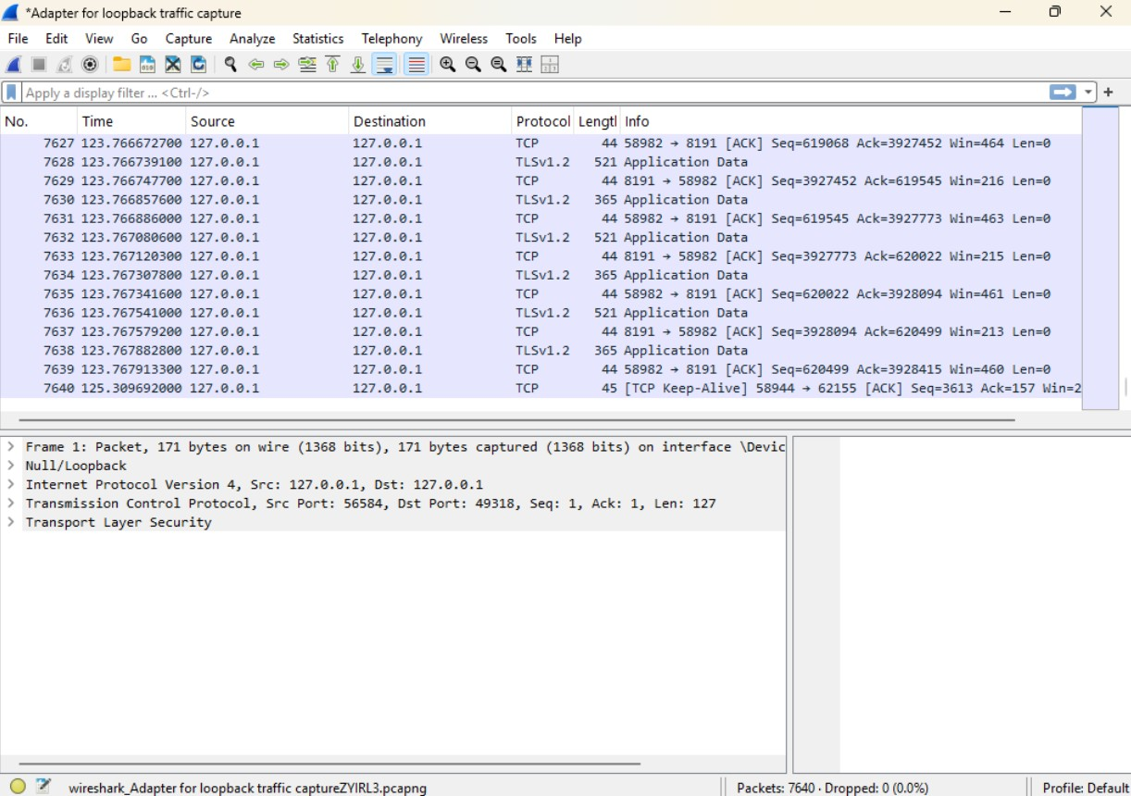

Screenshot 6: Filtered IP Traffic

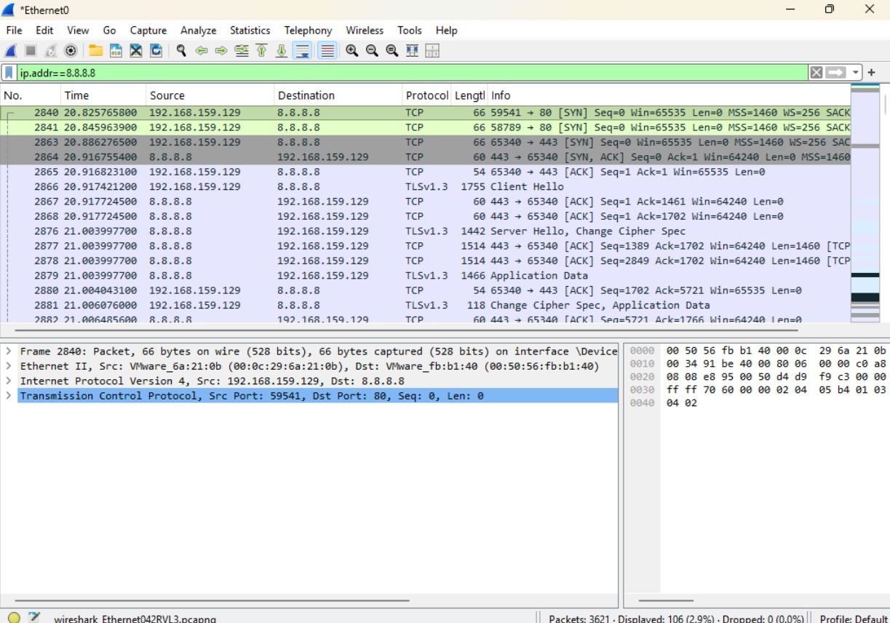Screenshot 7: HTTP or TLS Traffic
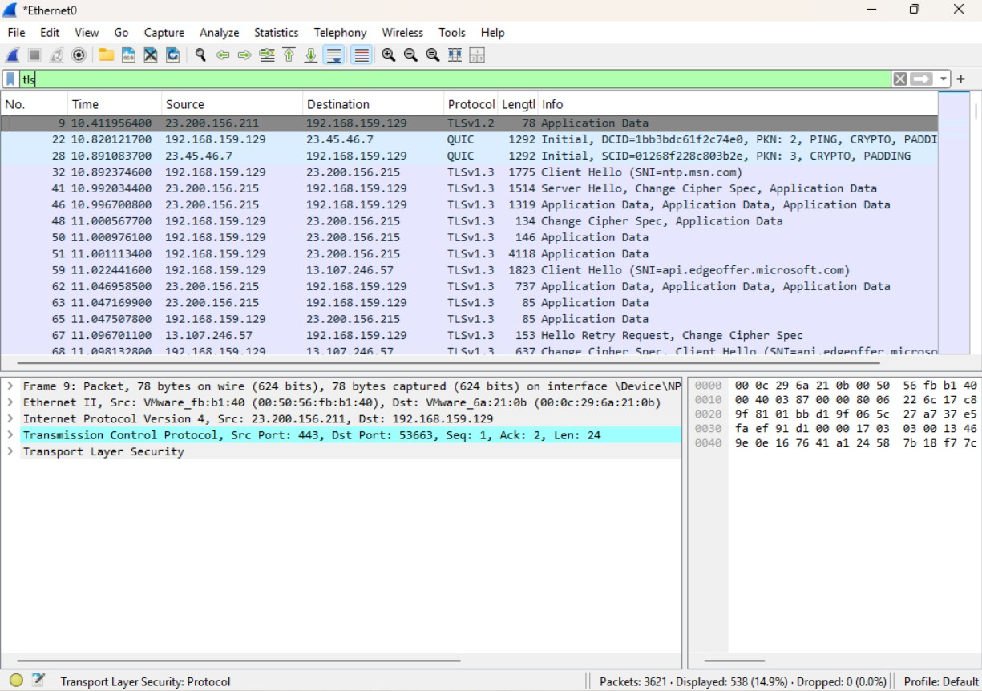
Screenshot 8: Follow TCP Stream Window

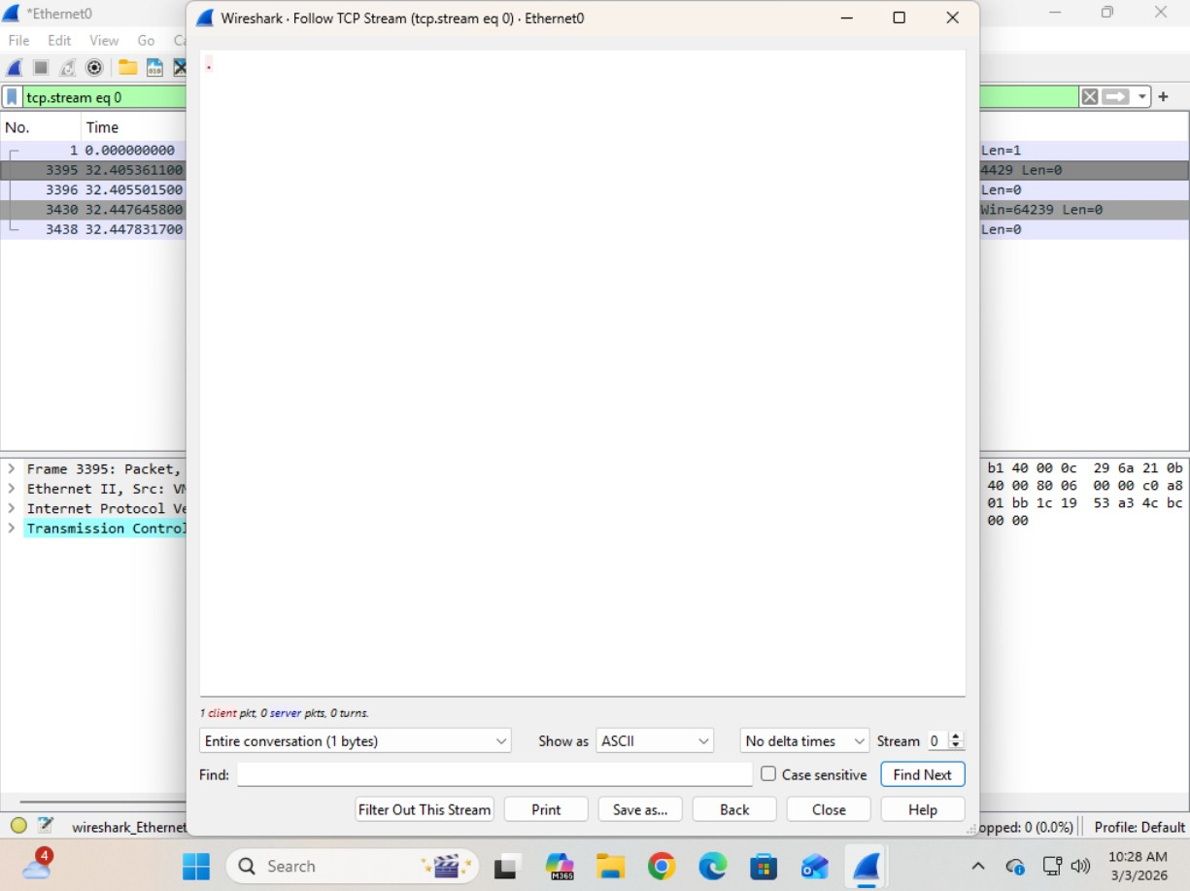Screenshot 9: Saved PCAP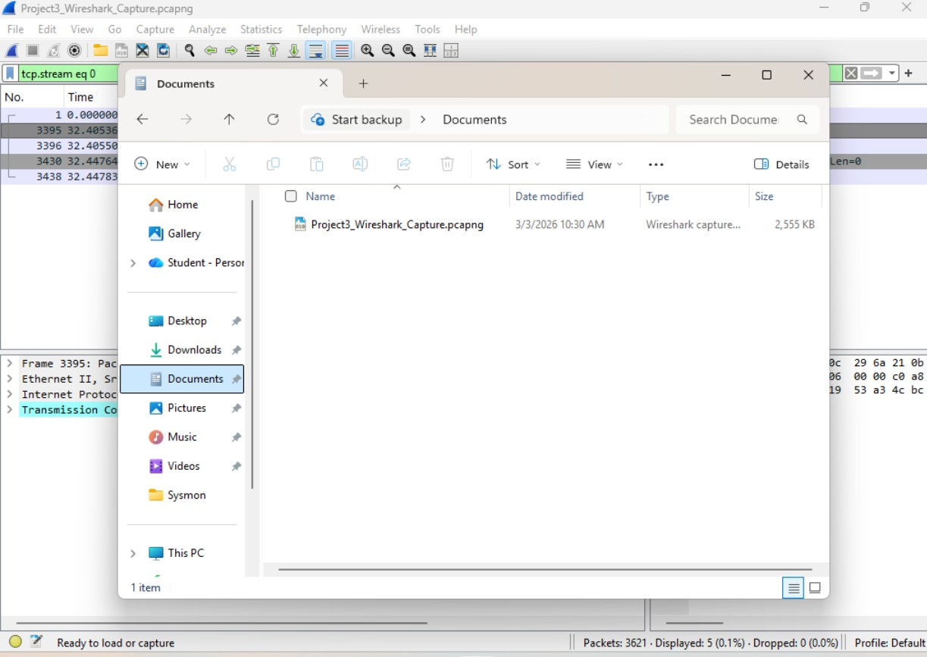

Reflection Questions
1. What surprised you most about network traffic? The number of invisible movements in the network.
2. Why is encryption important based on what you observed? Because tools like wireshark can capture the packets and if not encrypted, can get enough information to hackers can harm our systems.
3. How can Wireshark help during a security incident? We can track the packets destination and source to figure out what IP (and maybe who) attacked us. Also we can see what protocols are vulnerable (like http) and we can see what ports are used by these protocols.
4. How does this connect to threat hunting and SOC work? Using Wireshark in our SOC will enable us to have a picture of our network activity and what packets (data) is transacting.

