PROJECT 2– WIRESHARK ATTACK PCAP ANALYSIS
Student Submission Template
Student Name: Amir ali Ansari
Date: 03/24/2026
Screenshot 1: Port Scan PCAP Opened
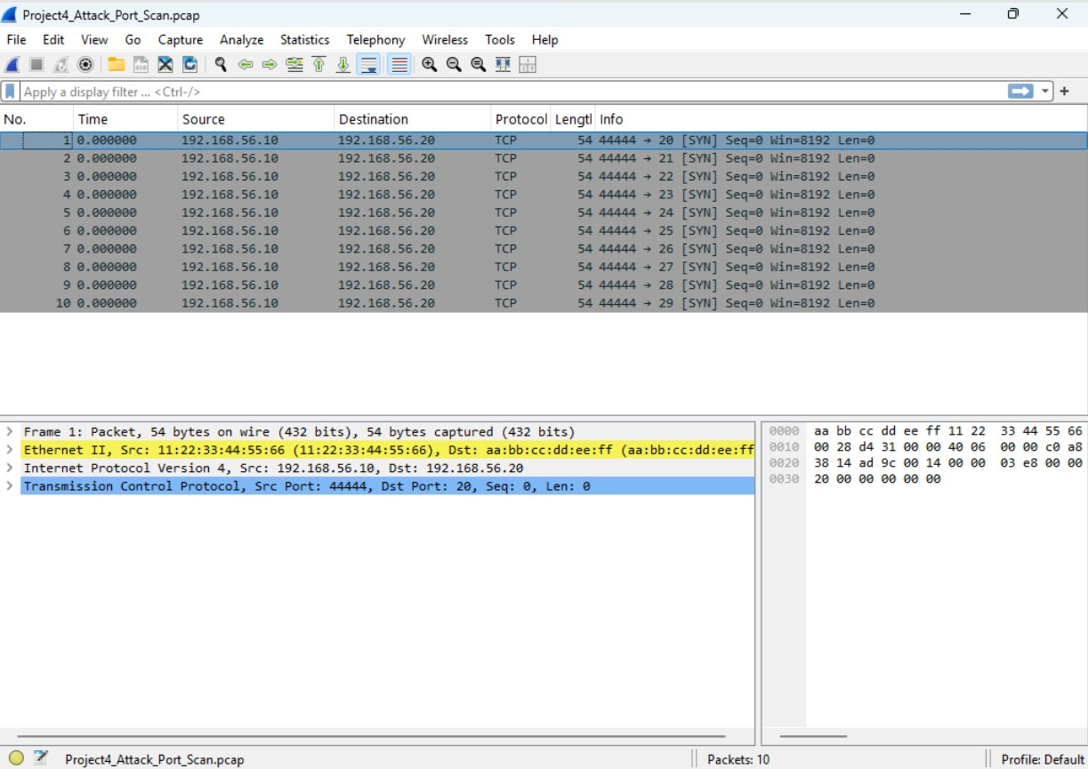
Screenshot 2: TCP Traffic Filtered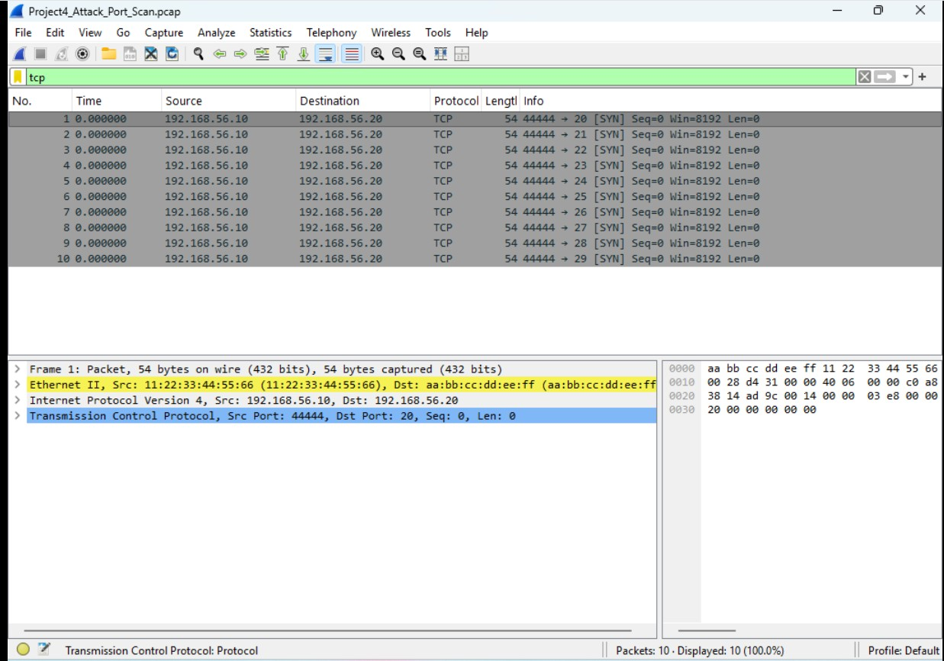Screenshot 3: Attacker IP Identified
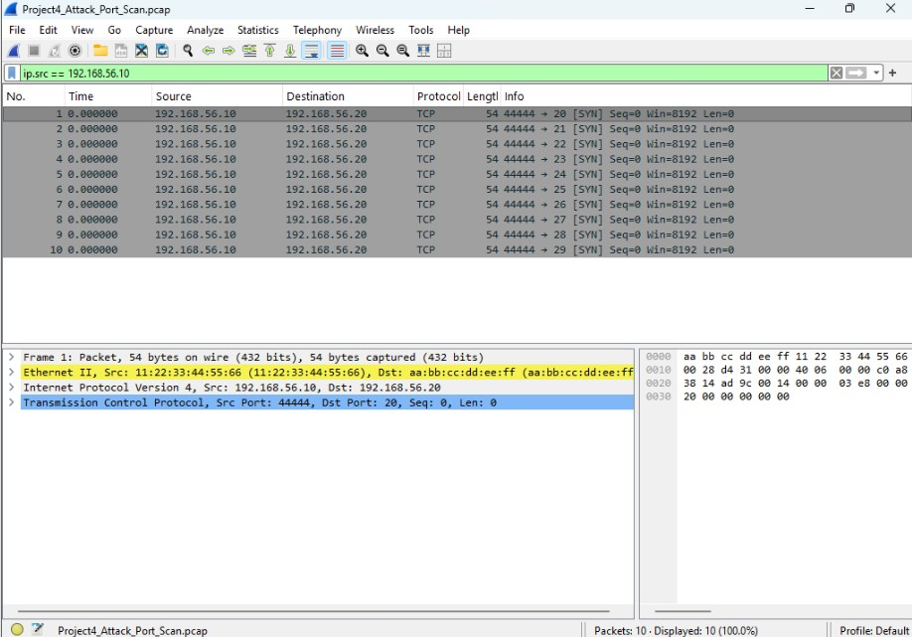
Screenshot 4: Follow TCP Stream
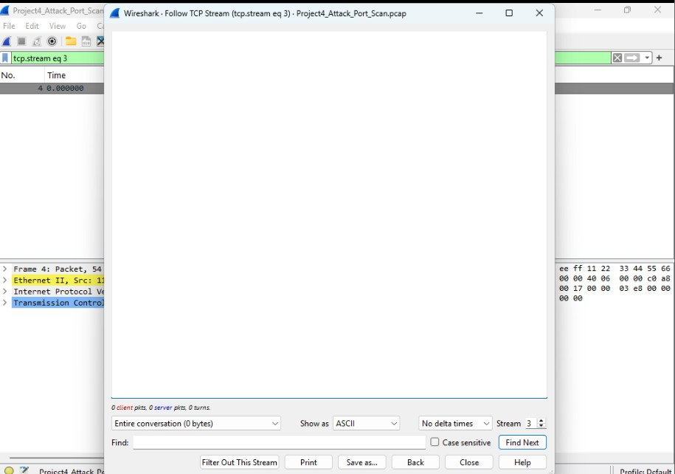
Screenshot 5 (Optional): HTTP Brute-Force Traffic
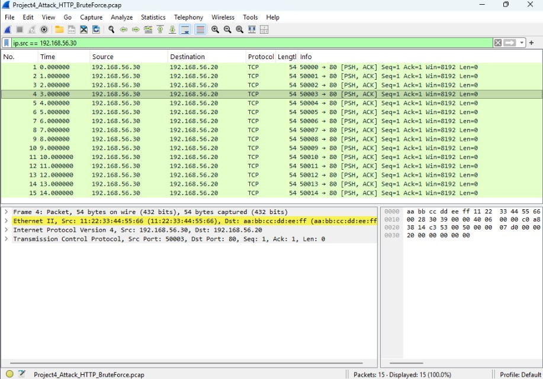
Attack Summary
Describe the attack you analyzed. include attacker IP, target IP, type of attack, and evidence from the PCAP.
I think it is a DDOS attack, because only port 80 is getting all packages from the same IP. All packages are received almost unstopped (one after another).
Reflection Questions
1. Why are patterns more important than individual packets? Its more visible and easier to figure out.
2. How does PCAP analysis help during incident response? PCAP will let us have a clear picture of infiltration to our network. We can see the path used by the attacker.
3. How did this lab connect to earlier Wireshark and threat hunting labs? This lab showed me the importance of keeping PCAP files even after the incident for further investigation.

