Project page:   
  
Project: Custom Pong Game

Course: AP Computer Science Principles  
Dates: 2023  
Designers: Amir Eftekhar, Rohith Gajula

In the Custom Pong Game project, undertaken as part of the AP Computer Science Principles course in 2023 alongside Rohith Gajula, our objective was to innovate on the traditional Pong game by integrating personalized gameplay features and improving user interaction. My responsibilities included designing and implementing the game’s mechanics, such as user input responsiveness and collision dynamics, and enhancing the game’s structure through object-oriented programming techniques. This role allowed me to significantly improve my Python programming skills, particularly in game development and real-time problem solving. One major challenge was refining the game physics to ensure smooth and engaging gameplay, which we addressed through rigorous testing and iteration. This project not only honed my technical skills but also enhanced my ability to work collaboratively in a team setting, utilizing platforms like Replit for version control and feedback integration.

Documentation and Links:

[Code](https://replit.com/@Amir-HosseinH55/pongCSP119#1.1.9/pong/main.py)

[Documentation](https://docs.google.com/document/d/1c8ML-BH5H2QVE633IacF6PUx1lKwqz3NHt62Kw-ngmA/edit?usp=sharing)  
  
Pictures:   
  
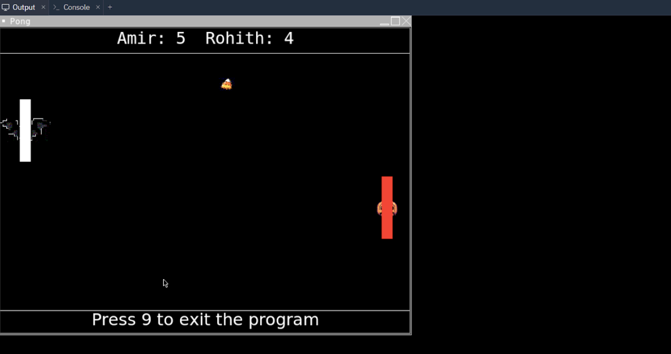

### Project: Christmas Hangman Game

Course: AP Computer Science Principles  
Dates: 2023  
Designers: Amir Hossein Eftekhar, Varun Chayanam

The Christmas Hangman Game, developed with Varun Chayanam for the AP Computer Science Principles course in 2023, aimed to put a festive spin on the classic hangman game format. I led the development of the graphical interface using Python’s Tkinter and Turtle modules, crafting a multi-level difficulty system to engage a diverse player base and programming the core mechanics for word guessing. This project was particularly challenging as it required developing an intuitive and appealing GUI that could handle dynamic user interactions smoothly. My efforts in this project greatly improved my abilities in GUI development and creative coding, teaching me valuable lessons in detailed-oriented interface design and the integration of visual elements to enhance user experience. This project was a significant step in exploring my passion for programming and applying classroom knowledge in practical, real-world applications.

Documentation and Links:

* [Game Code on Replit](https://replit.com/@Amir-HosseinH55/pongCSP119#1.1.9/pong/pong.py)
* [documentation](https://docs.google.com/document/d/11xRa6h1y6uV6EK3Q5uNDk0DJIqMWCExqkctqcNJeVas/edit?usp=sharing)

Images:

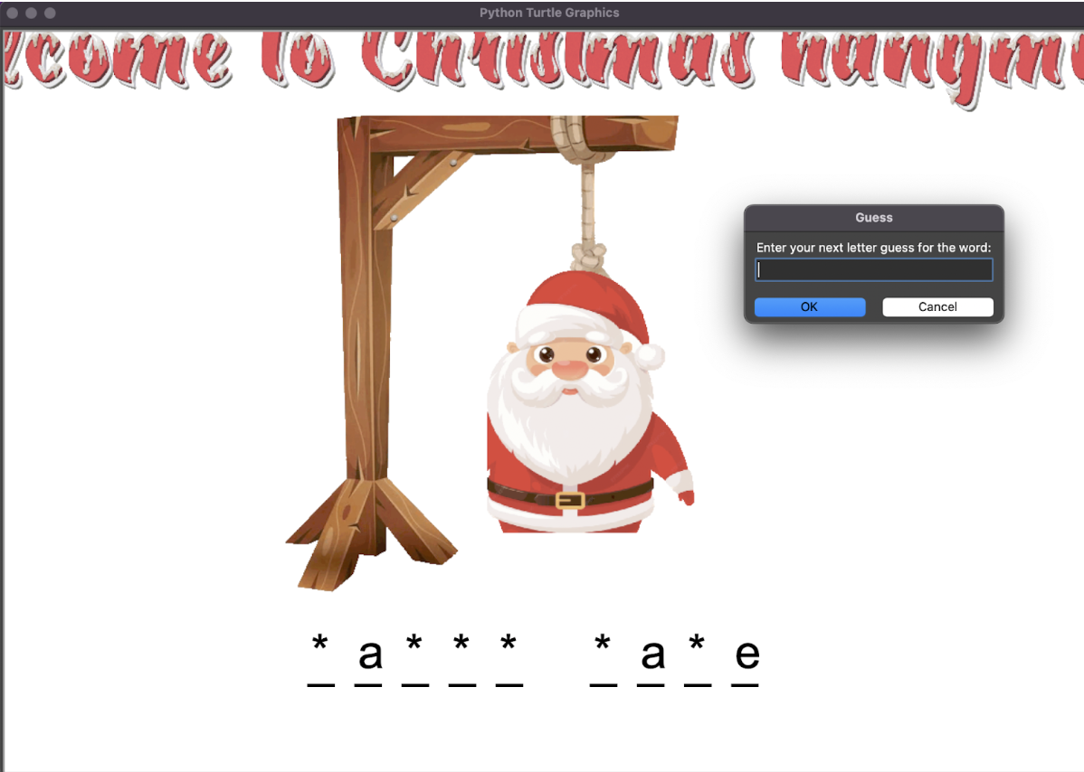

Project: Budget Planner App

Course: Computer Science Essentials

In this project I worked with a partner to create a custom app that solves a problem. Me and my partner experimented with a few ideas but the best one was a budget planner. Used everything I had learned about block based code as an MIT app inventor to make this project better. I spent hours of my time outside of class perfecting this project and added additional features like changing the background color of the app to make it more fun. My partner was absent for the majority of the time we worked on this so I had to take responsibility to do double the work at times. This project used timers, conditionals, math operations, procedures, equations, and other tools to provide customers with the ability to track their spending patterns over the course of time, based on their income and spendings, receive feedback on their spending habits, and use the app to keep track of their current bank balances. I wrote explanations through the app to make it user friendly so it would stand out more. I spent days debugging my code and it took me over 4 versions until it was perfect.This was my favorite project that I completed in CSE and this was a great opportunity to get creative with what I had learned in class. The project really showed me my passion for programming and was the start of a lot to come.

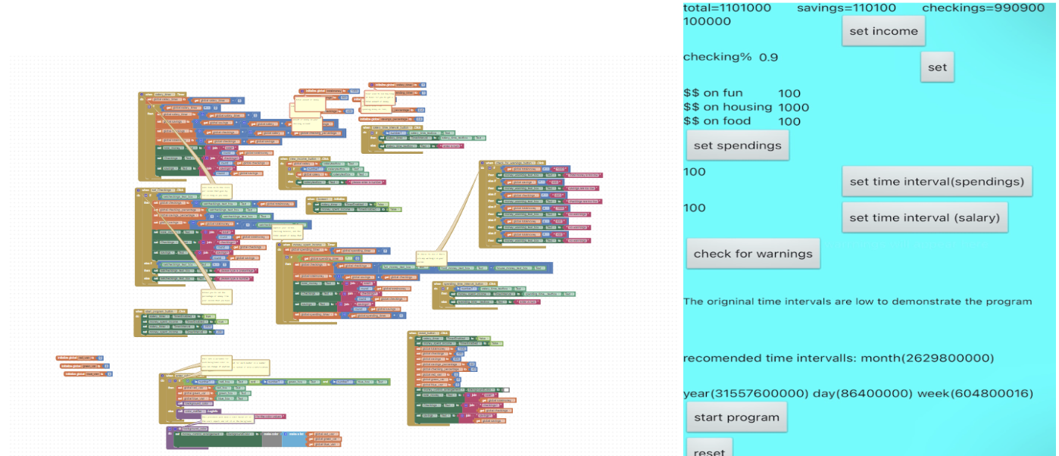  
  
  
Project: Map It Drive It

Course: Computer Science Essentials  
  
  
This was a partner project where my partner and I worked to write a code which would guide a robot through a maze without giving it direct instructions. We used procedures, sensory code, 2 dimensional lists, complex conditionals, and more in this project to make sure our robot takes the most efficient path towards the end. The first thing we did was map out each of the separate grids using a 2 dimensional list. A 0 in the list would stand for an empty square, 1 would stand for the beginning, 2, would stand for an obstacle and 3 would stand for the end. After this we took a variety of approaches towards it like finding common patterns in the mazes, coloring the squares first then moving based on the color, but the one we decided was best was using sensors. We made a procedure for every direction ( up, down, right, left) and in each procedure we wrote code for the robot to keep moving until the number 2 would show up in the according list in the square in front of it, we used 10s of variables through the program which would do things like keep track of where the robots, square, determine where the robot should start off, make sure the robot doesn’t go over the edge and more. This was not an easy project and it took hours of both of our time in and outside of school, but eventually we were able to finally get it right. I am proud of this project because I was able to use many of the programming concepts I have learned in this class through the project. This project taught me a lot about both programming and about collaboration with a partner. This was one of my favorite projects that I worked on in the class Computer Science Essentials.

