“ Relative comparison between different machine learning algorithms for

criminal offense detection and immediate response on the event using intelligent IoT

devices “

**Part 1:** **Detection**

**Approach 1**:

Criminal offence detection through the body pose estimation and movement prediction between persons on crime seen

**Approach 2:**

Criminal offence detection by detecting weapons carried by person and intension of crime

**Approach3:**

Detect criminal offence by combining both approach 1 & 2 in parallel or sequentially

**Part 2: Response**

**Approach 1:**

Notifying the event to the recpective authority in real time or keep log of the event in terms of pre-recorded video analytics

**Approach 2:**

**2.1** Start an alarm on the event around the sounding area or play a pre recorded voice message to the people that their activity is being suspected as crime and they have been warned about the consequences . This may reduce the offence at an early stage .

**2.2** Target a laser pointer towards the person suspected ( Detected criminal offences ) as a threat

. This will make an illution of being at a gun point with accurate shots . Which eventually may make the person psychologicaly weak towards aggressiveness . This is also an early stage reduction of offences .

**2.3** Target a laser pointer with a Gun mounted on a robotic arm that is loaded with real bullets or rubber bullet or sleeping injection to prevent intrution or the offence in real time both manually and/or automatically . Care should be taken when in automatic mode due to false positives . So we prefer detection threshold beyond 98 percent . Besides manual execution command from the central monitoring and dispatch system .

Study Notes:

**27th May 2022:**

[ Src: 1. <https://www.analyticsvidhya.com/blog/2021/10/human-pose-estimation-using-machine-learning-in-python/>

2. <https://viso.ai/deep-learning/pose-estimation-ultimate-overview/>

3. <https://www.google.com/url?sa=t&rct=j&q=&esrc=s&source=web&cd=&cad=rja&uact=8&ved=2ahUKEwigl6i4hYD4AhUkldgFHUESDawQFnoECDcQAQ&url=https%3A%2F%2Fwww.inf.uniri.hr%2Fimages%2Fstudiji%2Fposlijediplomski%2Fkvalifikacijski%2FSajina_kvalifikacijski.pdf&usg=AOvVaw067UNXdtQGJU9SCnjGZEnq>

4. ]

**What is Pose Estimation ?**

“In traditional [object detection](https://viso.ai/deep-learning/object-detection/), people are only perceived as a bounding box (a square). By performing pose detection and pose tracking, computers can develop an understanding of human body language. However, conventional pose tracking methods are neither fast enough nor robust enough to occlusions to be viable.

High-performing real-time pose detection and tracking will drive some of the biggest trends in computer vision. For example, tracking the human pose in real-time will enable computers to develop a finer-grained and more natural understanding of human behavior.

“—3

### What is Human Pose Estimation?

“Human pose estimation aims at predicting the poses of human body parts and joints in images or videos. Since pose motions are often driven by some specific human actions, knowing the body pose of a human is critical for action recognition. body pose estimation algorithms: “ --3

##### What is 2D Human Pose Estimation?

2D human pose estimation is used to estimate the 2D position or spatial location of human body keypoints from visuals such as images and videos. Traditional 2D human pose estimation methods use different hand-crafted feature extraction techniques for the individual body parts.

##### What is 3D Human Pose Estimation?

3D Human Pose Estimation is used to predict the locations of body joints in 3D space. Besides the 3D pose, some methods also recover 3D human mesh from images or videos. This field has attracted much interest in recent years since it is used to provide extensive 3D structure information related to the human body.

##### 3d Human Body Modeling

In human pose estimation, the location of human body parts is used to build a human body representation (such as a body skeleton pose) from visual input data. Therefore, human body modeling is an important aspect of human pose estimation. It is used to represent features and keypoints extracted from visual input data. Typically, a model-based approach is used to describe and infer human body poses and render 2D or 3D poses.

Most methods use an N-joints rigid kinematic model where a human body is represented as an entity with joints and limbs, containing body kinematic structure and body shape information.

There are three types of models for human body modeling:

1. Kinematic Model 2. Planar Model 3.Volumetric model

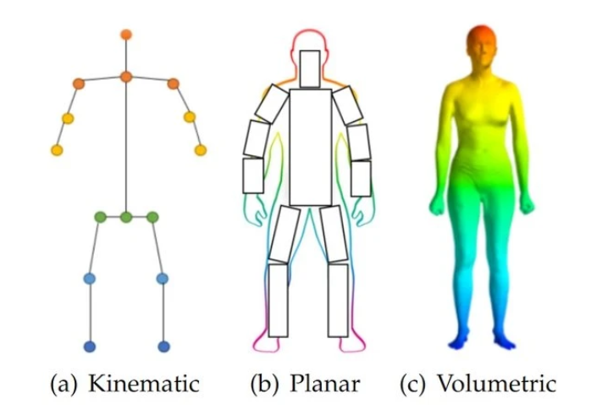

1. Open pose
2. High-Resolution Net (HRNet)
3. Pose net
4. Blaze pose
5. Deep Pose
6. Dense pose
7. Deep cut
8. CPN,
9. Regional Multi-Person Pose Estimation (AlphaPose)

**28th May 2022:**

[Src: 1.

]

[ cmd lines:

sudo apt-get install protobuf-compiler libprotobuf-dev

]

OpenPose : Test

**1st June 2022:**

#Environment Setup for OpenPose on Windows10

Tools: IDE – VSCode

ENVIRONMENT – Anaconda ( <https://www.anaconda.com/products/distribution/download-success-2> )

**17th June 2022:**

Conda Installation Guide

https://docs.nvidia.com/cuda/cuda-installation-guide-microsoft-windows/index.html

**Paper1:** “**OpenPose: Realtime Multi-Person 2D Pose Estimation using Part Afinity Fields”**

**Summary:**

**Remark:**

**Paper2: “Real-time_2D_Multi-Person_Pose_Estimation_on_CPU_LightWeight_OpenPose”**

**Summary:**

**Remark:**

**Paper3:**

**“Shi_End-to-End_Multi-Person_Pose_Estimation_With_Transformers_CVPR_2022_paper”**

**Summary:**

**Remark:**