

**Faculty of engineering**

Fall 2021

Physics applications project

**Solar Power Bank**

Alhusseain Shalaby - Akram Hany – Amir Anwar

Amir Ashraf – Ekwan Ehab - Albashir Altayeb

Enji Ashraf - Amira Hisham - Omnia Mostafa

Section: 6

ENG/ Mahmoud Mostafa

**Table of Contents**

Task Sheet 3

Motivation 4

Background 5

Key points 6

References 8

# Task Sheet

|  |  |
| --- | --- |
| **Member** | **Tasks Participated in** |
| **Amir Anwar** | * Merging & formatting |
| **Alhusseain Shalaby** | * Revisor |
| **Akram Hany** |  |
| **Amir Ashraf** |  |
| **Ekwan Ehab** |  |
| **Albashir Altayeb** |  |
| **Enji Ashraf** | * Background (research) |
| **Amira Hisham** | * Motivation |
| **Omnia Mostafa** | * Background (research) |

# Motivation

Using electronics today is so much a part of our daily lives, it has become difficult for us to do work without using electronic devices, and as batteries lose their charge quickly, dealing with an empty battery in the middle of a long trip can be a frustrating experience. That's why it's convenient to carry around a power bank, “Solar-powered” ones specifically, as they provide a clean, eco-friendly source of energy and less wastes along with a pure DC current which is good for the battery life. Solar power banks can be either stationary or portable, with the latter being the focus of our project, since portable banks eliminate the problem of unavailability of outlets and allow the user to move around while charging their phone with an unlimited power supply. Anyone can benefit from solar power banks, from students using their phones for studying to construction engineers, travelers and hikers spending their whole day outdoors. (1)

# Background

A solar power bank is an energy-storing device that collects and stores the energy of the sun and uses that energy to power and charge electronic gadgets. It contains a Solar panel placed on the surface of the bank body to be in direct contact with sunlight. A solar panel is created by combining photovoltaic cells made out of a semiconducting material (silicone being the most commonly used. When the sun shines over the cells, an electric field is created, thus converting sunlight hitting it into electricity. Solar panels produce around 250-400 watts. Power would then be transmitted to the bank’s rechargeable battery from a cable connected from the panel to a step-up booster USB connected to the battery. Both The battery and step-up booster are Lithium Ion (Li-ion). When an electronic device is then connected to one of the USB ports present on the power bank board, power then flows from the battery to the device. In other words, the device is being charged. (2) (3)

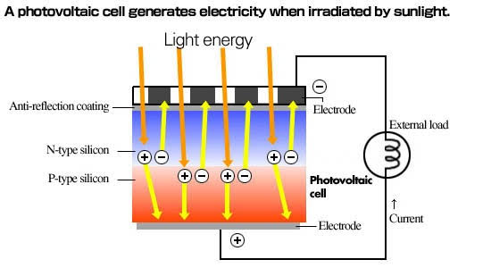

## **Key points**

There are some important points to be considered when using a solar power bank:

1. **Efficiency**: The more efficient the solar panel is, the more energy output it will have per amount of light energy hitting the cell. Most solar panels have an energy efficiency rating between 11 and 15 percent, which is the percentage of solar energy that is being converted into useable electricity. Solar power efficiency depends on a variety of factors including insolation, temperature, shading and orientation, and advances in technology will inevitably increase efficiency. (4)

2. **Charging Duration (of the power bank itself)**: There are different factors that determine the charging duration of a solar power bank, of which are: The capacity of the solar power bank, weather conditions and the brand or model being used. Assuming that the power bank is operating in ideal conditions, it would take it about 25-30 hours to be fully charged via solar energy, which is a pretty long time to fully charge a power bank compared to using normal charging methods (around 5-6 hours). We can however try to speed up the charging process by adding more panels. (5)

3. **Charging Capacity:** Solar power banks come in various capacities (usually between 1000 – 50,000 mAh), Depending on manufacturing techniques and the brand being used, Most portable solar power banks can’t be used for high-power and output less power than stationary ones, which is understandable due to its portability being a good enough compensation, and it should be taken into consideration that the user would still be able to use it adequately, charging two or more devices full. (2)

4. **Productivity:** one of the most important features of a solar bank is that as long as there is sunlight, even the slightest amount (a cloudy day for example), it will be able to produce power. The power that it drew during the presence of sunlight is saved for later use if a device is not connected to it.

# References

1. **[Online] https://solaric.com.ph/blog/why-get-solar-powerbank/.**

**2. [Online] https://www.ecomena.org/what-is-a-solar-power-bank/.**

**3. [Online] https://www.greenmatch.co.uk/blog/2014/08/what-are-pv-panels.**

**4. [Online] http://solarbyempire.com/why-solar/solar-panel-efficiency.**

**5. [Online] https://altenergyoptions.com/how-many-amps-does-a-solar-panel-produce/.**