**Link Sharing**

We need to develop a link sharing application which could be used for sharing useful links/documents amongst a group of subscribers.

Users can create new topics or subscribe to existing topics. A topic can be either private or public. A public topic is visible/open for subscription to every user. A private topic can be subscribed only through an invitation sent by an existing subscriber.

The application should provide a solution to following stories:

1. A user should be able to login.

2. A new user should be able to register. An active valid user should be able to login with correct credentials.

3. A user should be able to reset his/her password by clicking on the forgot password link.

4. User can create a new topic and he will be automatically subscribed to it. The topic can be private or public. Name of the topic should be unique per user.

5. User can subscribe to an existing public topic.

6. User can specify his/her seriousness to a particular topic.

7. Subscribed users can send invites to a public or private topic.

8. The user should be able to browse all the public topics.

9. The user should be able to add a resource to a subscribed topic.

1. A resource can either be a link resource or a document resource.

2. A link resource will contain a link to an external resource or even an internal resource.

3. A document resource will consist of downloadable content.

10. The user cannot be deleted.

11. The user should be able to mark a resource as read/unread.

12. Only a Creator of a resource or admin can delete a resource.

13. Only a Creator of a topic or admin can delete a topic. Its resources should also be deleted irrespective of the ownership status or resources.

14. User can rate a resource. Most subscribed topic will be a trending topic.

**UI**

1. Header shown on dashboard page will show on every user logged in page, non logged in user will see home page header.
2. Flash message should pop up on every ajaxified create, delete or update of any record.
3. Ajax related tasks (search,pagination,model, rating etc) will be done after ajax session is done till then normal page load behaviour will work.
4. Social share will be the last feature.

**Class Structure**

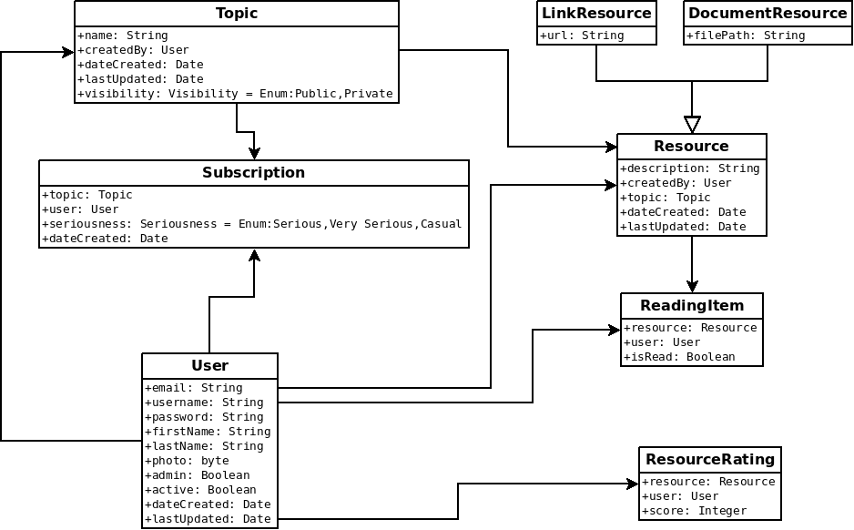

1. Domains of the project should match this class diagram.
2. Take care of belongsTo and hasmany relationships.
3. Seriousness and visibility will be enums.

**Home Page**

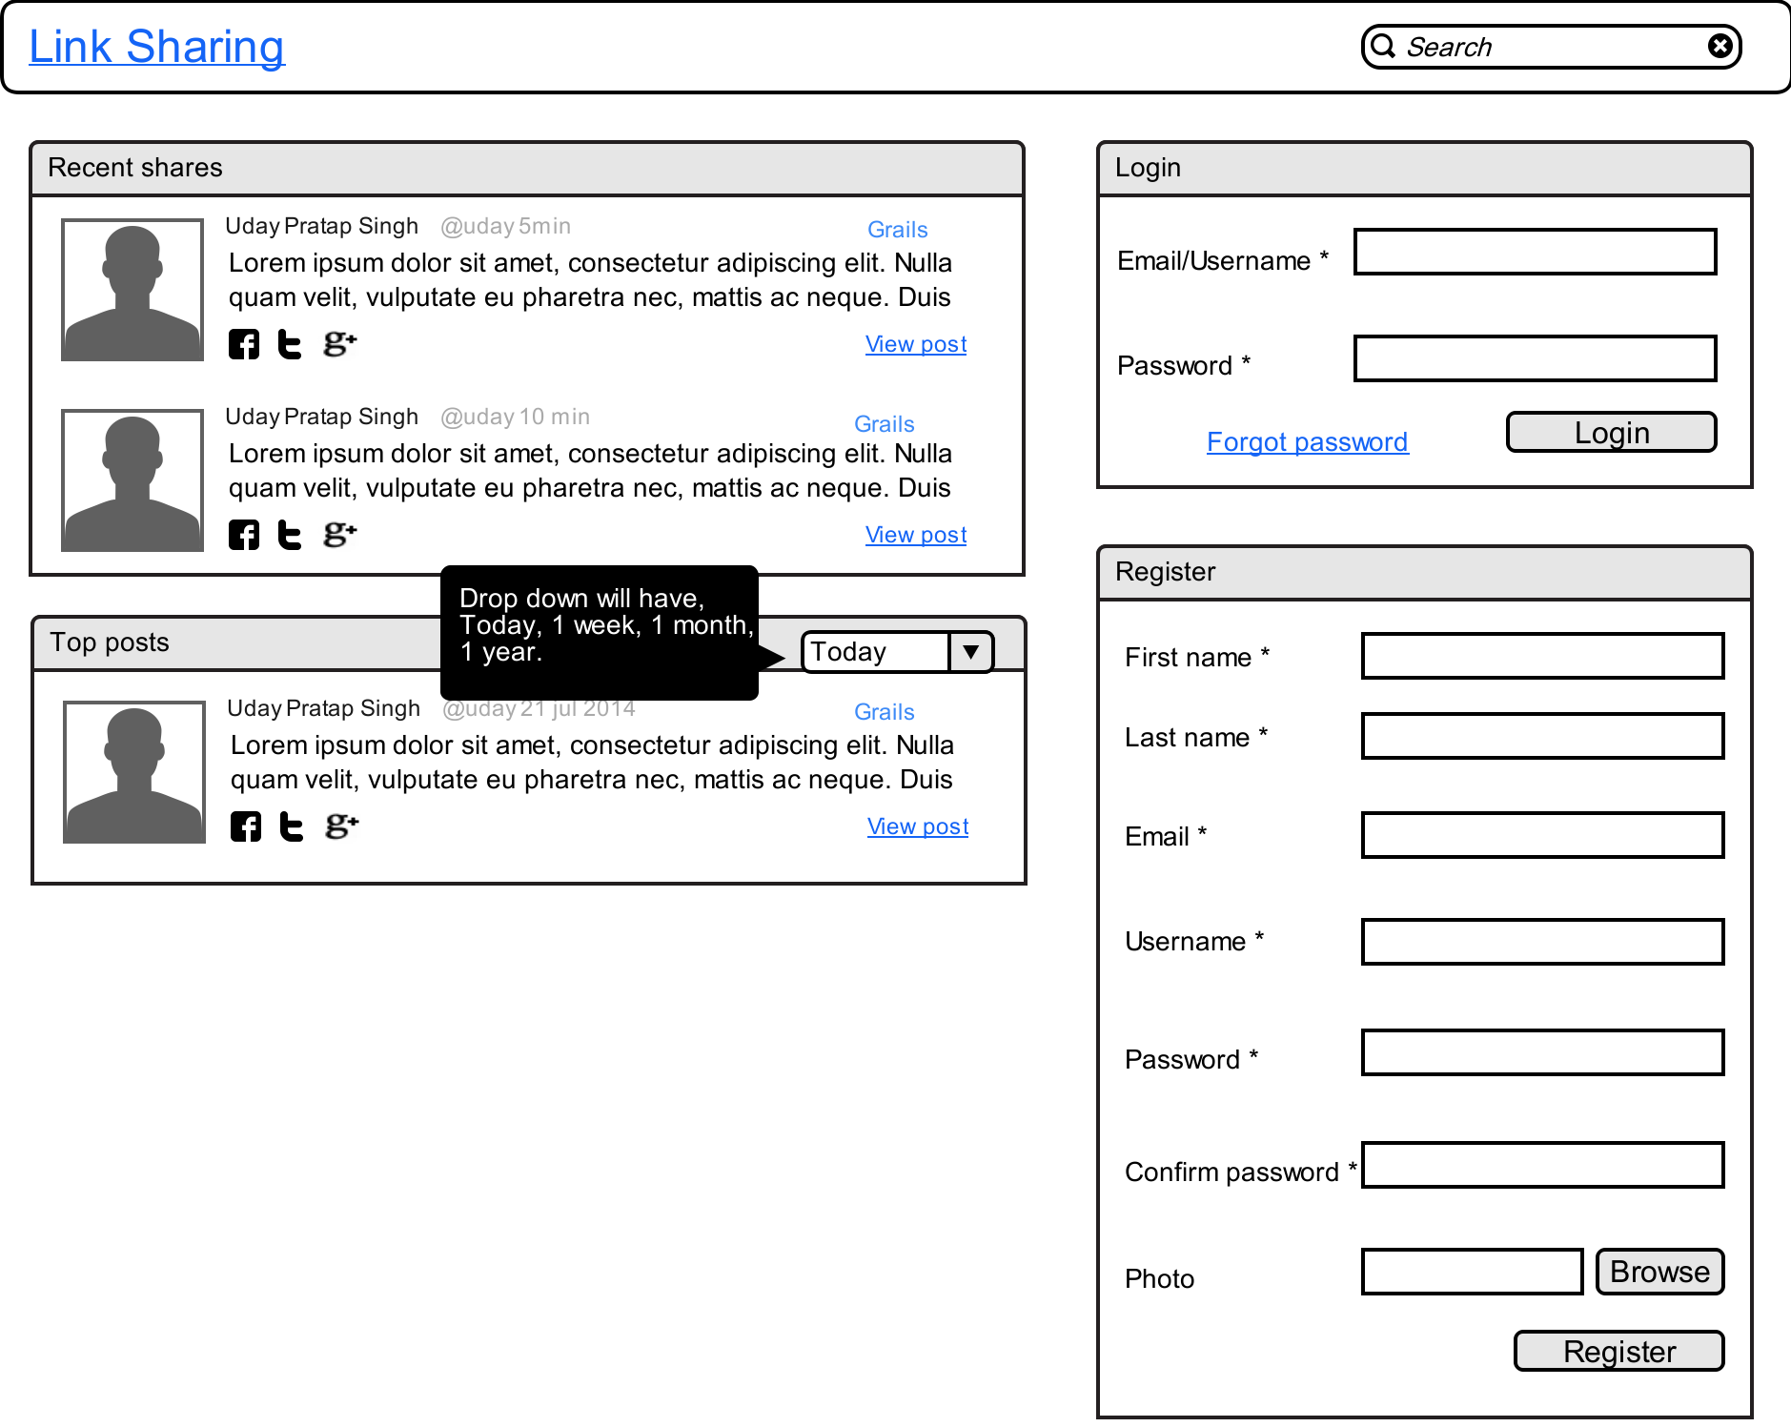

1. Home page will appear if user is not logged in.

2. Top posts are those resources which have maximum rating. Top 5 records will be shown.

3. Recent share will have latest 5 resources created.

4. Posts of public topics will be shown only.

5. Email and username will be unique.

6. After register or login, user will go to dashboard.

7. Drop down in top post will change the content on change of dropdown.(It will be ajaxified)

8. Clicking on user image will take to user profile page.

9. Clicking on topic name e.g; ***Grails*** will show the topic show page.

**Dashboard Page**

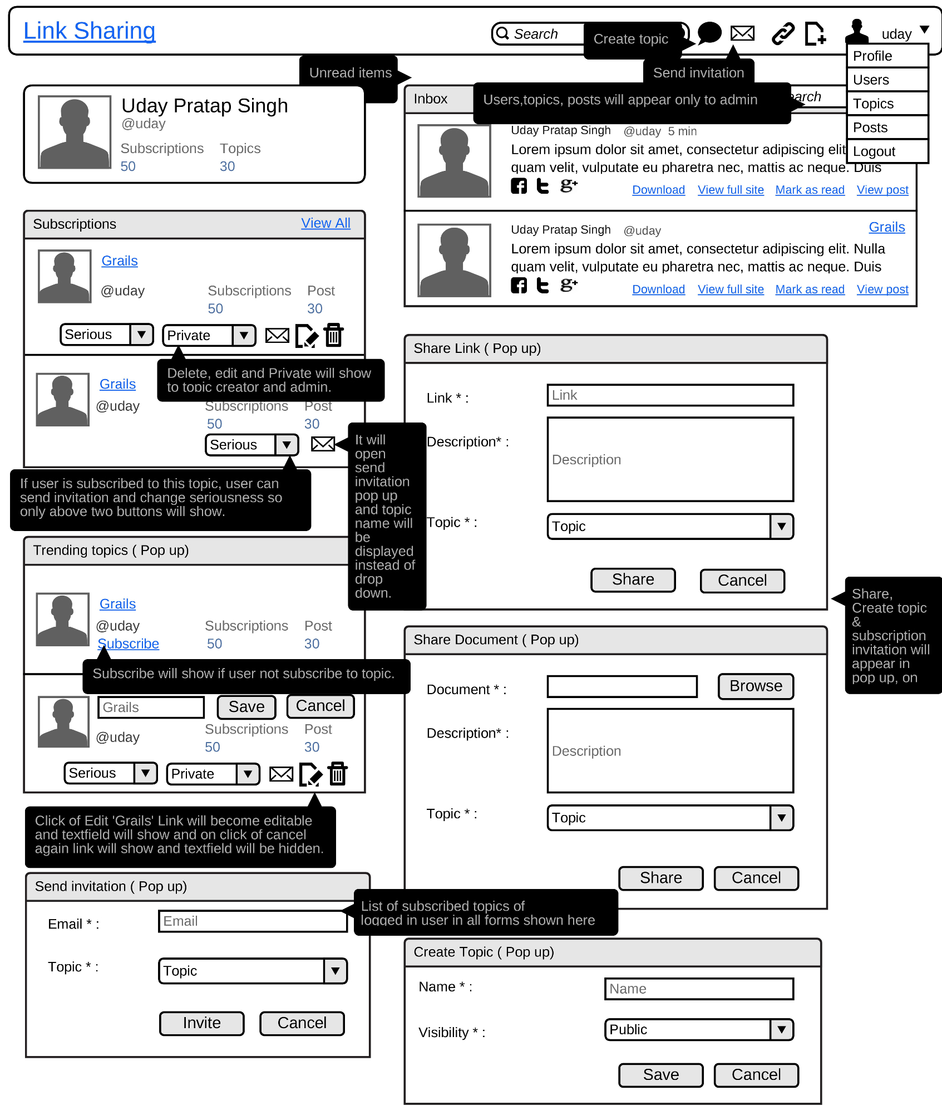

1. This is the default/home page for logged in user.
2. User information will be shown on top left like number of subscriptions and topics created by user. Clicking on user subscription will show the list of subscribed topics of user. Click on user topic will show topics created by user. It will be topic list page.
3. Inbox will show all the unread items. Search will be ajaxified and the ajaxed paginated.
4. Clicking on mark as read will remove the record from inbox.
5. Download will appear for document resource otherwise view full site will appear.
6. View full site will open the link in new tab.
7. Trending topics will be based on maximum number of posts. Top 5 will be shown.
8. Subscriptions will show the 5 subscribed topics of the user, ordered by latest post entered in the topic. It will show the number of subscribed users for the topic and the number of post shared in that topic.
9. Clicking on view all will show all the topics in alphabetical order.
10. Only admin and the owner of the topic will be able to see the Edit, Delete and change of visibility of the topic.
11. Edit will be inline editing of topic name.
12. Changing the drop down of topic visibility will update the topic. Same for seriousness.
13. Visibility drop down will appear only if the user is admin or the topic is created by logged in user, same for changing the name of topic
14. Send invitation will open the pop up, where user will select the existing subscribed topics or can create a new topic which will update the topic dropdown.
15. Clicking on comment icon next to search box will open create topic pop up.
16. Topic name will be unique per owner.
17. Share link and document will be a pop up as well which will open by clicking on the links given on header.
18. Clicking on topic name will show topic show page.
19. User can create new topic by clicking on header icon, it will show the pop of create topic.
20. Navigation will be same for all the users.

**Topic Show**

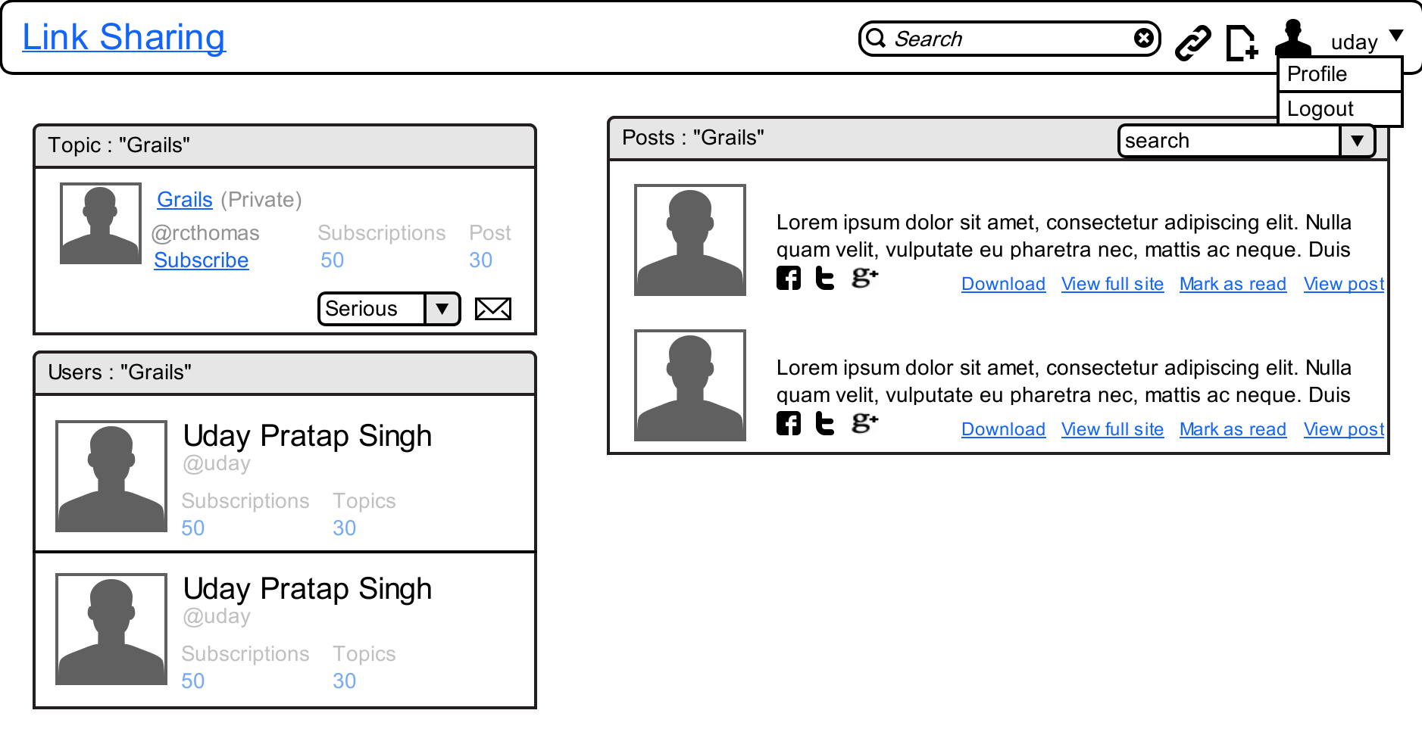

1. Clicking on the topic name will show this page
2. Ajaxified paginated list of users and posts of the topic will be shown.
3. Users and posts will be 10 per page.
4. User can search post within the selected topic.
5. Topic name will be shown on posts, users and topic panel header.
6. If topic is subscribed then unsubscribe link will be shown.
7. Owner of the topic cannot unsubscribe the topic

**Subscription/Topics**

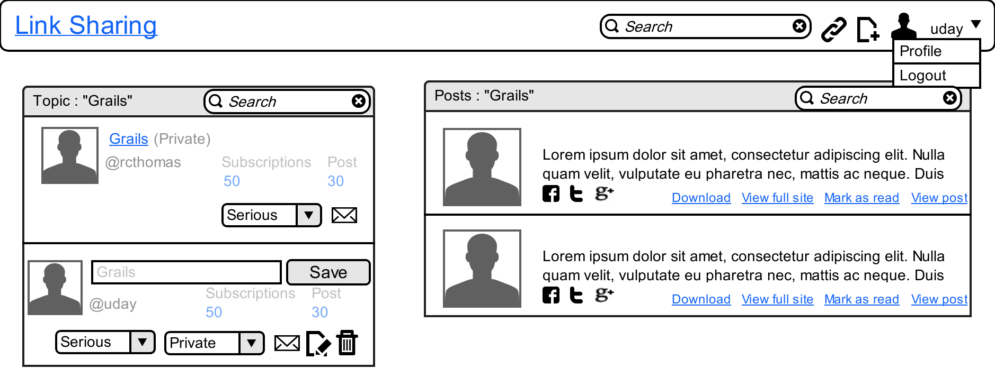

1. This page will appear from the ***View All*** link on dashboard subscription panel and also for admin from top navigation.
2. Ajaxified pagination and searching on posts and topic.
3. Search on post will work on selected topic.
4. Topics and posts will be 10 per page.
5. Selected topic name will be show on post and topic widget.
6. Edit, Delete links will be shown to topic owner and admin.
7. Topic listing will be alphabetical order and posts will be on the basis of dateCreated.
8. Mark as unread will be shown if the post is already read by user.
9. This page will be used as topics listing page for admin.
10. Deleting the topic will delete all the subscription resources and readingitems.

**Search**

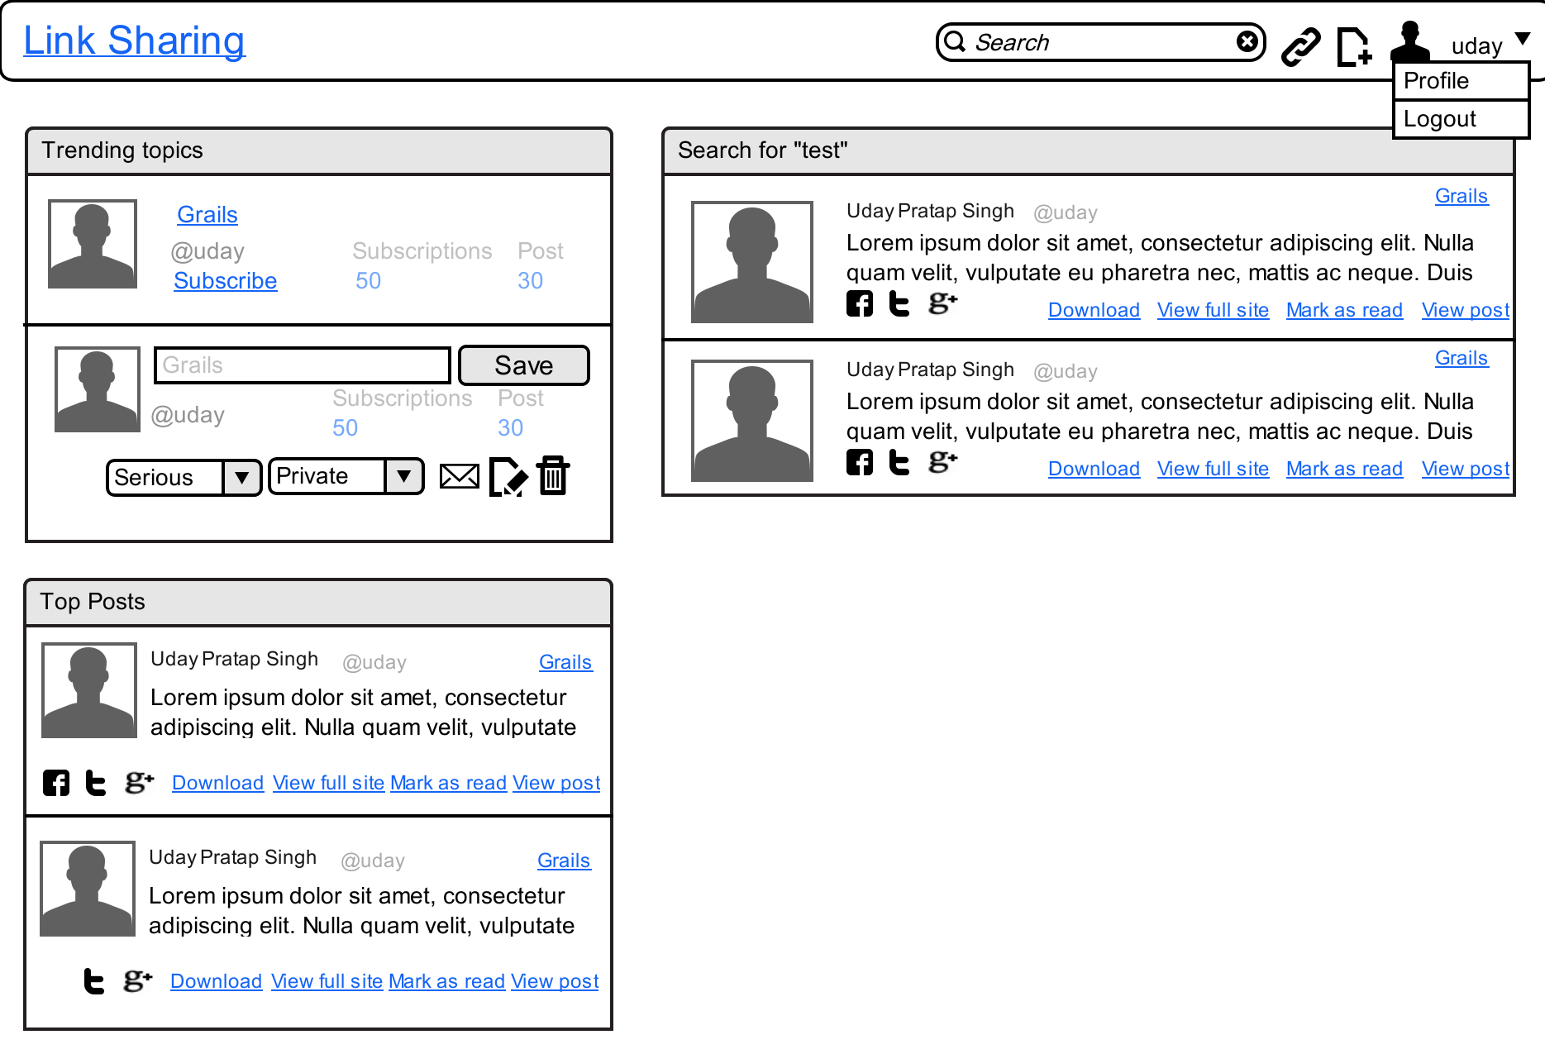

1. Top post and trending topics will show 5 records.
2. Search will be based on text in topic name or resource description.
3. ajaxified pagination on search with 10 records each page.
4. Search needs to have some text.
5. Admin can search all the post by entering blank text in search.

**Post**

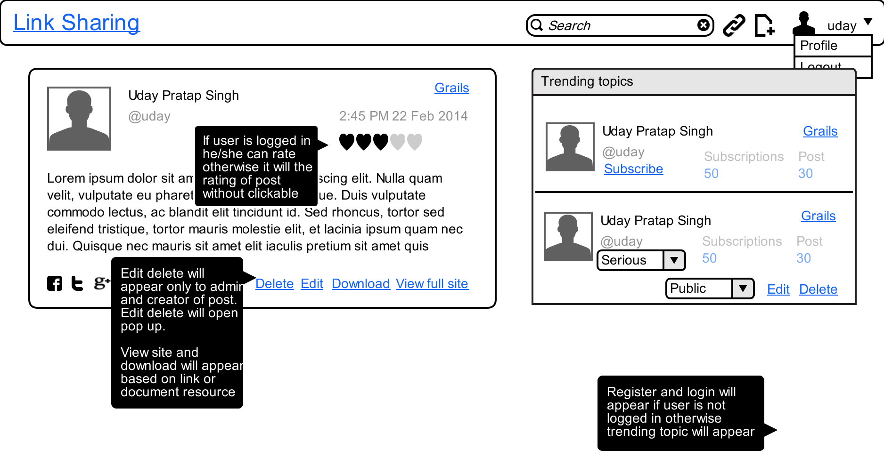

1. This page will appear when user click on ***View Post***  link posts panel.
2. Edit will open the popup same as used for creating the post.
3. User can rate post and share it on social sites.
4. Rating widget will be created after advance jquery till then drop down will work.
5. Number of users rated the post should be displayed adjacent to the ratings.

**Edit Profile**

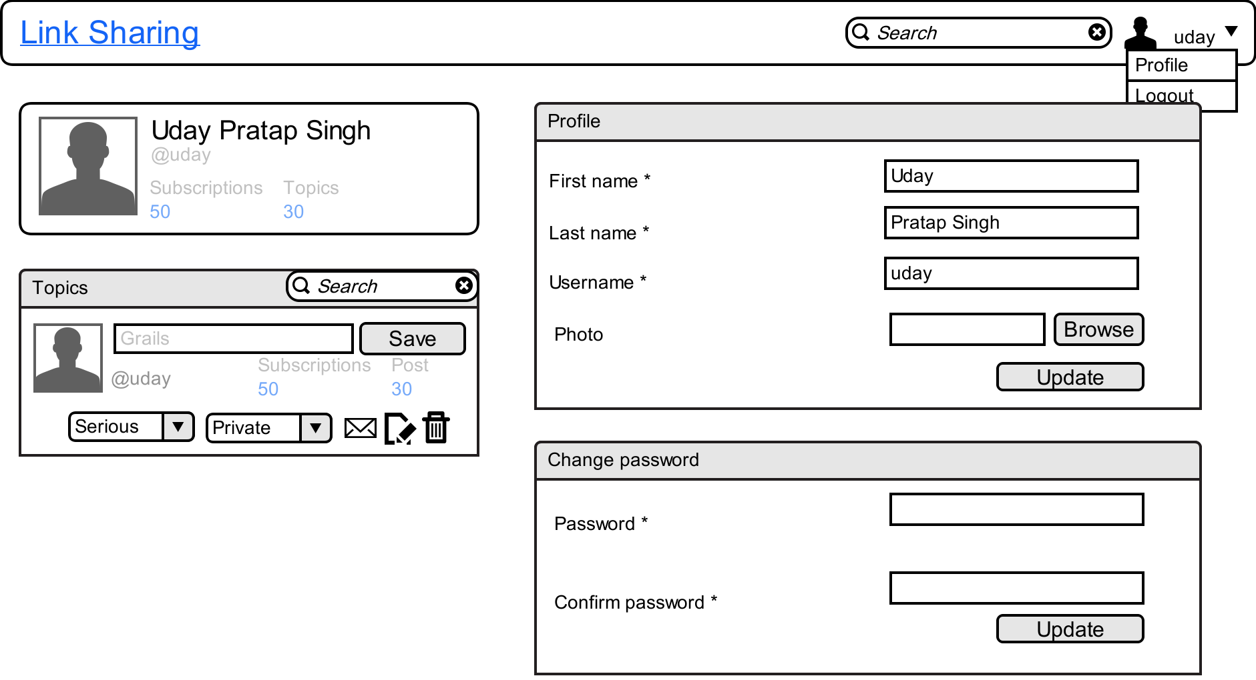

1. This page will appear when user click on profile link in header.
2. Topic created by user will be shown, 10 per page.
3. Pagination and searching of topic will be ajaxified.
4. It will show up when user clicks on profile link in top navigation.

**User**

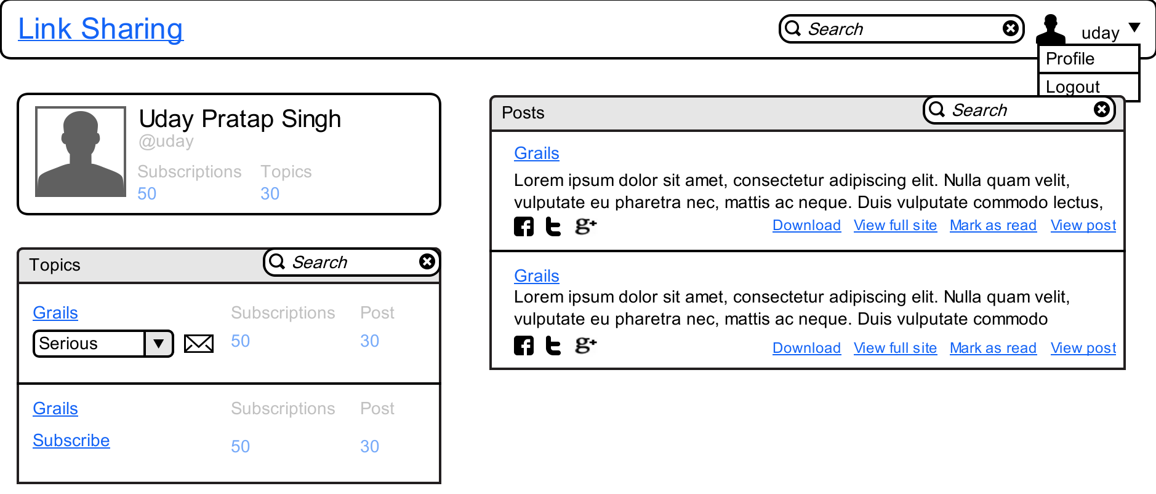

1. This page will appear for user public profile. It will show up when anybody clicks on user image.
2. All the public subscription count will be shown and the public topics created by user will be shown. If logged in user is admin then public and pvt both will be shown.
3. Topics panel will show all the public topics created by user 5 per page, ajaxified searching and pagination.
4. All the post added in public topics will be shown in posts panel, ajaxified searching and pagination.

**Users (For admin)**

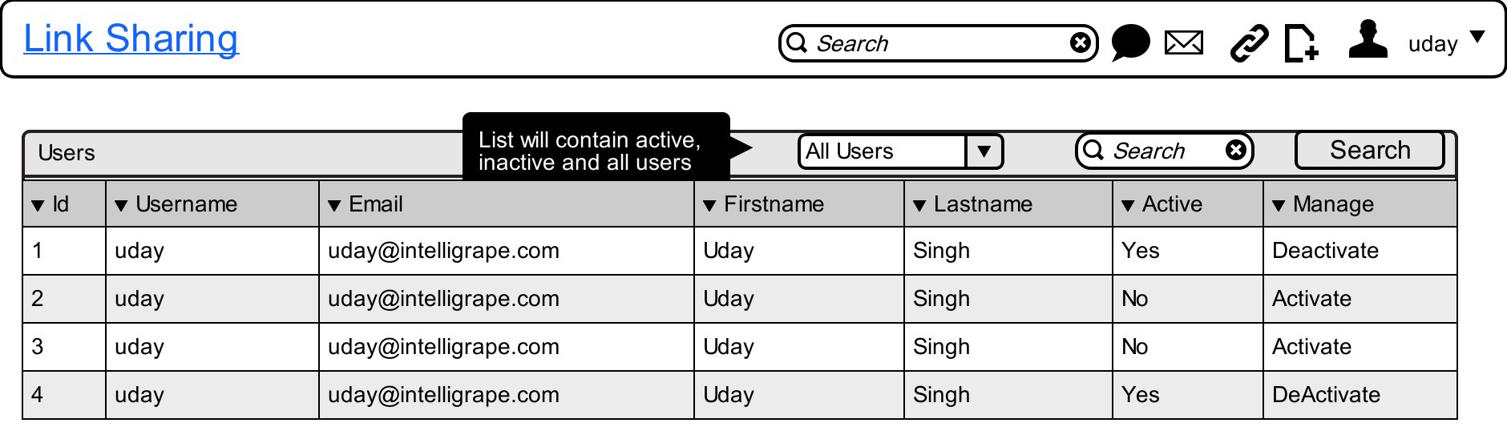

1. 20 records per page will be shown to admin.
2. Only admin can access this page.
3. User can be deactivated by admin, by doing this user will not be able to login.