Week 3
Contents
SETUP | Create a working directory:
SETUP | Download sample log file:
SETUP | Verify the file:
EX 1 | Exercise 1: Count Total Requests
EX 2 | Exercise 2: Extract IP Addresses
EX 3 | Exercise 3: Find Top Talkers
EX 4 | Exercise 4: Analyze HTTP Status Codes
EX 5 | Exercise 5: Identify Suspicious URLs
EX 6 | Exercise 6: Detect Scanning Activity
EX 7 | Exercise 7: Detect SQL Injection Attempts
EX 8 | Exercise 8: Detect XSS Attempts
EX 9 | Exercise 9: Detect Directory Traversal
EX 10 | Exercise 10: Analyze Traffic by Time
EX 11 | Exercise 11: Analyze Request Methods
EX 12 | Exercise 12: Extract POST Requests
EX 13 | Exercise 13: Calculate Bandwidth Usage
EX 14 | Exercise 14: Extract and Format IPs
EX 15 | Exercise 15: Anonymize IP Addresses
EX 16 | Exercise 16: Extract URLs Only
STEP 17 | Step 17: Document Your Findings

Create a working directory:
mkdir -p ~/soc-labs/week3
cd ~/soc-labs/week3

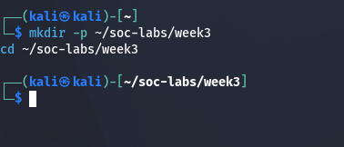

Download sample log file:
wget https://raw.githubusercontent.com/elastic/examples/master/Common%20Data%20Formats/apache_logs/apache_logs -O access.log

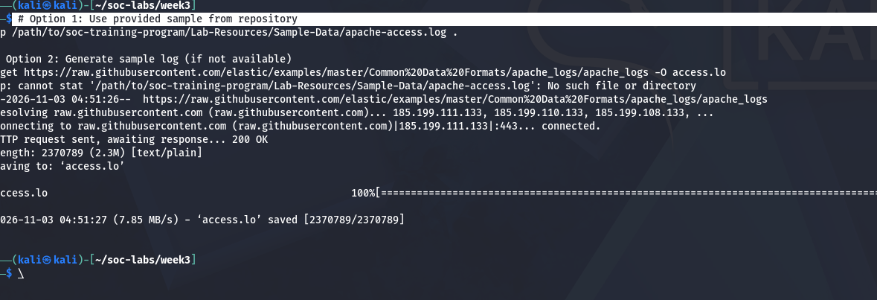

Verify the file:
ls -lh access.log
head -5 access.log

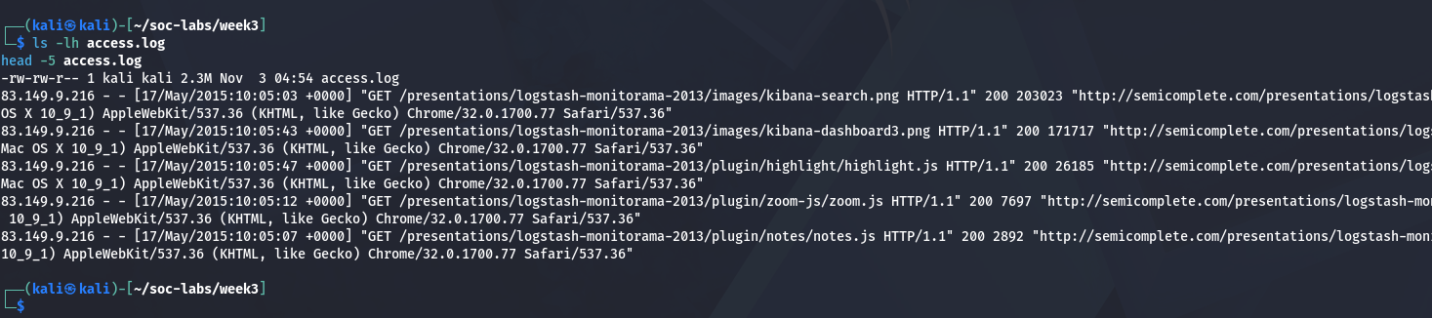

Exercise 1: Count Total Requests
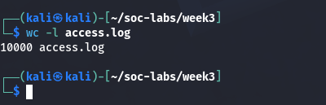

Exercise 2: Extract IP Addresses
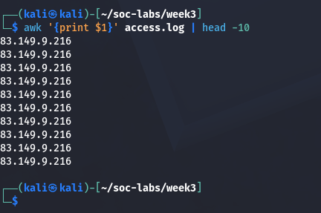

Exercise 3: Find Top Talkers
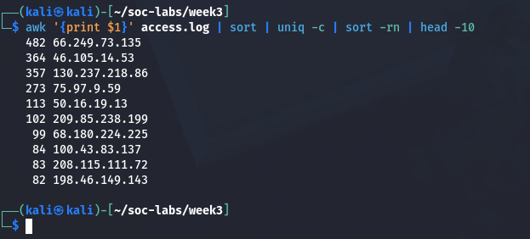

Exercise 4: Analyze HTTP Status Codes
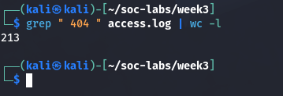

Exercise 5: Identify Suspicious URLs
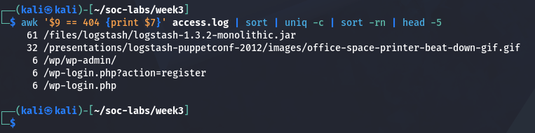

Exercise 6: Detect Scanning Activity
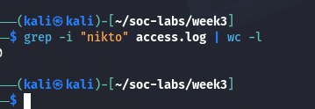

Exercise 7: Detect SQL Injection Attempts
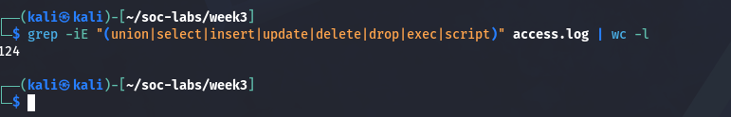

Exercise 8: Detect XSS Attempts
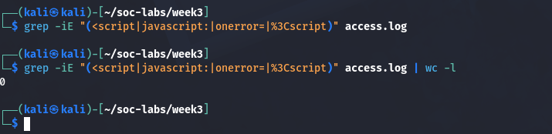

Exercise 9: Detect Directory Traversal
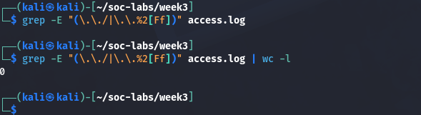

Exercise 10: Analyze Traffic by Time
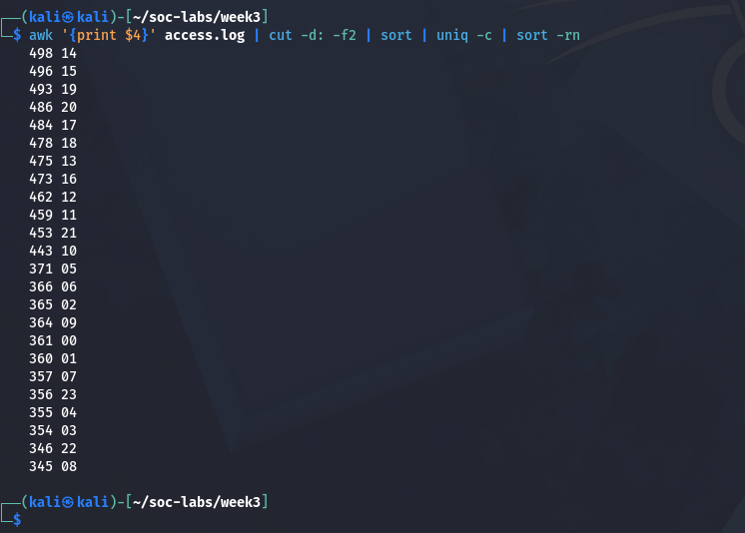

Exercise 11: Analyze Request Methods
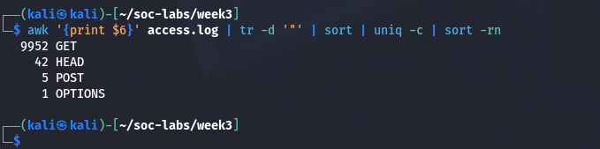

Exercise 12: Extract POST Requests
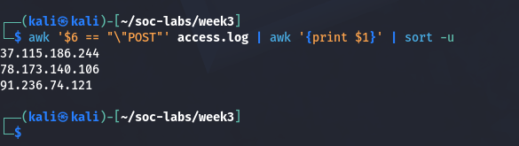

Exercise 13: Calculate Bandwidth Usage
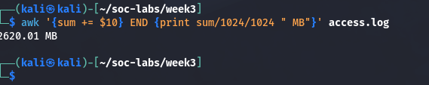

Exercise 14: Extract and Format IPs
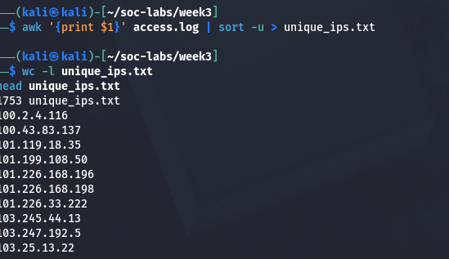

Exercise 15: Anonymize IP Addresses
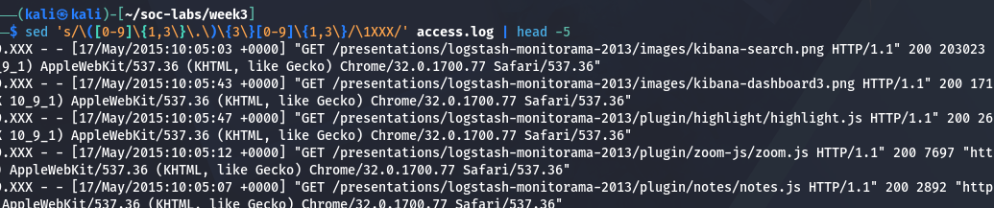

Exercise 16: Extract URLs Only
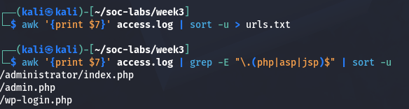

Step 17: Document Your Findings


