Week 4
Contents
EX 1 | Exercise 1: View Recent Security Events
EX 2 | Exercise 2: Filter by Event ID
EX 3 | Exercise 3: Filter by Time Range
EX 4 | Exercise 4: Count Events
PART 3 | Part 3: Extracting Event Properties (60 minutes)
EX 5 | Exercise 5: Understanding Event Structure
EX 6 | Exercise 6: Extract Data from Failed Logons
EX 7 | Exercise 7: Analyze Failed Logon Attempts
EX 8 | Exercise 8: Identify Targeted Accounts
EX 9 | Exercise 9: Analyze Logon Types

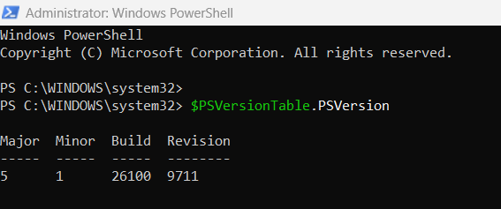

Exercise 1: View Recent Security Events
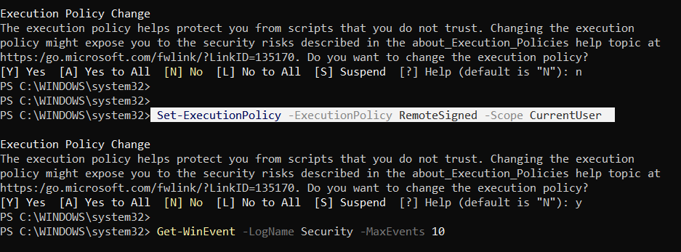

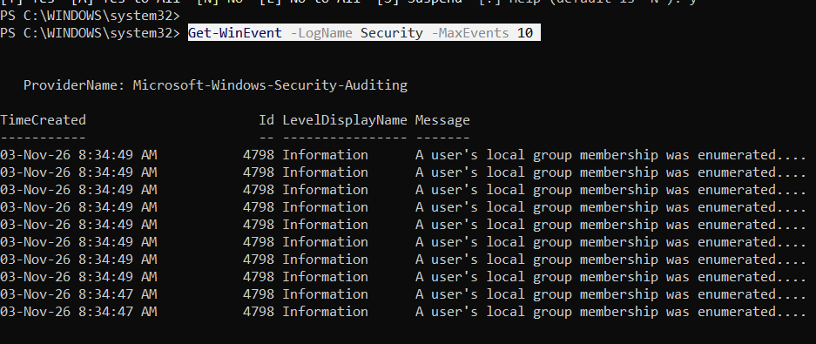

Exercise 2: Filter by Event ID
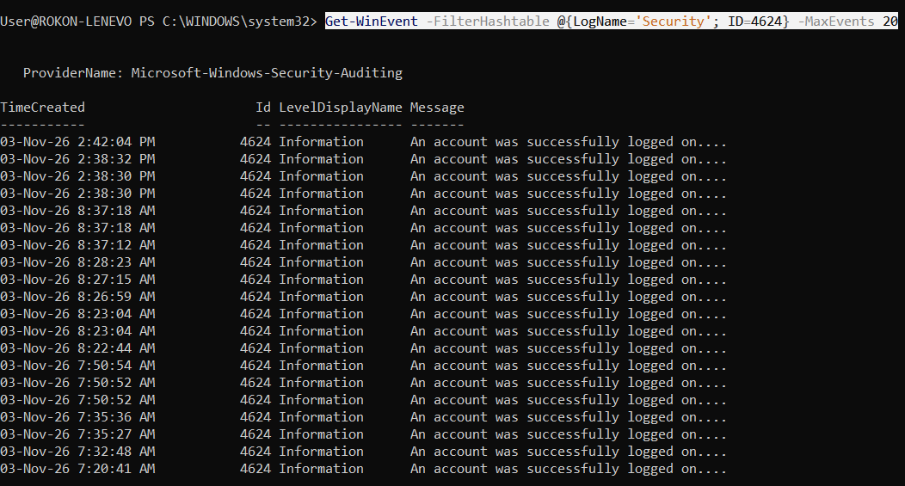

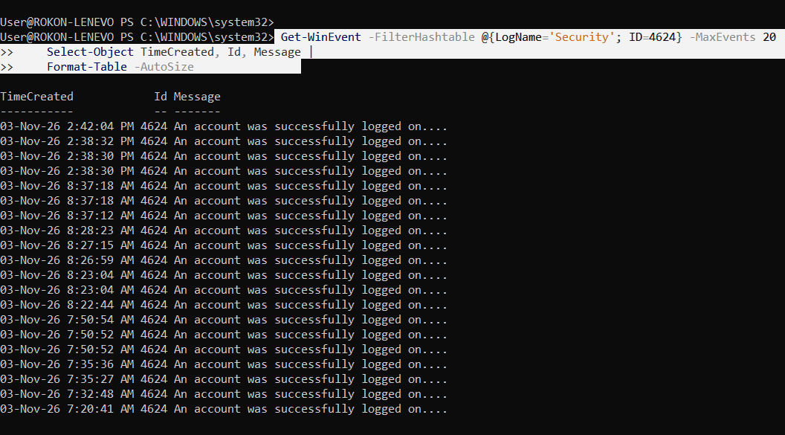

Exercise 3: Filter by Time Range
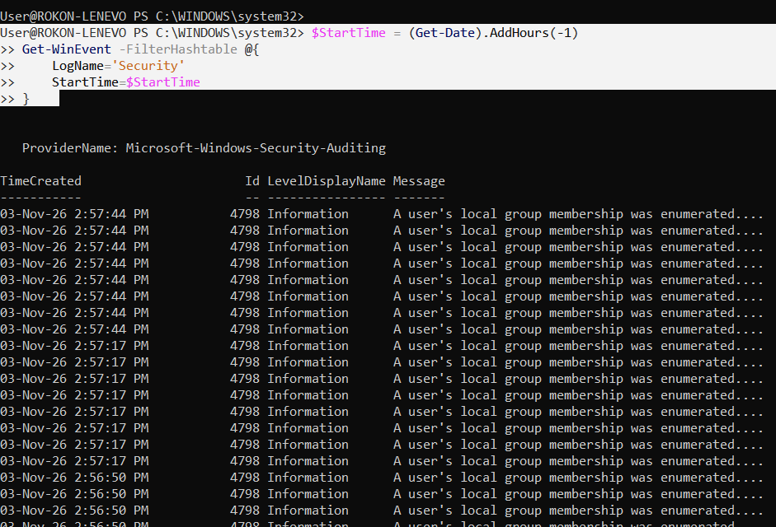

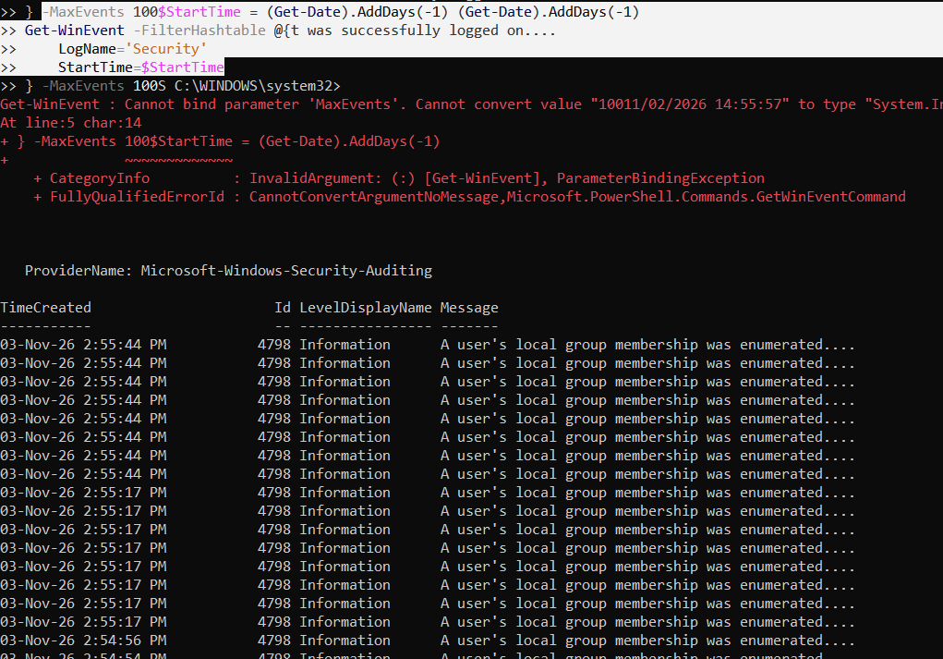

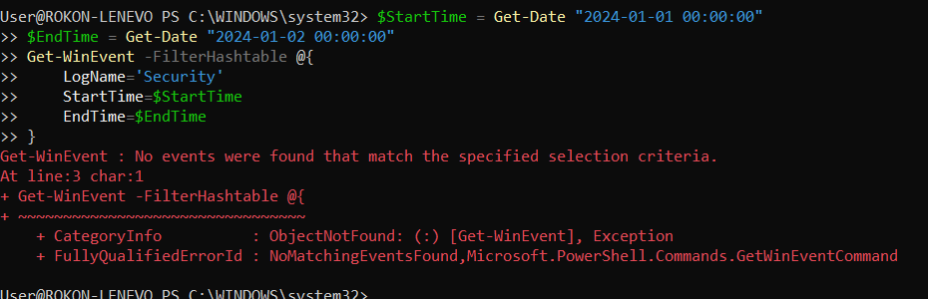

Exercise 4: Count Events
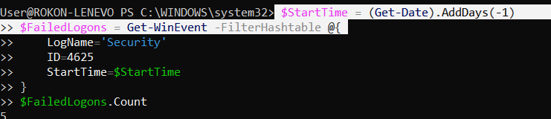

Part 3: Extracting Event Properties (60 minutes)

Exercise 5: Understanding Event Structure
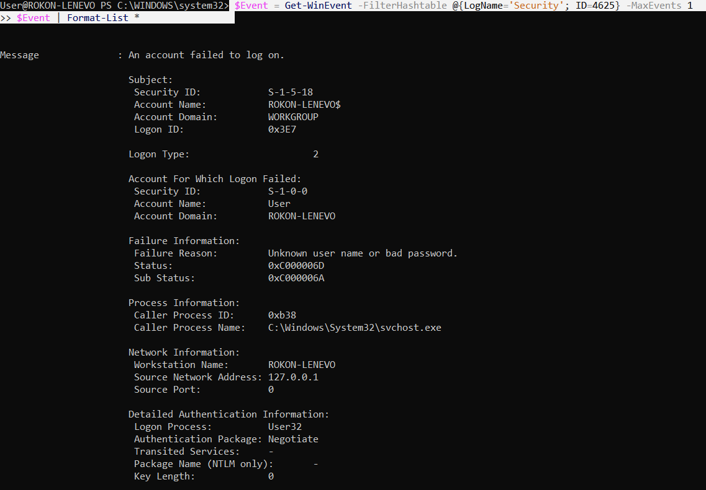

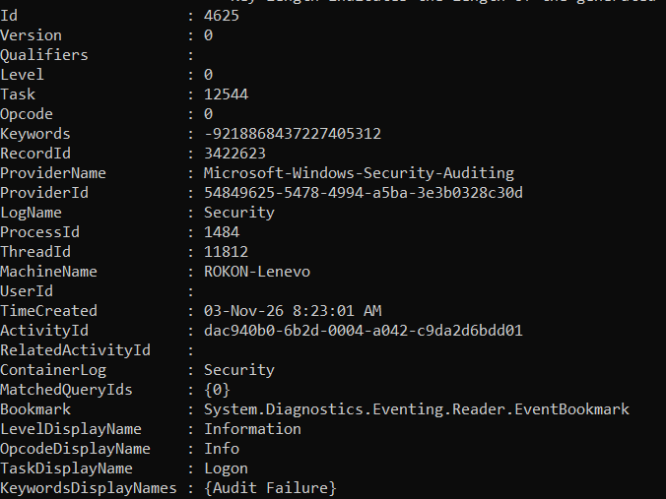

Exercise 6: Extract Data from Failed Logons
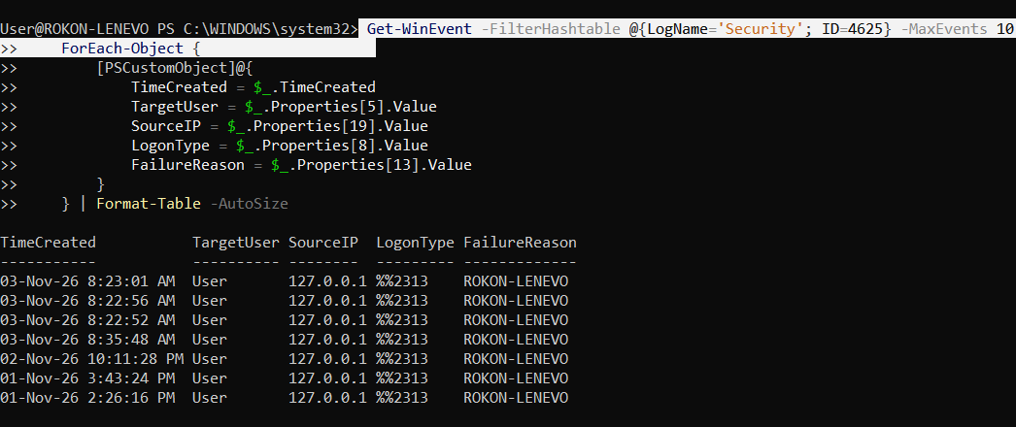

Exercise 7: Analyze Failed Logon Attempts
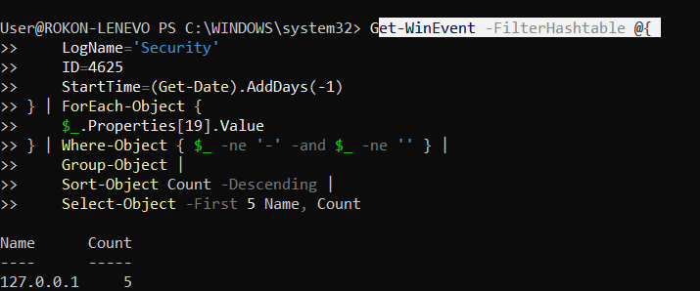

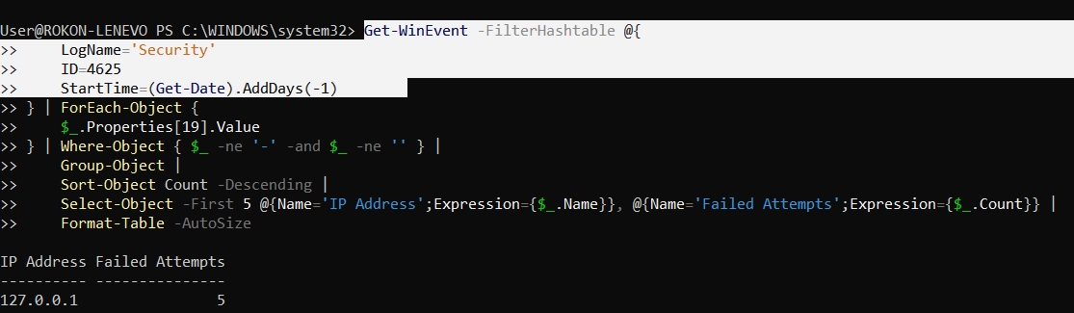

Exercise 8: Identify Targeted Accounts
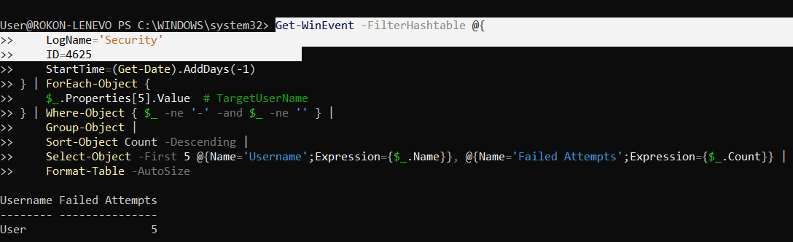

Exercise 9: Analyze Logon Types


