🡺 Your name: Amirhossein Sabagh Student No.: 152956199 UserID: asabagh@mySeneca.ca

🡺 How many seconds did it take to copy and paste using the mouse?

9.5 seconds

🡺 What were the steps including all hand movements?   
 (if too difficult to explain, explain why it is difficult)

Pressing the left-click and dragging it to cover the whole text -> right-click and choose ‘Copy’ -> click on the white space. If it didn’t work, double click to make the space -> right-click again and choose one of the Paste Options (same last two steps for the second copy)

🡺 After practicing, how many seconds did it take to copy / paste using the keyboard?

It got down to near 4 seconds after couple of attempts

*🡺* **Begin-Practice**

🡺 Move this paragraph *(Alt+Shift+Up)* to appear immediately below "**Begin-Practice"**. As long as the cursor is somewhere within this paragraph, the whole paragraph will be auto selected and moved with the Alt+Shift+Up/Down keyboard shortcut.

🡺 Sequence the words of an A – Z typing exercise from alphabetical order into  
a grammatically correct sentence. *Select, cut, paste. Home, End, Ctrl+🡨🡪*   
**The quick brown fox jumps over a lazy dog.**

🡺 Go to the end of this line using a single keystroke and type your name 🡺 Amir Sabagh  
 What was the keystroke that sent the cursor to the end of the line? 🡺End/Fin (digit 1)

**🡺 Convert this line to bold using the minimum number of keystrokes.**   
What were the keystrokes to position, select, and perform the text enhancement?  
End/Fin -> Ctrl + Shit + up arrow -> then Ctrl+B

🡺 Underline the word underline where it appears in this sentence.

🡺 Make all instances of the word "*italics*" on this line into *italics*…and more *italics*.

🡺 Move the following three paragraphs so they are in ascending order   
and change their font type, style, and size to be the same as this line's:

1. Real Programmers use C because it's the easiest language to spell.

2. Real Programmers don't write specs -- users should consider themselves lucky to get any programs at all, and take what they get.

3. Real Programmers don't comment their code.   
If it was hard to write, it should be hard to understand.

🡺 Cut this entire line and paste it to appear immediately above **End-Practice**.

*🡺* **End-Practice**

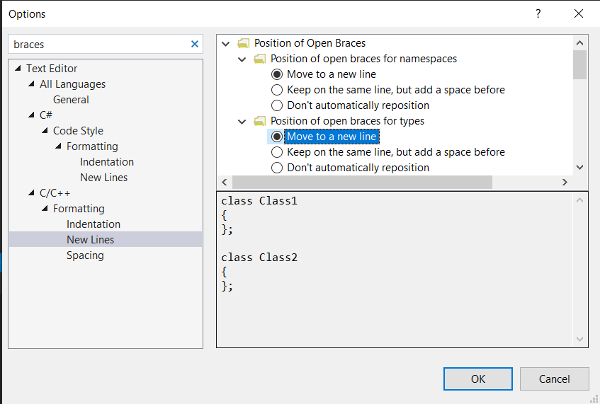

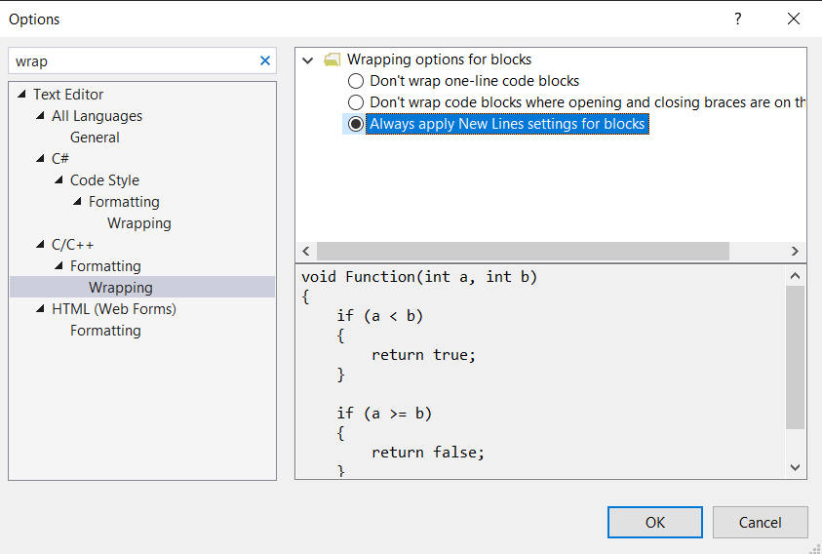

🡺 Copy your new helloWorld2.c source code from Visual Studio (Ctrl+A, Ctrl+C) and paste in the box below using the Paste Option to either Merge Formatting (M) or Keep Text Only (T)

/* Hello World program. Computer Principles for Programmers Week 2. IntelliSense exercise. */

int main(void)

{

printf("Hello World, ");

printf("This is Amir Sabagh\n");

printf("more console output");

return 0;

}

🡺 Their are three misteaks in this sentence. 🡸 Is that sentence True or False…and why?

There are two mistakes in this sentence.

The sentence has two mistakes, therefore the third mistake would be saying the sentence has “three” mistakes :))