🡺 Your name: Amirhossein Sabagh

Student No.: 152956199

UserID: ­­­­ asabagh @mySeneca.ca

🡺 your dictionary of compression token to string characters, one entry per line.

**@and**

**\*the**

**+bitsy**

**-itsy**

**(out**

**)rain**

**#spider**

**%up**

🡺 the compressed rhyme with the token substitutions,   
 i.e. the compressed text (not the sorted analysis list of words)

**\*-+#crawled %*water sp(**

**down came *)@washed *#(**

**(came *sun @dried %all *)**

**@*-+#went %*sp(again**

🡺 how many characters are in the dictionary + compressed text and what is it as percentage of the original’s 187?

number of characters are in the dictionary + compressed text = 138

it's %73 of the original text.

🡺 **Now test your compression dictionary.** Reverse the process to see if your compression dictionary is accurate. Process dictionary items from the bottom up: find the compression character in the compressed data and replace it with the original string. **Paste the decompressed version below** – *even if it is not perfect*. **What modifications, if any, does the compression dictionary need to return the compressed data back into its original state?**

**the itsy bitsy spider crawled up the water spout**

**down came the rain and washed the spider out**

**out came the sun and dried up all the rain**

**and the itsy bitsy spider went up the spout again**

the decompression worked perfectly and everything got back to what it was originally. I first wanted to replace the word 'spout' with '$', but then I found out that when I replaced 'out' with '(', it effected the word 'spout', too. I could have done more compressing and replace some the group of characters in a word (like 'ed' at the end of the verbs of this song) but I just rathered to keep it simple for now.

**🡺** Paste the image of the Windows Explorer .zip archive information.

Use the Snipping Tool ( + “snip”) to copy only the information seen above.

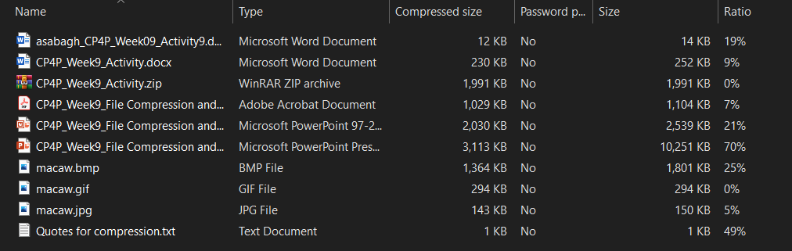

🡺 Files with the **lowest** ratios were compressed the **least**. Ratio indicates % of space saved.  
Which file types compressed the least? Why would that be? (10 pts)

the gif file and the jpg file were compressed the least; the reason for that is that it's harder to compress a bitmap or image file a lot, without losing the quality. What this simple compression does is that it reduces the size of the image without losing a single pixel from the original file. It adjusts the quality of the image by discarding unnecessary data. There are more advanced tools that will compress these image files much more and reduce their size to a greater extent. What they do is that they use certain tricks based on how the human visual system works to take away information, and the removed information can be barely seen.

🡺 Files with the **highest** ratios were compressed the **most**.   
Which file types compressed the most? Why would that be? (10 pts)

The pptx file was compressed the most. PowerPoint files are mostly very large because of their visual elements, 3d objects, images, etc.; we don't see this problem in the previous versions of PowerPoint like 97-2003 PowerPoint files. When we compress a pptx file, all these images, texts, and elements are compressed to an extent and this ends up having a greater compression ratio.

The next largest compression percentage belongs to the .txt file. This type of text file contains plain text and does not have these shiny options in Word; therefore, with a simple compression algorithm, you can compress the texts and reduce the file size up to 50%. The thing about these files is that they already have a very small size like 1 KB and compressing 50 percent of it wouldn't be a great help :)

🡺 paste a screen shot of your backup results. (use the Screen Snip tool) **(10 points)**



**Imagine your laptop just stopped working and could not be restarted**after you completed a great many hours of work today and yesterday.   
You need a backup & restore strategy. **(30 points)**

🡺 What is (or what should have been) your backup routine? How do you ensure your backup is current?

My backup plan is using a cloud storage like Google Drive to store my important files in it. I used to use a USB drive, but the disadvantages of it was numerous; it is harder to carry a USB drive everywhere you go and is more difficult to access it anywhere. They also have a limited storage size, but there is no such thing as limit in cloud drives.

For keeping my files current, I have a folder in my laptop that I keep a copy of the crucial files and folders in it; and once a week, I upload that folder in my cloud drive and update the existing files or add the new ones.

🡺 How does your backup routine address the three characteristics of a real backup and fulfill the 3-2-1 backup check?

I mostly have more than one copy of an important file in my laptop; so, in case that one file gets deleted, there's another copy in my laptop that I can use. The offsite copy is in my cloud drive. I don't use my cloud drive as the primary storage as I never know when I may get disconnected form the internet.

🡺 Now that you have a backup *but no laptop*, how will you access and work with the current version of your backed up files? What is your restore/recovery strategy?

The good thing about having a cloud drive is that you can access it anywhere you want, doesn't matter if it's on another laptop or a mobile.

I would try to access my files in my cell phone if it doesn't need much control. If necessary, I would borrow my sister's laptop or use my brother-in-law's computer to get my job done.

🡺 How long would this all take…and what if you a had a big assignment due tomorrow?

It wouldn't take much as all I need is remembering my password to my account. I live near my sister and even if she is not accessible not, I'm definitely near a library or a copy/fax place. They have systems and I can use them to access my cloud storage.