**Connect to Oracle from Visual Studio C++**

**Download and Install Oracle Instant Client**

Go to the following link to download the following version of Oracle Instant Client:

**Oracle Database 12*c* Release 2 Client (12.2.0.1.0) for Microsoft Windows (x64)**

**Link:** [**https://www.oracle.com/database/technologies/oracle12c-windows-downloads.html**](https://www.oracle.com/database/technologies/oracle12c-windows-downloads.html)

Extract the file. Execute the “setup.exe” in the following path where you downloaded Client Instant:

…\Oracle Instant Client\winx64_12201_client\client\setup.exe

Wait until the installation wizard starts. It may take time to start up.

Choose the “Administrator” option, in the “Select Installation Type” page. Click “Next”

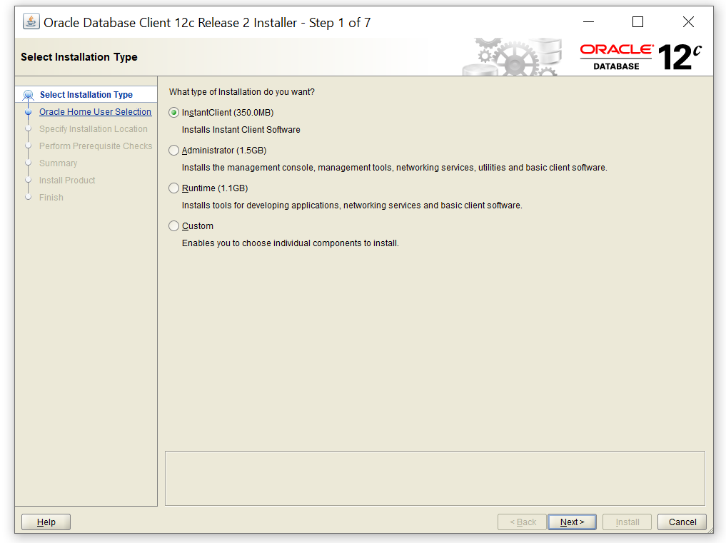

In this page, you create a username. Choose “Create New Windows User”. You can define any username and password. Make sure you choose a password that can be remembered easily.

You may see the following message:

Administrative password:[INS-30011] The ADMIN password entered does not conform to the Oracle recommended standards.

Ignore the message and continue. Click on “Next”.

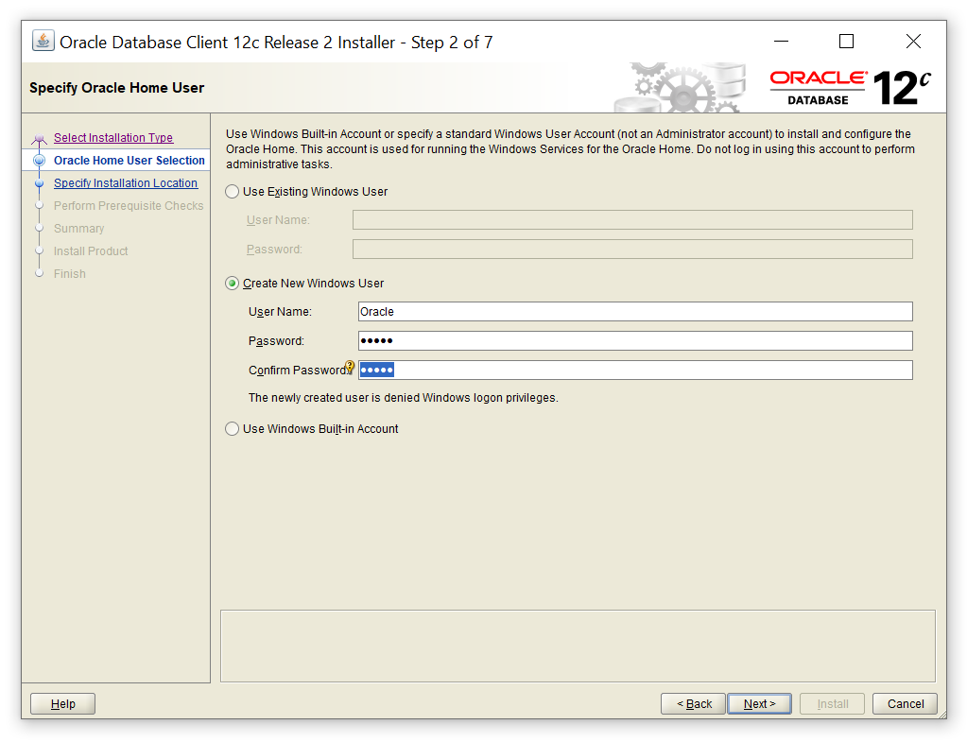

In oracle base filed, you define where to install oracle. We use this location later to set up Oracle in Visual studio.

For oracle base use the path C:\app\

And for software location use the path C:\app\oracle\product\12.2.0\client_1

You can browse the in following window

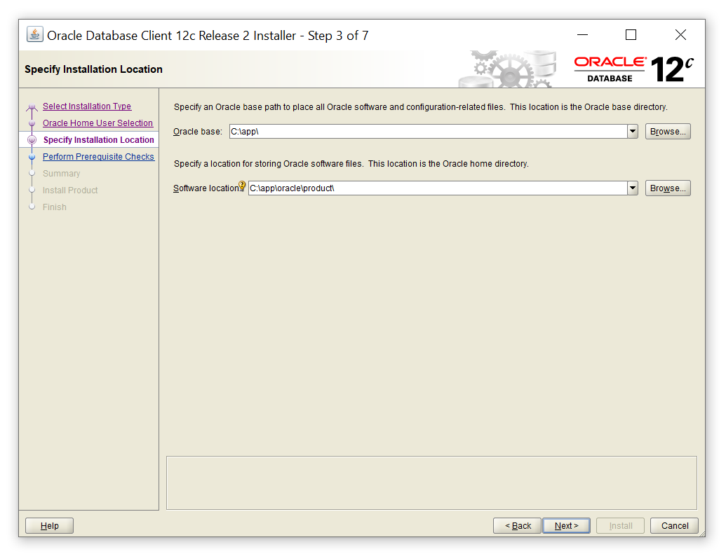

In the summary page, click on “Install” button.

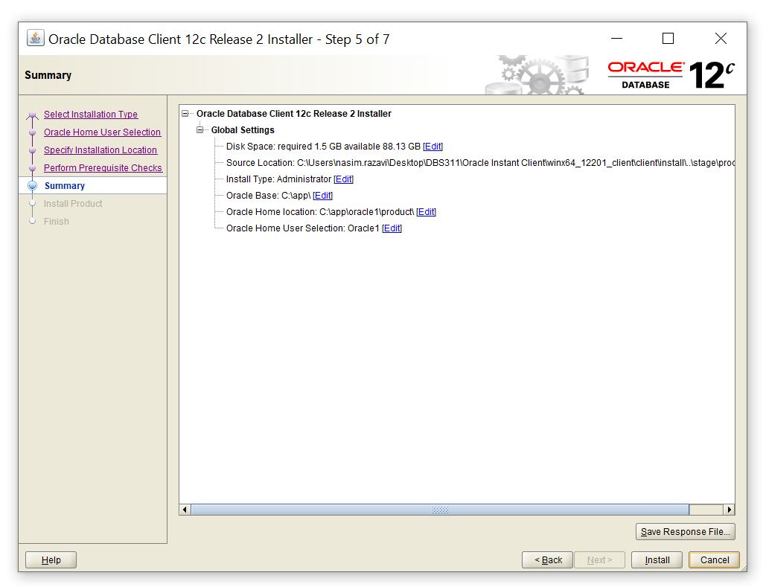

**Configure Visual Studio C++**

Create a new project in VC++. Add your .cpp source file to your project. Then, go to the project properties:

Open “Configuration Manager”, set “Active solution configuration” to “release” and “Active solution platform” to “x64”.

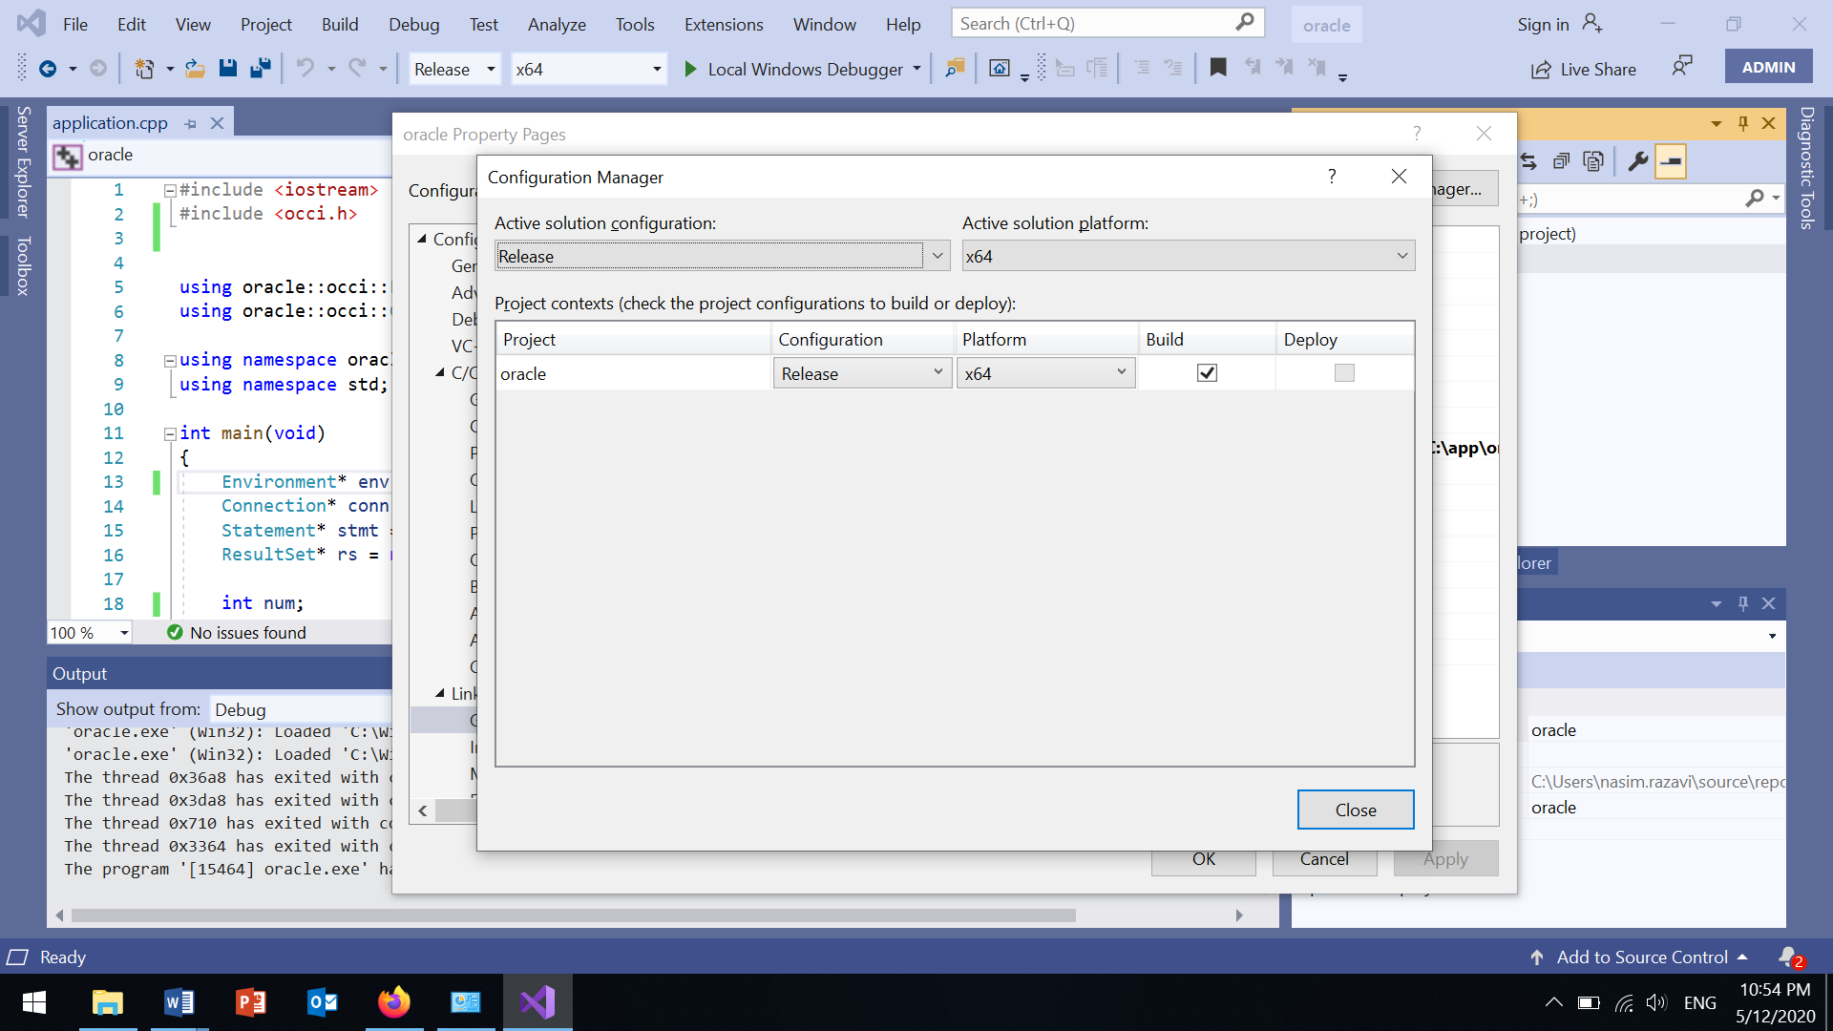

In the project properties navigator, under C/C++, select “General”. Add the following path to “Additional Include Directories”.

C:\app\**oracle**\product\12.2.0\client_1\oci\include

“oracle” is the new windows user name that I created when installing Oracle Client Instant. If you have chosen a different user name, you will see your username in the C:\app\ folder.

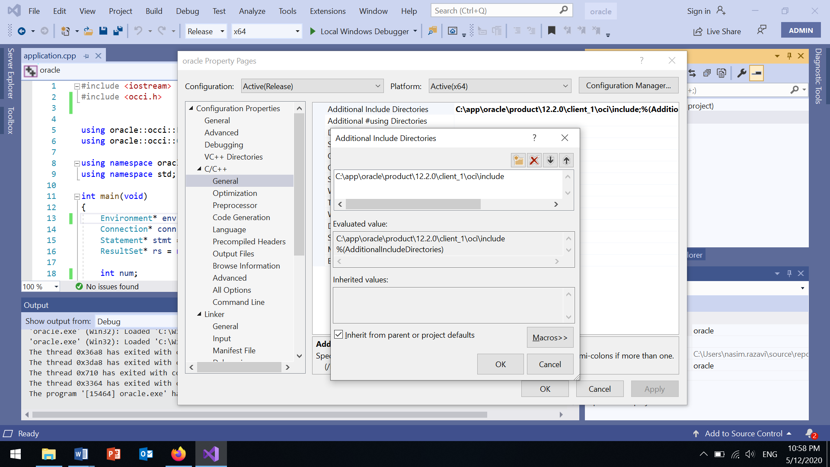

In “Linker/General”, add the following paths to “Additional Library Directories”:

C:\app\oracle\product\12.2.0\client_1\oci\lib\msvc

C:\app\oracle\product\12.2.0\client_1\oci\lib\msvc\vc14

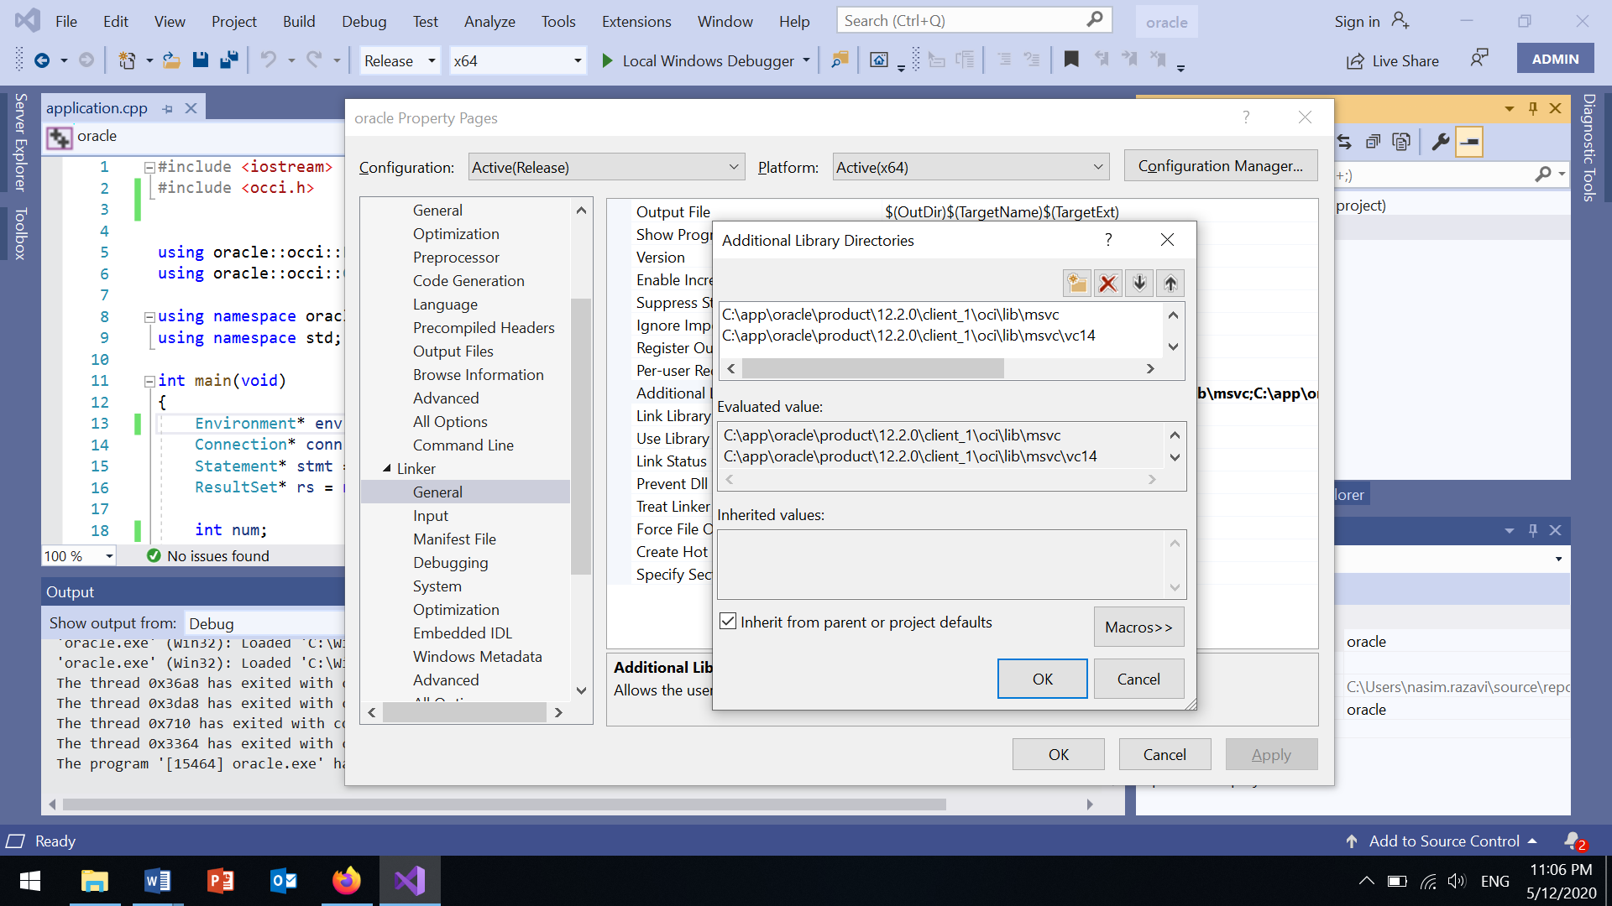

In “Linker/Input”, write “oraocci12.lib” to the “Additional Dependencies”.

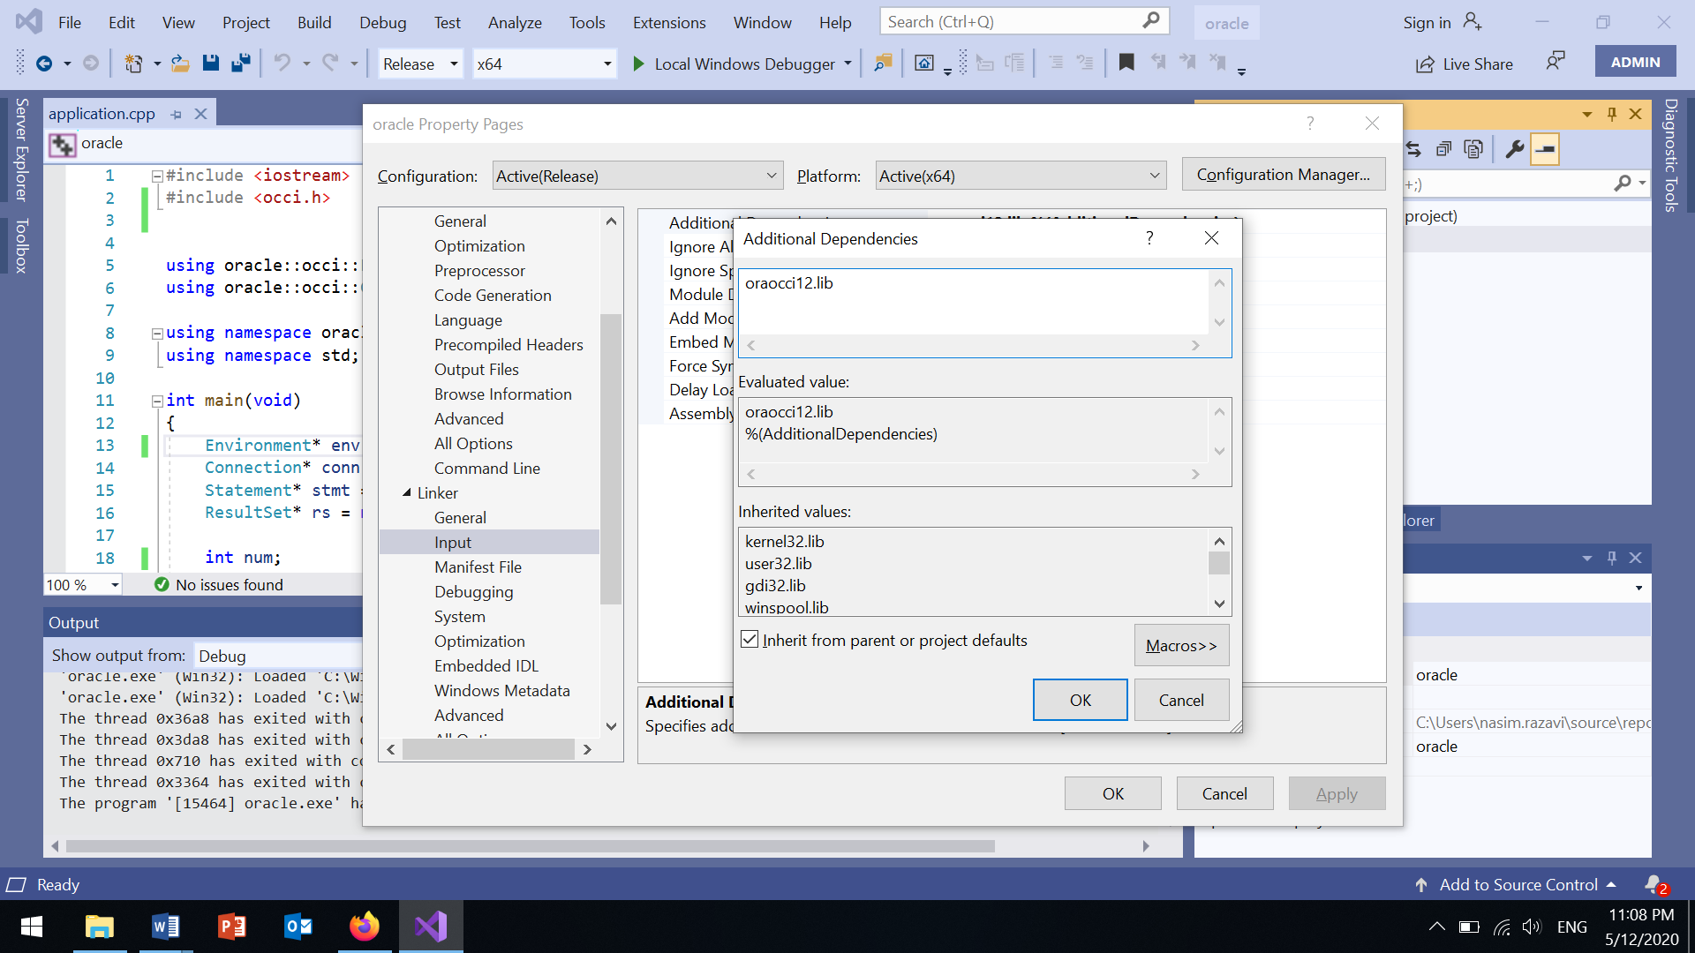

Clink “Apply” and then “Ok”.