APPENDIX – B
USER MANUAL

Voice Launch

User MANUAL

AMIR RAMINFAR
April 2005

Version 1.0

Table of Contents
1. Introduction 3
2. System Requirements 4
3. Installation 5
4. Library View 8
5. Inserting New Items to the Library 10
6. Launching Applications 12
7. Recording Yes, No and Computer 14
8. Preferences 15
9. Contacting the Author 17

Introduction
Voice Launch is a speech recognition program that will recognize and launch a selection of at least fifteen applications. A number of phrases will need to be recorded and associate each phrase with an application. The expected accuracy is equal or greater than 80%. To launch an application, a phrase is recorded and passed to the recognition thread. The recognition thread will find the most similar item from the library by comparing the recorded phrase to all other templates in the library. A template holds features of a previously recorded phrase and is stored in the library. Confirmation dialog is shown prior to launching any application. If the found application is not what was desired, then the best next application is displayed by clicking “No.” If after three attempts, the correct application was not found then no application is launched. The process can be cancelled anytime by clicking “Cancel” in the confirmation dialog.

This user manual will initially guide users to install the program. After installation, the application will be explained in detail for use. To use this application, a microphone is required and speakers are strongly recommended for playback. Please refer to the System Requirements section for more details.

System Requirements

The following are the hardware requirements for Voice Launch. Please note that speakers are not required but only recommended.

  - Microphone
  - Speakers (Not required but recommended)
  - At least 800 MHz Processor
  - At least 256 MB RAM
  - Keyboard and Mouse
  - Enough disk space to save the WAV files

The following are software requirements for Voice Launch. Voice Launch requires Windows XP or later with Java Virtual Machine 1.5 or higher installed.

  - Windows XP or later
  - Java Virtual Machine 1.5 or later

Installation
Prior to installation, make sure all system requirements are met. Most important of all, Java JRE 1.5 or later needs to be installed correctly. Double click on the setup file to begin installation. Follow instructions on screen to install Voice Launch. After installation, Voice Launch will be added to Start Menu and a shortcut will be added to the desktop.
Before starting Voice Launch, make sure that the recording microphone level is about 40% with Mic Boost turned on. To adjust you microphone settings go to volume control and under the Options menu choose Properties. Choose Recoding and make sure Microphone is selected. Figure 1 demonstrates the Properties window that should be shown.
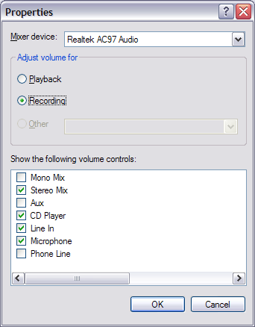
Figure 1 - Properties

Then adjust the volume by moving the slider for Microphone up and down. Click Advanced and check “Mic Boost.” Figure 2 shows a good volume level for the microphone level, and Figure 3 shows the advanced controls for microphone.
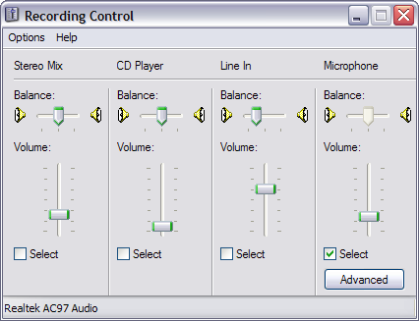
Figure 2 - Recording Control

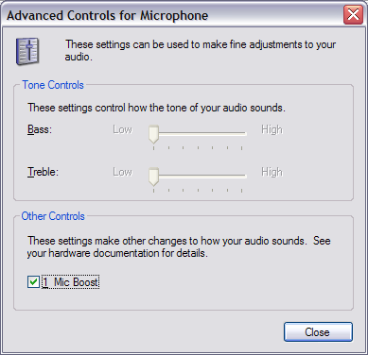
Figure 3 - Advance Controls for Microphone

Voice Launch has a built in Microphone Monitor which displays the loudness of the microphone. Go to View and choose View > View Microphone Monitor. Enabling this will show similar window to Figure 4.
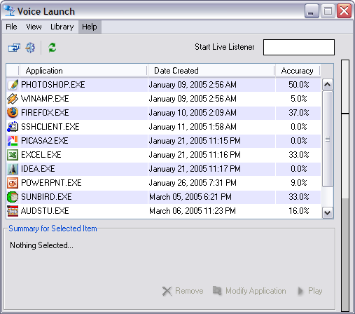
Figure 4 - Voice Launch's Microphone Level

For best result, try keeping the maximum amplitude around 75%. Be sure to hide the monitor after the microphone has been setup, because it does take some processing time to show the Microphone Monitor.

After the microphone has been setup, follow these steps to record ‘Yes’ and ‘No’ phrases. If you wish to use Continuous Recording then also record the word ‘computer’.

Library View

When Voice Launch is initially launched, a similar window to Figure 5 is shown. This window will allow adding, modifying or deleting library contents.

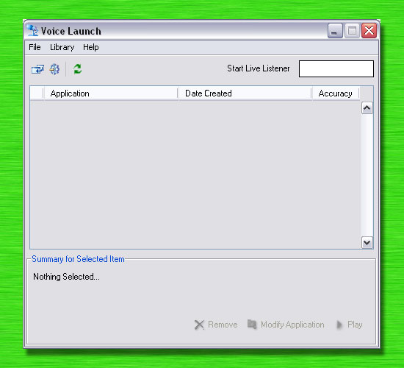
Figure 5 - Initial launch

Figure 6 shows a library with no items. In this window, all of user’s applications are listed and sorted by date. This window also displays accuracy for each item. To modify an item, first click on the item to enable the summary section near the bottom of the window. The user can click remove to delete the selected item, click play to play the sample which was recorded for that item or click modify to change the application which is mapped to. The next section will show how to add new items to the library.

Hint: You may run application by doubling clicking on them from the library window.
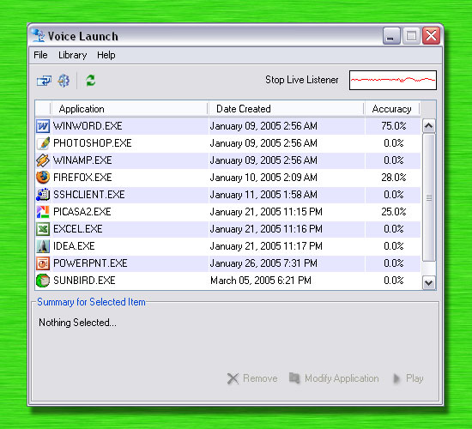
Figure 6 - Typical Library

Inserting New Items to the Library

There are two methods to add new items to the library. Choose “Insert New Application to Library” in the Library menu as shown in Figure 7 or click the first icon from the left on the toolbar.

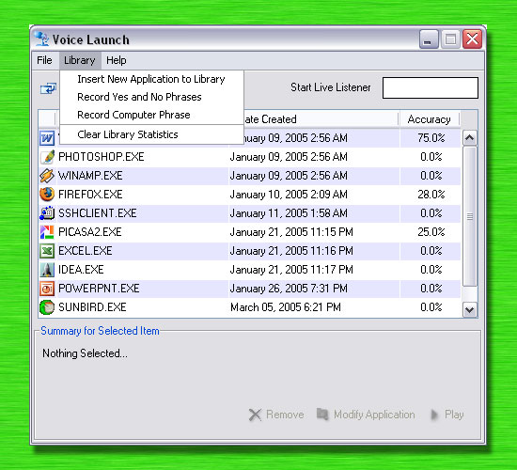
Figure 7 - Library Menu

After performing either of these methods, a similar window as shown in Figure 8 is displayed. In this window, the user is required to first record a two-second phrase. This phrase file will later be associated with the application to be launched. To record the phrase, click Record and wait for the progress bar to be displayed. After the recording, the phrase can be previewed by clicking Preview.
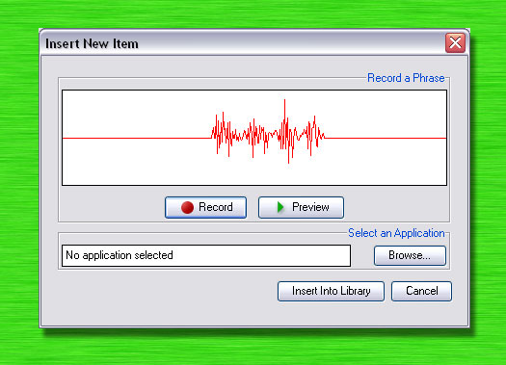
Figure 8 - Insert new Item

Hint: For best performance, make sure there is no other sound before and after the sample. For example, Figure 8 displays a word which was recorded. Notice how on both sides of the sample are completely straight lines.

After the recording is complete, click “Browse…” to select an application which should be launched when this phrase is recognized. Finally, click “Insert into Library” to finish and insert the new item into the library.

Note: For best results, quite backgrounds are ideal. Also try to remember the distance between the microphone and your mouth. This distance should be the same every time. It has been known for the results to be impacted greatly when the distance between the mouth and the microphone is different to the distance which was previously used to record the phrase.

Launching Applications

There are three methods that can start the recognition phase. The first method requires the use of keyboard. To start the recognition phase press the Windows key and the letter A. This will prompt the user for a two-second phrase. After the two-second phrase has been recorded, a confirmation dialog is displayed. Figure 9 displays an example of a confirmation dialog. This dialog displays the name of the application in addition to the icon of the application which was best recognized compared to the recorded phrase. Say or click ‘Yes’ to launch this application or ‘No’ to find the next best matched application. If ‘Yes’ is clicked, the application is launched immediately even before the progress bar is finished. Similarly, if ‘No’ is clicked, then the next best-match application is found immediately. Cancel can be clicked at anytime to stop the recognition phase without launching any applications.

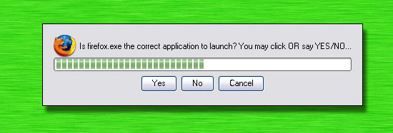
Figure 9 - Confirmation Dialog

The second method involves clicking the system tray icon. As shown in Figure 10, right click on the Voice Launch system tray icon and click “Launch Application…” The same action could be performed by left clicking on the icon if the default action is to “Launch Application…” Changing the user preferences is explained in a later section.

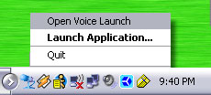
Figure 10 - System Tray

The third and final way to launch applications does not involve the mouse or the keyboard. If “Continuous Recording” is enabled then the recognition phase can be started by saying the word “Computer.” The accuracy level for this feature is not very high. For best performance, it is best advised if there is no background noise. Also, if the feature is enabled but there is a lot of conversation occurring in the background, then at times the word “computer” might be recognized even though the user did not say that phrase. For best results, each user should record their own computer phase by going to Library > Record Computer Phrase. If the Continuous Recording feature is enabled then the live listener displays what the user has said graphically. Figure 11 shows a snapshot of a live listener. When the word “computer” is recognized, then the live listener’s turns green temporarily.

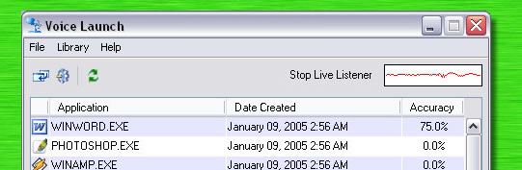
Figure 11 - Live Monitor

Recording Yes, No and Computer

For best results, the phrases “Yes” and “No” should be recorded for every user. To record ‘yes’ and ‘no’, go to Library > Record Yes and No Phrases. Figure 12 shows the dialog that is displayed. First record the word ‘Yes’ and when satisfied click ‘Next’ to record the word ‘No’. Once done with both phrases click ‘Finish’.
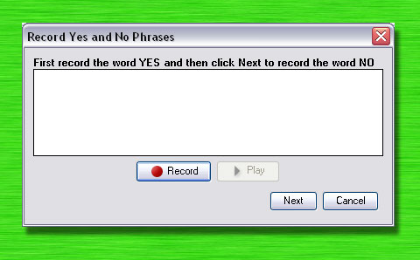
Figure 12 - Record Yes and No Phrases

Similarly, to use continuous recording, it is required to record the phrase ‘computer’. To record the phrase ‘computer’ go to Library > Record Computer Phrase. Figure 13 shows a snapshot of this window.
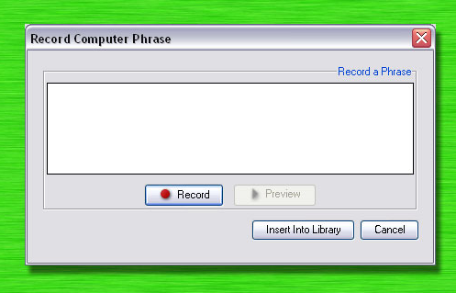
Figure 13 - Record Computer

Preferences
Figure 14 and Figure 15 show screenshots of Settings window. The system tray setting allows the user to set the default action for left clicking on the system tray icon. The user has also the option of changing the path to the library files. This is not recommended for the average user because it may result is loss of data.

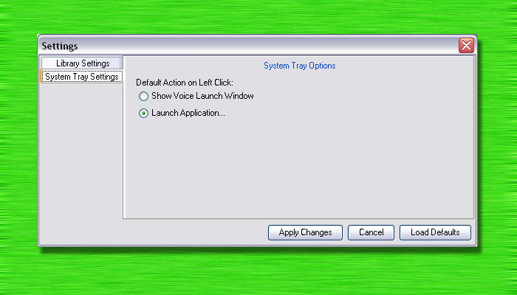
Figure 14 - System Tray Options

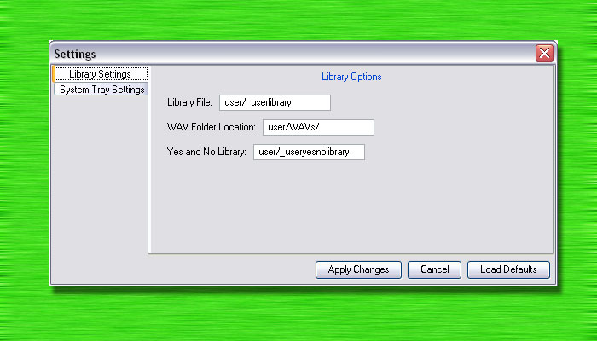
Figure 15 - Library Options
Troubleshooting & Frequently Asked Questions

I get the following error when trying to execute Voice Launch?
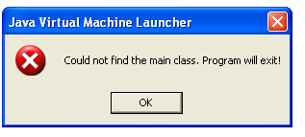
This error is caused when the host machine does not have Java JRE 1.5 or later installed correctly. The latest version of Java JRE can be obtained from http://java.sun.com

My microphone does not record any voice? What is going on?
Step 1) Make sure that the microphone is properly connected to the computer.
Step 2) Make sure the microphone is not set to mute.
Step 3) The Java Virtual Machine records from the selected device under Windows Recording Option. Please refer to installation page on how to setup Windows Recording Options.

I cannot launch any application using the hotkey feature?
If for some reason there is another application running which uses the same combination of hotkeys, then there is possibility that application might have overridden Voice Launch’s hotkey settings. Try closing all other applications and restarting Voice Launch.

Can I backup my library?
Yes, go to Voice Launch’s installation directory (by default it is C:\Program File\Voice Launch) and look for the ‘Classes’ folder. Under Classes folder, there is another folder called ‘user’. That folder contains all the data that has been saved. Make a copy of that folder to create a backup of your data.

How do I open Voice Launch window once I have hidden it?
Right click on the system tray icon and choose Open Voice Launch.

The Continuous Recording does not work for me?
Continuous Recording was created as a test and was not expected to have very high accuracy. Unfortunately, there is not much that can be done to improve the accuracy.

Can I distribute Voice Launch to my friends?
Yes, certainly.
However, THIS APPLICATION SHALL NOT BE SOLD TO ANYBODY FOR ANY PRICE, and all credits must be given to Amir Raminfar.

Contacting the Author
This project was implemented and designed as part of a senior design project for the George Washington’s Computer Science Department. The author can be contacted by email at:
amirxoxo@gwu.edu

Choose “About Voice Launch…” under the Help menu for more details.

