The George Washington University
School of Engineering and Applied Science
Department of Computer Science

Critical Design Review

for the

Design of a Discrete User-Dependent
Speech Recognition Program

By

Amir Raminfar

CSci 195-10
Senior Computer Science Design Project

Abstract of the Critical Design Review for the
Design of a Discrete User-Dependent Speech Recognition Program
by
Amir Raminfar

This report is a critical design review on how to implement a speech recognition program. The program will recognize a selection of at least fifteen words with at least 80% accuracy. Once the word is recognized, the program will launch an application which the user had chosen earlier. The project consists of eight main modules. The modules include record and filter, write to disk, insert to library, sample and filter, recognize and launch application. Furthermore, the project consists of a library module and a Graphical User Interference module. The recognize module is the heart of the project. The program will require a machine of at least 800 MHz and at least 256 MB of RAM. A microphone is required for recording speech and speakers are recommended for playback.

The project will require 36 weeks to complete and will need an estimated 675 hours of labor at an estimated labor cost of $25,806. A working prototype is estimated to cost $86,709. An economic analysis has determined that if one-million units are sold over the Internet at a cost of $18.60 per unit, this will result in a profit of $11,329,822. To date an expenditure of $5,941 has been used to develop this report.
TABLE OF CONTENTS
Abstract............................................................................................................................................ii
List of Figures.................................................................................................................................iv
List of Tables...................................................................................................................................v
1. Introduction 1
2. Design of the Project 2
2.1 Record and Filter 7
2.2 Save to Disk 8
2.3 Insert to Library 9
2.4 Sample 10
2.5 Recognize 11
2.6 Launch Application 13
2.7 Library 14
2.8 Graphical User Interface 15
3. Specifications of the Project 16
4. Tests to Verify the Design 17
5. Module List 19
6. Gantt Chart 20
7. Labor Costs by Week 21
8. Economic Analysis 23
9. Comparative Product Survey 25
10. Status Matrices 26
11. Conclusion 30
12. References 31
Appendix A – Task Table
Appendix B – Gantt Chart
Appendix C – User Manual Outline

LIST OF FIGURES

Figure 1 – Block Diagram of Modules 3
Figure 2 - Data Flow Diagram 1 4
Figure 3 - Data Flow Diagram 2 5
Figure 4 - Control Flow Diagram 6
Figure 5 - PDL for Recording and Filtering 7
Figure 6 - PDL for Saving to Disk 8
Figure 7 - PDL for Inserting to Library 9
Figure 8 - PDL for Sampling 10
Figure 9 - PDL for Recognition 12
Figure 10 - PDL for Launching Application 13
Figure 11 - PDL of Library 14
Figure 12 - PDL for Graphical User Interface 15
Figure 13 - Cumulative Labor Cost Graph 22

LIST OF TABLES

Table 1 - Verification 17
Table 2 - Module List 19
Table 3 - Labor Costs by Week 21
Table 4 - Prototype Cost 23
Table 5 - Unit Costs Sold 24
Table 6 - Product Survey 25
Table 7 - Outlined Matrix 26
Table 8 - Designed Matrix 27
Table 9 - Constructed Matrix 27
Table 10 - Tested Matrix 28
Table 11 - Integrated Matrix 28
Table 12 - Documented Matrix 29
Table 13 - Total Matrix 29

Introduction

This project uses speech recognition to allow users to launch applications of their choice using only voice commands. It will support up to fifteen words which the user can choose.
Chapter two discusses the modules in detail and also provides a block diagram of the design. In addition to a block diagram, data flow diagrams and control diagrams are also provided. Later in chapter two, Pseudo Design Language (PDL) for each module is presented. Chapter three discusses what the minimum system requirements are to run this product successfully. Subsequently, chapter four discusses what tests are needed to verify that each module and all modules together will function correctly.
Chapters six, seven and eight discuss the costs associated with the project. Chapter six explains the Gantt chart which was produced by Microsoft Project. Chapter seven discusses costs by week and provides a detailed table and graph. Chapter eight describes how much the prototype will cost, as well as how much profit can be acquired if one-million units were to be sold.
Finally, in chapter ten, seven matrices are presented. Each matrix provides progress about one aspect of this project. The seven matrices are outlined, designed, constructed, tested, integrated, documented and total progress completed.

Design of the Project

This project has six processing modules plus a GUI and library modules. The program first needs to build a collection of WAV files that can be used as a library. The library hold features about each WAV file and the application which will be launched for that WAV file. Second, the program needs to be able to recognize any given samples from the library of templates. This part will be the heart of the project. As illustrated in Figure 1, record and filter module records the WAV file. Once the user is satisfied the WAV file in memory will be written to disk in the second module. The third module inserts the new recorded WAV file into a collection of WAV files by extracting its features and providing information such as which application will be launched when this word is pronounced. The sampling module which is very familiar to the record and filtering module is responsible for recording the user’s phrase and sending it to the recognition module. The recognition module, which is the most sophisticated module, is responsible for recognizing and finding the closest match to the sample within a threshold. Finally, the last module will launch the user’s application which was pre-selected by the user. As Figure 1 shows, the GUI module is where all the events are triggered. Depending on the event, the GUI calls either the record or sample module. The GUI also has access to the library for maintenance purposes. The library keeps a record of WAV-file-to-application mappings and a folder to store the WAV files. The recognize module needs access to the library to recognize which word the user spoke and to retrieve which application is mapped to that phrase.

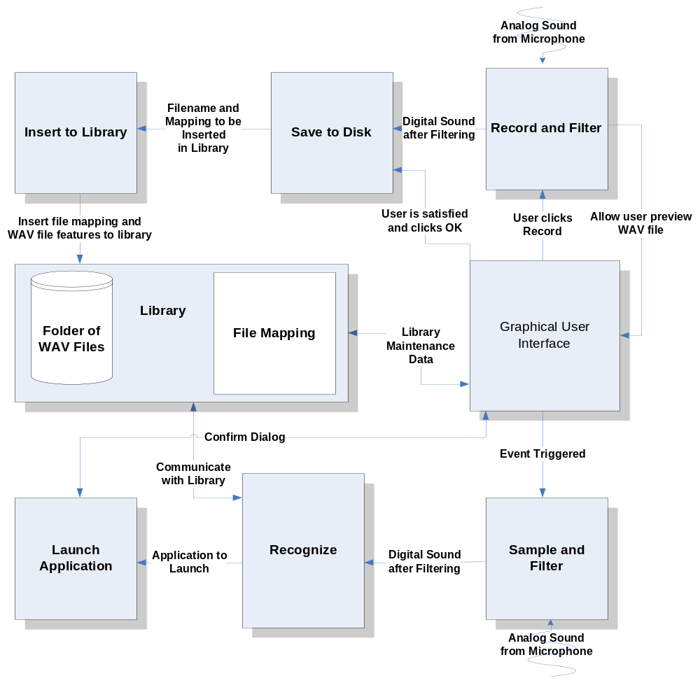
Figure 1 – Block Diagram of Modules

Data-Flow and Control-Flow Diagrams

Figure 2 shows the data flow diagram for recording and populating the library. Analog sound is captured and converted to digital sound in the record and filter module. Once the user is ready, it must then be saved to disk and inserted into the library.

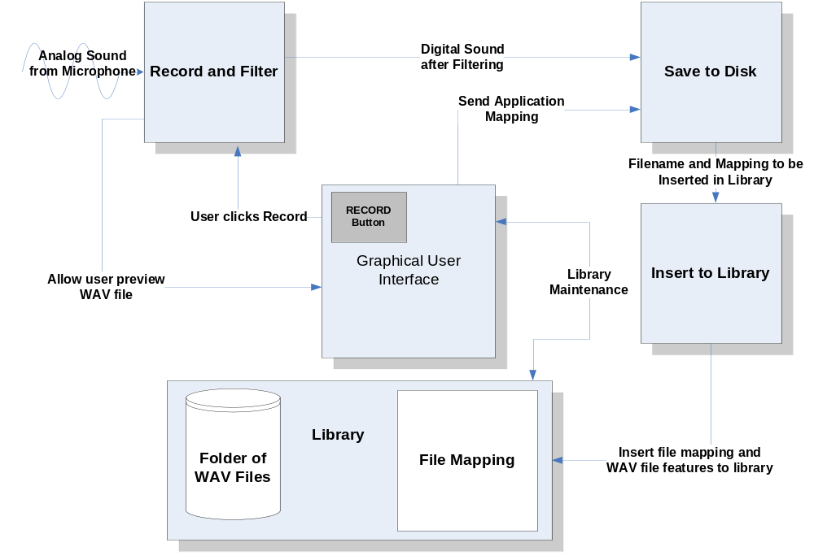
Figure 2 - Data Flow Diagram 1

Figure 3 shows, in further detail, how a sample is recognized. Similar to Figure 2, a WAV file is captured and the digital file is passed to the next module. The next module, being the recognize module, uses the library to find the best match. Once completed, the recognize module notifies the launch application module of which application should be launched.
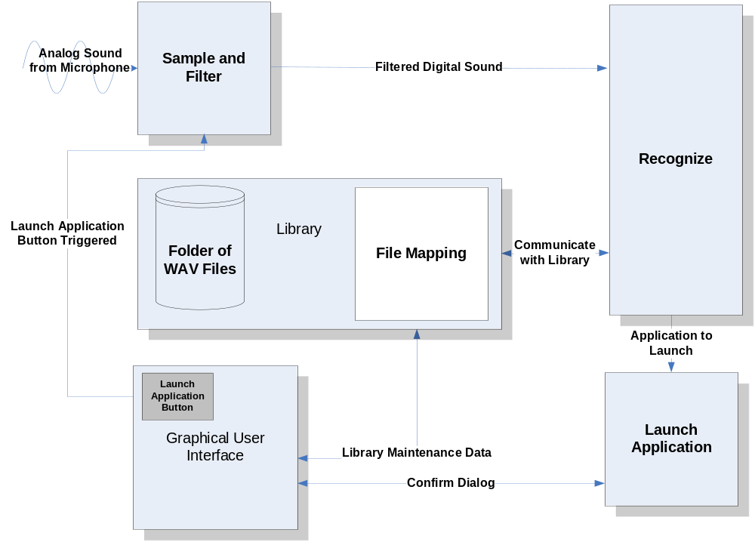
Figure 3 - Data Flow Diagram 2

Figure 4 displays the control flow diagram for all the modules. In this diagram, the boxes represent data and the arrows represent processes. Analog sounds, digital data, WAV files and the applications to launch are the only data that are being processed. To insert WAV files in the library, analog sound is converted to digital which is then saved to disk as a WAV file. The WAV file’s features and the application mapping are inserted into the library.

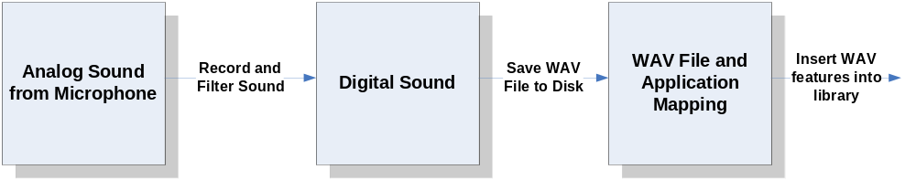

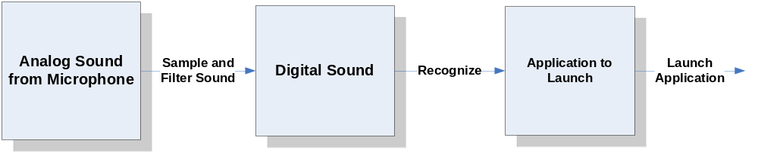
Figure 4 - Control Flow Diagram

Record and Filter

Figure 5 displays the steps needed to record with Java for two seconds. An instance of AudioInputStream is used because it expands the buffer as needed and therefore making it a lot easier for the project by not worrying about memory management. The audio is recorded at a rate of 16000 Hz. This project does not require the WAV files to be at a very high rate such as 441000 Hz. Record and filter does not need any parameters but however when it is done recording it needs to return the instance of AudioInputStream to the GUI. When the control is returned to the GUI the user will have the opportunity to review and accept the options if he or she is satisfied.

Parameters: IN (Nothing)
OUT (AudioInputStream: audioInputStream)

Initialize AudioInputStream
Create instance of AudioFormat(16000.0, 16, 2, true, true)
Create DataLine.Info from DataLine.Info(TargetDataLine.class, AudioFormat);
If AudioSystem.isLineSupported(info) is false, return with error
Create a new TargetDataLine instance called line with given info from earlier
Open line
Start recording on line
While line.getMicrosecondPosition()/1000/1000 < 2
Read data from line into a temporary buffer
Place the temporary buffer into a ByteArrayOutputStream
End while
Stop and close line
Flush and close ByteArrayOutputStream
Convert ByteArrayOutputStream to ByteArrayInputStream
Convert ByteArrayInputStream to AudioInputStream
Return AudioInputStream to GUI so that user can preview

Figure 5 - PDL for Recording and Filtering

Save to Disk

Once the user is satisfied with his or her recording, it is the responsibility of next module to save the WAV file to disk. Save to disk module takes an instance of AudioInputStream as one of its parameters and the application which is launched when the recognize module distinguishes this phrase. The WAV file is saved to disk so that the user can later hear it and modify it if needed. The next module will extract features from WAV files and will only use these features to recognize words. Figure 6 displays the steps needed to save a WAV file to disk.

Parameters: IN (AudioInputStream: audioInputStream, Application Filename: filename)
OUT (WAV file, Application Filename: filename)

- Check to see audioInputStream is not null
- audioInputStream.reset()
- Parse the name of the application
- Create a new file with the same name of application
- AudioSystem.write(audioInputStream, AudioFileFormat.WAVE, file)
- If AudioSystem.write returns -1 then throw exception
- Insert to library with new created WAV file and application mapping

Figure 6 - PDL for Saving to Disk

Insert to Library

In this module, the features of the sample file are extracted and saved to the library. In addition, the library also saves which application needs to be launched in relationship with this sample. As shown below in Figure 7, to extract the features of a WAV file it must first be divided into n intervals. In each interval, the number of zero-crossings is calculated in addition to the average time between each zero crossing. Finally this information is saved into a file which resides on the disk.

Parameters: IN (Recorded Sample File: sample, Application Filename: filename)
OUT (Nothing)

- Open sample file
- Divide sample into n intervals
- For every interval
- Compute number of zero-crossings
- Compute average time between each zero-crossing
- End for
- Open database file
- Append n features to database file and application that it is mapped to
- Close file
- Update GUI if needed

Figure 7 - PDL for Inserting to Library

Sample

The sample module is very similar to the first module. As shown in Figure 8, the algorithm is identical to record and filter module. The only subtle difference is that the recorded sample must be passed to the next module so that it can be recognized.

Parameters: IN (Nothing)
OUT (AudioInputStream: audioInputStream)

- Initialize AudioInputStream
- Create instance of AudioFormat(16000.0, 16, 2, true, true)
- Create DataLine.Info from DataLine.Info(TargetDataLine.class, AudioFormat)
- If AudioSystem.isLineSupported(info) is false, return with error
- Create a new TargetDataLine with given info from earlier
- Open line
- Start recording on line
- While line.getMicrosecondPosition()/1000/1000 < 2
- Read data from line into a temporary buffer
- Place the temporary buffer into a ByteArrayOutputStream
- End while
- Stop and close line
- Flush and close ByteArrayOutputStream
- Convert ByteArrayOutputStream to ByteArrayInputStream
- Convert ByteArrayInputStream to AudioInputStream
- Call recognize module with AudioInputStream as a parameter

Figure 8 - PDL for Sampling

Recognize

As seen on the next page in Figure 9, to recognize a sample is a lengthy procedure. First, the sample’s features are extracted very much like the insertion to library module. This module will then get a list of templates and their features. For every template, a matrix of size n is created, where n is the number of features. Each row of the matrix is populated by taking the difference of one feature from the sample and comparing it with all the features in the template. This way each template and sample is normalized. After completing this with all the features in the sample, the next step is to perform a pattern matching algorithm. The pattern matching algorithm which is being used is called Dynamic Time-Warping (DTW). DTW walks though the matrix and computes the shortest distance from the top-right to the left-bottom corner. The template with the shortest path is chosen and the application that is related to is returned to the next module. There needs to be a threshold set because from time to time the best match is not a very close match. An example of this problem is if a phrase that does not exist in the library is being processed on, then obviously the best matched phrase is not the correct match and no application should be launched.
Parameters: IN (Recorded Sample: sample)
OUT (String: Best matched application)

- Extract features from sample
- Divide sample into n intervals
- For every interval
- Compute number of zero-crossings
- Compute average time between each zero-crossing
- End for
- Get all templates from library
- For every template
- Create n x n matrix, called M, where n is the size of features in each template
- For i features in sample
- For j features in each template
- M(i,j) = |sample_feature(i) – template_feature(j)|
- End for
- End for
- Cost = 0
- While i != 1 OR j != 1
- Start from top right of matrix M
- Step through to the top corner
- Cost += M (i,j)
- For every step M(i,j) look at M(i-1,j), M(i,j-1), and M(i-1,j-1)
- M(i,j) = min(M(i-1,j), M(i,j-1), M(i-1,j-1))
- End while
- End for
- Find the template with the least cost
- Get which application correlates to the least cost template
- Return the application address as a string

Figure 9 - PDL for Recognition

Launch Application

Figure 10, shows the PDL for the final module. This module is responsible for launching the user’s application. If the user wishes to have a confirm dialog then at this point a confirm dialog is displayed and the application is launched only if the user clicks ‘Yes,’ otherwise nothing happens.

Parameters: IN (Application address: filename)
OUT (Nothing)

- Check if filename exists
- If filename does not exist then show warning and return
- Get runtime class
- Check to see if user wants a confirm dialog, and if yes show confirm dialog
- Call runtime.exec(filename)
- Minimize window

Figure 10 - PDL for Launching Application

Library

The library is only responsible for returning all the templates to the recognition module or the Graphical User Interface. All WAV features are saved to a file in disk. As shown in Figure 11, the library module returns a matrix which has m samples and n features for each sample. In addition to the features, application mappings are also return to the recognition module. If the user is choosing to view the templates, he or she has the option of deleting or editing the library. In this case the library will need to modify the database file.

Parameters: IN (Nothing)
OUT (Templates)

- Open database file
- For every template
- Read template features and application mappings
- Save each template into an array of n features
- End for
- Close database files
- Return a matrix of size m by n where n is size of features and m is number of templates

Figure 11 - PDL of Library

Graphical User Interface

The Graphical User Interface consists of two tabbed windows. The first tabbed window allows the user to record and insert new samples in the library. The second tabbed window allows the user the view the library. He or she has the option of deleting and editing any chosen template. The steps to add buttons and panels are not shown in Figure 12. The use of hotkeys allows the user to press a combination of keys which sample a phrase and recognize it. Unfortunately, Java does not support global hotkeys on an operating system level. However, there is a way to use C++ and embed that code in Java using JNI.
Parameters: IN (Nothing)
OUT (Nothing)

- Get all templates from library for library maintenance
- For each template add a new row to JTable
- If use clicked preview, fetch file and play
- Create global hotkeys in C++
- Add JButtons and JPanels to tabbed windows(Not Shown)

Figure 12 - PDL for Graphical User Interface

Specifications of the Project

Theory of speech recognition is used in this project to differentiate between vocabularies of up to fifteen words. The user can then relate each word to an application that he or she would like to launch. As a result, the project must keep a collection of WAV file features, also called templates, which were recorded by the user. When users want to launch an application, they can initialize the project and say the program’s name that they want to launch. The word would then be recognized and the user’s application will be launched. This project will assume 80% accuracy.
Below describes the minimum system requirements needed to execute this project successfully:
  - Microphone
  - Speakers (Not required but recommended)
  - Windows XP (C and C++ are operating system dependent languages)
  - At least 800 MHz Processor
  - At least 256 MB RAM
  - Keyboard
  - Java Virtual Machine
  - Enough disk space to save the WAV files (Less than one megabyte per wav file)

The modules that do not have any computation will be implemented in Java. The use of Java will ease the process of recording and playing WAV files. However, the recognition module will be implemented in C because a great amount of speed is needed for the speech recognition algorithm. Java also doesn’t allow any system calls to the operating system, thus making it impossible to implement a global hotkey. The implementation of hotkeys will be done in C++ and embedded in Java.

Tests to Verify the Design

The recording module can be tested by first recoding a sound sample and then verifying the sample by playing it. If the recording module is successful, it can be used in conjunction with the writing WAV file module to test that both work together properly. A third-party WAV player can be used to verify that the WAV file was properly written to disk. Inserting WAV files to the library can be simply tested because the library will be kept in a text file. Each WAV-to-application mapping can be written on a separate line. One can view the text file to verify that it is correct. Recording a sample is similar to the first module and it can use the same method to verify its correctness.
The recognition module can be tested with some simple templates. The algorithm normalizes each template. This fixes the problem of phrases being shifted slightly. Lastly, the module that launches applications can be tested by providing the module with a string to launch. Table 1, describes the tests needed to verify that each module functions correctly independently.

Table 1 - Verification

Module Name | Input | Expected Result | Status
Record and Filter | Analog Sound | To be digitized and played successfully after recording. | Not Tested
Save to File | Sound from record and filter module | Digital sound to be saved on disk and played through a third-party WAV player. | Not Tested
Insert to Library | WAV file from save to disk module | Library must extract zero-crossings and save application mapping for each WAV file. | Not Tested
Sample | Analog Sound | Digitized and played successfully after recording. | Not Tested
Recognize | Digital sound from sample module | Template with best match and within threshold is returned. | Not Tested
Launch Application | Application address from recognize module | Application should be launched. | Not Tested
Library | WAV files | All templates should be returned in a matrix. When needed it should return all WAV files to the GUI. | Not Tested
GUI | Events are triggered by user | Buttons can trigger a number of events ranging from recording to recognition. | Not Tested

The completed project can be tested by performing all tasks possible. To do this, a user can provide a phrase or word so that it can be captured. Once user is satisfied with the WAV file, it is saved to disk and its features are extracted and inserted into the library. The user specifies which application will be launched in relation to the new recorded WAV file. This process should be repeated at least ten times. Once ten words have been added to the library, the same user initializes the recognition phase and hopefully it will be 80% accurate. If it is not 80% successful, the threshold will be changed and the whole process will be repeated until the requirements are met.

Module List

Table 2 summarizes how much time and money is needed to implement each module. The recoding module captures sound from the microphone. The writing and inserting modules are responsible for populating the library. The microphone also provides sound for the sampling module which calls the recognition module. The recognition module takes the majority amount of time and money to build; hence it is the most complicated module to implement.

Table 2 - Module List

Module Name | Called By | It Calls | Lines of Code | Hours to Code | $ to Code
INPUT FROM MIC | - | - | - | - | -
RECORD AND FILTER | GUI | Save to File | 1,500 | 30 | $ 1,200
SAVE TO FILE | Record and Module | Insert to Library | 750 | 15 | $ 600
INSERT TO LIBRARY | Save to File | - | 2,400 | 48 | $ 1,920
SAMPLE | GUI | Recognize | 500 | 10 | $ 400
RECOGNIZE | Sample | Launch Application | 3,000 | 60 | $ 2,400
LAUNCH APPLICATION | Recognize | - | 100 | 2 | $ 80
LIBRARY | - | - | 200 | 4 | $ 160
GUI | User | - | 1,650 | 33 | $ 1,320
TOTAL |  |  | 10,100 | 202 | $8,080

Gantt Chart

Appendix A includes a table produced by Microsoft Project. This table includes costs, hours worked, start and end times, duration and resource name for each task. Appendix B includes a Gantt chart. Gantt chart provides a detailed timeline to build a working prototype. As shown in the table, from September 1, 2004 to May 4, 2005 a total time of 675 hours and cost of $25,806 is needed to complete this project.

Labor Costs by Week

The labor for the prototype is estimated to cost $25,806 in a period of 36 weeks. The first ten weeks will mostly focus on designing and analyzing, whereas after ten weeks programmers start building the prototype. During this period a large amount of the budget is used toward building the prototype. Table 3 illustrates labor costs by week in more detail. Figure 13 displays a graph of the data given by Table 3. The X-axis represents time and the Y-axis represents cumulative cost.
Table 3 - Labor Costs by Week
Week # | ESTIMATED LABOR COSTS | ESTIMATED CUMM COSTS | ACTUAL COSTS | ACTUAL CUMM COSTS | PROJECTED LABOR COSTS | PROJECTED CUMM COSTS
0 | $0 | $0 | $0 | $0
1 | $135 | $135 | $225 | $225
2 | $700 | $835 | $736 | $961
3 | $700 | $1,535 | $665 | $1,626
4 | $1,150 | $2,685 | $215 | $1,841
5 | $300 | $2,985 | $315 | $2,156
6 | $700 | $3,685 | $450 | $2,606
7 | $300 | $3,985 | $920 | $3,526
8 | $400 | $4,385 | $135 | $3,661
9 | $200 | $4,585 | $435 | $4,096
10 | $200 | $4,785 | $1,180 | $5,276
11 | $200 | $4,985 | $665 | $5,941 | $665 | $5,941
12 | $400 | $5,385 |  |  | $820 | $6,761
13 | $700 | $6,085 |  |  | $1,020 | $7,781
14 | $700 | $6,785 |  |  | $1,200 | $8,981
15 | $200 | $6,985 |  |  | $2,060 | $11,041
16 | $100 | $7,085 |  |  | $1,345 | $12,386
17 | $700 | $7,785 |  |  | $630 | $13,016
18 | $500 | $8,285 |  |  | $350 | $13,366
19 | $1,087 | $9,372 |  |  | $350 | $13,716
20 | $1,043 | $10,415 |  |  | $1,360 | $15,076
21 | $700 | $11,115 |  |  | $1,680 | $16,756
22 | $700 | $11,815 |  |  | $315 | $17,071
23 | $1,000 | $12,815 |  |  | $745 | $17,816
24 | $750 | $13,565 |  |  | $1,570 | $19,386
25 | $955 | $14,520 |  |  | $880 | $20,266
26 | $1,000 | $15,520 |  |  | $215 | $20,481
27 | $1,200 | $16,720 |  |  | $1,425 | $21,906
28 | $805 | $17,525 |  |  | $140 | $22,046
29 | $400 | $17,925 |  |  | $0 | $22,046
30 | $950 | $18,875 |  |  | $1,010 | $23,056
31 | $955 | $19,830 |  |  | $135 | $23,191
32 | $900 | $20,730 |  |  | $0 | $23,191
33 | $1,000 | $21,730 |  |  | $135 | $23,326
34 | $826 | $22,556 |  |  | $135 | $23,461
35 | $895 | $23,451 |  |  | $1,260 | $24,721
36 | $385 | $23,836 |  |  | $1,085 | $25,806

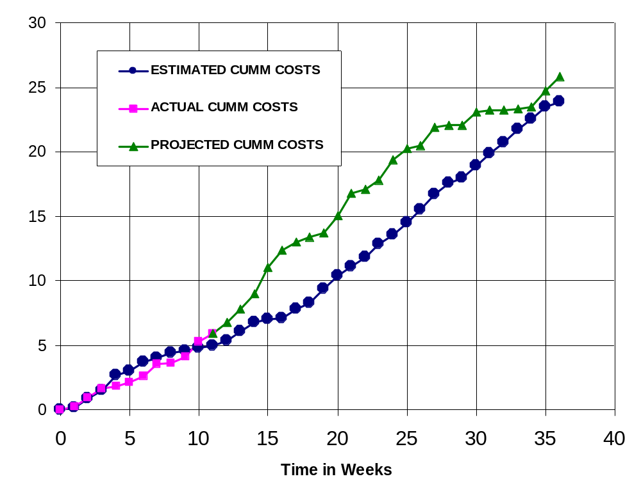
Figure 13 - Cumulative Labor Cost Graph

Economic Analysis

Table 4 illustrates in detail how much the prototype will cost. Overhead, A&G costs and profit were added to initial estimates. The total cost of the prototype is $86,709.
Table 4 - Prototype Cost

PROTOTYPE COSTS
 | Labor Rate | Current Est. Hours | Current Est. Cost | Initial Est. Hours | Initial Est. Cost
System Analyst | $45.00 | 118 | $5,321 | 215 | $9,686
Programmer | $40.00 | 198 | $7,920 | 268 | $10,720
Test Programmer | $35.00 | 174 | $6,090 | 31 | $1,085
Technical Writer | $35.00 | 185 | $6,475 | 67 | $2,345
TOTAL |  | 675 | $25,806 | 581 | $23,836
DIRECT OVERHEAD @ 100% |  |  | $25,806 |  | $23,836
SUBTOTAL |  |  | $51,613 |  | $47,673
A&G COSTS @ 40% |  |  | $20,645 |  | $19,069
SUBTOTAL |  |  | $72,258 |  | $66,742
PROFIT @ 20% |  |  | $14,452 |  | $13,348
TOTAL COST OF PROTOTYPE |  |  | $86,709 |  | $80,090

Table 5 describes unit costs sold if the corporation was to act as a retailer on the Internet. This calculation assumes 1,000,000 units will be sold. The first 20,000 units will recoup the amount of money that the prototype costs. The price of each copy was chosen to be $18.60 because as shown in comparative product survey, all similar products range $20 to $300.

Table 5 - Unit Costs Sold

UNIT COSTS SOLD BY CORPORATION AS A RETAILER ON THE INTERNET
 | Current Estimate |  |  |  | Initial Estimate
PROTOTYPE COSTS | $86,709 |  |  |  | $80,090
INSTALL MACHINE AND SOFTWARE | $50,000 |  |  |  | $50,000
SUBTOTAL | $136,709 |  |  |  | $130,090
OVERHEARD @ 200% | $273,418 |  |  |  | $260,180
SUBTOTAL | $410,127 |  |  |  | $390,269
DOCUMENTATION | $0 |  |  |  | $0
PACKAGING SUBTOTAL | $0 |  |  |  | $0
SUBTOTAL | $410,127 |  |  |  | $390,269
A&G @ 40% | $164,051 |  |  |  | $156,108
SUBTOTAL | $574,178 |  |  |  | $546,377
PROFIT @ 20% | $114,836 |  |  |  | $109,275
SUBTOTAL | $689,013 |  |  |  | $655,653
 |  | Current Estimate |  | Initial Estimate
 | # of copies | Price/Copy | Total Profit | Price/Copy | Total Profit
Total to Sell | 1,000,000
Recoup Prototype Costs | 100,000 | $6.89 | $114,836 | $6.56 | $109,275
Profit from Recoup | 100,000 | $11.71 | $1,170,987 | $12.04 | $1,204,347
Remainder to Sell | 900,000 | $18.60 | $16,740,000 | $18.60 | $16,740,000
 |  | Minus 40% for A&G | $6,696,000 | Minus 40% for A&G | $6,696,000
Subtotal |  |  | $10,044,000 |  | $10,044,000
Total Profit |  |  | $11,329,822 |  | $11,357,623

Comparative Product Survey

Table 6 describes some of the products that are similar to this product. Amongst these products, Realize Voice Lite 4.0 has sold 253,432 units and cost $49. However, other products have not been as successful as Realize Voice Lite 4.0. For example, HAL 2.0 is only $20 but has only sold 1,144 units. The most popular products are Naturally Speaking and ViaVoice, but unfortunately units sold were not provided by their vendors.

Table 6 - Product Survey

Product Name | Cost | Units Sold | Publisher | System Requirements
HAL 2.0 | $19.95 | 1,144 | David Henry Company | Windows 98/Me/2000/XP
iListen 1.6.3 | $140.00 | - | MacSpeech | PowerMacintosh G3, 256MB RAM
Naturally Speaking | $150.00 | - | ScanSoft | Intel® Pentium® III / 500 MHz processor, 128 MB RAM, 300 MB free hard disk
Realize Voice Lite 4.0 | $49.00 | 253,432 | Realize Software | Windows 98SE/ME/NT/2000/XP, a noise-canceling microphone
ViaVoice | $200.00 | - | IBM | Pentium II 300 MHz, 510 MB Hard drive, 96 MB RAM
Voice Studio 1.4.2 | $49.97 | 41,914 | Ultimate Interactive Desktops | Windows 98/Me/NT/2000/XP
Voice Tools 7.0 | $300.00 | 51,157 | Wizzard Software | Not Provided

Status Matrices

The following seven tables display the progress which has been completed on each module. Table 7 displays the amount of time each module has been planned and outlined to date. The Launching application module is the simplest module and as a result takes the least amount of time to design. Table 8 shows the amount of time needed to design each module. Table 9 displays the amount of time needed to construct each module. The hours spent to date for this table and many other tables are zero since building period has not begun. Table 10 and Table 11 illustrate the amount of time needed to test each module separately and all modules together. As expected, the amount of time to test the recognition module is the greatest. Table 12 displays the amount of time to document the entire project including this article and the user manual. Finally, Table 13 totals all matrices and class time together.

Table 7 - Outlined Matrix

OUTLINED
MODULE NAME | INIT. EST. HRS. | CUR. EST. HRS. | HRS SPENT TO DATE | % COMPT. | EST. HRS TO COMP.
RECORD AND FILTER | 8 | 8 | 8 | 100.0% | 0
SAVE TO FILE | 7 | 7 | 7 | 100.0% | 0
INSERT TO LIBRARY | 5 | 5 | 5 | 100.0% | 0
SAMPLE | 3 | 3 | 3 | 100.0% | 0
RECOGNIZE | 12 | 12 | 12 | 100.0% | 0
LAUNCH APPLICATION | 2 | 2 | 2 | 100.0% | 0
LIBRARY | 2 | 2 | 2 | 100.0% | 0
GUI | 2 | 2 | 2 | 100.0% | 0
TOTALS | 41 | 41 | 41 | 100.0% | 0

Table 8 - Designed Matrix

DESIGNED
MODULE NAME | INIT. EST. HRS. | CUR. EST. HRS. | HRS SPENT TO DATE | % COMPT. | EST. HRS TO COMP.
RECORD AND FILTER | 6 | 8 | 8 | 100.0% | 0
SAVE TO FILE | 7 | 10 | 10 | 100.0% | 0
INSERT TO LIBRARY | 6 | 8 | 8 | 100.0% | 0
SAMPLE | 4 | 5 | 5 | 100.0% | 0
RECOGNIZE | 12 | 36 | 36 | 100.0% | 0
LAUNCH APPLICATION | 3 | 4 | 4 | 100.0% | 0
LIBRARY | 2 | 2 | 2 | 100.0% | 0
GUI | 4 | 4 | 4 | 100.0% | 0
TOTALS | 44 | 77 | 77 | 100.0% | 0

Table 9 - Constructed Matrix

CONSTRUCTED
MODULE NAME | INIT. EST. HRS. | CUR. EST. HRS. | HRS SPENT TO DATE | % COMPT. | EST. HRS TO COMP.
RECORD AND FILTER | 40 | 30 | 0 | 0.0% | 30
SAVE TO FILE | 20 | 15 | 0 | 0.0% | 15
INSERT TO LIBRARY | 28 | 28 | 0 | 0.0% | 28
SAMPLE | 40 | 10 | 0 | 0.0% | 10
RECOGNIZE | 120 | 80 | 0 | 0.0% | 80
LAUNCH APPLICATION | 20 | 2 | 0 | 0.0% | 2
LIBRARY | 4 | 4 | 0 | 0.0% | 4
GUI | 15 | 33 | 0 | 0.0% | 33
TOTALS | 287 | 202 | 0 | 0.0% | 202

Table 10 - Tested Matrix

TESTED
MODULE NAME | INIT. EST. HRS. | CUR. EST. HRS. | HRS SPENT TO DATE | % COMPT. | EST. HRS TO COMP.
RECORD AND FILTER | 6 | 14 | 0 | 0.0% | 14
SAVE TO FILE | 4 | 9 | 0 | 0.0% | 9
INSERT TO LIBRARY | 4 | 9 | 0 | 0.0% | 9
SAMPLE | 4 | 6 | 0 | 0.0% | 6
RECOGNIZE | 10 | 18 | 0 | 0.0% | 18
LAUNCH APPLICATION | 3 | 7 | 0 | 0.0% | 7
LIBRARY | 2 | 2 | 0 | 0.0% | 2
GUI | 4 | 4 | 0 | 0.0% | 4
TOTALS | 37 | 69 | 0 | 0.0% | 69

Table 11 - Integrated Matrix

INTEGRATED
MODULE NAME | INIT. EST. HRS. | CUR. EST. HRS. | HRS SPENT TO DATE | % COMPT. | EST. HRS TO COMP.
RECORD AND FILTER | 4 | 12 | 0 | 0.0% | 12
SAVE TO FILE | 4 | 9 | 0 | 0.0% | 9
INSERT TO LIBRARY | 3 | 11 | 0 | 0.0% | 11
SAMPLE | 1 | 5 | 0 | 0.0% | 5
RECOGNIZE | 6 | 21 | 0 | 0.0% | 21
LAUNCH APPLICATION | 2 | 4 | 0 | 0.0% | 4
LIBRARY | 2 | 3 | 0 | 0.0% | 3
GUI | 20 | 20 | 0 | 0.0% | 20
TOTALS | 42 | 85 | 0 | 0.0% | 85

Table 12 - Documented Matrix

DOCUMENTED
MODULE NAME | INIT. EST. HRS. | CUR. EST. HRS. | HRS SPENT TO DATE | % COMPT. | EST. HRS TO COMP.
RECORD AND FILTER | 15 | 24 | 9 | 37.5% | 15
SAVE TO FILE | 13 | 12 | 5 | 41.7% | 7
INSERT TO LIBRARY | 15 | 16 | 4 | 25.0% | 12
SAMPLE | 15 | 13 | 5 | 38.5% | 8
RECOGNIZE | 25 | 24 | 10 | 41.7% | 14
LAUNCH APPLICATION | 15 | 12 | 6 | 50.0% | 6
LIBRARY | 1 | 5 | 3 | 60.0% | 2
GUI | 2 | 8 | 5 | 62.5% | 3
TOTALS | 101 | 114 | 47 | 41.2% | 67

Table 13 - Total Matrix

TOTAL
MODULE NAME | INIT. EST. HRS. | CUR. EST. HRS. | HRS SPENT TO DATE | % COMPT. | EST. HRS TO COMP.
RECORD AND FILTER | 79 | 96 | 25 | 26.0% | 71
SAVE TO FILE | 55 | 62 | 22 | 35.5% | 40
INSERT TO LIBRARY | 61 | 97 | 17 | 17.5% | 80
SAMPLE | 67 | 42 | 13 | 31.0% | 29
RECOGNIZE | 185 | 171 | 58 | 33.9% | 113
LAUNCH APPLICATION | 45 | 31 | 12 | 38.7% | 19
LIBRARY | 13 | 18 | 7 | 38.9% | 11
GUI | 47 | 71 | 11 | 15.5% | 60
CLASS TIME | 87 | 87 | 30 | 34.5% | 57
TOTALS | 639 | 675 | 195 | 28.9% | 480

Conclusion

The previous chapters demonstrated how the speech recognition project will be designed and outlined. It provides a detailed explanation of the modules and how long it will take to produce each one. Furthermore, the cost of each module was calculated and the profit which can be obtained if 1,000,000 units are sold was shown. Last, progress of each module was discussed using matrices.

References

Anonymous, “Dragon NaturallySpeaking 7” <http://www.scansoft.com/naturallyspeaking/>
Henry, David, “David Henry Company”, < http://www.davidhenryco.com/>
Hill, Pamela, “IBM ViaVoice”, <http://www-306.ibm.com/software/voice/viavoice/>
Lyon, Jack, “Realize Software”, <http://www.realizesoftware.com/>
Spencer, Chris, “Wizzard Software Corp.”, <http://www.wizzardsoftware.com/>
Ultimate Interactive, “Ultimate Interactive Desktops Inc.” <http://www.voicestudio.us/>

Appendix A – Gantt Chart

