The George Washington University
School of Engineering and Applied Science
Department of Computer Science

Final Design Report

for the

Design of a User-Dependent Discrete
Speech Recognition Program

By

Amir Raminfar

CSci 195-10
Senior Computer Science Design Project

Abstract of the Final Design Report for the
Design of a User-Dependent Discrete Speech Recognition Program
by
Amir Raminfar

This report is a final design report for a speech recognition program. The program will recognize a selection of at least fifteen words with at least 80% accuracy. Once the word is recognized, the program will launch an application which the user had chosen earlier. The project consists of eight main modules. The modules include record and filter, write to disk, insert to library, sample and filter, recognize and launch application. Furthermore, the project consists of a library and Graphical User Interference. The recognize module is the heart of the project. The program will require a machine of at least 800 MHz and at least 256 MB of RAM. A microphone is required for recording speech and speakers are recommended for playback.

The project will require 36 weeks to complete and will need an estimated 609 hours of labor at an estimated labor cost of $23,165. A working prototype is estimated to cost $77,834. An economic analysis has determined that if one-million units are sold over the Internet at a cost of $18.60 per unit, this will result in a profit of $11,367,096. To date an expenditure of $9,085 has been used to develop this report.

TABLE OF CONTENTS
Abstract............................................................................................................................................ii
List of Figures.................................................................................................................................iv
List of Tables...................................................................................................................................v
1. Introduction 1
2. Theory 2
3. Design of the Project 4
3.1 Data-Flow and Control-Flow Diagrams 6
3.2 Record and Filter Module 8
3.3 Save to Disk Module 9
3.4 Insert to Library Module 10
3.5 Sample Module 10
3.6 Recognize Module 11
3.7 Launch Application Module 12
3.8 Feature Extractor Module 13
3.9 Library 13
3.10 Graphical User Interface 14
4. History 15
5. Specifications of the Project 16
6. Tests to Verify the Design 17
7. Module List 19
8. Gantt Chart 20
9. Labor Costs by Week 21
10. Economic Analysis 23
11. Comparative Product Survey 25
12. Status Matrices 26
13. Conclusion 30
14. References 31
Appendix A – Task Table
Appendix B – Gantt Chart
Appendix C – User Manual Outline

LIST OF FIGURES

Figure 1 - Example Matrix for DTW 3
Figure 2 - Neighboring Elements for DTW 3
Figure 3 - Resulting Matrix for DTW 3
Figure 4 – Block Diagram of Modules 5
Figure 5 - Data Flow Diagram 1 6
Figure 6 - Data Flow Diagram 2 7
Figure 7 - Control Flow Diagram 8
Figure 8 - PDL for Record and Filter 9
Figure 9 - PDL for Saving to Disk 9
Figure 10 - PDL for Inserting to Library 10
Figure 11 - PDL for Sampling 11
Figure 12 - PDL for Recognition 12
Figure 13 - PDL for Launching Application 13
Figure 14 - PDL for Feature Extractor Module 13
Figure 15 - PDL of Library 14
Figure 16 - PDL for Graphical User Interface 14
Figure 17 - Cumulative Labor Cost Graph 22

LIST OF TABLES

Table 1 - Verification 17
Table 2 - Module List 19
Table 3 - Labor Costs by Week 21
Table 4 - Prototype Cost 23
Table 5 - Unit Costs Sold 24
Table 6 - Product Survey 25
Table 7 - Outlined Matrix 26
Table 8 - Designed Matrix 27
Table 9 - Constructed Matrix 27
Table 10 - Tested Matrix 28
Table 11 - Integrated Matrix 28
Table 12 - Documented Matrix 29
Table 13 - Total Matrix 29

Introduction

This project uses speech recognition to allow users to launch applications of their choice using only voice commands. It will support up to fifteen words which the user can choose.
Chapter two discusses the algorithm of Dynamic Time Warping and presents an example. Chapter three discusses the modules in detail and also provides a block diagram of the design. In addition to a block diagram, data flow diagrams and control diagrams are also provided. Program Design Language (PDL) for each module is presented. Chapter four discusses the major changes since the Project Proposal Report. Chapter five discusses what the minimum system requirements are to run this product successfully. Subsequently, chapter six discusses what tests are needed to verify that each module and all modules together will function correctly.
Chapters seven, eight and nine discuss the costs associated with the project. Chapter seven explains the Gantt chart which was produced by Microsoft Project. Chapter eight discusses costs by week and provides a detailed table and graph. Chapter nine describes how much the prototype will cost, as well as how much profit can be acquired if one-million units were to be sold. Chapter ten gives a summary of how much the prototype will cost and what is the price that has been set for each unit.
Finally, in chapter twelve, seven matrices are presented. Each matrix provides progress about one aspect of this project. The seven matrices are outlined, designed, constructed, tested, integrated, documented and total progress completed.

Theory

Dynamic Time Warping (DTW) is a pattern recognition algorithm that has been used commonly for speech recognition with a small size of vocabularies. The requirements for DTW is to have two given array of features. For this project, the features that will be extracted from each sample are its zero-crossings and average time between each zero-crossing. Zero-crossing occurs when there is a change in sign on the vertical axis. For example, going from 1 to -1 counts as one zero-crossing and then going back from -1 to 1 (or any other positive number) is another zero-crossing. To compute zero-crossings for each sample, the sample’s data is divided into n intervals and then for each interval the number of zero-crossings is computed. The samples are recorded at 16,000 Hz, which mean 16,000 samples per second. The length of each sample will be two seconds and therefore the total number of samples will be 32,000 samples. The samples will be divided into 64 intervals. Each interval consists of 500 samples and is 31.25 milliseconds long. For each interval the average time between each zero-crossing can be computed by the length of each interval divided by the number of zero-crossings for each interval. The length is always 31.25 milliseconds and the number of zero-crossings was calculated previously.
Once all the features are extracted, DTW algorithm is used for pattern recognition. This algorithm was used for its ease of implementation and high accuracy rate for a small number of vocabularies. The algorithm for DTW is as follows:
- Compute matrix M where M(i,j) = |sample_feature(i) – template_feature(j)|
- While i != 1 OR j != 1
- Start from top right of matrix M
- Step through to the top corner
- Cost += M (i,j)
- For every step M(i,j) look at M(i-1,j), M(i,j-1), and M(i-1,j-1)
- M(i,j) = min(M(i-1,j), M(i,j-1), M(i-1,j-1))
- End while

An example will be presented to help understand the concept of DTW. For this example, assume that S₁ and S₂ are given features for samples. S₁ has given data of {1, 6, 9, 6, 5} and S₂ has given data {2, 6, 8, 9, 8}.

Figure 1 shows the matrix after all elements are computed. To clarify, the bottom row is computed by |2 – 1| which is 1, |2 – 6| which is 4, |2 – 9| which is 7, |2 – 6| which is 4 and |2 – 5| which is 3.

7 | 2 | 1 | 2 | 3
8 | 3 | 0 | 3 | 4
7 | 2 | 1 | 2 | 3
5 | 0 | 3 | 0 | 1
1 | 4 | 7 | 4 | 3
Figure 1 - Example Matrix for DTW

Starting from the top-right corner, the matrix is stepped through and finding the smallest neighboring element until the bottom-left corner is reached. At each step, if the current element is at location M(i, j) then the candidate neighbors are M(i-1,j), M(i,j-1) and M(i-1,j-1). Figure 2 illustrates in which directions the neighboring elements are searched.
i,j
i-1,j
i-1,j-1
i,j-1
Figure 2 - Neighboring Elements for DTW

Figure 3 shows the resulting matrix with the smallest neighboring elements highlighted after each step. Finally, to compute the final cost, all the numbers are added up. For this example, the final cost is 7 (3+2+0+1+0+1=7).

7 | 2 | 1 | 2 | 3
8 | 3 | 0 | 3 | 4
7 | 2 | 1 | 2 | 3
5 | 0 | 3 | 0 | 1
1 | 4 | 7 | 4 | 3

Figure 3 - Resulting Matrix for DTW

Design of the Project

This project has seven processing modules plus GUI and library modules. The program will first build a collection of WAV files that can be used as a library. The library holds features about each WAV file and the application which will be launched for that WAV file. Second, the program will be able to recognize samples from the library of templates, which is the heart of the project.
As illustrated in Figure 4, record and filter module records the WAV file. Once the user likes the resulting WAV file in memory, the buffer will be written to disk in save to disk module. The new recorded WAV file is inserted into a collection of WAV files and its features are extracted in the feature extractor module. This module finds the number of zero-crossing and average time between each zero-crossing. This information along with the application mapping is passed to insert library module which saves all necessary information to disk. The sampling module, similar to the record and filtering module, is responsible for recording the user’s phrase and sending it to the recognize module. The recognize module, which is the most sophisticated module, is responsible for recognizing and finding the closest match to the sample within a threshold. The recognize module will first extract the sample’s features by passing it to the feature extractor. After all the features are extracted, the recognize module will use the DTW algorithm to find the best matched template. Finally, the last module will launch the user’s application which was pre-selected by the user.
As Figure 4 shows, the GUI module is where all the events are triggered. Depending on the event, the GUI calls either the record and filter or sample and filter module. The GUI also has access to the library for maintenance purposes. The library keeps a record of WAV-file-to-application mappings and a folder to store the WAV files. The recognize module will access to the library to recognize which phrase the user spoke and to retrieve which application is mapped to that phrase.

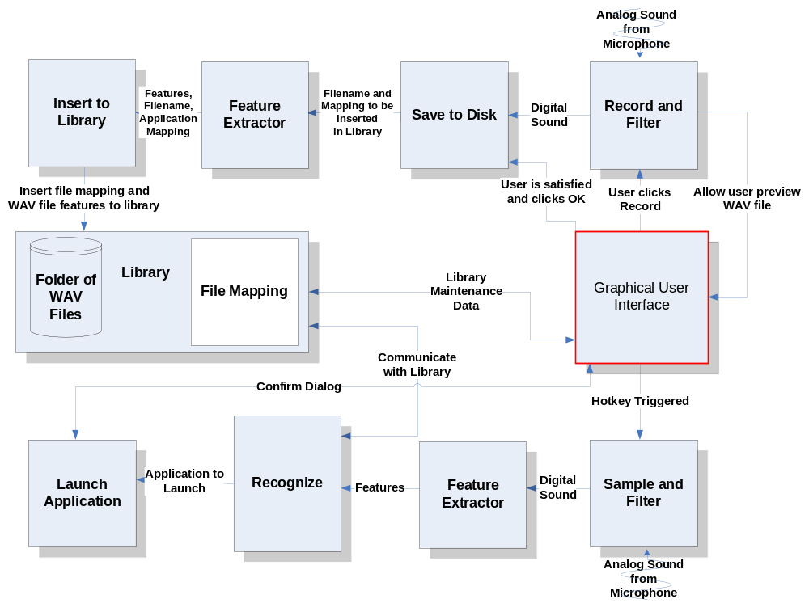
Figure 4 – Block Diagram of Modules

Data-Flow and Control-Flow Diagrams

Figure 5 shows the data flow diagram for recording and populating the library. Analog sound is captured and converted to digital sound in the record and filter module. Once the user is ready, it must then be saved to disk, extract its features and finally inserted into the library.

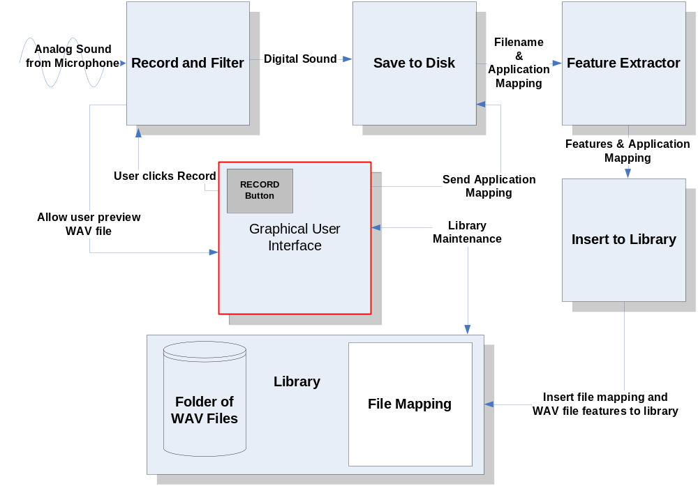
Figure 5 - Data Flow Diagram 1

Figure 6 shows, in further detail, how a sample is recognized. Similar to Figure 5, a WAV file is captured and the digital signal is passed to the next module. The next module, extracts the features of the digital signal and passes them to the recognize module. The recognize module communicates with the library to find the best matched phrase. Once completed, the recognize module notifies the launch application module of which application should be launched. The launch application module will then prompt the user to confirm that the recognized application-mapping is the correct application to launch. The user may click or say ‘yes’ or ‘no.’

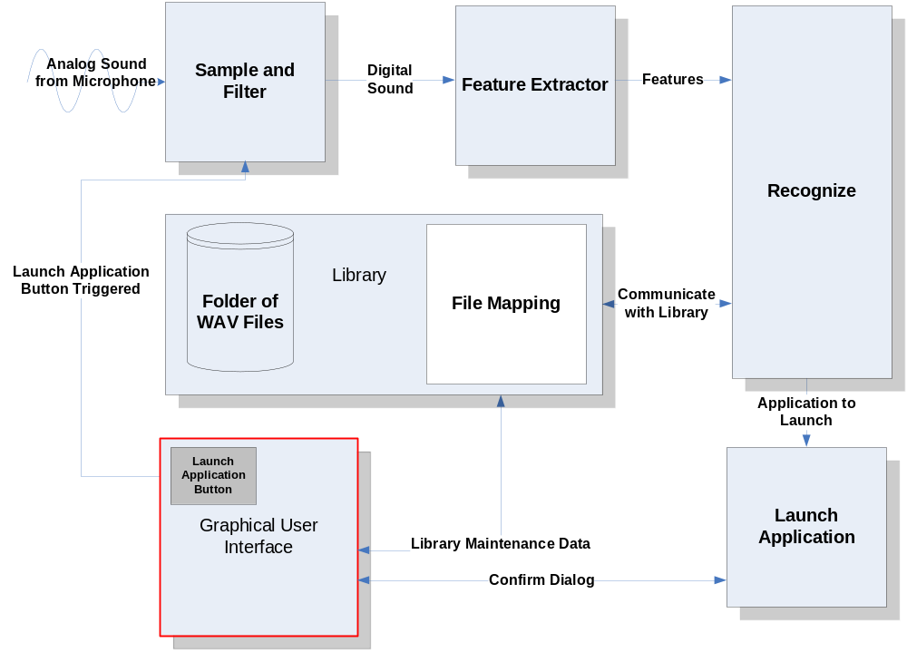
Figure 6 - Data Flow Diagram 2

Figure 7 displays the control flow diagram for all the modules. In this diagram, the boxes represent data and the arrows represent processes. Analog sounds, digital data, WAV files, WAV file features and the applications to launch are the only data that are being processed. To insert WAV files into the library, analog sound is converted to digital which is then saved to disk as a WAV file. The WAV file’s features are extracted and along with the application mapping is inserted into the library.

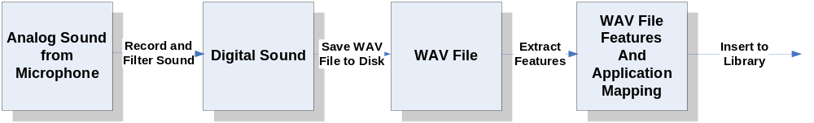

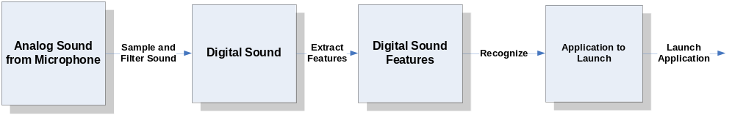
Figure 7 - Control Flow Diagram

Record and Filter Module

Figure 8 displays the steps needed to record with Java for two seconds. An instance of AudioInputStream is used because it expands the buffer as needed and therefore making it a lot easier for the project by not worrying about memory management. The audio is recorded at a rate of 16000 Hz. This project does not require the WAV files to be at a very high rate such as 441000 Hz. Record and filter will not take any parameters, however when it is done recording it will return an instance of AudioInputStream to the GUI. When the control is returned to the GUI the user will have the opportunity to report and accept the options if he or she is satisfied.

Parameters: IN (Nothing)
OUT (AudioInputStream: audioInputStream)

Initialize AudioInputStream
Create instance of AudioFormat(16000.0, 16, 2, true, true)
Create DataLine.Info from DataLine.Info(TargetDataLine.class, AudioFormat);
If AudioSystem.isLineSupported(info) is false, return with error
Create a new TargetDataLine instance called line with given info from earlier
Open line
Start recording on line
While line.getMicrosecondPosition()/1000/1000 < 2
Read data from line into a temporary buffer
Place the temporary buffer into a ByteArrayOutputStream
End while
Stop and close line
Flush and close ByteArrayOutputStream
Convert ByteArrayOutputStream to ByteArrayInputStream
Convert ByteArrayInputStream to AudioInputStream
Return AudioInputStream to GUI so that user can preview

Figure 8 - PDL for Record and Filter

Save to Disk Module

Once the user is satisfied with his or her recording, it is the responsibility of next module to save the WAV file to disk. Save to disk module takes an instance of AudioInputStream as one of its parameters and the application which is launched when the recognize module distinguishes this phrase. The WAV file is saved to disk so that the user can later hear it and modify it if needed. The next module will extract features from WAV files and will only use these features to recognize words. Figure 9 displays the steps needed to save a WAV file to disk.

Parameters: IN (AudioInputStream: audioInputStream, Application Filename: filename)
OUT (WAV file, Application Filename: filename)

- Check to see audioInputStream is not null
- audioInputStream.reset()
- Parse the name of the application
- Create a new file with the same name of application
- AudioSystem.write(audioInputStream, AudioFileFormat.WAVE, file)
- If AudioSystem.write returns -1 then throw exception
- Insert to library with new created WAV file and application mapping

Figure 9 - PDL for Saving to Disk

Insert to Library Module

In this module, the features of the sample file are extracted and saved to the library. In addition, the library also saves which application will be launched in relationship with this sample. This information is saved into a file which resides on the disk.

Parameters: IN (Sample Features: samplefeatures, Application Filename: filename)
OUT (Nothing)

- Open sample file
- Open database file
- Append n features to database file and application that it is mapped to
- Close file
- Update GUI if needed

Figure 10 - PDL for Inserting to Library

Sample Module

The sample module is very similar to record and sample module. As shown in Figure 11, the algorithm is identical to record and filter module. The only subtle difference is that the recorded sample must be passed to the next module so that its features become extracted.

Parameters: IN (Nothing)
OUT (AudioInputStream: audioInputStream)

- Initialize AudioInputStream
- Create instance of AudioFormat(16000.0, 16, 2, true, true)
- Create DataLine.Info from DataLine.Info(TargetDataLine.class, AudioFormat)
- If AudioSystem.isLineSupported(info) is false, return with error
- Create a new TargetDataLine with given info from earlier
- Open line
- Start recording on line
- While line.getMicrosecondPosition()/1000/1000 < 2
- Read data from line into a temporary buffer
- Place the temporary buffer into a ByteArrayOutputStream
- End while
- Stop and close line
- Flush and close ByteArrayOutputStream
- Convert ByteArrayOutputStream to ByteArrayInputStream
- Convert ByteArrayInputStream to AudioInputStream
- Call recognize module with AudioInputStream as a parameter

Figure 11 - PDL for Sampling

Recognize Module

Figure 12, to recognize a sample is a lengthy procedure. First, the samples features are extracted by using the feature extractor module. For every template, a matrix of size n is created, where n is the number of features. Each row of the matrix is populated by taking the difference of one feature from the sample and comparing it with all the features in the template. This way each template and sample is normalized. After completing this with all the features in the sample, the next step is to perform a pattern matching algorithm. The pattern matching algorithm which is being used is called Dynamic Time-Warping (DTW). DTW walks through the matrix and computes the shortest distance from the top-right to the bottom-left corner. The template with the shortest path is chosen and the associated application is returned to the launch application module. There will be a threshold set because from time to time the best match is not a very close match. An example of this problem is if a phrase that does not exist in the library is being processed. The best matched phrase will not be the correct match and no application should be launched.
Parameters: IN (Recorded Sample: sample)
OUT (String: Best matched application)

- Extract features from sample
- Get all templates from library
- For every template
- Create n x n matrix, called M, where n is the size of features in each template
- For i features in sample
- For j features in each template
- M(i,j) = |sample_feature(i) – template_feature(j)|
- End for
- End for
- Cost = 0
- While i != 1 OR j != 1
- Start from top right of matrix M
- Step through to the top corner
- Cost += M (i,j)
- For every step M(i,j) look at M(i-1,j), M(i,j-1), and M(i-1,j-1)
- M(i,j) = min(M(i-1,j), M(i,j-1), M(i-1,j-1))
- End while
- End for
- Find the template with the least cost
- If cost is not within threshold then
- return nothing
- else
- Get which application correlates to the least cost template
- Return the application address as a string

Figure 12 - PDL for Recognition

Launch Application Module

Figure 13, shows the PDL for the final module. This module is responsible for launching the user’s application. If the user wishes to have a confirm dialog then at this point a confirm dialog is displayed and the application is launched only if the user clicks ‘Yes,’ otherwise nothing happens.
Parameters: IN (Application address: filename)
OUT (Nothing)

- Check if filename exists
- If filename does not exist then show warning and return
- Get runtime class
- Check to see if user wants a confirm dialog, and if yes show confirm dialog
- Call runtime.exec(filename)
- Minimize window

Figure 13 - PDL for Launching Application

Feature Extractor Module

The feature extractor module is responsible for extracting the features of WAV files. It will divide the sample into n internals and then for each interval it will find number of zero-crossings and average time between each zero crossing.

Parameters: IN (WAV File)
OUT (Feature Array)

Divide sample into n intervals
For every interval
Compute number of zero-crossings
Compute average time between each zero-crossing
End for

Figure 14 - PDL for Feature Extractor Module

Library

The library is only responsible for returning all the templates to the recognition module or the Graphical User Interface. All WAV features are saved to a file in disk. As shown in Figure 15, the library module returns a matrix which has m samples and n features for each sample. In addition to the features, application mappings are also return to the recognition module. If the user is choosing to view the templates, he or she has the option of deleting or editing the library. In this case the library will need to modify the database file.

Parameters: IN (Nothing)
OUT (Templates)

- Open database file
- For every template
- Read template features and application mappings
- Save each template into an array of n features
- End for
- Close database files
- Return a matrix of size m by n where n is size of features and m is number of templates

Figure 15 - PDL of Library

Graphical User Interface

The Graphical User Interface consists of two tabbed windows. The first tabbed window allows the user to record and insert new samples in the library. The second tabbed window allows the user to view the library. He or she has the option of deleting and editing any chosen template. The steps to add buttons and panels are not shown in Figure 16. The use of hotkeys allows the user to press a combination of keys which sample a phrase and recognize it. Unfortunately, Java does not support global hotkeys on an operating system level. However, there is a way to use C++ and embed that code in Java using JNI.
Parameters: IN (Nothing)
OUT (Nothing)

- Get all templates from library for library maintenance
- For each template add a new row to JTable
- If use clicked preview, fetch file and play
- Create global hotkeys in C++
- Add JButtons and JPanels to tabbed windows(Not Shown)

Figure 16 - PDL for Graphical User Interface

History

Since the Project Proposal Report (PPR), three new modules have been added to the design. Previously, the Graphical User Interface and library module were not part of the design. In addition, feature extraction has become it own module and the user can now confirm prior to launching applications by saying ‘yes’ or ‘no.’ In PPR, it was also assumed that C++ code would easily be able to execute on all other operating systems. Unfortunately after some testing, it was shown that implementing C++ hotkeys relied on Windows header files; making it very difficult to execute this product on other operating systems.
Project Proposal Report projected 6,700 total lines of code. However, in the Critical Design Report, it was projected to be over 10,000 lines of code. After researching implementations of DTW, the number of lines for the recognition was decreased from 3,000 lines to 1,500 lines of codes. During PPR it was assumed for an average programmer to be able to code 25 lines of code per hour, but now it is assumed for an average programmer to code 50 lines per hour; therefore causing the number of hours decreased from 287 hours to 132 hours of programming. Instead, there is now more time allocated for testing and integrating all modules. Overall, the total number of hours to complete this product has been decreased form 639 hours to 609 hours.
Economically there have not been any major changes to this project’s financial status. However, since the product will take less time to construct, the prototype will cost $11,368 less, resulting in more profit, because price per copy is set at a constant rate.

Specifications of the Project

Theory of speech recognition is used in this project to differentiate between vocabularies of up to fifteen words. The user can then relate each word to an application that he or she would like to launch. As a result, the project must keep a collection of WAV file features, also called templates, recorded by the user. To launch an application, the user will trigger an event which will display a dialog and immediately start recording for the duration of two seconds. Once the user’s phrase is captured and converted into digital signal, it can then be recognized and correlating application is launched. This project will assume 80% accuracy.
The minimum system requirements include:
  - Microphone
  - Speakers (Not required but recommended)
  - Windows XP (C and C++ are operating system dependent languages)
  - At least 800 MHz Processor
  - At least 256 MB RAM
  - Keyboard
  - Java Virtual Machine
  - Enough disk space to save the WAV files (Less than one megabyte per wav file)
  - Estimated less than 1000 ms for computation time

The modules that do not have any processing (such as GUI, inserting to library and recording) will be implemented in Java. The use of Java will minimize the steps for recording and playing WAV files. However, the recognition module will be implemented in C because a great amount of speed is needed for the speech recognition algorithm. Java also does not allow any system calls to the operating system, thus making it impossible to implement a global hotkey. The implementation of hotkeys will be done in C++ and embedded in Java. This information is all also presented in the User Manual. The outline for User Manual is presented in Appendix C.

Tests to Verify the Design

The recording module can be tested by first recoding a sound sample and then verifying the sample by playing it. If the recording module is successful, it can be used in conjunction with the writing WAV file module to test that both work together properly. A third-party WAV player can be used to verify that the WAV file was properly written to disk. Inserting WAV files to the library will be tested by inspecting the text file. Each WAV-to-application mapping will be written on a separate line. One can view the text file to verify that it is correct. Recording a sample is similar to record and filter module and it can use the same method to verify its correctness.
The recognition module can be tested with some simple templates. Lastly, launch application module can be tested by providing the module with a string to launch. Table 1, describes the tests needed to verify that each module functions correctly independently.

Table 1 - Verification

Module Name | Input | Expected Result | Status
Record and Filter | Analog Sound | To be digitized and played successfully after recording. | Pass
Record and Filter | Analog Sound | Test with a quiet room. | Pass
Record and Filter | Analog Sound | Record with microphone. | Pass
Record and Filter | Analog Sound | Record with other sources besides a microphone. | Pass
Save to File | Sound from record and filter module | Digital sound to be saved on disk and played through a third-party WAV player. | Not Tested
Feature Extractor | WAV file | Successfully divided into 64 uniform intervals. | Not Tested
Feature Extractor | WAV file | The correct number of zero-crossings for 500 samples should be extracted. | Not Tested
Feature Extractor | WAV file | The correct number of zero -crossings for all interval should be extracted successfully. | Not Tested
Feature Extractor | WAV file | The correct number of average time for each interval is returned. | Not Tested
Insert to Library | WAV file from save to disk module | Open and write to file successfully. | Not Tested
Insert to Library | WAV file from save to disk module | Extract should be successfully written to file. | Not Tested
Sample | Analog Sound | Digitized and played successfully after recording. | Not Tested
Recognize | Digital sound from sample module | Stepped through the matrix successfully. | Not Tested
Recognize | Digital sound from sample module | Matrix created successfully. | Not Tested
Recognize | Digital sound from sample module | Template with best match and within threshold is returned. | Not Tested
Launch Application | Application address from recognize module | Application should be launched. | Not Tested
Library | WAV files | All templates should be returned in a matrix. When needed it should return all WAV files to the GUI. | Not Tested
GUI | Events are triggered by user | Buttons can trigger a number of events ranging from recording to recognition. | Not Tested
GUI | Hotkey | Hotkey should trigger the recording to being | Pass
GUI | Events are triggered by user | Buttons can trigger a number of events ranging from recording to recognition. | Not Tested

The completed project can be tested by performing all tasks possible. To do this, a user can provide a phrase or word so that it can be captured. Once the user is satisfied with the WAV file, it is saved to disk, and its features are extracted and inserted into the library. The user specifies which application will be launched in relation to the new recorded WAV file. This process should be repeated at least ten times. Once ten words have been added to the library, the same user initializes the recognition phase and hopefully it will be 80% accurate. If it is not 80% successful, the threshold will be changed and the whole process will be repeated until the requirements are met. The threshold is a number that limits the maximum distance allowed using DTW.

Module List

Table 2 summarizes how much time and money is needed to implement each module. The recoding module captures sound from the microphone. The writing and inserting modules are responsible for populating the library. The microphone also provides sound for the sampling module which calls the recognition module. The recognition module takes the majority amount of time and money to build; hence it is the most complicated module to implement.

Table 2 - Module List

Module Name | Called By | It Calls | Lines of Code | Hours to Code | $ to Code
RECORD AND FILTER | GUI | Save to Disk | 500 | 10 | $ 400
SAVE TO DISK | Record and Filter | Feature Extractor | 600 | 12 | $ 480
INSERT TO LIBRARY | Save to Disk | - | 1,000 | 20 | $ 800
SAMPLE | GUI | Recognize | 500 | 2 | $ 80
RECOGNIZE | Sample | Launch Application | 1,500 | 30 | $ 1,200
LAUNCH APPLICATION | Recognize | - | 100 | 2 | $ 80
FEATURE EXTRACTOR | Save to Disk/Sample | Recognize/Insert to Library | 1,000 | 20 | $ 800
LIBRARY | - | - | 300 | 6 | $ 240
GUI | User | - | 1,600 | 32 | $ 1,280
TOTAL |  |  | 7,100 | 134 | $5,360

Gantt Chart

Appendix A includes a table produced by Microsoft Project. This table includes costs, hours worked, start and end times, duration and resource name for each task. Appendix B includes a Gantt chart. Gantt chart provides a detailed timeline to build a working prototype. As shown in the table, from September 1, 2004 to May 4, 2005 a total time of 609 hours and cost of $23,165 is needed to complete this project.

Labor Costs by Week

The labor for the prototype is estimated to cost $23,165 in a period of 36 weeks. The first ten weeks will mostly focus on designing and analyzing, whereas after ten weeks programmers start building the prototype. During this period a large amount of the budget is used toward building the prototype. Table 3 illustrates labor costs by week in more detail. Figure 17 displays a graph of the data given by Table 3. The X-axis represents time and the Y-axis represents cumulative cost.
Table 3 - Labor Costs by Week
Week # | ESTIMATED LABOR COSTS | ESTIMATED CUMM COSTS | ACTUAL COSTS | ACTUAL CUMM COSTS | PROJECTED LABOR COSTS | PROJECTED CUMM COSTS
0 | $0 | $0 | $0 | $0
1 | $135 | $135 | $225 | $225
2 | $700 | $835 | $635 | $860
3 | $700 | $1,535 | $665 | $1,525
4 | $1,150 | $2,685 | $215 | $1,740
5 | $300 | $2,985 | $315 | $2,055
6 | $700 | $3,685 | $450 | $2,505
7 | $300 | $3,985 | $920 | $3,425
8 | $400 | $4,385 | $135 | $3,560
9 | $200 | $4,585 | $435 | $3,995
10 | $200 | $4,785 | $1,180 | $5,175
11 | $200 | $4,985 | $665 | $5,840
12 | $400 | $5,385 | $660 | $6,500
13 | $700 | $6,085 | $985 | $7,485
14 | $700 | $6,785 | $1,600 | $9,085 | $1,600 | $9,085
15 | $200 | $6,985 |  |  | $2,240 | $11,325
16 | $100 | $7,085 |  |  | $1,285 | $12,610
17 | $700 | $7,785 |  |  | $770 | $13,380
18 | $500 | $8,285 |  |  | $525 | $13,905
19 | $1,087 | $9,372 |  |  | $210 | $14,115
20 | $1,043 | $10,415 |  |  | $680 | $14,795
21 | $700 | $11,115 |  |  | $1,480 | $16,275
22 | $700 | $11,815 |  |  | $315 | $16,590
23 | $1,000 | $12,815 |  |  | $285 | $16,875
24 | $750 | $13,565 |  |  | $615 | $17,490
25 | $955 | $14,520 |  |  | $1,180 | $18,670
26 | $1,000 | $15,520 |  |  | $135 | $18,805
27 | $1,200 | $16,720 |  |  | $600 | $19,405
28 | $805 | $17,525 |  |  | $280 | $19,685
29 | $400 | $17,925 |  |  | $280 | $19,965
30 | $950 | $18,875 |  |  | $415 | $20,380
31 | $955 | $19,830 |  |  | $170 | $20,550
32 | $900 | $20,730 |  |  | $700 | $21,250
33 | $1,000 | $21,730 |  |  | $415 | $21,665
34 | $826 | $22,556 |  |  | $1,115 | $22,780
35 | $895 | $23,451 |  |  | $385 | $23,165
36 | $385 | $23,836 |  |  | $0 | $23,165

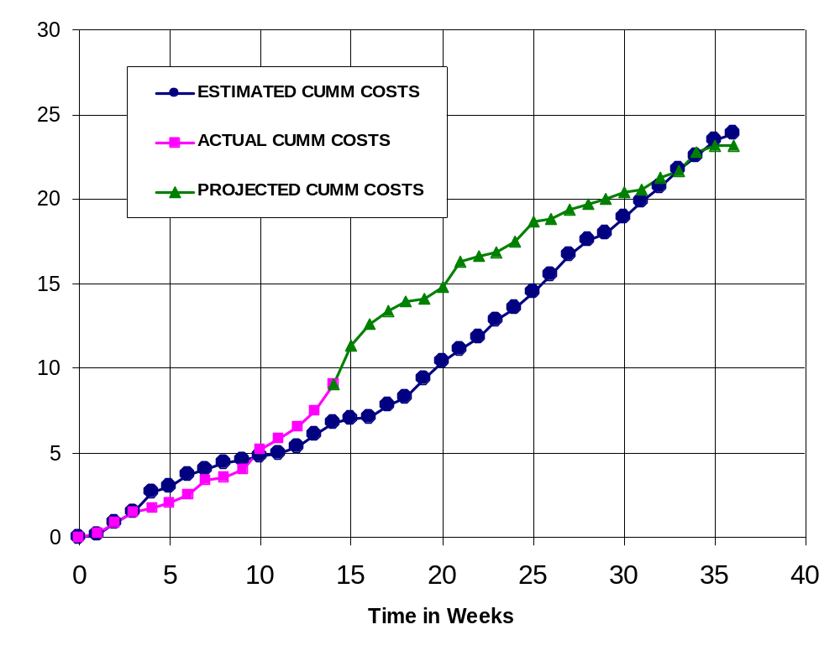
Figure 17 - Cumulative Labor Cost Graph

Economic Analysis

Table 4 illustrates in detail how much the prototype will cost. Overhead, A&G costs and profit were added to initial estimates. The total cost of the prototype is $86,709.
Table 4 - Prototype Cost

PROTOTYPE COSTS
 | Labor Rate | Initial Est. Hours | Initial Est. Cost | Current Est. Hours | Current Est. Cost
System Analyst | $45.00 | 215 | $9,686 | 113 | $5,085
Programmer | $40.00 | 268 | $10,720 | 144 | $5,760
Test Programmer | $35.00 | 31 | $1,085 | 168 | $5,880
Technical Writer | $35.00 | 67 | $2,345 | 184 | $6,440
TOTAL |  | 581 | $23,836 | 609 | $23,165
DIRECT OVERHEAD @ 100% |  |  | $23,836 |  | $23,165
SUBTOTAL |  |  | $47,673 |  | $46,330
A&G COSTS @ 40% |  |  | $19,069 |  | $18,532
SUBTOTAL |  |  | $66,742 |  | $64,862
PROFIT @ 20% |  |  | $13,348 |  | $12,972
TOTAL COST OF PROTOTYPE |  |  | $80,090 |  | $77,834

Table 5 describes unit costs sold if the corporation was to act as a retailer on the Internet. This calculation assumes 1,000,000 units will be sold. The first 20,000 units will recoup the amount of money that the prototype costs. The price of each copy was chosen to be $18.60 because as shown in comparative product survey, all similar products range $20 to $300.

Table 5 - Unit Costs Sold

UNIT COSTS SOLD BY CORPORATION AS A RETAILER ON THE INTERNET
 | Initial Estimate |  |  | Current Estimate
PROTOTYPE COSTS | $80,090 |  |  | $77,834
INSTALL MACHINE AND SOFTWARE | $50,000 |  |  | $50,000
SUBTOTAL | $130,090 |  |  | $127,834
OVERHEARD @ 200% | $260,180 |  |  | $255,669
SUBTOTAL | $390,269 |  |  | $383,503
DOCUMENTATION | $0 |  |  | $0
PACKAGING SUBTOTAL | $0 |  |  | $0
SUBTOTAL | $390,269 |  |  | $383,503
A&G @ 40% | $156,108 |  |  | $153,401
SUBTOTAL | $546,377 |  |  | $536,904
PROFIT @ 20% | $109,275 |  |  | $107,381
SUBTOTAL | $655,653 |  |  | $644,285
 |  | Initial Estimate |  | Current Estimate
 | # of copies | Price/Copy | Total Profit | Price/Copy | Total Profit
Total to Sell | 1,000,000
Recoup Prototype Costs | 100,000 | $6.56 | $109,275 | $6.44 | $107,381
Excessive Profit from Recoup | 100,000 | $12.04 | $1,204,347 | $12.16 | $1,215,715
Remainder to Sell | 900,000 | $18.60 | $16,740,000 | $18.60 | $16,740,000
 |  | Minus 40% for A&G | $6,696,000 | Minus 40% for A&G | $6,696,000
Subtotal |  |  | $10,044,000 |  | $10,044,000
Total Profit |  |  | $11,357,623 |  | $11,367,096

Comparative Product Survey

Table 6 describes some of the products that are similar to this product. Amongst these products, Realize Voice Lite 4.0 has sold 253,432 units and cost $49. However, other products have not been as successful as Realize Voice Lite 4.0. For example, HAL 2.0 is only $20 but has only sold 1,144 units. The most popular products are Naturally Speaking and ViaVoice, but unfortunately units sold were not provided by their vendors.

Table 6 - Product Survey

Product Name | Cost | Units Sold | Publisher | System Requirements
HAL 2.0 | $19.95 | 1,144 | David Henry Company | Windows 98/Me/2000/XP
iListen 1.6.3 | $140.00 | - | MacSpeech | PowerMacintosh G3, 256MB RAM
Naturally Speaking | $150.00 | - | ScanSoft | Intel® Pentium® III / 500 MHz processor, 128 MB RAM, 300 MB free hard disk
Realize Voice Lite 4.0 | $49.00 | 253,432 | Realize Software | Windows 98SE/ME/NT/2000/XP, a noise-canceling microphone
ViaVoice | $200.00 | - | IBM | Pentium II 300 MHz, 510 MB Hard drive, 96 MB RAM
Voice Studio 1.4.2 | $49.97 | 41,914 | Ultimate Interactive Desktops | Windows 98/Me/NT/2000/XP
Voice Tools 7.0 | $300.00 | 51,157 | Wizzard Software | Not Provided

Status Matrices

The following seven tables display the progress which has been completed on each module. Table 7 displays the amount of time each module has been planned and outlined to date. The Launching application module is the simplest module and as a result takes the least amount of time to design. Table 8 shows the amount of time needed to design each module. Table 9 displays the amount of time needed to construct each module. The hours spent to date for this table and many other tables are zero since building period has not begun. Table 10 and Table 11 illustrate the amount of time needed to test each module separately and all modules together. As expected, the amount of time to test the recognition module is the greatest. Table 12 displays the amount of time to document the entire project including this article and the user manual. Finally, Table 13 totals all matrices and class time together.

Table 7 - Outlined Matrix

OUTLINED
MODULE NAME | INIT. EST. HRS. | CUR. EST. HRS. | HRS SPENT TO DATE | % COMPT. | EST. HRS TO COMP.
RECORD AND FILTER | 8 | 8 | 8 | 100.0% | 0
SAVE TO DISK | 7 | 5 | 5 | 100.0% | 0
INSERT TO LIBRARY | 5 | 5 | 5 | 100.0% | 0
SAMPLE | 3 | 3 | 3 | 100.0% | 0
RECOGNIZE | 12 | 10 | 10 | 100.0% | 0
LAUNCH APPLICATION | 2 | 2 | 2 | 100.0% | 0
FEATURE EXTRACTOR | 0 | 2 | 2 | 100.0% | 0
LIBRARY | 2 | 2 | 2 | 100.0% | 0
GUI | 2 | 2 | 2 | 100.0% | 0
TOTALS | 41 | 39 | 39 | 100.0% | 0

Table 8 - Designed Matrix

DESIGNED
MODULE NAME | INIT. EST. HRS. | CUR. EST. HRS. | HRS SPENT TO DATE | % COMPT. | EST. HRS TO COMP.
RECORD AND FILTER | 6 | 8 | 8 | 100.0% | 0
SAVE TO DISK | 7 | 4 | 4 | 100.0% | 0
INSERT TO LIBRARY | 6 | 8 | 8 | 100.0% | 0
SAMPLE | 4 | 5 | 5 | 100.0% | 0
RECOGNIZE | 12 | 30 | 30 | 100.0% | 0
LAUNCH APPLICATION | 3 | 4 | 4 | 100.0% | 0
FEATURE EXTRACTOR | 0 | 6 | 6 | 100.0% | 0
LIBRARY | 2 | 2 | 2 | 100.0% | 0
GUI | 4 | 4 | 4 | 100.0% | 0
TOTALS | 44 | 71 | 71 | 100.0% | 0

Table 9 - Constructed Matrix

CONSTRUCTED
MODULE NAME | INIT. EST. HRS. | CUR. EST. HRS. | HRS SPENT TO DATE | % COMPT. | EST. HRS TO COMP.
RECORD AND FILTER | 40 | 10 | 6 | 60.0% | 4
SAVE TO DISK | 20 | 10 | 0 | 0.0% | 10
INSERT TO LIBRARY | 28 | 20 | 0 | 0.0% | 20
SAMPLE | 40 | 2 | 1 | 50.0% | 1
RECOGNIZE | 120 | 30 | 0 | 0.0% | 30
LAUNCH APPLICATION | 20 | 2 | 0 | 0.0% | 2
FEATURE EXTRACTOR | 0 | 20 | 0 | 0.0% | 20
LIBRARY | 4 | 6 | 0 | 0.0% | 6
GUI | 15 | 32 | 3 | 9.4% | 29
TOTALS | 287 | 132 | 10 | 7.6% | 122

Table 10 - Tested Matrix

TESTED
MODULE NAME | INIT. EST. HRS. | CUR. EST. HRS. | HRS SPENT TO DATE | % COMPT. | EST. HRS TO COMP.
RECORD AND FILTER | 6 | 14 | 2 | 14.3% | 12
SAVE TO DISK | 4 | 9 | 0 | 0.0% | 9
INSERT TO LIBRARY | 4 | 9 | 0 | 0.0% | 9
SAMPLE | 4 | 2 | 1 | 50.0% | 1
RECOGNIZE | 10 | 15 | 0 | 0.0% | 15
LAUNCH APPLICATION | 3 | 7 | 0 | 0.0% | 7
FEATURE EXTRACTOR | 0 | 15 | 0 | 0.0% | 15
LIBRARY | 2 | 2 | 0 | 0.0% | 2
GUI | 4 | 4 | 3 | 75.0% | 1
TOTALS | 37 | 77 | 6 | 7.8% | 71

Table 11 - Integrated Matrix

INTEGRATED
MODULE NAME | INIT. EST. HRS. | CUR. EST. HRS. | HRS SPENT TO DATE | % COMPT. | EST. HRS TO COMP.
RECORD AND FILTER | 4 | 12 | 1 | 8.3% | 11
SAVE TO DISK | 4 | 9 | 0 | 0.0% | 9
INSERT TO LIBRARY | 3 | 11 | 0 | 0.0% | 11
SAMPLE | 1 | 5 | 1 | 20.0% | 4
RECOGNIZE | 6 | 15 | 0 | 0.0% | 15
LAUNCH APPLICATION | 2 | 4 | 0 | 0.0% | 4
FEATURE EXTRACTOR | 0 | 6 | 0 | 0.0% | 6
LIBRARY | 2 | 3 | 0 | 0.0% | 3
GUI | 20 | 20 | 2 | 10.0% | 18
TOTALS | 42 | 85 | 4 | 4.7% | 81

Table 12 - Documented Matrix

DOCUMENTED
MODULE NAME | INIT. EST. HRS. | CUR. EST. HRS. | HRS SPENT TO DATE | % COMPT. | EST. HRS TO COMP.
RECORD AND FILTER | 15 | 24 | 10 | 41.7% | 14
SAVE TO DISK | 13 | 10 | 6 | 60.0% | 4
INSERT TO LIBRARY | 15 | 16 | 5 | 31.3% | 11
SAMPLE | 15 | 13 | 6 | 46.2% | 7
RECOGNIZE | 25 | 20 | 11 | 55.0% | 9
LAUNCH APPLICATION | 15 | 12 | 7 | 58.3% | 5
FEATURE EXTRACTOR | 0 | 10 | 5 | 50.0% | 5
LIBRARY | 1 | 5 | 4 | 80.0% | 1
GUI | 2 | 8 | 6 | 75.0% | 2
TOTALS | 101 | 118 | 60 | 50.8% | 58

Table 13 - Total Matrix

TOTAL
MODULE NAME | INIT. EST. HRS. | CUR. EST. HRS. | HRS SPENT TO DATE | % COMPT. | EST. HRS TO COMP.
RECORD AND FILTER | 79 | 76 | 35 | 46.1% | 41
SAVE TO DISK | 55 | 47 | 15 | 31.9% | 32
INSERT TO LIBRARY | 61 | 69 | 18 | 26.1% | 51
SAMPLE | 67 | 30 | 17 | 56.7% | 13
RECOGNIZE | 185 | 120 | 51 | 42.5% | 69
LAUNCH APPLICATION | 45 | 31 | 13 | 41.9% | 18
FEATURE EXTRACTOR | 0 | 59 | 5 | 8.5% | 54
LIBRARY | 13 | 20 | 8 | 40.0% | 12
GUI | 47 | 70 | 20 | 28.6% | 50
CLASS TIME | 87 | 87 | 48 | 55.2% | 39
TOTALS | 639 | 609 | 230 | 37.8% | 379

Conclusion

The previous chapters demonstrated how the speech recognition project will be outlined, designed, constructed, tested, integrated and documented. It provides a detailed explanation of the modules and how long it will take to produce each one. Furthermore, the cost of each module was calculated and the profit which can be obtained if 1,000,000 units are sold was shown. Last, progress of each module was discussed using matrices.

References

Anonymous, “Dragon NaturallySpeaking 7” <http://www.scansoft.com/naturallyspeaking/>
Henry, David, “David Henry Company”, < http://www.davidhenryco.com/>
Hill, Pamela, “IBM ViaVoice”, <http://www-306.ibm.com/software/voice/viavoice/>
Lyon, Jack, “Realize Software”, <http://www.realizesoftware.com/>
Spencer, Chris, “Wizzard Software Corp.”, <http://www.wizzardsoftware.com/>
Ultimate Interactive, “Ultimate Interactive Desktops Inc.” <http://www.voicestudio.us/>

Appendix A – Gantt Chart

