The George Washington University
School of Engineering and Applied Science
Department of Computer Science

Preliminary Design Review

for the

Design of a Discrete User-Dependent
Speech Recognition Program

By

Amir Raminfar

CSci 195-10
Senior Computer Science Design Project

Abstract of the Preliminary Design Review for the
Design of a Discrete User-Dependent Speech Recognition Program
by
Amir Raminfar

This report is a proposal on how to implement and build a speech recognition program. The program will recognize a selection of fifteen words with 80% accuracy. Once the word is recognized, the program will launch an application which the user had chosen previously for that specific word. The project consists of six main modules. The modules include record and filter, write to disk, insert to library, sample and filter, recognize and launch application. Furthermore, the project has a library module and a Graphical User Interference. The recognize module is the heart of the project. The program will require a machine of at least 800 MHz and at least 256 MB of RAM. A microphone is required for recording speech and speakers are recommended for playback.

The project will require 36 weeks to complete and will need an estimated 675 hours of labor at an estimated labor cost of $25,791. A working prototype is estimated to cost $86,659. Economic Analysis has determined that if one-million units are sold over the internet at a cost of $18.60 per unit will result in a profit of $11,051,593. To date an expenditure of $3,526 has been used to develop this proposal.
TABLE OF CONTENTS

Abstract | ii
List of Figures | iv
List of Tables | v
1. Introduction 1
2. Design of the project 2
3. Specifications of the Project 7
4. Tests to Verify the Design 8
5. Module List 10
6. Gantt Chart 11
7. Labor Costs by Week 12
8. Economic Analysis 14
9. Comparative Product Survey 16
10. Status Matrices 17
11. Conclusion 21
12. References 22
Appendix A – Gantt Charts

LIST OF FIGURES

Figure 1 – Block Diagram of Modules 3
Figure 2 - Data Flow Diagram 1 4
Figure 3 - Data Flow Diagram 2 5
Figure 4 - Control Flow Diagram 6
Figure 5 - Cumulative Labor Costs 13

LIST OF TABLES

Table 1 - Module List 10
Table 2 - Labor Costs by Week 12
Table 3 - Prototype Cost 14
Table 4 - Unit Costs Sold 15
Table 5 - Product Survey 16
Table 6 - Outlined Matrix 17
Table 7 - Designed Matrix 18
Table 8 - Constructed Matrix 18
Table 9 - Tested Matrix 19
Table 10 - Integrated Matrix 19
Table 11 - Documented Matrix 20
Table 12 - Total Matrix 20

Introduction

Speech Recognition has been researched for the last 30 years, and is now able to recognize numerous amounts of words. This project uses the power of speech recognition so users can launch applications of their choice using voice commands. Furthermore, this project is focusing ten to fifteen words only and is not expected to be accurate with anymore words.
Chapter two discusses the modules in detail and also provides a block diagram of the design. In addition to a block diagram, chapter two provides data flow diagrams and control diagrams. Chapter three discusses what type of system is needed to perform calculations in this project. Subsequently, chapter four discusses what tests are needed to verify that each module and all modules together will function correctly.
Chapters six, seven, and eight discuss the costs associated with the project. Chapter six shows the Gantt chart which was produced by Microsoft Project. Chapter seven discusses costs by week and provides a detailed table and graph. Chapter eight describes how much the prototype will cost, as well as how much profit can be acquired if one-million units were to be sold.
Finally, in chapter nine, seven matrices are provided. The first matrix illustrates how much of each module has been outlined up to date. The second matrix illustrates how much of each module has been designed. The third matrix shows the number of hours coded to date. The fourth matrix illustrates the number of hours tested on each module. The fifth matrix illustrates the amount of time needed to test all modules together. The sixth matrix demonstrates how much of the project has been document and finally the last matrix totals all other matrices together plus the amount of time in class.

Design of the project

This project has six processing modules plus a GUI and library modules. The program first needs to build a collection of WAV files that can be used as a library. The library maintains information about each WAV file and the application which will be launched for that WAV file. Second, the program needs to be able to recognize any given sample from the library of WAV files. This part will be the heart of the project. As illustrated in Figure 1, the first of the six modules records the WAV file which will then be written to disk in the second module. The third module inserts the new recorded WAV file to a collection of WAV files and includes information such as which application will be launched when this word is pronounced. The fourth module is responsible of recording the sample. The fifth module, which is the most sophisticated module, is responsible for recognizing and finding the closest match to the sample. Finally, the last module will launch the user’s application which was pre-selected by the user. As Figure 1 shows, the GUI module is where all the events get triggered. Depending on the event, the GUI calls either the record or sample module. The GUI also has access to the library for maintenance purposes. The library keeps a record of WAV file to application mappings and a folder of WAV files to store the WAV files. The recognize module needs access to the library to recognize what the user said and retrieve which application is mapped to that phrase.

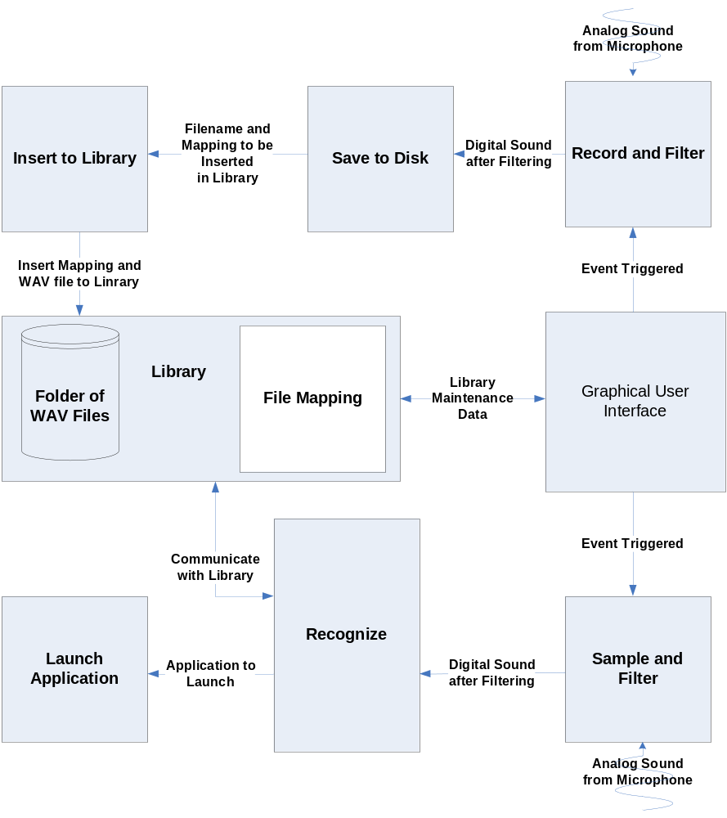
Figure 1 – Block Diagram of Modules
Figure 2 shows the data flow diagram for recording and populating the library. Analog sound is captured and converted to digital sound in the record and filter module. It must then be saved to disk and inserted into the library.

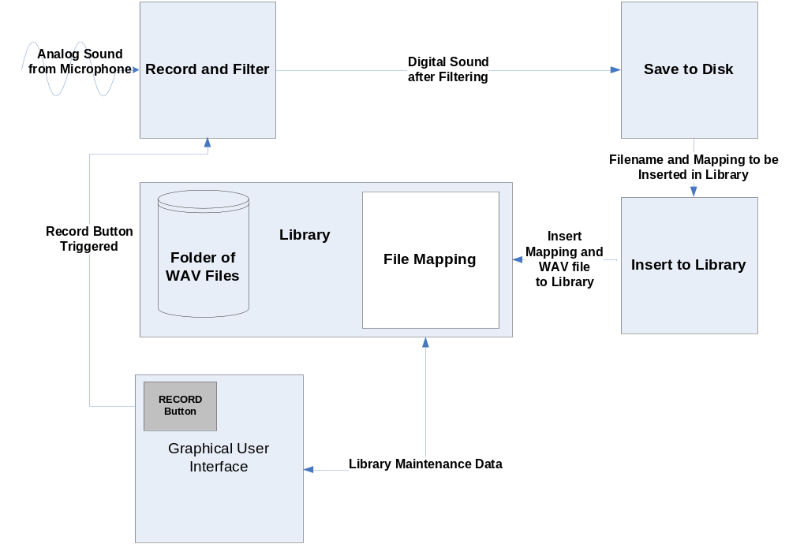
Figure 2 - Data Flow Diagram 1
Figure 3 shows in further detail on how a sample is recognized. Similarly to Figure 2, a WAV file is captured and the digital file is passed to the next module. The next module being the recognize module uses the library to find the best match. Once completed, the recognize module notifies the launch application module which application should be launched.
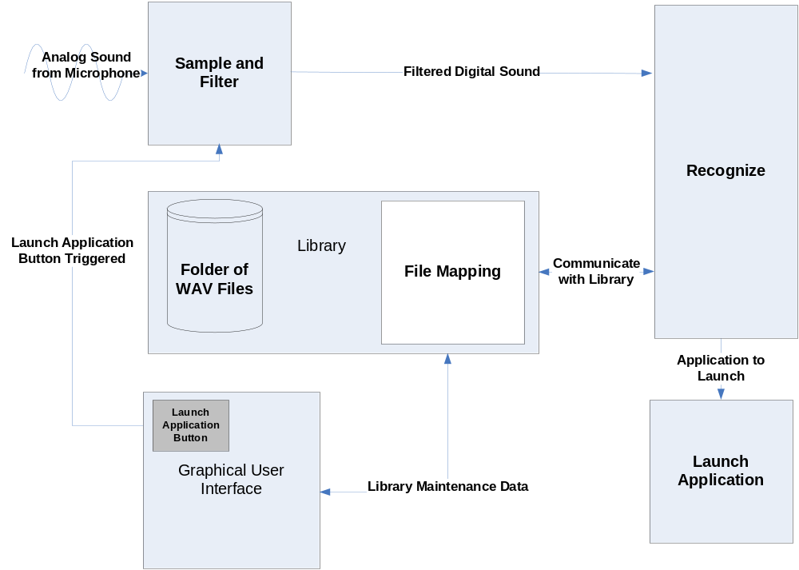
Figure 3 - Data Flow Diagram 2

Figure 4 displays the control flow diagram for all the modules. In this diagram, the boxes represent data and the arrows represent processes. Analog sounds, digital data, WAV files and the applications to launch are the only data that are being processed on. To insert WAV files in the library, analog sound is converted to digital which is then saved to disk as a WAV file. That WAV file in addition to the application mapping is inserted to the library. Similarly, to recognize phrases, analog sound must be converted to digital sound first. The phrase is recognized and the associated application is launched.
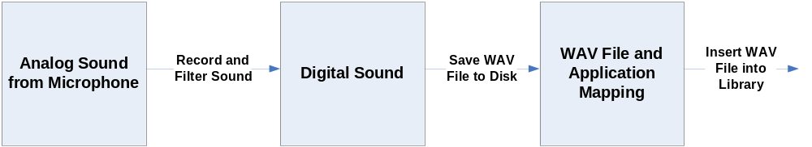

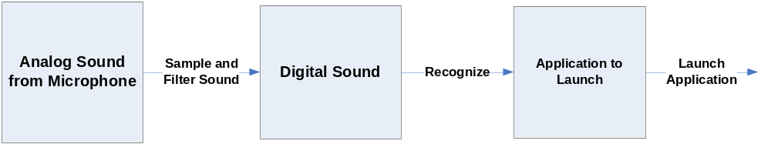
Figure 4 - Control Flow Diagram

Specifications of the Project

Theory of speech recognition is used in this project to differentiate between vocabularies of ten to fifteen words. The user can then relate each word to an application that he or she would like to launch. As a result, the project must keep a collection of WAV files which were recorded by the user. When users want to launch an application, they can initialize the project and say the program’s name that they want to launch. The word would then be recognized and the user’s application will be launched. This project will assume 80% accuracy and will be targeting ten to fifteen words because any more words would decrease the accuracy.
Below are the system requirements needed to execute this project successfully:
Microphone
Speakers (Not required but recommended)
800 MHz Processor
256 MB RAM
Keyboard
Java Virtual Machine
Enough disk space to save the WAV files

The modules that do not have any computation will be implemented in Java. The use of Java will ease the process of recording and playing WAV files. However, the recognition module will be implemented in C because a great amount of speed is needed for the speech recognition algorithm.

Tests to Verify the Design

The recording module can be tested by first recoding a sound sample and then verifying the sample by playing it. If the recording module is successful, it can be used in conjunction with the writing WAV file module to test that both work together properly. A third-party WAV player can be used to verify that the WAV file was properly written to disk. Inserting WAV files to the library can be simply tested because the library will be kept in a text file. Each WAV to application mapping can be written on a separate line. One can view the text file to verify that it is correct. Recording a sample is similar to the first module and it can use the same method to verify its correctness.
The next module, speech recognition, is the most difficult module to test and verify. Assuming 80% accuracy, this module should be able to distinguish between words such as “cat” and “dog.” However, this module is not expected to differentiate between words such as “stab” and “stub.” Below are some phrases and words that the project should be able to recognize:
Test Phrase | Expected Result
Email | OK
Internet | OK
Music | OK
Word Processor | OK
Address Book | OK
Show Desktop | OK
My Computer | OK
G-Mail compared with C-Mail | NOT OK
Cannot Make OS calls like:
Copy and Paste | NOT OK
Close/Create New Email | NOT OK

The last module is tested independently by specifying which program should be launched. If the program specified is launched successfully then the last module is considered successful.
The completed project can be tested by doing a simulation. To simulate, a user can provide a phrase or word so that it can be captured. Once captured, the WAV file is saved to disk and the file is added to the library. The user specifies which application will be launched in relation with the new recorded WAV file. This process should be repeated ten times. Once ten words have been added to the library, the same user initializes the recognition phase and hopefully it will be 80% accurate. If it is not 80% successful, the threshold will be changed and the whole process will be repeated until the requirements are met.

Module List

Table 1 summarizes how much time and money is needed to implement each module. The recoding module captures sound from the microphone. The writing and inserting modules are responsible for populating the library. The microphone also provides sound for the sampling module which calls the recognition module. The recognition module takes the majority amount of time and money to build; hence it is the most complicated module to implement.

Table 1 - Module List

Module Name | Called By | It Calls | Lines of Code | Hours to Code | $ to Code
INPUT FROM MIC | - | - | - | - | -
RECORD AND FILTER | GUI | Save to File | 1,500 | 30 | $ 1,200
SAVE TO FILE | Record and Module | Insert to Library | 750 | 15 | $ 600
INSERT TO LIBRARY | Save to File | - | 1,400 | 28 | $ 1,120
SAMPLE | GUI | Recognize | 500 | 10 | $ 400
RECOGNIZE | Sample | Launch Application | 4,000 | 80 | $ 3,200
LAUNCH APPLICATION | Recognize | - | 1,000 | 20 | $ 800
LIBRARY | - | - | 200 | 4 | $ 160
GUI | User | - | 750 | 15 | $ 600
TOTAL |  |  | 10,100 | 202 | $8,080

Gantt Chart

Appendix A includes a table that has been produced by Microsoft Project. The first table includes costs, hours worked, start and end times, duration and resource name for each task. In addition to the table, there is also a timeline that was generated by Microsoft Project. As shown in the table, from September 1st to May 4th, a total time of 581 hours and cost of $23,836 is needed to complete this project. The total time needed for fall is 188 hours and spring is 393 hours. The last table, which is also provided but Microsoft Project, shows the amount of time and associated costs per week for each person. System analyst, who is in charge of designing and outlining, has a total of 215 hours. Programmer has a total of 268 hours whereas test programmer has only 36 hours of work. Finally, Technical writer has a total of 67 hours of work which includes writing the manual and final presentation. It should be no surprise that the Programmer has the most amount of work because the implanting phase is the most difficult phase.

Labor Costs by Week

The prototype is estimated to cost $25,791 in a period of 36 weeks. First ten weeks will mostly focus on designing and analyzing, whereas after ten weeks programmers start building the prototype. During this period a large amount of the budget is used toward building the prototype. Table 2 illustrates labor costs by week in more detail. In Table 2, Microsoft Projected was used to export costs by weeks into Microsoft Excel.
Table 2 - Labor Costs by Week
Week # | ESTIMATED LABOR COSTS | ESTIMATED CUMM COSTS | ACTUAL COSTS | ACTUAL CUMM COSTS | PROJECTED LABOR COSTS | PROJECTED CUMM COSTS
0 | 0 | 0 | 0 | 0
1 | 225 | 225 | 225 | 225
2 | 736 | 961 | 736 | 961
3 | 665 | 1,626 | 665 | 1,626
4 | 215 | 1,841 | 215 | 1,841
5 | 315 | 2,156 | 315 | 2,156
6 | 450 | 2,606 | 450 | 2,606
7 | 920 | 3,526 | 920 | 3,526 | 920 | 3,526
8 | 135 | 3,661 |  |  | 135 | 3,661
9 | 135 | 3,796 |  |  | 135 | 3,796
10 | 765 | 4,561 |  |  | 765 | 4,561
11 | 1,365 | 5,926 |  |  | 1,365 | 5,926
12 | 820 | 6,746 |  |  | 820 | 6,746
13 | 670 | 7,416 |  |  | 670 | 7,416
14 | 1,550 | 8,966 |  |  | 1,550 | 8,966
15 | 2,060 | 11,026 |  |  | 2,060 | 11,026
16 | 1,345 | 12,371 |  |  | 1,345 | 12,371
17 | 630 | 13,001 |  |  | 630 | 13,001
18 | 350 | 13,351 |  |  | 350 | 13,351
19 | 350 | 13,701 |  |  | 350 | 13,701
20 | 1,360 | 15,061 |  |  | 1,360 | 15,061
21 | 1,680 | 16,741 |  |  | 1,680 | 16,741
22 | 315 | 17,056 |  |  | 315 | 17,056
23 | 135 | 17,191 |  |  | 135 | 17,191
24 | 1,795 | 18,986 |  |  | 1,795 | 18,986
25 | 1,345 | 20,331 |  |  | 1,345 | 20,331
26 | 135 | 20,466 |  |  | 135 | 20,466
27 | 240 | 20,706 |  |  | 240 | 20,706
28 | 140 | 20,846 |  |  | 140 | 20,846
29 | 0 | 20,846 |  |  | 0 | 20,846
30 | 135 | 20,981 |  |  | 135 | 20,981
31 | 455 | 21,436 |  |  | 455 | 21,436
32 | 865 | 22,301 |  |  | 865 | 22,301
33 | 135 | 22,436 |  |  | 135 | 22,436
34 | 695 | 23,131 |  |  | 695 | 23,131
35 | 1,575 | 24,706 |  |  | 1,575 | 24,706
36 | 1,085 | 25,791 |  |  | 1,085 | 25,791

Figure 5 displays a graph of the data given by Table 2. The X-axis represents time and the Y-axis represents cumulative cost.
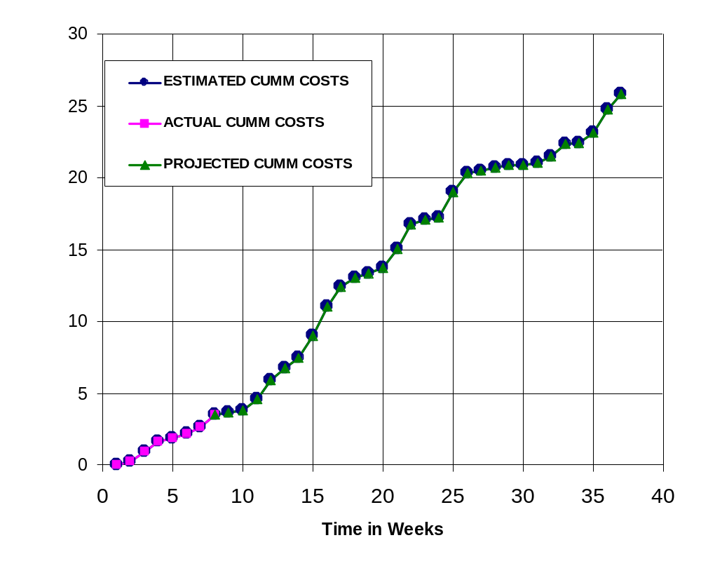
Figure 5 - Cumulative Labor Costs

Economic Analysis

Table 3 illustrates in detail how much the prototype will cost. Initial estimated hours were produced by Microsoft Project and afterwards overhead, A&G costs and profit were added. The total cost of the prototype is $86,659.
Table 3 - Prototype Cost

PROTOTYPE COSTS
 | Labor Rate | Current Est. Hours | Current Est. Cost | Initial Est. Hours | Initial Est. Cost
System Analyst | $45.00 | 118 | $5,321 | 215 | $9,686
Programmer | $40.00 | 195 | $7,800 | 268 | $10,720
Test Programmer | $35.00 | 174 | $6,090 | 31 | $1,085
Technical Writer | $35.00 | 188 | $6,580 | 67 | $2,345
TOTAL |  | 675 | $25,791 | 581 | $23,836
DIRECT OVERHEAD @ 100% |  |  | $25,791 |  | $23,836
SUBTOTAL |  |  | $51,583 |  | $47,673
A&G COSTS @ 40% |  |  | $20,633 |  | $19,069
SUBTOTAL |  |  | $72,216 |  | $66,742
PROFIT @ 20% |  |  | $14,443 |  | $13,348
TOTAL COST OF PROTOTYPE |  |  | $86,659 |  | $80,090

Table 4 describes unit costs sold if the corporation was to act as a retailer on the Internet. This calculation assumes one million units will be sold. The first 20,000 units will recoup the amount of money that the prototype costs. The price of each copy was chosen to be $18.60 because as shown in comparative product survey, all similar products range $20 to $300.

Table 4 - Unit Costs Sold

UNIT COSTS SOLD BY CORPORATION AS A RETAILER ON THE INTERNET
PROTOTYPE COSTS |  | $86,659
INSTALL MACHINE AND SOFTWARE |  | $50,000
SUBTOTAL |  | $136,659
OVERHEARD @ 200% |  | $273,317
SUBTOTAL |  | $409,976
DOCUMENTATION |  | $0
PACKAGING SUBTOTAL |  | $0
SUBTOTAL |  | $409,976
A&G @ 40% |  | $163,990
SUBTOTAL |  | $573,966
PROFIT @ 20% |  | $114,793
SUBTOTAL |  | $688,759
 | # of copies | Price/Copy | Total Profit
Total to Sell | 1,000,000
Recoup Prototype Costs | 20,000 | $18.60 | $114,793
Remainder to Sell | 980,000 | $18.60 | $18,228,000
 |  | Minus 40% for A&G | $7,291,200
Subtotal |  |  | $10,936,800
Total Profit |  |  | $11,051,593

Comparative Product Survey

Table 5 describes some of the products that are similar to this product. Amongst these products, Realize Voice Lite 4.0 has sold 253,432 units and cost $49. However, other products have not been as successful as Realize Voice Lite 4.0. For example, HAL 2.0 is only $20 but has only sold 1,144 units. The most popular products are Naturally Speaking and ViaVoice, but unfortunately units sold were not provided by their vendors.

Table 5 - Product Survey

Product Name | Cost | Units Sold | Publisher | System Requirements
Voice Studio 1.4.2 | $49.97 | 41,914 | Ultimate Interactive Desktops | Windows 98/Me/NT/2000/XP
HAL 2.0 | $19.95 | 1,144 | David Henry Company | Windows 98/Me/2000/XP
Voice Tools 7.0 | $300.00 | 51,157 | Wizzard Software | Not Provided
Realize Voice Lite 4.0 | $49.00 | 253,432 | Realize Software | Windows 98SE/ME/NT/2000/XP, a noise-canceling microphone
ViaVoice | $200.00 | Not Provided | IBM | Pentium II 300 MHz, 510 MB Harddrive, 96 MB RAM
Natuallry Speaking | $150.00 | Not Provided | ScanSoft | Intel® Pentium® III / 500 MHz processor, 128 MB RAM, 300 MB free hard disk
iListen 1.6.3 | $140.00 | Not Provided | MacSpeech | PowerMacintosh G3, 256MB RAM

Status Matrices

The following seven tables display the progress which has been completed on each module. Table 1 displays the amount of time each module has been planned and outlined to date. The Launching application module is the simplest module and as a result it takes the least amount of time to design. Table 7 shows the amount of time needed to design each module. Table 8 Table 1displays the amount of time needed to construct each module. Hours spent to date for this table and many other tables are none since building period has not begun. Table 9 and Table 10 illustrate the amount of time needed to test each module separately and all modules together. As expected, amount of time to test the recognition module is the greatest. Table 11 displays the amount of time to document the entire project including this article. Finally, Table 12 totals all matrices and class time together.

Table 6 - Outlined Matrix

OUTLINED
MODULE NAME | INIT. EST. HRS. | CUR. EST. HRS. | HRS SPENT TO DATE | % COMPT. | EST. HRS TO COMP.
RECORD AND FILTER | 8 | 8 | 8 | 100.0% | 0
SAVE TO FILE | 7 | 7 | 7 | 100.0% | 0
INSERT TO LIBRARY | 5 | 5 | 5 | 100.0% | 0
SAMPLE | 3 | 3 | 3 | 100.0% | 0
RECOGNIZE | 12 | 12 | 12 | 100.0% | 0
LAUNCH APPLICATION | 2 | 2 | 2 | 100.0% | 0
LIBRARY | 2 | 2 | 2 | 100.0% | 0
GUI | 2 | 2 | 2 | 100.0% | 0
TOTALS | 41 | 41 | 41 | 100.0% | 0

Table 7 - Designed Matrix

DESIGNED
MODULE NAME | INIT. EST. HRS. | CUR. EST. HRS. | HRS SPENT TO DATE | % COMPT. | EST. HRS TO COMP.
RECORD AND FILTER | 6 | 8 | 7 | 87.5% | 1
SAVE TO FILE | 7 | 10 | 9 | 90.0% | 1
INSERT TO LIBRARY | 6 | 8 | 7 | 87.5% | 1
SAMPLE | 4 | 5 | 5 | 100.0% | 0
RECOGNIZE | 12 | 36 | 20 | 55.6% | 16
LAUNCH APPLICATION | 3 | 4 | 3 | 75.0% | 1
LIBRARY | 2 | 2 | 2 | 100.0% | 0
GUI | 4 | 4 | 3 | 75.0% | 1
TOTALS | 44 | 77 | 56 | 72.7% | 21

Table 8 - Constructed Matrix

CONSTRUCTED
MODULE NAME | INIT. EST. HRS. | CUR. EST. HRS. | HRS SPENT TO DATE | % COMPT. | EST. HRS TO COMP.
RECORD AND FILTER | 40 | 30 | 0 | 0.0% | 30
SAVE TO FILE | 20 | 15 | 0 | 0.0% | 15
INSERT TO LIBRARY | 28 | 28 | 0 | 0.0% | 28
SAMPLE | 40 | 10 | 0 | 0.0% | 10
RECOGNIZE | 120 | 80 | 0 | 0.0% | 80
LAUNCH APPLICATION | 20 | 20 | 0 | 0.0% | 20
LIBRARY | 4 | 4 | 0 | 0.0% | 4
GUI | 15 | 15 | 0 | 0.0% | 15
TOTALS | 287 | 202 | 0 | 0.0% | 202

Table 9 - Tested Matrix

TESTED
MODULE NAME | INIT. EST. HRS. | CUR. EST. HRS. | HRS SPENT TO DATE | % COMPT. | EST. HRS TO COMP.
RECORD AND FILTER | 6 | 14 | 0 | 0.0% | 14
SAVE TO FILE | 4 | 9 | 0 | 0.0% | 9
INSERT TO LIBRARY | 4 | 9 | 0 | 0.0% | 9
SAMPLE | 4 | 6 | 0 | 0.0% | 6
RECOGNIZE | 10 | 18 | 0 | 0.0% | 18
LAUNCH APPLICATION | 3 | 7 | 0 | 0.0% | 7
LIBRARY | 2 | 2 | 0 | 0.0% | 2
GUI | 4 | 4 | 0 | 0.0% | 4
TOTALS | 37 | 69 | 0 | 0.0% | 69

Table 10 - Integrated Matrix
INTEGRATED
MODULE NAME | INIT. EST. HRS. | CUR. EST. HRS. | HRS SPENT TO DATE | % COMPT. | EST. HRS TO COMP.
RECORD AND FILTER | 4 | 12 | 0 | 0.0% | 12
SAVE TO FILE | 4 | 9 | 0 | 0.0% | 9
INSERT TO LIBRARY | 3 | 11 | 0 | 0.0% | 11
SAMPLE | 1 | 5 | 0 | 0.0% | 5
RECOGNIZE | 6 | 21 | 0 | 0.0% | 21
LAUNCH APPLICATION | 2 | 4 | 0 | 0.0% | 4
LIBRARY | 2 | 3 | 0 | 0.0% | 3
GUI | 20 | 20 | 0 | 0.0% | 20
TOTALS | 42 | 85 | 0 | 0.0% | 85

Table 11 - Documented Matrix

DOCUMENTED
MODULE NAME | INIT. EST. HRS. | CUR. EST. HRS. | HRS SPENT TO DATE | % COMPT. | EST. HRS TO COMP.
RECORD AND FILTER | 15 | 24 | 7 | 29.2% | 17
SAVE TO FILE | 13 | 12 | 5 | 41.7% | 7
INSERT TO LIBRARY | 15 | 16 | 6 | 37.5% | 10
SAMPLE | 15 | 13 | 5 | 38.5% | 8
RECOGNIZE | 25 | 24 | 10 | 41.7% | 14
LAUNCH APPLICATION | 15 | 12 | 5 | 41.7% | 7
LIBRARY | 1 | 5 | 2 | 40.0% | 3
GUI | 2 | 8 | 5 | 62.5% | 3
TOTALS | 101 | 114 | 45 | 39.5% | 69

Table 12 - Total Matrix

TOTAL
MODULE NAME | INIT. EST. HRS. | CUR. EST. HRS. | HRS SPENT TO DATE | % COMPT. | EST. HRS TO COMP.
RECORD AND FILTER | 79 | 96 | 22 | 22.9% | 74
SAVE TO FILE | 55 | 62 | 21 | 33.9% | 41
INSERT TO LIBRARY | 61 | 77 | 18 | 23.4% | 59
SAMPLE | 67 | 42 | 13 | 31.0% | 29
RECOGNIZE | 185 | 191 | 42 | 22.0% | 149
LAUNCH APPLICATION | 45 | 49 | 10 | 20.4% | 39
LIBRARY | 13 | 18 | 6 | 33.3% | 12
GUI | 47 | 53 | 10 | 18.9% | 43
CLASS TIME | 87 | 87 | 18 | 20.7% | 69
TOTALS | 639 | 675 | 160 | 23.7% | 515

Conclusion

The previous chapters demonstrated how the speech recognition project will be designed and outlined. It provides a detailed explanation of the modules and how long it will take to code each one. Furthermore, the amount of money that each module will cost was calculated and the profit which can be obtained if one-million units were sold was shown. Last, progress of each module was discussed using tables and matrices.

References

Anonymous, “Dragon NaturallySpeaking 7” <http://www.scansoft.com/naturallyspeaking/>
Henry, David, “David Henry Company”, < http://www.davidhenryco.com/>
Hill, Pamela, “IBM ViaVoice”, <http://www-306.ibm.com/software/voice/viavoice/>
Lyon, Jack, “Realize Software”, <http://www.realizesoftware.com/>
Spencer, Chris, “Wizzard Software Corp.”, <http://www.wizzardsoftware.com/>
Ultimate Interactive, “Ultimate Interactive Desktops Inc.” <http://www.voicestudio.us/>

Appendix A – Gantt Chart

