The George Washington University
School of Engineering and Applied Science
Department of Computer Science

Project Proposal Report

for the

Design of a Discrete User-Dependent Speech Recognition Program

By

Amir Raminfar

CSci 195-10
Senior Computer Science Design Project

Abstract of the Project Proposal Report for the
Design of a Discrete User-Dependent Speech Recognition Program
by
Amir Raminfar

This report is a proposal on how to implement and build a speech recognition program. The program will recognize a selection of fifteen words with 80% accuracy. Once the word is recognized, the program will launch an application which the user had chosen previously for that specific word. The project consists of six main modules. The modules include recording, writing to disk, inserting to library, sampling, recognizing word and launching application; thus, the speech recognition module is the heart of the project. The program will require a machine of at least 800 MHz and at least 256 MB of RAM. A microphone is required for recording speech and speakers are recommended for playback.

The project will require 36 weeks to complete and will need an estimated amount of 581 hours of labor at an estimated labor cost of $23,836. A working prototype is estimated to cost $80,089.80. Economic Analysis has determined that if one-million units are sold over the internet at a cost of about $19 per unit will result in a profit of $11,046,075.43. To date an expenditure of $2,666.25 has been used to develop this proposal.
TABLE OF CONTENTS
1. Introduction 1
2. Design of the project 2
3. Specifications of the Project 3
4. Test to Verify the Design 4
5. Module List 5
6. Gantt Chart 6
7. Labor Costs by Week 7
8. Economic Analysis 9
9. Comparative Product Survey 11
10. Status Matrices 12
11. Conclusion 16
12. References 17
Appendix A – Gantt Charts
LIST OF FIGURES
Figure 1 – Block Diagram of Modules 2
Figure 2 - Cumulative Labor Costs 8

LIST OF TABLES
Table 1 - Module List 5
Table 2 - Labor Costs by Week 7
Table 3 - Prototype Cost 9
Table 4 - Unit Costs Sold 9
Table 5 - Product Survey 11
Table 6 - Outlined Matrix 12
Table 7 - Constructed Matrix 12
Table 8 - Designed Matrix 13
Table 9 - Tested Matrix 13
Table 10 - Integrated Matrix 13
Table 11 - Documented Matrix 14
Table 12 - Total Matrix 14

Introduction

Speech Recognition has been researched for the last 30 years. Thanks to this research, technology is now able to recognize between a numerous amounts of words. This project uses the power of speech recognition so dependent-users can launch applications of their choice using voice commands. Furthermore, this project is focusing ten to fifteen words only and is not expected to be accurate with anymore words.
Chapter two discusses the modules in detail and also provides a block diagram of the design. Later on in chapter five, each module’s estimated time and cost is described in more detail.
Chapter three discusses the kind of system which is needed to perform calculations in this project. Subsequently, chapter four discusses what tests are needed to verify that each module and all modules together will function correctly.
Chapters six, seven, and eight discuss the amount of money to complete the whole project. Chapter six shows the Gantt chart which was produced by Microsoft Project. Chapter seven discusses costs by week and provides a detailed table and graph. Chapter eight describes how much the prototype will cost. It then goes further by providing how much profit can be acquired if one-million units were to be sold.
Finally, in chapter nine, seven matrices are provided. First matrix illustrates how much of each module has been outlined up to date. Second matrix illustrates how much of each module has been designed. Third matrix shows the number of hours coded to date. Fourth matrix illustrates the number of hours tested on each module. Fifth matrix illustrates the amount of time needed to test all modules together. Sixth matrix demonstrates how much of the project has been document and finally the last matrix totals all other matrices together plus the amount of time in class.

Design of the project

This project consists of six modules. The program first needs to build a collection of wave files that can be used as a library. The library maintains information about each wave file and the application which will be launched for that wave file. Second, the program needs to be able to recognize any given sample from the library of wave files. This part will be the heart of the project. As illustrated in Figure 1, the first of six modules records the wave file which will then be written to disk in the second module. The third module inserts the new recorded wave file to a collection of wave files and includes information such as which application will be launched when this word is pronounced. The fourth module is responsible of recording the sample. The fifth module, which is the most sophisticated module, is responsible for recognizing and finding the closest match to the sample. Finally, the last module will launch the user’s application which was pre-selected by the user.

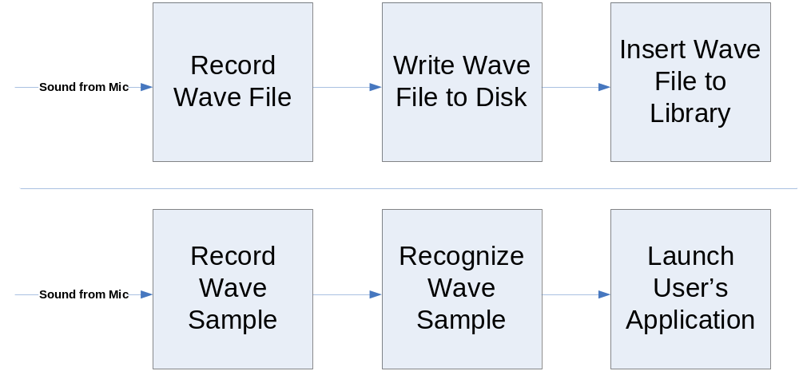
Figure 1 – Block Diagram of Modules

Specifications of the Project

Theory of speech recognition is used in this project to differentiate between vocabularies of ten to fifteen words. The user can then relate each word to an application that he or she would like to launch. As a result, the project must keep a collection of wave files which were recorded by the user. When users want to launch an application, they can initialize the project and say the program’s name that they want to launch. The word would then be recognized and the user’s application will be launched. This project will assume 80% accuracy and will be targeting ten to fifteen words because any more words would decrease the accuracy.
Below is the system requirements needed to execute this project successfully:
  - Microphone
  - Speakers (Not required but recommended)
  - 800 MHz Processor
  - 256 MB RAM
  - Keyboard
  - Java Virtual Machine
  - Enough disk space to save the wave files

The modules that do not have any computation will be implemented in Java. The use of Java will ease the process of recording and playing wave files. However, the recognition module will be implemented in C because a great amount of speed is needed for the speech recognition algorithm.

Test to Verify the Design

The recording module can be tested by first recoding a sound sample and then verifying the sample by playing it. If the recording module is successful, it can be used in conjunction with the writing wave file module to test that both work together properly. A third-party wave player can be used to verify that the wave file was properly written to disk. Inserting wave files to library can be simply tested because the library will be kept in a text file. One can view the text file to verify that it is correct. Recording a sample is similar to the first module and it can use the same method to verify its correctness.
The next module, speech recognition, is the most difficult module to test and verify. Assuming 80% accuracy, this module should be able to recognize between words such as “cat” and “dog.” However, this module is not expected to differentiate between words such as “stab” and “stub.” Below are some words that the project should be able to recognize:
- Email
- Internet
- Music
- Word Processor
- Address Book
- Show Desktop
- My Computer
The last module is tested independently by specifying which program to be launched. If the program specified is launched successfully then the last module is considered successful.
The final six modules are to be tested together. A word will be provided so that the recording module can capture it. Once captured, the wave file is saved to disk and the file is added to the library. The user specifies which application will be launched in relation with the new recorded wave file. This process should be repeated ten times. Once ten words have been added to the library, the same user initializes the recognition phase and hopefully it will be 80% accurate. If it is not 80% successful, the threshold will be changed and the whole process will be repeated until the requirements are met.

Module List

Table 1 summarizes how much money and time is needed to implement each module. The recoding module captures sound from the microphone. The writing and inserting modules are responsible for populating the library. The microphone also provides sound for the sampling module which calls the recognition module. Recognition module takes the majority amount of time and money to build; hence it is the most complicated module to implement.

Table 1 - Module List
Module Name | Called By | It Calls | Lines of Code | Hours to Code | $ to Code
Input from Microphone | - | Recording | - | - | -
1: Recording | Input | Writing | 1000 | 40.00 | $ 1,600.00
2: Writing | Module 1 | Inserting | 500 | 20.00 | $ 800.00
3: Inserting | Module 2 | - | 700 | 28.00 | $ 1,120.00
4: Sampling | Input | Distinguishing | 1000 | 40.00 | $ 1,600.00
5: Recognizing | Module 4 | Launching Application | 3000 | 120.00 | $ 4,800.00
6: Launching Application | Module 5 | - | 500 | 20.00 | $ 800.00
TOTALS |  |  | 6700 | 268.00 | $ 10,720.00

Gantt Chart

Appendix A includes a table that has been produced by Microsoft Project. The first table includes costs, hours worked, start and end times, duration and resource name for each task. In addition to the table, there is also a timeline that was generated by Microsoft Project. As shown in the table, from September 1st to May 4th, a total time of 581 hours and cost of $23,836 is needed to complete this project. The total time needed for fall is 188 hours and spring is 393 hours. The last table, which is also provided but Microsoft Project, shows the amount of time and associated costs per week for each person. System analyst, who is in charge of designing and outlining, has a total of 215 hours. Programmer has a total of 268 hours whereas test programmer has only 36 hours of work. Finally, Technical writer has a total of 67 hours of work which includes writing the manual and final presentation. It should be no surprise that the Programmer has the most amount of work because the implanting phase is the most difficult phase.

Labor Costs by Week

The prototype is estimated to cost $23,836 in a period of 36 weeks. First 18 weeks will focus more on designing and analyzing, whereas after 18 weeks programmers start building the prototype. During this period a large amount of the budget is used toward building the prototype. Table 2 illustrates labor costs by week in more detail.
Table 2 - Labor Costs by Week
Week # | ESTIMATED LABOR COSTS | ESTIMATED CUMM COSTS | ACTUAL COSTS | ACTUAL CUMM COSTS | PROJECTED LABOR COSTS | PROJECTED CUMM COSTS
0 | 0 | 0 | 0 | 0
1 | 135 | 135 | 135 | 135
2 | 700 | 835 | 500 | 635
3 | 700 | 1535 | 600 | 1235
4 | 1150 | 2685 |  |  | 1150 | 2685
5 | 300 | 2985 |  |  | 300 | 2985
6 | 700 | 3685 |  |  | 700 | 3685
7 | 300 | 3985 |  |  | 300 | 3985
8 | 400 | 4385 |  |  | 400 | 4385
9 | 200 | 4585 |  |  | 200 | 4585
10 | 200 | 4785 |  |  | 200 | 4785
11 | 200 | 4985 |  |  | 200 | 4985
12 | 400 | 5385 |  |  | 400 | 5385
13 | 700 | 6085 |  |  | 700 | 6085
14 | 700 | 6785 |  |  | 700 | 6785
15 | 200 | 6985 |  |  | 200 | 6985
16 | 100 | 7085 |  |  | 100 | 7085
17 | 700 | 7785 |  |  | 700 | 7785
18 | 500 | 8285 |  |  | 500 | 8285
19 | 1087 | 9372 |  |  | 1087 | 9372
20 | 1043 | 10415 |  |  | 1043 | 10415
21 | 700 | 11115 |  |  | 700 | 11115
22 | 700 | 11815 |  |  | 700 | 11815
23 | 1000 | 12815 |  |  | 1000 | 12815
24 | 750 | 13565 |  |  | 750 | 13565
25 | 955 | 14520 |  |  | 955 | 14520
26 | 1000 | 15520 |  |  | 1000 | 15520
27 | 1200 | 16720 |  |  | 1200 | 16720
28 | 805 | 17525 |  |  | 805 | 17525
29 | 400 | 17925 |  |  | 400 | 17925
30 | 950 | 18875 |  |  | 950 | 18875
31 | 955 | 19830 |  |  | 955 | 19830
32 | 900 | 20730 |  |  | 900 | 20730
33 | 1000 | 21730 |  |  | 1000 | 21730
34 | 826 | 22556 |  |  | 826 | 22556
35 | 895 | 23451 |  |  | 895 | 23451
36 | 385 | 23836 |  |  | 385 | 23836

Figure 2 displays a graph of the data given by Table 2. X-axis represents time and Y-axis represents cumulative cost.
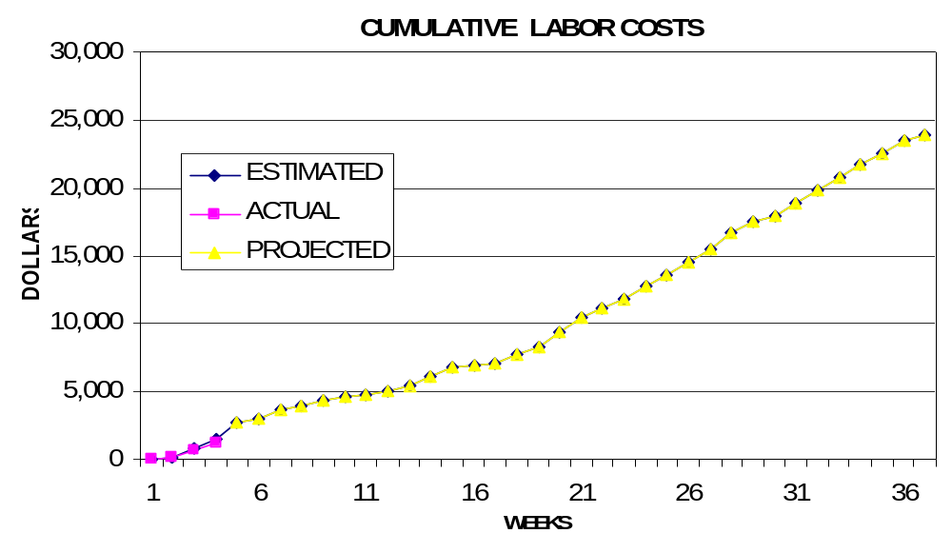
Figure 2 - Cumulative Labor Costs

Economic Analysis

Table 3 illustrates in detail how much the prototype costs. Initial estimated hours were produced by Microsoft Project and afterwards overhead, A&G costs and profit were cumulated. Total cost of prototype is $80,089.80.
Table 3 - Prototype Cost
 | Labor Rate | Initial Est. Hours | Initial Est. Cost
System Analyst | $45.00 | 215.25 | $9,686.25
Programmer | $40.00 | 268 | $10,720.00
Test Programmer | $35.00 | 31 | $1,085.00
Technical Writer | $35.00 | 67 | $2,345.00
TOTAL |  | 581.25 | $23,836.25
DIRECT OVERHEAD @ 100% |  |  | $23,836.25
SUBTOTAL |  |  | $47,672.50
A&G COSTS @ 40% |  |  | $19,069.00
SUBTOTAL |  |  | $66,741.50
PROFIT @ 20% |  |  | $13,348.30
TOTAL COST OF PROTOTYPE |  |  | $80,089.80

Distributing the product is a very important aspect. It costs money to copy CDs and package them. It is cheaper to use the internet to distribute the product. Therefore, Table 4 describes unit costs sold if corporation was to use retailer on the internet. This calculation assumes one million units will be sold. The first 20,000 units will recoup the amount of money that the prototype costs.
Table 4 - Unit Costs Sold
UNIT COSTS SOLD BY CORPORATION AS A RETAILER ON THE INTERNET
PROTOTYPE COSTS |  |  | $80,090
INSTALL MACHINE AND SOFTWARE |  |  | $50,000
SUBTOTAL |  |  | $130,090
OVERHEARD @ 200% |  |  | $260,180
SUBTOTAL |  |  | $390,269
DOCUMENTATION |  |  | $0
PACKAGING SUBTOTAL |  |  | $0
SUBTOTAL |  |  | $390,269
A&G @ 40% |  |  | $156,107.76
SUBTOTAL |  |  | $546,377
PROFIT @ 20% |  |  | $109,275.4
SUBTOTAL |  |  | $655,653
 |  | # of copies | Price/Copy | Total Profit
Total to Sell |  | 1,000,000
Recoup Prototype Costs |  | 20,000 | $18.60 | $109,275.4
Remainder to Sell |  | 980,000 | $18.60 | $18,228,000.00
 |  |  | Minus 40% for A&G | $7,291,200.00
Subtotal |  |  |  | $10,936,800.00
Total Profit |  |  |  | $11,046,075.43

Comparative Product Survey

Table 5 describes some of the products that are similar to this project. Amongst these products, Realize Voice Lite 4.0 has sold 253,432 units and cost $49. However, other products have not been as successful as Realize Voice Lite 4.0. For example, HAL 2.0 is only $20 but has only sold 1,144 units.

Table 5 - Product Survey
Product Name | Cost | Units Sold | Publisher | System Requirements
Voice Studio 1.4.2 | $49.97 | 41,914 | Ultimate Interactive Desktops | Windows 98/Me/NT/2000/XP
HAL 2.0 | $19.95 | 1,144 | David Henry Company | Windows 98/Me/2000/XP
HomeGallery 2.5 | $25.00 | 4,596 | GRR Systems, Inc. | Windows 98/Me/NT/2000/XP, sound card, microphone
Voice Tools 7.0 | $300.00 | 51,157 | Wizzard Software | Not Provided
Realize Voice Lite 4.0 | $49.00 | 253,432 | Realize Software | Windows 98SE/ME/NT/2000/XP, a noise-canceling microphone

Status Matrices

The following seven tables display the progress which has been completed on each module. Table 6 displays the amount of time each module has been planned and outlined to date. Launching application module is the simplest module and as a result it takes the least amount of time to design. Table 7 displays the amount of time needed to construct each module. Hours spent to date for this table and many other tables are none since building period has not begun. Table 8 shows the amount of time needed to design each module. Table 9 and Table 10 illustrate the amount of time needed to test each module separately and all modules together. As expected, amount of time to test the recognition module is the greatest. Table 10 displays the amount of time to document the entire project including this article. Finally, Table 12 totals all matrices and class time together.
Table 6 - Outlined Matrix
OUTLINED
MODULE NAME | INIT. EST. HRS. | CUR. EST. HRS. | HRS SPENT TO DATE | % COMPT. | EST. HRS TO COMP.
RECORDING | 5 | 5 | 0.5 | 10.0% | 4.5
SAVING TO FILE | 5 | 5 | 0.4 | 8.0% | 4.6
INSERTING TO LIBRARY | 5 | 5 | 0.2 | 4.0% | 4.8
SAMPLING | 3 | 3 | 0.5 | 16.7% | 2.5
RECOGNIZING | 10 | 10 | 0.5 | 5.0% | 9.5
LAUNCHING APPLICATION | 2 | 2 | 0.5 | 25.0% | 1.5
TOTALS | 30 | 30 | 2.6 | 8.7% | 27.4

Table 7 - Constructed Matrix
CONSTRUCTED
MODULE NAME | INIT. EST. HRS. | CUR. EST. HRS. | HRS SPENT TO DATE | % COMPT. | EST. HRS TO COMP.
RECORDING | 40 | 40 | 0 | 0.0% | 40
SAVING TO FILE | 20 | 20 | 0 | 0.0% | 20
INSERTING TO LIBRARY | 28 | 28 | 0 | 0.0% | 28
SAMPLING | 40 | 40 | 0 | 0.0% | 40
RECOGNIZING | 120 | 120 | 0 | 0.0% | 120
LAUNCHING APPLICATION | 20 | 20 | 0 | 0.0% | 20
TOTALS | 268 | 268 | 0 | 0.0% | 268

Table 8 - Designed Matrix
DESIGNED
MODULE NAME | INIT. EST. HRS. | CUR. EST. HRS. | HRS SPENT TO DATE | % COMPT. | EST. HRS TO COMP.
RECORDING | 6 | 6 | 1 | 16.7% | 5
SAVING TO FILE | 7 | 7 | 0 | 0.0% | 7
INSERTING TO LIBRARY | 6 | 6 | 0 | 0.0% | 6
SAMPLING | 4 | 4 | 0 | 0.0% | 4
RECOGNIZING | 12 | 12 | 1 | 8.3% | 11
LAUNCHING APPLICATION | 3 | 3 | 0 | 0.0% | 3
TOTALS | 38 | 38 | 2 | 5.3% | 36

Table 9 - Tested Matrix
TESTED
MODULE NAME | INIT. EST. HRS. | CUR. EST. HRS. | HRS SPENT TO DATE | % COMPT. | EST. HRS TO COMP.
RECORDING | 6 | 6 | 0 | 0.0% | 6
SAVING TO FILE | 4 | 4 | 0 | 0.0% | 4
INSERTING TO LIBRARY | 4 | 4 | 0 | 0.0% | 4
SAMPLING | 4 | 4 | 0 | 0.0% | 4
RECOGNIZING | 10 | 10 | 0 | 0.0% | 10
LAUNCHING APPLICATION | 3 | 3 | 0 | 0.0% | 3
TOTALS | 31 | 31 | 0 | 0.0% | 31

Table 10 - Integrated Matrix
INTEGRATED
MODULE NAME | INIT. EST. HRS. | CUR. EST. HRS. | HRS SPENT TO DATE | % COMPT. | EST. HRS TO COMP.
RECORDING | 4 | 4 | 0 | 0.0% | 4
SAVING TO FILE | 4 | 4 | 0 | 0.0% | 4
INSERTING TO LIBRARY | 3 | 3 | 0 | 0.0% | 3
SAMPLING | 1 | 1 | 0 | 0.0% | 1
RECOGNIZING | 6 | 6 | 0 | 0.0% | 6
LAUNCHING APPLICATION | 2 | 2 | 0 | 0.0% | 2
TOTALS | 20 | 20 | 0 | 0.0% | 20

Table 11 - Documented Matrix
DOCUMENTED
MODULE NAME | INIT. EST. HRS. | CUR. EST. HRS. | HRS SPENT TO DATE | % COMPT. | EST. HRS TO COMP.
RECORDING | 15 | 15 | 5 | 33.3% | 10
SAVING TO FILE | 13 | 13 | 3 | 23.1% | 10
INSERTING TO LIBRARY | 15 | 15 | 4 | 26.7% | 11
SAMPLING | 15 | 15 | 3 | 20.0% | 12
RECOGNIZING | 25 | 25 | 9 | 36.0% | 16
LAUNCHING APPLICATION | 15 | 15 | 3 | 20.0% | 12
TOTALS | 98 | 98 | 27 | 27.6% | 71

Table 12 - Total Matrix
TOTAL
MODULE NAME | INIT. EST. HRS. | CUR. EST. HRS. | HRS SPENT TO DATE | % COMPT. | EST. HRS TO COMP.
RECORDING | 76 | 76 | 6.5 | 8.6% | 69.5
SAVING TO FILE | 53 | 53 | 3.4 | 6.4% | 49.6
INSERTING TO LIBRARY | 61 | 61 | 4.2 | 6.9% | 56.8
SAMPLING | 67 | 67 | 3.5 | 5.2% | 63.5
RECOGNIZING | 183 | 183 | 10.5 | 5.7% | 172.5
LAUNCHING APPLICATION | 45 | 45 | 3.5 | 7.8% | 41.5
CLASS TIME | 75 | 75 | 3 | 4.0% | 72
TOTALS | 560 | 560 | 34.6 | 6.2% | 525.4

Conclusion

These previous chapters demonstrated how the speech recognition project will be designed and outlined. It provides a detail explanation of module and how long it will take to code each module. Furthermore, the amount of money that each module will cost was calculated and showed how much profit can be obtained if one-million units were sold. Last, progress of each module has been discussed using tables and matrices. It is hoped that this documentation was helpful and all aspects of this project are clear.

References

- http://www.davidhenryco.com/
- http://www.grrsystems.com/
- http://www.realizesoftware.com/
- http://www.voicestudio.us/
- http://www.wizzardsoftware.com/

Appendix A – Gantt Chart

