## **Team 21 – A6 Recipe Website**

|  |  |  |
| --- | --- | --- |
| **Completed Tasks** | **Assigned Tasks** | **Team Member** |
| Everything | User page, design and work on the server, programmer case file, readme, deployment, db diagram | Amir - System Engineer |
| Everything | Shopping list page, Use case | Dana |
| Everything | Main recipes page, User Manual, system architecture | Lital |
| Everything | Sharing page, work on the server, Requirements, | Michael |

**Functional Requirements:**

* The system should allow searching for a recipe by name.
* The system should enable sharing the recipe with everyone.
* The system stores the nutritional value of the recipe from the products.
* The system allows for creating a shopping list.
* The system also allows for preparing a meal from existing recipes.
* The system allows user registration.
* The system includes user login.
* The system remembers the user's favorite recipes.
* The system stores the recipes that the user has shared.
* The system will allow the user to edit their profile picture, user description, and preferred theme set.

**Non-Functional Requirements:**

**Reliability**:

* Search: The system must allow users to search for recipes by name efficiently with a response time of up to 4 seconds.
* Content Sharing: A success or failure message upon sharing recipes. For sharing recipes, the system must support the following fields: Recipe name, URL of an image, Description, Difficulty level, Category, Author`s username, Preparation instructions, Required ingredients.

**Security**:

* Users must be able to register using full name, email, username, and password. The system needs to verify the email for authenticity and ensure strong password criteria (at least 8 characters, including a number and a special character) to enhance security.
* Authentication: User authentication should be performed using username and password. Steps should be implemented to protect against brute force attacks, such as account lockout after several failed attempts or password storage using HASH.

**Scalability**:

* + The system needs to be scalable to support a growing number of users and recipes, with the ability to handle at least 10,000 concurrent users and a growing recipe database without performance degradation.

**Accessibility**:

* + The site should be designed with a user-friendly interface, intuitive navigation, and accessible to users with varying levels of technical skills. This includes features like rating recipes, user comments, and the ability to save and catalog favorite recipes.
  + Fields should allow rich text where relevant (e.g., description, preparation instructions) to enable better design and user experience.
  + The site should offer a choice between dark and light theme modes, respecting the user's system preferences by default.

**Architecture:**

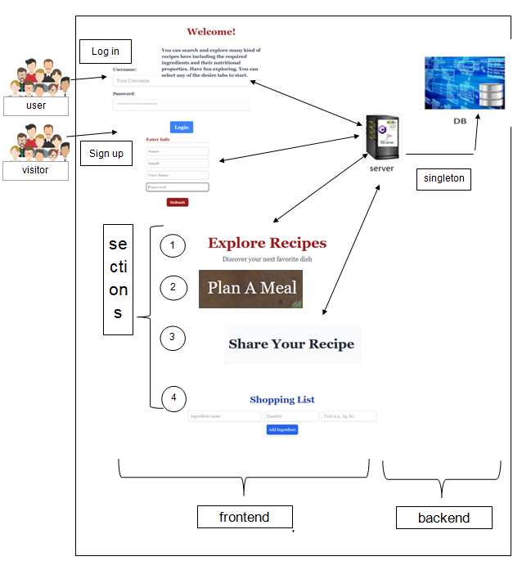

**DB-Diagram:**

The database consists of 3 tables: Users, Recipes, and Meals. This database is hosted on MongoDB and is updated in real-time during the use of the website. Additionally, there is the use of another API called Spoonacular, which is essentially a library of products and their nutritional values, including various units of measurement and a very wide range of products.

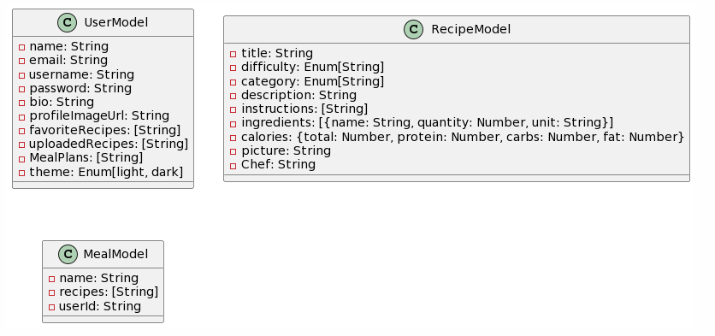

**Use case:**

