**Project 4**

# Rating Migrations

Financial Engineering AY 2024-2025

Credit portfolio VaR (Schonbucher par. 10.4) is very sensitive to the average correlation between standardized asset returns $ρ$, which is an unobservable parameter for which calibration on historical data has been in the last twenty years a problem not completely solved. For a review of results see [2].

Gupton et al. [1] published an elaboration based on quarterly joint rating migrations of two corporate issuers reported by S&P across a time series of 40 quarters, with a sample composed by firms with initial rating A and BBB (table 8.2, page 84). Count of joint migrations is translated into probabilities of joint credit movements (table 8.3, page 84) across a three month period. The two tables are in the annex spreadsheet RatingMigrations_data.xlsx.

1. Let’s assume that the standardized asset returns of firms rated A or BBB is described by the single-factor Vasicek model with constant correlation $ρ$. Based on the probabilities of joint credit movements above, students shall calibrate $ρ$. Discuss the calibration results varying the loss function and the starting point of the minimization algorithm.
2. Extend the elementary single-factor Markov Chain model for the calculation of the Credit Portfolio VaR, by introducing seven rating classes (i.e. AAA, AA, A, BBB, BB, B, CCC) prior to default according to the following 1-year rating transition matrix:

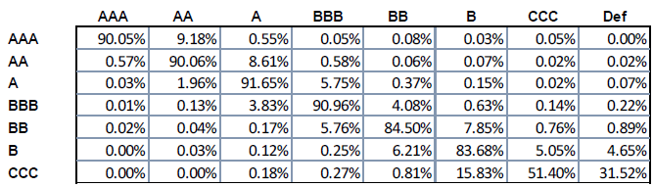

Consider the spot risk-free zero-coupon rate on the 31st of January 2023 and recovery rate $π= 40\%$ for all issuers.

Thanks to the improved MC simulation, students shall calculate the 99.9% VaR with one year time horizon given the portfolio composed by 100 exposures as follows:

* 50 zero-coupon bonds with 2y original maturity, which pay the Face Value FV = 1$ at maturity issued by different A-rated issuers;
* 50 zero-coupon bonds with 2y original maturity, which pay the Face Value FV = 1$ at maturity issued by different BBB-rated issuers.

Students shall execute the VaR calculation under the two assumptions:

1. The correlationused to simulate the Vasicek model should be derived from the constant correlation calibrated at the point 1 above;
2. The correlationused to simulate the Vasicek model should be derived from the rating class of the i-th issuer (i.e. from the one year PD associated to each rating class - see the transition matrix above) thanks to the asset correlation function presented on page 13 of [3] with size adjustment calculated in the case of annual sales S = €50m.

Students shall discuss the results of the points 2.a and 2.b above, taking also into account the evidence provided by Frye (see [2]).

Room: Soldati

Realize a library in Matlab and Python.

References:

[1] Gupton, G. M., Finger C. C. and Bhatia, M. *CreditMetrics - Technical Document* J.P. Morgan, New York 1997.

[2] Frye, Jon. "Correlation and asset correlation in the structural portfolio model." *The Journal of Credit Risk* 4.2 (2008): 75-96.

[3] Basel Committee on Banking Supervision, *An Explanatory Note on the Basel II IRB Risk Weight functions*, July 2005.

Delivery address: financial.engineering.polimi@gmail.com