Software Requirements Specification (SRS)

For: Web Up Platform

Version: 1.0

Prepared by:
Adjaoud Ilias Zoheir, Nemdil Amira, Aguenarous Abdelghani, Arab Lydia Marya, Tertag Noureddine

Date: January 12, 2025

Table of Contents
- Introduction
  - Purpose
  - Document Conventions
  - Intended Audience and Reading Suggestions
  - Product Scope
  - References
- Overall Description
  - Product Perspective
  - Product Functions
  - User Classes and Characteristics
  - Operating Environment
  - Design and Implementation Constraints
  - User Documentation
  - Assumptions and Dependencies
- System Features
  - Multivendor B2B2B SaaS Platform
  - Agency and Sub Accounts Management
  - Website & Funnel Builder
  - Role-based Access Control
  - Stripe Subscription and Add-on Products
  - Customizable Dashboards
  - Media Storage for Users
  - AI-Powered Face ID and Recognition
- External Interface Requirements
  - User Interfaces
  - Hardware Interfaces
  - Software Interfaces
  - Communications Interfaces
- Other Nonfunctional Requirements
  - Performance Requirements
  - Safety Requirements
  - Security Requirements
  - Software Quality Attributes
  - Business Rules
- Other Requirements
- Appendix A: Glossary
- Appendix B: Analysis Models
- Appendix C: To Be Determined List

1. Introduction

1.1 Purpose
The purpose of this SRS document is to provide a detailed description of the Web Up Project, a SaaS platform designed to simplify the process of building and managing websites and sales funnels. This document outlines the system's functionalities, constraints, and requirements to ensure all stakeholders have a clear understanding of the project.

1.2 Document Conventions

- Use of "shall" indicates a mandatory requirement.
- Use of "should" indicates a recommended but not mandatory requirement.
- Use of "may" indicates an option

1.3 Intended Audience and Reading Suggestions
This document is intended for:
- Project managers
- Developers
- Testers
- End users
- Stakeholders

1.4 Product Scope
The Web Up Project aims to provide a comprehensive platform for building and managing websites and sales funnels, supporting multivendor B2B2B operations, role-based access control, and Stripe integrations for payments.

1.5 References
- Next.js documentation
- Prisma documentation
- Stripe API documentation
- Bun Documentation

2. Overall Description

2.1 Product Perspective
The Web Up Project is a web-based SaaS platform that integrates with various third-party services like Stripe for payments and provides tools for website and sales funnel creation.

2.2 Product Functions
- Multivendor B2B2B SaaS Platform
- Agency and Sub Accounts Management
- Website & Funnel Builder
- Role-based Access Control
- Stripe Subscription and Add-on Products
- Stripe Connect for User Payments
- Customizable Dashboards
- Media Storage for Users
- Lead Generation from Funnels
- Project Management System (Kanban Board)
- Funnel Performance Metrics
- Light & Dark Mode
- Graph and Chart Integrations
- Functioning Landing Page

2.3 User Classes and Characteristics
- Administrators: Manage the entire platform, including user accounts and settings.
- Agencies: Create and manage sub-accounts for clients.
- End Users: Use the platform to build and manage their websites and sales funnels.

2.4 Operating Environment
- Web browsers (Chrome, Firefox, Safari, Edge)
- Internet connection

2.5 Design and Implementation Constraints
- Must comply with GDPR and other relevant data protection regulations.
- Must provide secure authentication and authorization mechanisms.
- Technology Stack: Must use Next.js 14, Prisma, and Stripe.

2.6 User Documentation
- User manual
- Online help and tutorials

2.7 Assumptions and Dependencies
- The system relies on third-party services like Stripe for payment processing.
- The system assumes users have basic knowledge of web browsing and form filling.

3. System Features

3.1 Multivendor B2B2B SaaS Platform
The platform shall support multivendor operations, allowing users to manage multiple vendors within a single platform.

3.2 Agency and Sub Accounts Management
The platform shall allow agencies to create and manage sub-accounts for clients or teams, segmenting responsibilities and billing.

3.3 Website & Funnel Builder
The platform shall provide tools for building and managing websites and sales funnels directly on the platform.

3.4 Role-based Access Control
The platform shall ensure users access only the features and data they are authorized for, enhancing security and data segregation.

3.5 Stripe Subscription and Add-on Products
The platform integrates with Stripe to manage subscriptions and add-on products seamlessly.

3.6 Customizable Dashboards
The platform shall allow users to customize dashboards to view relevant data and metrics.

3.7 Media Storage for Users
The platform shall provide media storage for users to store and manage images, documents, and other media files.

3.8 AI-Powered Face ID and Recognition

Feature Description
The AI-Powered Face ID and Recognition feature is an optional sign-in mechanism that utilizes facial recognition technology to facilitate the sign-in process and enhance security. This feature serves as an additional authentication factor, ensuring that only authorized users can access the platform.

Functional Requirements
- The system shall provide an option for users to enable or disable AI-Powered Face ID and Recognition for their accounts.
- The system shall capture and store facial data securely for registered users who opt to use this feature.
- The system shall perform real-time face recognition during the sign-in process to verify the user's identity.
- The system shall notify users if the face recognition attempt fails and prompt them to use an alternative sign-in method.
- The system shall comply with all relevant data protection and privacy regulations concerning the storage and processing of biometric data.

Non-Functional Requirements
- The face recognition process shall complete within 2 seconds under normal network conditions.
- The system shall ensure a false acceptance rate (FAR) of less than 0.01% and a false rejection rate (FRR) of less than 1%.
- The system shall encrypt all stored facial data using industry-standard encryption techniques.
- The system shall provide a user-friendly interface for managing face recognition settings.
Assumptions and Dependencies
- Users have devices equipped with a camera that meets the minimum resolution requirements for facial recognition.
- The platform relies on third-party AI and machine learning services to perform face recognition.

Security Requirements
- The system shall use secure communication channels (HTTPS) for transmitting facial data.
- The system shall implement measures to prevent unauthorized access to facial data.
- The system shall regularly update the facial recognition algorithms to address new security threats.

4. External Interface Requirements

4.1 User Interfaces
- The platform shall provide an intuitive and user-friendly interface for all user classes.
- The platform shall support both light and dark modes.

4.2 Hardware Interfaces
- The platform shall be accessible via standard computer hardware with internet connectivity.

4.3 Software Interfaces
- The platform shall use HTTPS for secure communication over the internet.

5. Other Nonfunctional Requirements

5.1 Performance Requirements
- The platform shall handle up to 10,000 concurrent users without performance degradation.

5.2 Safety Requirements
- The platform shall ensure data integrity and prevent data loss.

5.3 Security Requirements
- The platform shall use secure authentication mechanisms, including optional AI-powered Face ID and recognition.
- The platform shall comply with GDPR and other relevant data protection regulations.

5.4 Software Quality Attributes
- The platform shall be reliable, maintainable, and scalable.
- The platform shall provide a responsive user interface.

5.5 Business Rules
- The platform shall charge application fees on sales through Stripe.

6. Other Requirements

- The platform shall support multilingual capabilities.

7. Appendices A: Glossary

- SaaS: Software as a Service
- GDPR: General Data Protection Regulation
- B2B2B: Business to Business to Business
- API: Application Programming Interface

8. Appendices B: Analysis Models

- Use case diagrams
Use Case Diagram:
Actors:
- Administrator: Manages the entire platform, including user accounts and settings.
- Agency: Creates and manages sub-accounts for clients.
- End User: Uses the platform to build and manage their websites and sales funnels.
Use Cases:
- Manage Platform: Administrator manages the platform.
- Create Sub-Accounts: Agency creates and manages sub-accounts.
- Build Website/Funnel: End User builds and manages websites and sales funnels.
- Enable Face ID: Users enable AI-Powered Face ID and Recognition.
- Sign In: Users sign in using Face ID or other methods.
- Manage Subscriptions: Users manage Stripe subscriptions and add-on products.
- Customize Dashboard: Users customize their dashboards.
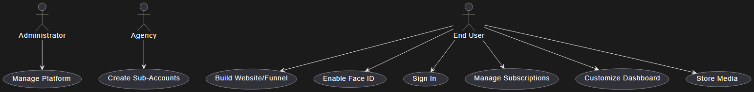
- Store Media: Users store and manage media files.
- Data flow diagrams
Data Flow Diagram
Processes:
- User Management: Handles user accounts and authentication.
- Website/Funnel Builder: Manages the creation and editing of websites and sales funnels.
- Payment Processing: Manages Stripe subscriptions and payments.
- Media Storage: Handles the storage and retrieval of media files.
- Face ID Recognition: Manages the AI-powered face recognition process.
Data Stores:
- User Data: Stores user account information.
- Website/Funnel Data: Stores data related to websites and sales funnels.
- Payment Data: Stores payment and subscription information.
- Media Data: Stores media files.
- Face ID Data: Stores facial recognition data.
External Entities:
- User: Interacts with the system.
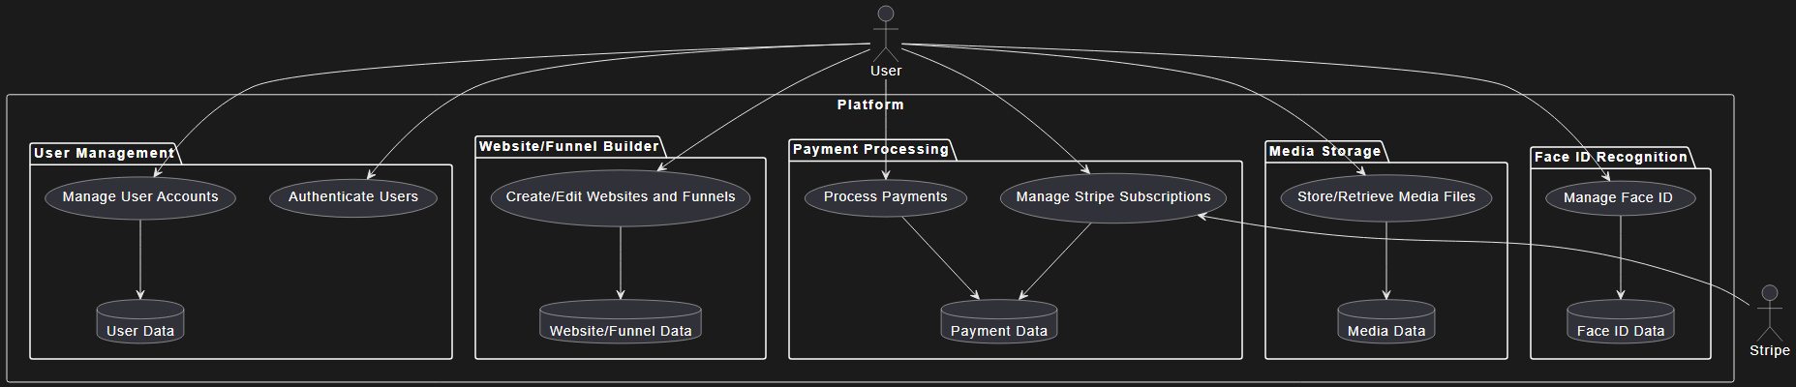
- Stripe: External payment processing service.

9.Appendices B: To Be Determined List

- Exact performance benchmarks
- Detailed data protection measures

