Moderated Learning Management System
Phase 3: System Design (Software Design Document)
Architecture, class design, behavioural models and database design
October 2026
Contents
1 Architecture 3
1.1 Architectural style and rationale 3
1.2 Component diagram 3
1.3 Alternatives considered and rejected 4
1.4 Cross-cutting decisions 4
2 Class Design 5
2.1 Domain model 5
2.2 Services, Strategy and Observer 7
2.3 Factory, password hashing and repositories 8
2.4 Design patterns used and why 9
2.5 SOLID principles 9
2.6 The late-penalty rule in the design 9
3 Behavioural Models 10
3.1 Submission life cycle (state machine) 10
3.2 End-to-end process (activity diagram with swimlanes) 11
3.3 Sequence diagrams 12
4 Database Design 14
4.1 Entity-relationship diagram 14
4.2 Normalisation to third normal form 14
4.3 Data dictionary 15
4.4 SQL schema 17
4.5 Mapping of classes to tables, and differences 19
5 Requirements Coverage 19
This document is the Phase 3 deliverable for the Moderated Learning Management System (LMS). It turns the Phase 2 requirements (FR-01 to FR-23, NFR-01 to NFR-12, business rules BR-1 to BR-10 and use cases UC01 to UC21) into an architecture, a class design with design patterns, behavioural models and a normalised database. Requirement IDs are quoted throughout so that the later traceability matrix can link each requirement to its design elements.

1 Architecture

1.1 Architectural style and rationale
The LMS uses a layered architecture with four layers and a small infrastructure layer, packaged as one C++17 program. Dependencies point downward only: the console UI calls application services; services work on domain objects and call repository interfaces; SQLite classes implement those interfaces. No layer reaches past its neighbour, and no SQL exists outside the data access layer.
Layer | Contents | Main responsibility
Presentation | Console UI: one menu and set of views per role | Read input, validate its format, call a service, display results in plain language
Application | AuthService, AdminService, AssignmentService, SubmissionService, MarkingService, ModerationService | Use-case logic, role checks (FR-18), transactions, business rules BR-1 to BR-10
Domain | User hierarchy, Assignment, Extension, Submission, Mark, AuditEntry; ILatePenaltyPolicy; mark change events | Business objects and rules that do not depend on storage or screen
Data access | Repository interfaces and their SQLite implementations | All persistence, using parameterised queries only (NFR-05)
Infrastructure | SQLite database file, local folder for submitted files, libsodium password hasher | Technical services behind interfaces
Why this style fits the requirements.
- Offline, one computer (NFR-03). A single process with an embedded database needs no network and no server.
- Testability (NFR-11). Services and the domain depend only on interfaces, so tests can replace SQLite with in-memory fakes and replace the clock with a fixed time. This is how the 70% coverage of the business logic and the deadline boundary tests will be reached.
- Security (NFR-04, NFR-05). Password hashing and SQL each live in exactly one place, which makes them easy to inspect.
- Change (Phase 8). Change request CR1 (class-wide extensions) touches AssignmentService and one repository, not the console or the domain rules.

1.2 Component diagram
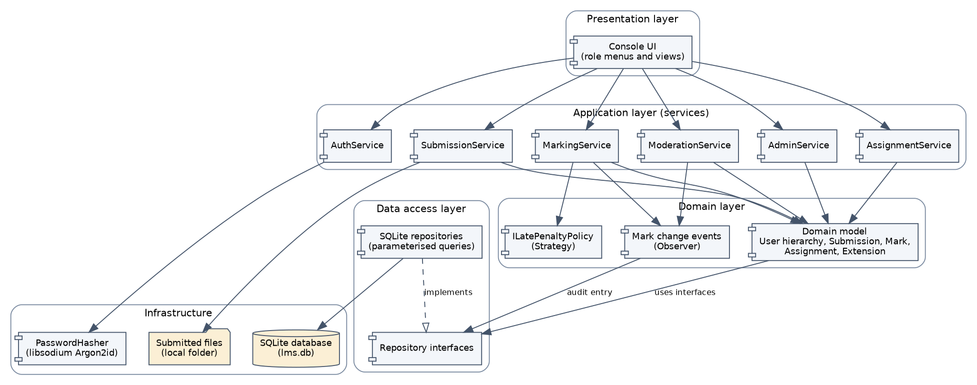
Figure 1: Component diagram of the Moderated LMS (layers and dependencies)
Component | Provides | Requires
Console UI | Role menus and views | The six application services
Application services | One operation per use case, for example submit(), mark(), release() | Domain model, repository interfaces, ILatePenaltyPolicy, mark change publisher, password hasher
Domain model | Entities, role permissions, penalty rule, mark change events | Nothing outside the domain
Repository interfaces | find, add, save operations per aggregate | The domain model
SQLite repositories | Implementations of those interfaces | SQLite database file
PasswordHasher | hash, verify using Argon2id | libsodium
FileStore | Copy a submitted file into the application folder | Local file system

1.3 Alternatives considered and rejected
Alternative | Why it was rejected
Model-View-Controller | MVC separates input handling from screens, which suits event-driven GUIs. This is a menu-driven console program with no events to route, so a controller layer would only forward calls. It also says nothing about where persistence or business rules belong. A layered design gives both.
Client-server with a database server | Would allow many simultaneous users but needs a network and an administered server. The IT officer requires offline operation on old computers, and the case study says a single computer or local network.
Single program with SQL in the menus | Simplest to write but business rules would be repeated in screens, tests would need a real database, and SQL injection checks would have to cover the whole code base.

1.4 Cross-cutting decisions
Concern | Decision
Errors (NFR-06) | One exception hierarchy: LmsError with ValidationError, AccessDeniedError, RuleViolation (business rules), NotFoundError and DatabaseError. The UI catches LmsError at the menu loop, shows a message and continues.
Transactions | An RAII Transaction object wraps every operation that changes more than one row (for example batch release): commit on success, rollback when an exception leaves the scope.
Security | Role checks in every service method through User::allows(Action) (BR-9); passwords hashed with Argon2id through libsodium (NFR-04); account lockout after 5 failures in AuthService (FR-21); prepared statements only (NFR-05).
Time | A Clock interface supplies “now”, so tests can place a submission exactly at, 1 second after, or 72 hours after a deadline.
Concurrency (NFR-10) | SQLite busy timeout of 5 seconds and BEGIN IMMEDIATE for writes, so simultaneous sessions wait instead of corrupting data.
Files | Submitted files are copied into an application folder under a generated name; the database stores only the path, size and original name.

2 Class Design

2.1 Domain model
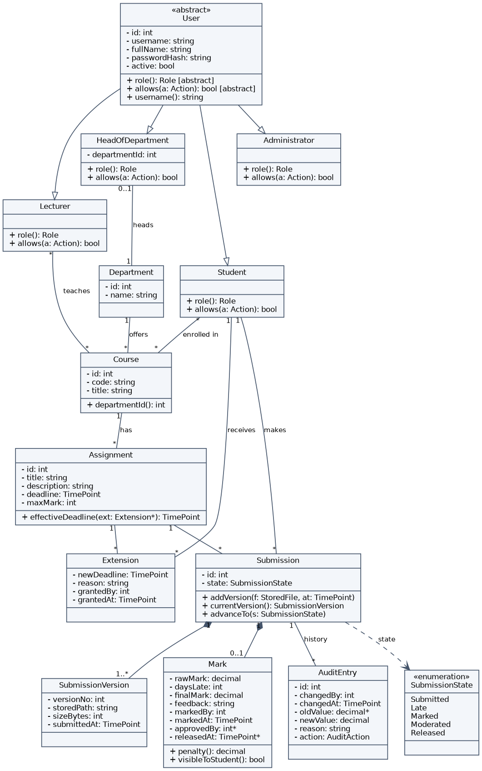
Figure 2: Domain class diagram (visibility, types, multiplicities, inheritance)
Notes on the diagram. User is abstract, with the polymorphic operations role() and allows(Action); the four subclasses give each role its permissions without any if (role == ...) code in the services. A Submission owns its versions (composition, one or more) and at most one Mark. Optional values are shown with * (for example approvedBy: int*). effectiveDeadline() implements BR-1: the extension deadline if the student has one, else the assignment deadline.
Action | Student | Lecturer | HoD | Administrator
Manage accounts, departments, courses, enrolments (FR-02 to FR-04) | no | no | no | yes
Create assignment, grant extension (FR-05, FR-10) | no | own courses | no | no
View courses and assignments (FR-06) | enrolled courses | own courses | own department | all
Submit work (FR-07 to FR-09) | yes | no | no | no
Mark submission (FR-12) | no | own courses, after deadline | no | no
Review, adjust, approve, release marks (FR-14 to FR-16, FR-19) | no | no | own department | no
View released mark and feedback (FR-17) | own, when Released | no | no | no
View audit log (FR-20), back up database (FR-22) | no | no | audit log, own department | yes

2.2 Services, Strategy and Observer
Figure 3 shows the services that carry out the use cases, with the Strategy pattern (the late-penalty policy) and the Observer pattern (mark change events and the audit observer). Each service receives its collaborators as interface references through its constructor. AssignmentService is left out of the figures for space; it follows the same structure (see section 5).
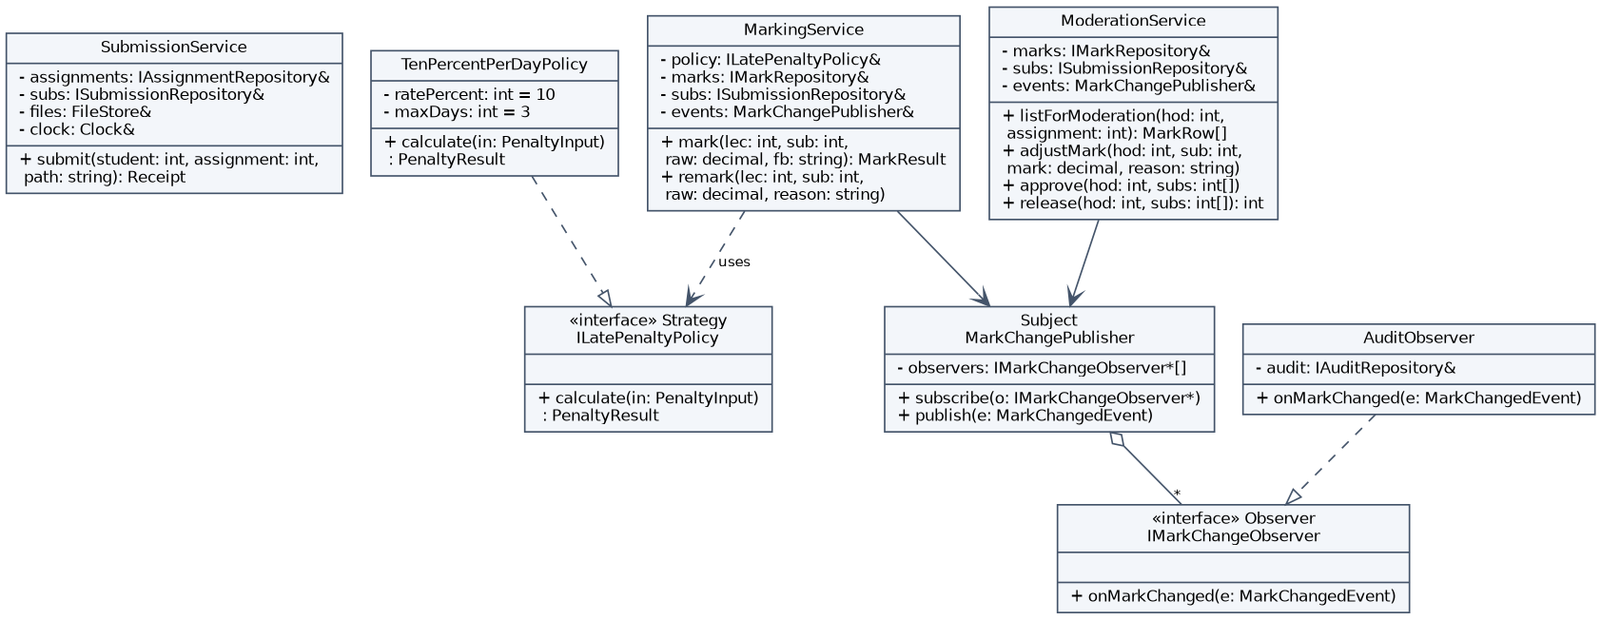
Figure 3: Application services with the Strategy and Observer patterns

2.3 Factory, password hashing and repositories
Figure 4 shows the Factory pattern (UserFactory), the password hasher behind an interface, and the Repository pattern. Only ISubmissionRepository and its SQLite class are drawn in full; the other repositories follow the same form.
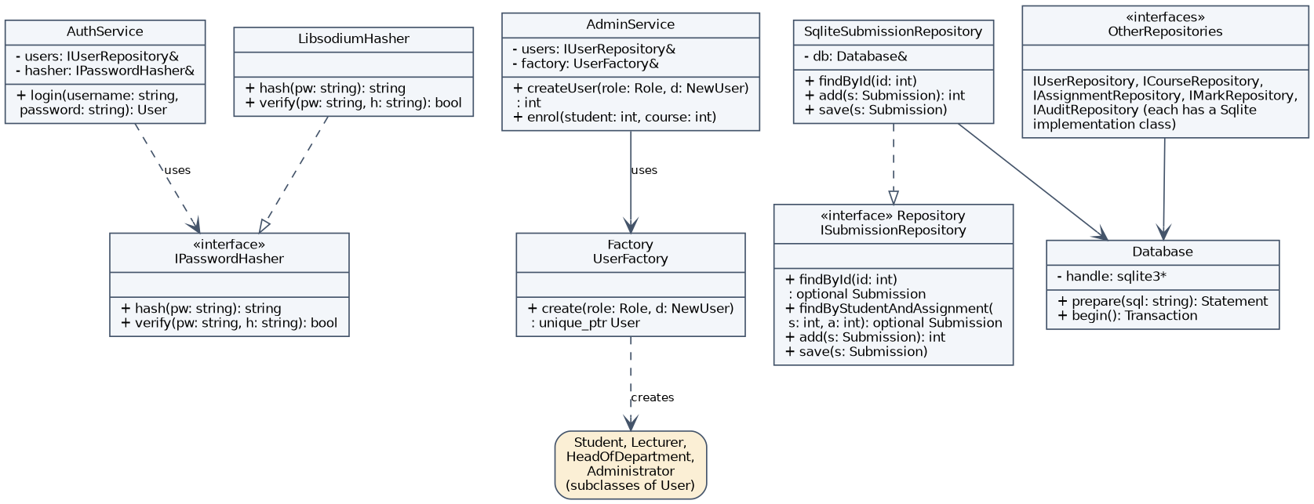
Figure 4: Factory, password hashing and Repository patterns

2.4 Design patterns used and why
Pattern | Where | Why it was chosen | Alternative rejected
Strategy | ILatePenaltyPolicy with TenPercentPerDayPolicy; used by MarkingService | The HoD’s rule (10% per started day, zero after three) is the most likely rule to change. Swapping the policy needs no change to marking code. Tests can use a fixed policy. | An if block inside mark(): rule changes would edit the marking logic.
Repository | ISubmissionRepository, IMarkRepository, and the others, each with a SQLite class | Keeps SQL in one layer, lets services be tested with fakes, and lets the database change without touching services. | Services calling SQLite directly: untestable and spreads SQL.
Factory | UserFactory::create(role, data) | The repository rebuilds the right subclass from a stored role, and AdminService creates new accounts, without either one knowing the four constructors. | A switch repeated in several places.
Observer | MarkChangePublisher with AuditObserver | Every mark change (FR-13) must be audited, whichever service makes it. Services publish an event and the observer writes the audit entry, so no service can forget it. More observers (for example notifications later) need no service change. | Each service calling the audit repository: easy to omit in a new code path.

2.5 SOLID principles
Principle | How the design follows it
Single responsibility | Each service handles one group of use cases; the hasher only hashes; repositories only store; the policy only calculates penalties.
Open-closed | New late-penalty rules, new observers and new user roles are added as new classes. MarkingService, the publisher and AuthService are unchanged.
Liskov substitution | Every User subclass can be used where a User is expected, because they all honour the allows() contract. Any ILatePenaltyPolicy returns a valid PenaltyResult for any valid input.
Interface segregation | Small, focused repository interfaces per aggregate instead of one large data interface; a service sees only what it needs.
Dependency inversion | Services receive interfaces (repositories, policy, hasher, clock) through their constructors; only the program’s main creates the concrete SQLite and libsodium classes.

2.6 The late-penalty rule in the design
ILatePenaltyPolicy::calculate(PenaltyInput) receives the maximum mark, the raw mark, the effective deadline and the submission time, and returns days late, penalty and final mark. TenPercentPerDayPolicy applies BR-2 to BR-4: days late = 0 if the submission time is not after the deadline, else the number of started 24-hour periods; 1 to 3 days subtract 10% of the maximum mark per day; more than 3 days gives 0; the result is never below 0 and is rounded half up to 2 decimal places. Worked boundary cases for a maximum of 20 and a raw mark of 16 (these become the Phase 5 boundary tests):
Submission time | Days late | Penalty | Final mark
Exactly at the deadline | 0 | 0 | 16
1 second late | 1 | 2 | 14
Exactly 24 hours late | 1 | 2 | 14
24 hours and 1 second late | 2 | 4 | 12
Exactly 72 hours late | 3 | 6 | 10
72 hours and 1 second late | 4 | n/a | 0

3 Behavioural Models

3.1 Submission life cycle (state machine)
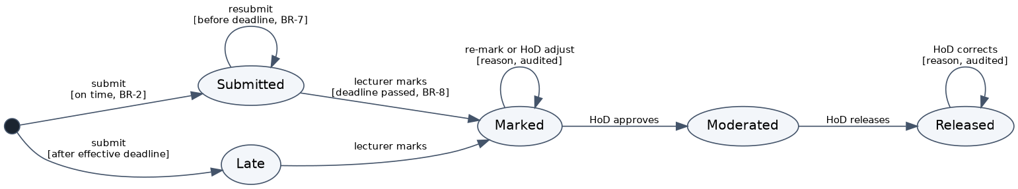
Figure 5: State machine diagram of the Submission life cycle
Transition | Trigger and guard | Who | Rule
start to Submitted | Submit file on or before the effective deadline | Student | BR-2
start to Late | Submit file after the effective deadline | Student | BR-2, FR-09
Submitted to Submitted | Resubmit before the effective deadline; new version added | Student | BR-6, BR-7
Submitted or Late to Marked | Mark entered; effective deadline has passed | Lecturer | BR-8, FR-12
Marked to Marked | Lecturer re-marks, or HoD adjusts, with a reason; audit entry written | Lecturer or HoD | BR-10, FR-13
Marked to Moderated | Approve | HoD | FR-15
Moderated to Released | Release | HoD | FR-16
Released to Released | Correction with a reason; audit entry written | HoD | FR-19
A Late submission has no transition back to Submitted, which is how BR-7 (“a late submission cannot be resubmitted”) is enforced.

3.2 End-to-end process (activity diagram with swimlanes)
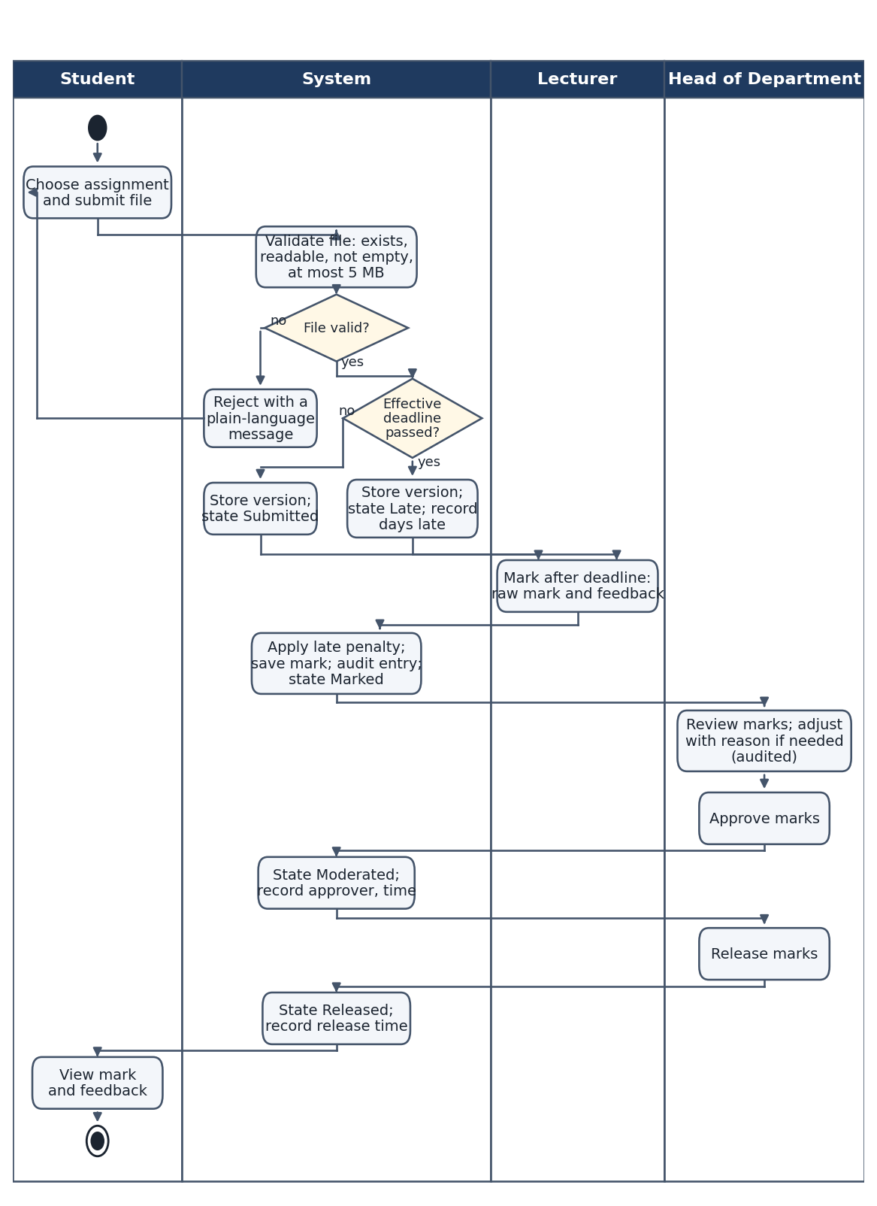
Figure 6: Activity diagram from submission to released mark

3.3 Sequence diagrams
Submit assignment. The diagram shows four paths in one combined fragment: on-time first submission, resubmission before the deadline, late first submission, and a refused attempt. The same service method handles all four, choosing the path from the effective deadline and the existing submission.
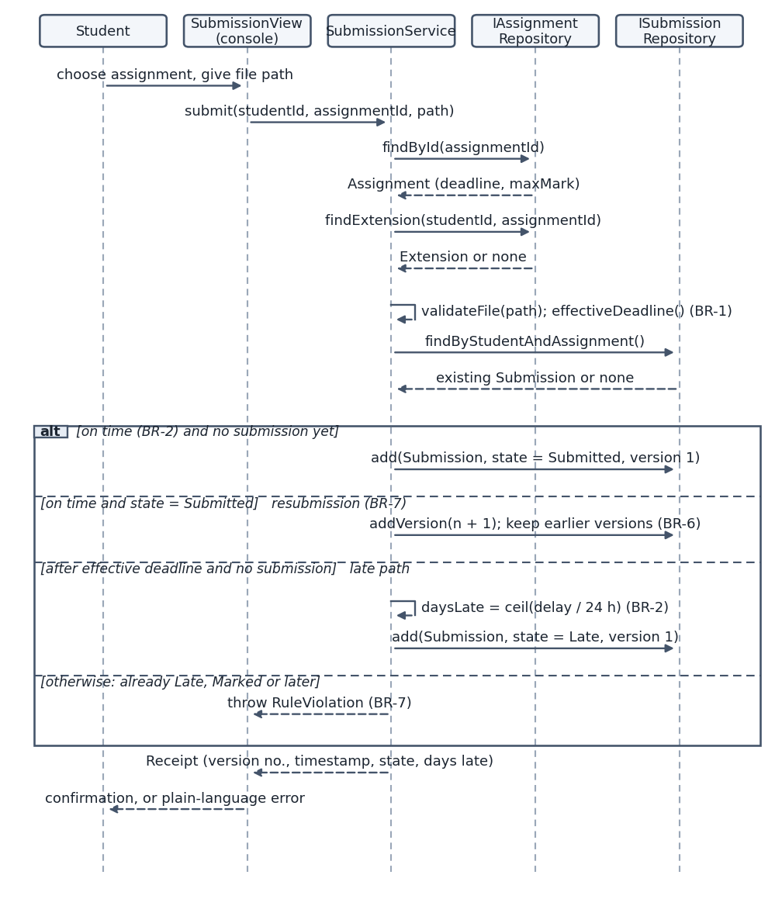
Figure 7: Sequence diagram for “Submit assignment” (on-time, resubmission and late paths)
Moderate and release marks. The optional fragment shows an adjustment; the approve and release steps are each one transaction, so a batch is never half-applied.
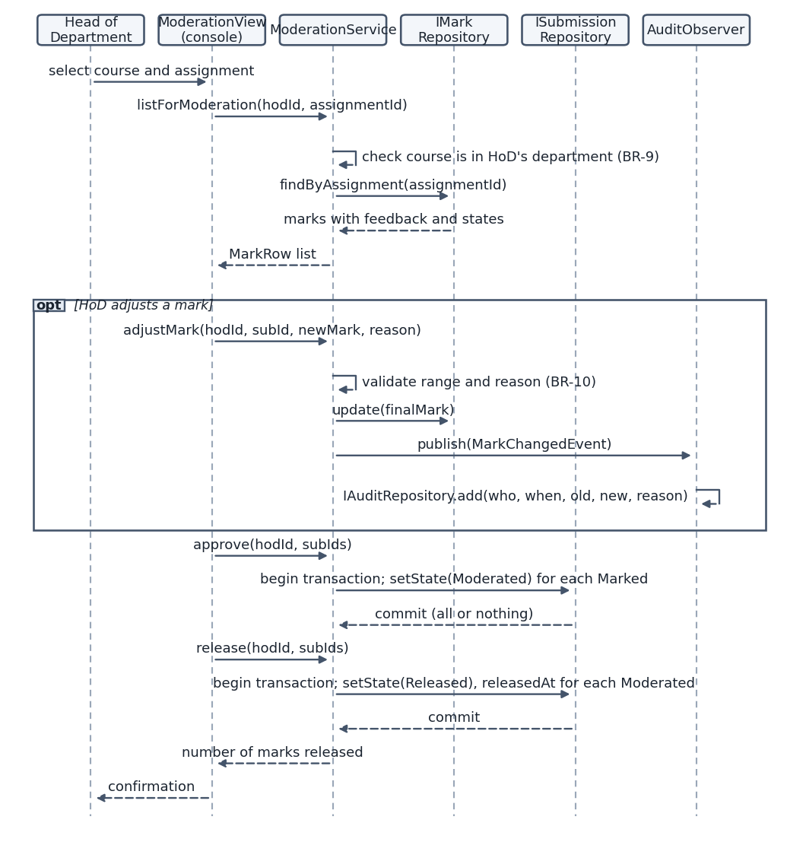
Figure 8: Sequence diagram for “Moderate and release marks”

4 Database Design

4.1 Entity-relationship diagram
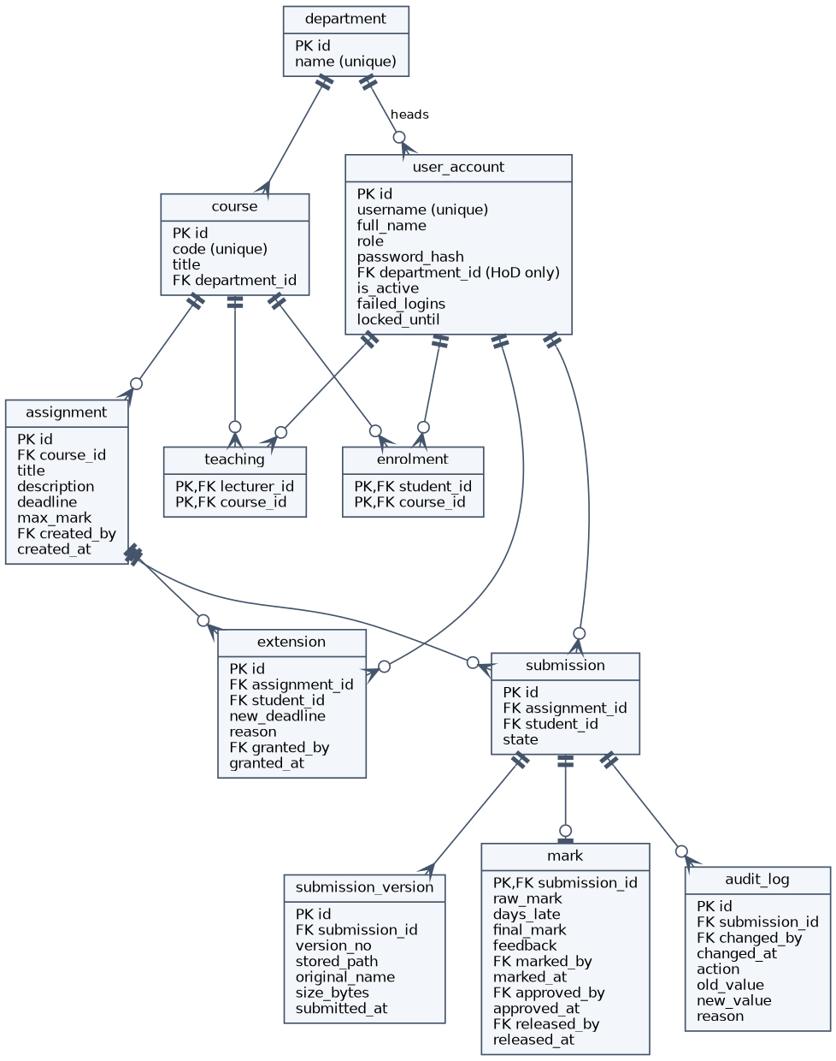
Figure 9: Entity-relationship diagram (crow’s foot notation; PK primary key, FK foreign key)

4.2 Normalisation to third normal form
- First normal form. Every column holds one value. A submission can have several versions, so they are in their own table submission_version instead of repeating columns. Many-to-many links (students to courses, lecturers to courses) are in the association tables enrolment and teaching.
- Second normal form. Tables with composite keys (enrolment, teaching) contain only the key columns, so no column depends on part of a key. Other tables have single-column keys.
- Third normal form. No non-key column depends on another non-key column. The department name is stored once in department, not repeated in course or user_account. A course’s lecturers and a student’s courses are not stored in course or user_account.
- Derived data. The current version of a submission is the highest version_no, so it is not stored. The penalty is raw_mark - final_mark, so it is not stored. mark does store days_late and final_mark because they record the result of the rule at marking time and must not change if the penalty rule changes later. Their value depends on assignment.max_mark and the submission time, which are in other tables, so no dependency exists between non-key columns inside mark, and the table remains in third normal form.

4.3 Data dictionary
Table | Column | Type | Constraints | Description
department | id | INTEGER | PK | Department identifier
 | name | TEXT | NOT NULL, UNIQUE | Department name
user_account | id | INTEGER | PK | Account identifier
 | username | TEXT | NOT NULL, UNIQUE, NOCASE | Login name
 | full_name | TEXT | NOT NULL | Display name
 | role | TEXT | NOT NULL, one of STUDENT, LECTURER, HOD, ADMIN | The account’s single role (BR-9)
 | password_hash | TEXT | NOT NULL | Argon2id hash with embedded salt
 | department_id | INTEGER | FK department; required exactly when role is HOD | Department headed by a HoD
 | is_active | INTEGER | NOT NULL, 0 or 1 | Deactivated accounts cannot log in
 | failed_logins | INTEGER | NOT NULL, at least 0 | Consecutive failed logins (FR-21)
 | locked_until | TEXT | nullable | Lock expiry, ISO 8601 UTC
course | id | INTEGER | PK | Course identifier
 | code | TEXT | NOT NULL, UNIQUE | Course code
 | title | TEXT | NOT NULL | Course title
 | department_id | INTEGER | NOT NULL, FK department | Owning department
enrolment | student_id | INTEGER | PK, FK user_account | Enrolled student
 | course_id | INTEGER | PK, FK course | Course
teaching | lecturer_id | INTEGER | PK, FK user_account | Assigned lecturer
 | course_id | INTEGER | PK, FK course | Course
assignment | id | INTEGER | PK | Assignment identifier
 | course_id | INTEGER | NOT NULL, FK course | Course
 | title | TEXT | NOT NULL | Title
 | description | TEXT | NOT NULL | Instructions
 | deadline | TEXT | NOT NULL | Deadline, ISO 8601 UTC
 | max_mark | INTEGER | NOT NULL, 1 to 1000 | Maximum mark (FR-05)
 | created_by | INTEGER | NOT NULL, FK user_account | Lecturer who created it
 | created_at | TEXT | NOT NULL | Creation time
extension | id | INTEGER | PK | Extension identifier
 | assignment_id | INTEGER | NOT NULL, FK assignment | Assignment
 | student_id | INTEGER | NOT NULL, FK user_account | Student receiving it
 | new_deadline | TEXT | NOT NULL | Extended deadline (BR-1)
 | reason | TEXT | NOT NULL, at least 5 characters | Reason (BR-10)
 | granted_by | INTEGER | NOT NULL, FK user_account | Lecturer
 | granted_at | TEXT | NOT NULL | Time granted
submission | id | INTEGER | PK | Submission identifier
 | assignment_id | INTEGER | NOT NULL, FK assignment | Assignment
 | student_id | INTEGER | NOT NULL, FK user_account | Submitting student
 | state | TEXT | NOT NULL, one of SUBMITTED, LATE, MARKED, MODERATED, RELEASED | Life cycle state (BR-5)
submission_version | id | INTEGER | PK | Version identifier
 | submission_id | INTEGER | NOT NULL, FK submission | Parent submission
 | version_no | INTEGER | NOT NULL, at least 1 | Version counter (BR-6)
 | stored_path | TEXT | NOT NULL | File location in application folder
 | original_name | TEXT | NOT NULL | Name the student used
 | size_bytes | INTEGER | NOT NULL, 1 to 5,242,880 | File size (FR-07)
 | submitted_at | TEXT | NOT NULL | Submission time
mark | submission_id | INTEGER | PK, FK submission | One mark per submission
 | raw_mark | REAL | NOT NULL, at least 0 | Lecturer’s mark
 | days_late | INTEGER | NOT NULL, at least 0 | Result of BR-2 at marking time
 | final_mark | REAL | NOT NULL, at least 0 | Mark after penalty or HoD adjustment
 | feedback | TEXT | NOT NULL, not blank | Written feedback (FR-12)
 | marked_by, marked_at | INTEGER, TEXT | NOT NULL, FK user_account | Lecturer and time
 | approved_by, approved_at | INTEGER, TEXT | both set or both null | HoD approval (FR-15)
 | released_by, released_at | INTEGER, TEXT | both set or both null; requires approval | HoD release (FR-16)
audit_log | id | INTEGER | PK, autoincrement | Entry identifier
 | submission_id | INTEGER | NOT NULL, FK submission | Submission whose mark changed
 | changed_by | INTEGER | NOT NULL, FK user_account | Who (FR-13)
 | changed_at | TEXT | NOT NULL | When
 | action | TEXT | NOT NULL, one of INITIAL_MARK, REMARK, MODERATION_ADJUST, RELEASED_CORRECTION | Kind of change
 | old_value | REAL | nullable | Previous final mark, null for the first mark
 | new_value | REAL | NOT NULL | New final mark
 | reason | TEXT | NOT NULL, at least 5 characters | Why (BR-10)

4.4 SQL schema
PRAGMA foreign_keys = ON;
CREATE TABLE department (
id INTEGER PRIMARY KEY,
name TEXT NOT NULL UNIQUE
);
CREATE TABLE user_account (
id INTEGER PRIMARY KEY,
username TEXT NOT NULL UNIQUE COLLATE NOCASE,
full_name TEXT NOT NULL,
role TEXT NOT NULL CHECK (role IN ('STUDENT','LECTURER','HOD','ADMIN')),
password_hash TEXT NOT NULL,
department_id INTEGER REFERENCES department(id),
is_active INTEGER NOT NULL DEFAULT 1 CHECK (is_active IN (0,1)),
failed_logins INTEGER NOT NULL DEFAULT 0 CHECK (failed_logins >= 0),
locked_until TEXT,
CHECK ((role = 'HOD') = (department_id IS NOT NULL))
);
CREATE UNIQUE INDEX ux_hod_department ON user_account(department_id) WHERE role = 'HOD';
CREATE TABLE course (
id INTEGER PRIMARY KEY,
code TEXT NOT NULL UNIQUE,
title TEXT NOT NULL,
department_id INTEGER NOT NULL REFERENCES department(id)
);
CREATE TABLE enrolment (
student_id INTEGER NOT NULL REFERENCES user_account(id),
course_id INTEGER NOT NULL REFERENCES course(id),
PRIMARY KEY (student_id, course_id)
);
CREATE TABLE teaching (
lecturer_id INTEGER NOT NULL REFERENCES user_account(id),
course_id INTEGER NOT NULL REFERENCES course(id),
PRIMARY KEY (lecturer_id, course_id)
);
CREATE TABLE assignment (
id INTEGER PRIMARY KEY,
course_id INTEGER NOT NULL REFERENCES course(id),
title TEXT NOT NULL,
description TEXT NOT NULL,
deadline TEXT NOT NULL,
max_mark INTEGER NOT NULL CHECK (max_mark BETWEEN 1 AND 1000),
created_by INTEGER NOT NULL REFERENCES user_account(id),
created_at TEXT NOT NULL
);
CREATE TABLE extension (
id INTEGER PRIMARY KEY,
assignment_id INTEGER NOT NULL REFERENCES assignment(id),
student_id INTEGER NOT NULL REFERENCES user_account(id),
new_deadline TEXT NOT NULL,
reason TEXT NOT NULL CHECK (length(reason) >= 5),
granted_by INTEGER NOT NULL REFERENCES user_account(id),
granted_at TEXT NOT NULL,
UNIQUE (assignment_id, student_id)
);
CREATE TABLE submission (
id INTEGER PRIMARY KEY,
assignment_id INTEGER NOT NULL REFERENCES assignment(id),
student_id INTEGER NOT NULL REFERENCES user_account(id),
state TEXT NOT NULL
CHECK (state IN ('SUBMITTED','LATE','MARKED','MODERATED','RELEASED')),
UNIQUE (assignment_id, student_id)
);
CREATE TABLE submission_version (
id INTEGER PRIMARY KEY,
submission_id INTEGER NOT NULL REFERENCES submission(id) ON DELETE CASCADE,
version_no INTEGER NOT NULL CHECK (version_no >= 1),
stored_path TEXT NOT NULL,
original_name TEXT NOT NULL,
size_bytes INTEGER NOT NULL CHECK (size_bytes BETWEEN 1 AND 5242880),
submitted_at TEXT NOT NULL,
UNIQUE (submission_id, version_no)
);
CREATE TABLE mark (
submission_id INTEGER PRIMARY KEY REFERENCES submission(id),
raw_mark REAL NOT NULL CHECK (raw_mark >= 0),
days_late INTEGER NOT NULL CHECK (days_late >= 0),
final_mark REAL NOT NULL CHECK (final_mark >= 0),
feedback TEXT NOT NULL CHECK (length(trim(feedback)) > 0),
marked_by INTEGER NOT NULL REFERENCES user_account(id),
marked_at TEXT NOT NULL,
approved_by INTEGER REFERENCES user_account(id),
approved_at TEXT,
released_by INTEGER REFERENCES user_account(id),
released_at TEXT,
CHECK ((approved_by IS NULL) = (approved_at IS NULL)),
CHECK ((released_by IS NULL) = (released_at IS NULL)),
CHECK (released_at IS NULL OR approved_at IS NOT NULL)
);
CREATE TABLE audit_log (
id INTEGER PRIMARY KEY AUTOINCREMENT,
submission_id INTEGER NOT NULL REFERENCES submission(id),
changed_by INTEGER NOT NULL REFERENCES user_account(id),
changed_at TEXT NOT NULL,
action TEXT NOT NULL CHECK (action IN
('INITIAL_MARK','REMARK','MODERATION_ADJUST','RELEASED_CORRECTION')),
old_value REAL,
new_value REAL NOT NULL,
reason TEXT NOT NULL CHECK (length(reason) >= 5)
);
CREATE TRIGGER audit_no_update BEFORE UPDATE ON audit_log
BEGIN SELECT RAISE(ABORT, 'audit log is append-only'); END;
CREATE TRIGGER audit_no_delete BEFORE DELETE ON audit_log
BEGIN SELECT RAISE(ABORT, 'audit log is append-only'); END;
CREATE INDEX ix_enrolment_course ON enrolment(course_id);
CREATE INDEX ix_teaching_course ON teaching(course_id);
CREATE INDEX ix_assignment_course ON assignment(course_id);
CREATE INDEX ix_submission_assign ON submission(assignment_id);
CREATE INDEX ix_submission_student ON submission(student_id);
CREATE INDEX ix_audit_submission ON audit_log(submission_id);
Rules that a CHECK constraint cannot express across tables, such as “the student is enrolled in the assignment’s course” and “a final mark does not exceed the assignment’s maximum”, are enforced in the services and covered by tests. The append-only triggers support NFR-07, and the indexes support the 1 second target of NFR-02 and the 2 second login of NFR-01 (the unique index on username).

4.5 Mapping of classes to tables, and differences
Class | Table | Difference and justification
User, Student, Lecturer, HeadOfDepartment, Administrator | user_account | One table with a role column instead of four tables: the roles share almost every attribute, and a single username lookup is needed for login. department_id is used only by a HoD, enforced by a CHECK. The repository calls UserFactory to rebuild the right subclass.
Department | department | None.
Course | course | None.
Student-Course and Lecturer-Course associations | enrolment, teaching | Many-to-many associations become tables with composite keys. The classes do not hold the lists; services ask the repository.
Assignment | assignment | created_by and created_at are added for accountability; they are not needed by the domain rules.
Extension | extension | UNIQUE (assignment_id, student_id) allows one extension per student and assignment.
Submission | submission | The versions are in submission_version; currentVersion() is the highest version_no. The enumeration SubmissionState is stored as text and protected by a CHECK.
SubmissionVersion | submission_version | Stores a path and size, not the file. The file is in the application folder.
Mark | mark | The primary key is submission_id (one mark per submission). penalty() is not stored: it is raw_mark - final_mark. Approval and release are columns because they belong to the same one-to-one record.
AuditEntry | audit_log | Attribute action is stored as a CHECK-limited text. Triggers make the table append-only.
ILatePenaltyPolicy and implementations, services, repositories, UserFactory, MarkChangePublisher, AuditObserver, PasswordHasher | none | Behaviour, not data. The penalty constants (10%, 3 days) live in TenPercentPerDayPolicy.
Naming and type differences throughout: class attributes use camelCase and SQL columns use snake_case; TimePoint is stored as ISO 8601 UTC text; decimal marks are stored as REAL and rounded half up in the code.

5 Requirements Coverage
Requirements | Design elements
FR-01, FR-18, FR-21; NFR-04 | AuthService, User::allows(), LibsodiumHasher, user_account
FR-02 to FR-04 | AdminService, UserFactory, department, course, enrolment, teaching
FR-05, FR-06, FR-10 | AssignmentService, Assignment, Extension, assignment, extension
FR-07 to FR-09 | SubmissionService, Submission, SubmissionVersion, FileStore, submission, submission_version; Figures 5 and 7
FR-11, FR-12, FR-13 | MarkingService, ILatePenaltyPolicy, Mark, AuditObserver, mark, audit_log
FR-14 to FR-17, FR-19, FR-20 | ModerationService, Mark, mark, audit_log; Figure 8
FR-22 | AdminService (backup through the SQLite backup interface), Database
NFR-01, NFR-02 | Indexes (4.4), repository design
NFR-03 | One-process layered design (1.1)
NFR-05 | Repository layer with parameterised statements only
NFR-06 | Exception hierarchy and menu-loop handler (1.4)
NFR-07 | AuditObserver and append-only triggers
NFR-10 | Busy timeout and BEGIN IMMEDIATE (1.4)
NFR-11 | Interfaces and Clock for testing (1.1, 1.4)
AssignmentService is not drawn in Figures 3 and 4 to keep them legible. It follows the same structure as SubmissionService: it receives IAssignmentRepository and ICourseRepository through its constructor and provides createAssignment, grantExtension and listSubmissions.

