



Faculty of Engineering, Cairo University
Department of Electronics and Electrical Communications

DisplayPort Link Layer

Verification Plan) Version 5 .0.0)

Authors:
Amira Atef Ismaeil El Komy
Aya Abduallah Eldesokey Mohamed
Mohamed Ayman Farouk Sayed

Supervised by:
Dr. Kareem Osama - Dr. Abdelrahman Abutaleb - Eng. Nour Eldeen Elhout

Contents
Revision Documents 3
AUX Services Overview 4
High-Level Block Diagram: 4
Interface Signal Description: 5
Features in SST Mode (8b/10b Encoding Only) 9
Necessary Features: 9
Optional Features: 9
Table of Attributes / Configuration (How to Change Them, Effects, and What Can Be Changed): 10
Limitations: 11
Table of Test Cases/Scenarios (Basic, More Complex, Advanced - Including Negative Testing) 12
Basic Tests: 12
More Complex Tests: 29
Advanced / Negative Testing: 29
Verification Environment: 30

Revision Documents
Revision | Who worked on it | Updates
1.0.0 | Aya, Amira, M.Ayman | SST mode: Optional and necessary features, Attributes, Limitations, Test cases, and Verification Architecture
2.0.0 | Aya, Amira, M.Ayman | Q1. I/p& O/P signals with the DUT?  Q2. Link Training Clarification?  Q3. Does the source adjust the lane count and rates and when?
3.0.0 |  | Set the plan for DP Source device only  choose the essential features only
4.0.0 | Aya, Amira, M. Ayman | - Added more to the necessary and optional features  - Set clearer test cases for the Link Training Sequence, Link Rates, Lane Count and ordering.  - Included tests for the HPD and AUX.  - Updated Verification Plan to verify the Source only.
5.0.0 | Aya, Amira, M. Ayman | - Updated the Verification Architecture.  - Added the AUX Services high-level block diagram.  - Added the AUX Services interface signal description.  - Added full details for the AUX flow.  - Updated Optional features, limitations and attributes.  - Updated Link Training.

AUX Services Overview

High-Level Block Diagram:

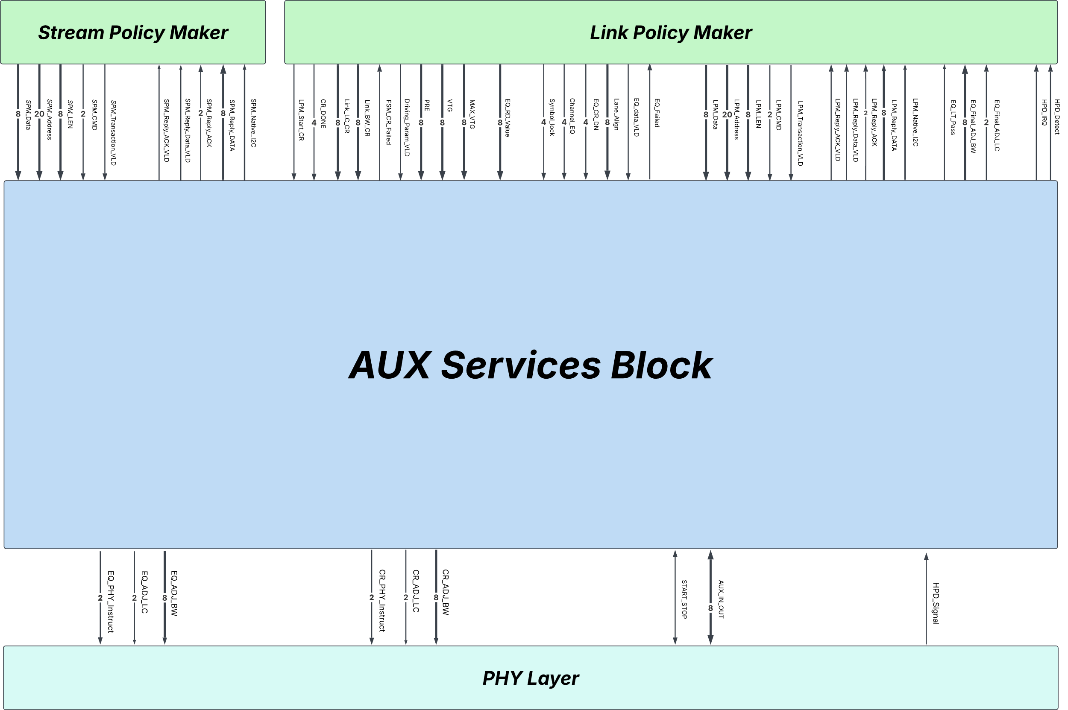

Interface Signal Description:
Signals | Interface | Type | Width (Bits) | Description
SPM_Reply_Data | Stream Policy Maker | Output | 8 | I2C-over-AUX Reply Transaction (Data Part) for I2C-over-AUX Request Read Transaction, using I2C Transaction Method 1 (transfer 1 byte per transaction)
SPM_Reply_ACK | Stream Policy Maker | Output | 2 | This signal represents the status of the reply transaction whether ACK, NACK or DEFER.
SPM_Reply_ACK_VLD | Stream Policy Maker | Output | 1 | A valid signal indicating that the status of the reply transaction is ready.
SPM_Reply_Data_VLD | Stream Policy Maker | Output | 1 | A valid signal indicating that the data is ready (set to one when receiving data from an I2C-over-AUX reply transaction).
SPM_Native_I2C | Stream Policy Maker | Output | 1 | Signal representing the most significant bit in the command field to determine the type of transaction whether I2C or Native
SPM_Data | Stream Policy Maker | Input | 8 | Data written by Stream Policy Maker when initiating a write transaction (byte-by-byte)
SPM_Address | Stream Policy Maker | Input | 20 | Address sent by Stream Policy Maker to indicate register to be written to or read from when initiating a transaction
SPM_LEN | Stream Policy Maker | Input | 8 | Length of data, in bytes, send by Stream Policy Maker to be written or read for request transaction
SPM_CMD | Stream Policy Maker | Input | 2 | The command field sent to specify the transaction type (Read or Write).
SPM_Transaction_VLD | Stream Policy Maker | Input | 1 | A valid signal activated by the Stream Policy Maker during a request transaction.
HPD_Detect | Link Policy Maker | Output | 1 | The signal is activated when the HPD (Hot Plug Detection) signal remains asserted for a period exceeding 2ms, which indicates that a sink device has been successfully connected.
HPD_IRQ | Link Policy Maker | Output | 1 | The signal is active when the HPD (Hot Plug Detection) signal is set to low for a duration of 0.5ms to 1ms before returning to high, indicating an interrupt request from the sink.
LPM_Reply_Data | Link Policy Maker | Output | 8 | Native Reply Transaction (Data Part) for a Native Request Read Transaction.
LPM_Reply_Data_VLD | Link Policy Maker | Output | 1 | A valid signal indicating that the data is ready (set to one when receiving data from a Native reply transaction).
LPM_Reply_ACK | Link Policy Maker | Output | 2 | Native Reply Transaction (Command Part) for a Native Request Transaction.
LPM_Reply_ACK_VLD | Link Policy Maker | Output | 1 | A valid signal indicating that the acknowledge data is ready (set to one when receiving reply acknowledge data from a Native reply transaction).
LPM_Native_I2C | Link Policy Maker | Output | 1 | Signal representing the most significant bit in the command field to determine the type of transaction whether I2C or Native
FSM_CR_Failed | Link Policy Maker | Output | 1 | A Signal indicating the failure of the Clock Recovery phase during link training, meaning the sink failed to acquire the clock frequency during the training process
EQ_Failed | Link Policy Maker | Output | 1 | Signal indicating the failure of the Channel Equalization phase during link training.
EQ_LT_Pass | Link Policy Maker | Output | 1 | This signal represents a successful channel equalization phase which indicates successful link training process
EQ_Final_ADJ_BW | Link Policy Maker | Output | 8 | The adjusted link BW after successful link training used for sending main video stream.
EQ_Final_ADJ_LC | Link Policy Maker | Output | 2 | The adjusted number of lanes after successful link training, used for sending main video stream.
LPM_Start_CR | Link Policy Maker | Input | 1 | After reading the DBCD capability register of the sink, the Link Policy Maker starts link training by asserting this signal, which marks the beginning of the Clock Recovery phase.
CR_Done | Link Policy Maker | Input | 4 | Four bits indicating whether clock recovery has been completed for the four lanes (with the least significant bit representing Lane 0). These bits are read from registers 00202h and 00203h in the DBCD registers of the sink device.
Link_LC_CR | Link Policy Maker | Input | 8 | The maximum number of lanes that the sink can support, based on its capability, which are specified in the sink DPCD capability registers.
Link_BW_CR | Link Policy Maker | Input | 8 | Maximum Bandwidth that the sink can support, based on its capability, which are specified in the sink DPCD capability registers.
PRE | Link Policy Maker | Input | 8 | The minimum pre-emphasis level, which is either retrieved from the sink DPCD capability registers at the beginning of the link training process or adjusted during the link training
VTG | Link Policy Maker | Input | 8 | The minimum voltage swing level, which is either retrieved from the sink DPCD capability registers at the beginning of the link training process or adjusted during the link training
Driving_Param_VLD | Link Policy Maker | Input | 1 | Flag signal asserted by link policy maker indicating the arrival of voltage swing and pre-emphasis data.
EQ_RD_Value | Link Policy Maker | Input | 8 | The time the source waits during the link training process before checking the status update registers, which are read from the Capability Register (0000Eh).
EQ_CR_DN | Link Policy Maker | Input | 4 | Clock recovery done bits that read from register 202h-203h and sent to link layer via link policy maker through this signal, if all ones indicating the successful clock recovery from different lanes
Channel_EQ | Link Policy Maker | Input | 4 | Channel Equalization bits read from register 202h-203h and sent to link layer via Link Policy Maker through this signal, if all ones indicating the successful channel equalization of different lanes
Symbol_Lock | Link Policy Maker | Input | 4 | Same concept as the both signals EQ_CR_DN and Channel_EQ
Lane_Align | Link Policy Maker | Input | 8 | The result of the Equalization phase during link training for the four lanes, found in the Status Update registers (00204h), indicating whether Lane Align achieved.
EQ_Data_VLD | Link Policy Maker | Input | 1 | Valid signal indicating the arrival of these data from link policy maker
MAX_VTG | Link Policy Maker | Input | 8 | Maximum voltage swing supported by the sink capability
LPM_Data | Link Policy Maker | Input | 8 | Data written by Link Policy Maker when initiating a write transaction
LPM_Address | Link Policy Maker | Input | 20 | Address sent by Link Policy Maker to indicate register to be written to or read from when initiating a transaction
LPM_LEN | Link Policy Maker | Input | 8 | Length of data, in bytes, send by Link Policy Maker to be written or read for request transaction
LPM_CMD | Link Policy Maker | Input | 2 | The command field sent to specify the transaction type (I2C-over-AUX or Native) and operation (Read or Write).
LPM_Transaction_VLD | Link Policy Maker | Input | 1 | A valid signal activated by the Stream Policy Maker during a request transaction.
AUX_IN_OUT | PHY Layer | Inout | 8 | A request/reply transaction where each byte is transmitted or received during every individual clock cycle, ensuring that the data transfer occurs sequentially, one byte at a time, ensuring a continuous, byte-by-byte data exchange.
START_STOP | PHY Layer | Inout | 1 | A single bit indicating the beginning and end of a transaction. It is set to one during the transmission or reception of the transaction and set to zero when no transaction is occurring.
CR_PHY_Instruct | PHY Layer | Output | 2 | A signal sent by CR FSM block which instructs the physical layer to begin sending a specific link training pattern (TPS1, 2, 3, 4) during the link training process.
CR_ADJ_BW | PHY Layer | Output | 8 | Maximum Bandwidth that the sink can support, based on its capability, which are specified in the sink DPCD capability registers in the beginning of the link training or the adjusted value of the BW during the link training. It is sent by CR FSM.
CR_ADJ_LC | PHY Layer | Output | 2 | Maximum Lane Count that the sink can support, based on its capability, which are specified in the sink's DPCD capability registers in the beginning of the link training or the adjusted value of the Lane Count during the link training. It is sent by CR FSM block
EQ_PHY_Instruct | PHY Layer | Output | 2 | Same description of the above 3 signals but they are sent by the EQ FSM Block in the channel equalization phase
EQ_ADJ_BW | PHY Layer | Output | 8
EQ_ADJ_LC | PHY Layer | Output | 2
HPD_Signal | PHY Layer | Input | 1 | The HPD signal indicates the connection status based on its duration, If set to one for more than 2ms, it indicates the start of a connection, If set to zero for more than 2ms, it indicates the end of a connection, If it toggles between high and low for 0.5 to 1ms it represents interrupt request IRQ

Features in SST Mode (8b/10b Encoding Only)

Necessary Features:
- Lane and Data Rate Selection:
  - SST mode supports 1, 2, or 4 lanes, with data rates of 1.62, 2.7, 5.4, or 8.1 Gbps per lane.
  - The DP device negotiates the best lane count and rates through Link Training.
- Main-Link Transport & Stream Synchronization:
  - Uses 8b/10b encoding to transport video and audio streams.
  - The Link Layer manages the stream clock regeneration and error correction.
- Forward Error Correction (FEC) for SST mode: Can only be used after complete link training. Necessary for UHBR for 128b/132b.
- Error Correction Codes (ECC): Optional unless SDPs are used, they become mandatory.
- TPS3 is required for HBR2.
- TPS4 is required for HBR3. However, TBS4 is recommended to be used even if HBR3 is not present as it is better than TPS2 and TPS3.
- Link establishment includes both Link Discovery and Link Initialization. Link initialization includes the Link Training sequence, which can be skipped if certain registers are set.

Optional Features:
- Forward Error Correction (FEC) for SST mode: Can only be used after link training is complete. FEC is done in the physical layer. Optional for HBR3 and lower.
- Error Correction Codes (ECC): Optional unless SDPs are used, they become mandatory.
- Secondary Data Packets (SDPs): Used to transmit audio data, audio is optional in DP, while video is mandatory.
- Content Protection via HDCP through AUX transactions.
- Display Stream Compression (DSC) is optional in SST mode.
- Panel Replay function: Optional function. Subset of the optional Panel Self Refresh2 function, which enables system-level power conservation for devices that have embedded displays (see eDPStandard). Panel Replay is a subset because it eliminates various Panel SelfRefresh function options
- Adaptive-Sync: Optional feature that allows the DP Source device to vary the video refresh rate by adjusting thenumber of VBlank video scan lines within a given video frame. Also used to synchronize the timing of the DP Sink device to the DP Source device during Panel Replay when the Main-Link is turned OFF while video data is not being transmitted (see Section2.17).
- AUX-less Advanced Link Power Management: Optional feature (DPv2.1 and higher) that may be used to power-off the Main Link during Live Frame mode and the optional Panel Replay (PR) function.
- High-Bandwidth Digital Content Protection (HDCP): is not part of the DP standard.
- LTTPR Non-transparent Mode: the usage of LTTPRs is optional in 8b/10b Link Layer.
- A per-lane drive setting adjustability is an optional feature of a DPTX of an upstream device.
- Upstream Device Detection: A downstream device that supports the optional upstream device detection feature shall monitor the DC voltage of the AUX_CH lines between the AC-coupling capacitors and its upstream connector. Has optional state D0' in the DPRX AUX_CH state diagram.
- Power Saving/Conservation mode
- A DP-aware Source Stream Policy Maker: The Source Stream Policy Maker may incorporate the receiver capability information for the stream source management.
- MCCS over DDC/CI: DDC/CI is an I²C Secondary device inside the DP Sink which takes the info from DPRX and extracts the data in the format that the MCCS can read and then sends the data to the MCCS. MCCS presence is not necessary and hence is the DDC/CI.
- The format change in the transported stream does not necessarily result in a Link Status change, as long as the link remains stable.
- TPS4 is optional if HBR3 is not supported but highly recommended.
- TPS3 is optional if HBR2 is not supported.
- A DPRX, with its own equalizer, may adjust its equalizer setting(s) in each link training loop.

Table of Attributes / Configuration (How to Change Them, Effects, and What Can Be Changed):
Attribute | Description | How to Change | Effects
Lane Count | Number of active lanes (1, 2, 4) | Set in DPCD registers via AUX transactions | Affects bandwidth and error rates
Per-lane Data Rate in 8b/10b DP | Link speed per lane (1.62-8.1 Gbps) | Adjusted during link training | Higher rates improve quality but require better channel conditions
Forward Error Correction(FEC) | Can be enabled or disabled | Enabled in Main-Link | Reduces errors but adds processing latency
Current Disparity Adjust  (CD_ADJ) | 10-bit code transmitted at the end of parity codes when FEC is enabled to carry the final four bits of the parity symbols and to ensure that the correct running disparity is maintained  on the DP Main-Link lanes. | Enabled in Main-Link PHY config | Reduces errors but adds processing latency
Stream Clock Regeneration | Maintains synchronization of video/audio | Controlled through MSA fields in Main-Link | Improves timing accuracy and reduces jitter
Parity Codes | Five 10-bit (4- and 2-lane configurations) or eleven 10-bit (1-lane configuration) codes | carried on the DP Main-Link lanes which, along with the CD_ADJ code, carry the parity symbols for the FEC block when FEC is enabled.
Pixel encoding formats | RGB, YCbCr 4:4:4, YCbCr 4:2:2, YCbCr 4:2:0 | Set in DPCD registers via AUX transactions | Affect the number of bits of each pixel
Bits per pixel (bpp) | RGB and YCbCr 4:4:4 (3x the bpc value)  YCbCr 4:2:2 (3x the bpc value)  YCbCr 4:2:0 (1.5x the bpc value) | Set in DPCD registers via AUX transactions
Source SPM Requirements | A DisplayID or legacy EDID Read preceding a DPCD read, it is not necessary to occur in that sequence. | N/A | N/A
LTTPR modes | - LTTPR Non-transparent Mode  - LTTPR transparent Mode (default mode) | Set in DPCD registers via AUX transactions. | Whether or not there is/are LTTPR device(s).
AUX Reply Timeout Timer | Can be >= 3.2ms or >= 400us | Minimum value can be reduced if we find out that LTTPR is not being used, but the reduction is not necessary. | Affects wait time.

Limitations:
- Main-Stream Attributes (MSA):
- MSA packet video timing information is designed for video modes in which the parameters are static.
- For modes that dynamically change the video timing, the MSA fields cannot be used.
- Nested transactions in AUX_CH:
- The AUX_CH shall not support nested transactions (i.e., one transaction shall end before another transaction can be initiated).
- SDP Splitting:
- Only one level of splitting is allowed. An SDP cannot split another SDP; it must maintain its structure.
- SDP splitting involves dividing the SDP along with its associated control symbols, metadata, and the Main-Stream Attributes (MSA) packet.
- Topology Management Layer:
  - Present in MST capable DP devices. Not present in SST-only capable DP devices.
- I2C-Over-AUX Transactions:
- Neither the DPTX nor DPRX shall be aware of how each of the data bytes in the I2C transaction is used for a specific I2C application.
- DisplayID:
  - This implementation of the DisplayPort (v2.1) does not implement the mandatory DisplayID but implements the legacy EDID -128 bytes- register file instead.

Table of Test Cases/Scenarios (Basic, More Complex, Advanced - Including Negative Testing)

Basic Tests:
Verification of Lane Training and Initialization:
- Ensure all bps supported by RGB are working correctly.
- Ensure the embedded clock was received correctly in both main & aux
- Ensure that the packed stream data rate is less than or equal to the main link's symbol rate.
- Ensure pixel data mapping over the 4 lanes is done correclty.
- Test that a Sink device may toggle the HPD signal to prompt the Source device to initiate an AUX request transaction to read DPCD Link/Sink status register bits, including the IRQ_HPD Vector register bits. (TEST THE INTERRUPT REQ).
- Ensure that AUX_CH transactions take no more than 500us each.
- Ensure that the AUX_CH provides a data rate of 1Mbps.
- Ensure that any reserved bit in the DPCD register is really reserved.
- Test the bit and byte ordering in main-link and AUX_CH

- Can it support all lanes and rates less than the maximum?
- Do all enabled lanes operate at the same link rate?

Details:
- HPD Events:
- Case 1 (IRQ_HPD Event) (HPD_IRQ = 1)
  - HPD pulse width greater than 0.25 ms, but narrower than HPD_Timeout timer period. (0.5 to 1 ms)
  - DPTX shall read either DPCD 00200h through 00205h in the Link/Sink Device Status field, –or– the ESI registers at DPCD 02002h through 0200Fh of the DPRX DPCD within 100 ms of the HPD signal’s rising edge.
- Case 2 (Hot Unplug Event) (HPD_Detect = 0)
  - HPD pulse remains low longer than the HPD_Timeout timer period
  - DPTX shall wait for the HPD signal to go high again
  - DPTX may enter a power-conservation mode (e.g., disable its Main-Link) while continuing to check HPD signal status.
- Case 3 (Hot Plug/Re-plug Event) (HPD_Detect =1)
  - HPD pulse goes high after HPD low period that exceeds HPD_Timeout timer period (re-plug event) –or– after reset event (plug event)
  - DPTX shall read DPCD 00000h through 0000Bh in the Receiver Capability field of the DPRX DPCD, and then retrain the link.

- AUX Transaction: SPM_Transaction_VLD && LPM_Transaction_VLD
      - I2C-over-AUX Transactions: Used in legacy EDID reading.
      - Native AUX Transactions: Used for DisplayPort operations.
      - Each transaction includes a SYNC sequence for synchronization.
      - Each transaction starts with a command, followed by an address field (20-bit), and an optional data payload (only with Native AUX).
      - The STOP condition marks the end of each transaction.
- Command Definitions (COMM3:0):
- REQUEST: (COMM[3] => SPM_Native_I2C or LPM_Native_I2C ) && (COMM[1:0] => SPM_CMD or LPM_CMD)
- If COMM[3] = 0: I2C-over-AUX Transaction:
- COMM[2]: (Middle-of-Transaction) bit.
- COMM[1:0] = 00b -> WRITE.
- COMM[1:0] = 01b -> READ.
- COMM[1:0] = 10b -> WRITE_Status_Update_Request.
- COMM[1:0] = 11b -> RESERVED.
- If COMM[3] = 1: Native AUX Transaction:
- COMM[2:0] = 000b -> WRITE.
- COMM[2:0] = 001b -> READ.
- REPLY:
- If COMM[3:2]: I2C-over-AUX Reply field (Valid only when Native AUX Reply field = 00b) SPM_Reply_ACK && SPM_Reply_ACK_VLD
- COMM[3:2] = 00b -> I2C_ACK.
- COMM[3:2] = 01b -> I2C_NACK.
- COMM[3:2] = 10b -> I2C_DEFER.
- COMM[3:2] = 11b -> RESERVED.
- If COMM[1:0]: Native AUX Replay field LPM_Reply_ACK && LPM_Reply_ACK_VLD
- COMM[1:0] = 00b -> AUX_ACK.
- COMM[1:0] = 01b -> AUX_NACK.
- COMM[1:0] = 10b -> AUX_DEFER.
- COMM[1:0] = 11b -> RESERVED.

- Address field (20-bit): SPM_Address && LPM_Address
- It specifies the location in the DisplayPort Configuration Data (DPCD) register map or I2C address space.
- Data Payload: SPM_LEN && LPM_LEN
- READ:
- If I2C-over-AUX Transaction: SPM_Reply_Data && SPM_Reply_Data_VLD
- If Native AUX Transaction: LPM_Reply_Data && LPM_Reply_Data_VLD
- WRITE:
• If I2C-over-AUX Transaction: SPM_Data
• If Native AUX Transaction: LPM_Data

- START && STOP Conditions:
• START: START_STOP = 1.
• STOP: START_STOP = 0.
AUX_CH Repy Timeout Timer: (in DPTX)
- The period ≥ 3.2ms (if LTTPR is supported or not)
- The period ≥ 400µs (if LTTPR is not supported)
- Starts counting down after request transaction completes
- Resets when:
  - An HP event occurs
  - The period has elapsed (timing out)
  - Starts receiving a reply CMD
AUX_CH Response Timeout Timer: (in DPRX)
- The period = 300µs
- Starts counting dwon after receving a request transaction
- Resets when:
  - The period has elapsed (timing out)
  - After transmitting a reply CMD

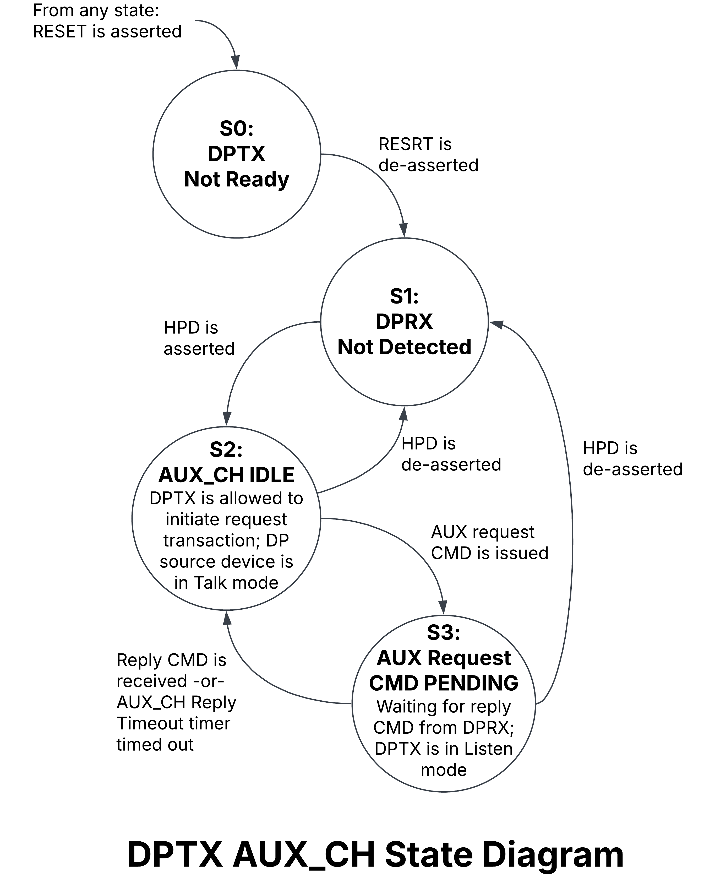

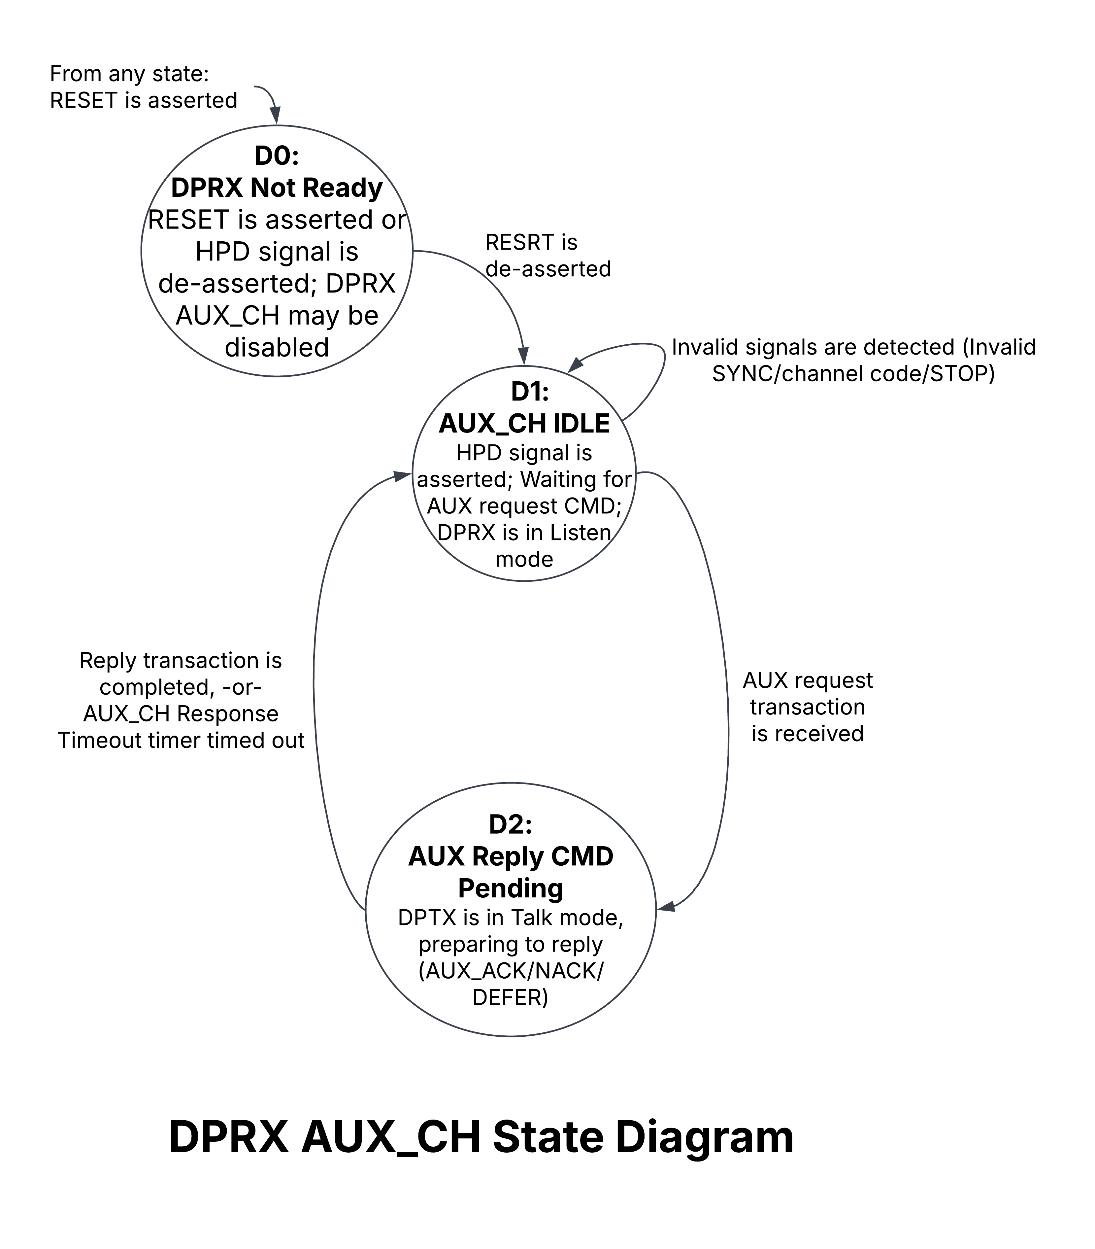
- Legacy EDID Registers Reading:
- Read 128 bytes across an I2C-over-AUX transaction. (Stream Policy Maker)
- DPCD Registers Reading (DPRX Capabilities field and Extended):
- Read them across a Native AUX transaction. (Link Policy Maker).
- After it, LPM set the value of the Link_LC_CR && Link_BW_CR which is specified in the sink registers.
- Link Configuration field Writing:
- Link Training:
- First: set LPM_start_CR = 1.
- Set the value of the PRE && VTG which is specified in the sink registers.
- Set the value of Driving_Param_VLD = 1, indicating the arrival of voltage swing and pre-emphasis data.
- consists of two distinct tasks that shall be successfully completed in sequence to establish the link:
- Clock Recovery:
- LPM Set the value of the CR_Done && EQ_CR_DN && EQ_RD_Value.
- If it failed: FSM_CR_Failed.
- If it passed: CR_PHY_Instruct && CR_ADJ_BW && CR_ADJ_LC.
- Channel Equalization:
- LPM Set the value of the Channel_EQ && Symbol_Lock && EQ_Data_VLD && Lane_Align && MAX_VTG.
- If it failed: EQ_Failed.
- If it passed: EQ_LT_Pass && EQ_Final_ADJ_BW && EQ_Final_ADJ_LC && EQ_PHY_Instruct && EQ_ADJ_BW && EQ_ADJ_LC.
Source SPM job:
- LTTPR recognition (if AUX Reply Timeout Timer >= 3.2ms)
- Read the DisplayID or legacy EDID from the Sink device. ($I^{2}$C-Over-AUX transactions)
- Set stream attributes for MSA data and CTA-861 INFOFRAME generation
- Should acquire the following information from the Source LPM:
  - Receiver Capability field (DPCD 00000h through 000FFh) – Before Link Training
  - Link Configuration field (DPCD 00100h through 001FFh) – Before Link Training
  - Link/Sink Device Status field (DPCD 00200h through 002FFh) – During & After Link Training
- Should start the transport of isochronous stream along with stream attributes data, when a stream is ready for transport.
  - Stream Sink should then decode the stream attributes data and start reconstructing the incoming isochronous stream.
- Should be unaware of DisplayPort
Events that cause stream (Main Stream + SDPs) termination by Source SPM:
- Link error event notice by a LPM
- Stream timing change
- Stream format change, unstable stream timing, or loss of stream
- In case of stream termination, the sink should either:
  - Display a blank screen (with an alert message) -or-
  - Turn off the display
until stable stream reception is resumed.
- If the stream gets terminated, SPM may re-initiate the transport, after the initiation sequence after the link the re-establishment.
Source LPM job: (page 477-479)
- 1st: Establishes the Main-Link
Link Establishment Steps:
PART A (Link Discovery):
- After HPD is asserted, the DP Source device initiates by performing LTTPR recognition.
- Source LPM reading the Receiver Capability and Extended Receiver Capability fields through the AUX_CH. (Native AUX transactions)
- Source LPM then determines the link configuration based on the DPRX’s capability and its own needs.
- Source LPM writes the following Link Configuration parameters through AUX_CH:
- LINK_BW_SET register (DPCD 00100h)
- To set Link rate value
- LANE_COUNT_SET field in the LANE_COUNT_SET register (DPCD 00101h[4:0])
- To set Lane count
- DOWNSPREAD_CTRL register (DPCD 00107h) MAIN_LINK_CHANNEL_CODING_SET register (DPCD 00108h)
- To set channel coding type of Main Link.
Note: These parameters are not to be changed after training has started until the next time the link is trained, except to reduce in the case of training failure.
PART B (Link Initialization):
- Source LPM starts link training by writing 21h to the TRAINING_PATTERN_SET register (DPCD 00102h = 21h) by way of the AUX_CH, unless Source Main-Link Tx and Sink Source Main-Link Rx are already in synchronization as indicated by the Link/Sink Device Status field.
- A loop of setting the Main-Link configuration and forwarding training pattern, while checking the status ends with the final result of either pass or fail. “Pass” means that LANEx_CR_DONE, LANEx_SYMBOL_LOCKED, and INTERLANE_ALIGN_DONE have been achieved on each configured lane. Otherwise, it is “fail”.
- Source LPM checks the training status and report of final results to the source SPM.
Note: If source LPM detects a failed link training attempt, it takes corrective action. Possible corrective actions are:
    - Reduction of the bit rate if the link was in the high bit rate mode
    - Termination of link initialization
- 2nd: After Link Establishment
  - Source LPM checks the link status whenever it detects HPD signal toggle (IRQ_HPD) by reading the Link/Sink Device Status field through a Native AUX request read transaction within 100 ms of the HPD’s rising edge.
  - Upon identifying the IRQ_HPD cause, Source LPM takes corrective action.
Note: The Source device should not attempt to transmit an AV stream that needs a bandwidth higher than the bandwidth currently in use.
Note: A link may be retrained for some reason. A Source device shall be tolerant to the available bandwidth resulting from retraining being lower than the bandwidth resulting from prior training, and this may in turn require a video mode set change.
Note: When transmitting a pattern that is not scrambled, the Source device shall set the SCRAMBLING_DISABLE bit in the TRAINING_PATTERN_SET register (DPCD 00102h[5] = 1). When a Link Quality test pattern is being transmitted by a DPTX, the bit is “don’t care.” (page 481)

In depth steps of step 6 of Link Initialization:
Clock Recovery (CR) Stage (using LANEx_CR_DONE sequence)
Clock Recovery ensures that the sink can recover the clock signal from the source.
- The upstream device starts TPS1 transmission. (TPS1 is generated from the PHY LAYER)
- DPTX writes (Native AUX Write Transaction)
- 21h to the TRAINING_PATTERN_SET register (DPCD 00102h = 21h)
- the current drive setting to the TRAINING_LANEx_SET register(s) (DPCD 00103h through 00106h). The transmitter should normally start signaling at Voltage Swing Level 0 and Pre-emphasis Level 0.
- The transmitter waits at least 100 us before issuing an AUX read request transaction for reading the lane’s LANEx_CR_DONE bit in the following registers which are set by the receiver:
- LANEx_y_STATUS register(s) (DPCD 00202h[0 and 4] and DPCD 00203h[0 and 4] for Lanes 0, 1, 2, and 3, respectively, as appropriate)
- LANEx_y_STATUS_ESI register(s) (DPCD 0200Ch[0 and 4] and DPCD 0200Dh[0 and 4] for Lanes 0, 1, 2, and 3, respectively, as appropriate)
- If not all the LANEx_CR_DONE bits are set, the transmitter shall perform the following:
- Read the ADJUST_REQUEST_LANEx_y register(s) (DPCD 00206h and 00207h).
- Check if any of the following conditions exists:
- Receiver keeps the same value in DPCD 00206h and 00207h while one or more of the LANEx_CR_DONE bit(s) remain unset after five AUX_ACKs for read request transactions for reading LANEx_CR_DONE bit(s) and DPCD 00206h and 00207h.
- Receiver fails to set all the LANEx_CR_DONE bit(s) after the transmitter transmits the maximum voltage swing level, which is the sum of the VOLTAGE_SWING_LANEx and PRE_EMPHASIS_LANEx field values in DPCD 00206h and 00207h.
- Receiver fails to set all the LANEx_CR_DONE bit(s) on the enabled lanes following a total of 10 AUX_ACKs for read request transactions for reading LANEx_CR_DONE bit(s) and DPCD 00206h and 00207h.
- If none of the conditions exist, then do the following:
- Adjust the voltage swing and/or pre-emphasis level according to the request.
- Update DPCD 00103h through 00106h to match the new voltage swing and/or pre-emphasis settings.
- Clear DPCD 00102h = 00h. Check if Link configuration continues to satisfy needed bandwidth. If it does, go back to step1. If it doesn’t, end link training.
- If any of the conditions exist, the transmitter shall downshift to the lower link rate (if it wasn’t already at RBR) and then repeat the LANEx_CR_DONE sequence.
- If any of the conditions exist, and the link rate is already at RBR, reduce the lane count to the count that matches the lowest-numbered LANEx_CR_DONE lane(s)
- Increase link rate to the value used at the start of this LANEx_CR_DONE sequence.
- Clear DPCD 00102h = 00h. Check if Link configuration continues to satisfy needed bandwidth. If it does, go back to step1. If it doesn’t, end link training. If all the LANEx_CR_DONE bits are set, end LANEx_CR_DONE (TPS1)sequence then proceed to LANEx_CHANNEL_EQ_DONE sequence.
Channel Equalization (EQ) Stage (using LANEx_CHANNEL_EQ_DONE sequence)
- The upstream device starts TPS2/3/4 transmission. (TPS2/3/4 are generated from the PHY LAYER)
- The upstream device then writes the appropriate value for TPS2, TPS3, or TPS4 to the TRAINING_PATTERN_SET register (DPCD 00102h = 22h, 23h, or 07h, respectively) and the current drive setting to the TRAINING_LANEx_SET register(s) (DPCD 00103h through 00106h).
- The transmitter shall wait at least the period of time specified in the TRAINING_AUX_RD_INTERVAL field in the 8b10b_TRAINING_AUX_RD_INTERVAL register (DPCD 0000Eh[6:0]) before reading the link status bits.
Note: How to measure the equalization result by DPRX is implementation-specific.
- Check the values of these bits for the appropriate lane count:
- LANEx_CHANNEL_EQ_DONE bit(s) in LANEx_y_STATUS register(s) and LANEx_y_STATUS_ESI register(s)
- LANEx_CR_DONE bits(s) in LANEx_y_STATUS register(s) and LANEx_y_STATUS_ESI register(s)
- LANEx_SYMBOL_LOCKED bit(s) in LANEx_y_STATUS register(s) and LANEx_y_STATUS_ESI register(s)
- INTERLANE_ALIGN_DONE bit in the LANE_ALIGN_STATUS_UPDATED and LANE_ALIGN_STATUS_UPDATED_ESI register(s) (DPCD 00204h[0] and DPCD 0200Eh[0], respectively)
  - If not all LANEx_CR_DONE bits(s) remained set to 1, check if at least one LANEx_CR_DONE bit remained set to 1.
- If yes, the 4 or 2 lanes were enabled, change them to 2 or 1 enabled lanes, respectively. If it was only 1 enabled lanes, then go to step 4.1.1.2.
- If not even 1, check to see if link rate is at RBR. If yes clear DPCD 00102h = 00h and end link training. If no, reduce the link rate and go be to the OG lane count then go back to step 1 of CR Stage.
- If any of LANEx_CHANNEL_EQ_DONE bit(s), LANEx_SYMBOL_LOCKED bit(s), INTERLANE_ALIGN_DONE bit are not set, do the following:
- Adjust the voltage swing and/or pre-emphasis level according to the request.
- Update DPCD 00103h through 00106h to match the new voltage swing and/or pre-emphasis settings.
- Then go back to step 3. If this loop happens more than 5 times, in the 6th time go to step 4.1.1.1.
  - If all these bits are set, clear DPCD 00102h = 00h. Link training has successfully concluded. Now, we can start streaming data.
Notes:

- The receiver sets the LANEx_SYMBOL_LOCKED bit(s) only when it has properly detected and aligned the 8b/10b DP symbol boundaries.
- The receiver should detect no more than a single symbol error during link training to set the LANEx_SYMBOL_LOCKED bits.
- The receiver sets the INTERLANE_ALIGN_DONE bits only when its PHY Layer digital sub-block has successfully aligned the symbol boundaries of all the enabled lanes with one another so that the Link Layer block can handle the incoming symbol patterns.
- During the normal operation following the link training, the receiver clears the LANEx_SYMBOL_LOCKED and INTERLANE_ALIGN_DONE bits when its Link Layer block can no longer process the incoming symbol patterns due to symbol errors, which causes noticeable visible/audible glitches to the regenerated streams. The receiver should otherwise maintain these bits during normal operation. The receiver should not clear these bits upon isolated Symbol errors.
- The receiver may issue up to seven consecutive AUX_DEFERs, if needed. However, use of AUX_DEFER should be minimized to meet the 10-ms link training completion time target. When the transmitter receives more than seven consecutive AUX_DEFERs, the transmitter may terminate link training.
Link Training Sequence Testing:
- After HPD is asserted, Link Policy Maker in Source requests to read the Receiver Capabilities Field and the Extended one in the DPCD registers in the Sink using AUX_CH.
- Link Policy Maker shall then determine the link configuration based on the DPRX’s capability and its own needs.
- Link Policy Maker writes the following Link Configuration parameters through AUX_CH:
LINK_BW_SET register (DPCD 00100h)
- To set Link rate value
LANE_COUNT_SET field in the LANE_COUNT_SET register (DPCD 00101h[4:0])
- To set Lane count
DOWNSPREAD_CTRL register (DPCD 00107h)
MAIN_LINK_CHANNEL_CODING_SET register (DPCD 00108h)
- To set channel coding type of Main Link.
- Link Policy Maker shall start link training by writing 21h to the TRAINING_PATTERN_SET register (DPCD 00102h = 21h) by way of the AUX_CH.
- Check every 100us if:
  - DPCD 0x0202 & 0x0203 (LANEx_CR_DONE) → 1 if CR is achieved for a lane.
  - DPCD 0x0204 (LINK_STATUS_UPDATED) → 1 if status changed.
  - Clears DPCD 00102h = 00h then go back to step 4 in order to reduce link rate or lane count and restart training if:
- Receiver keeps the same value in DPCD 00206h and 00207h while one or more of the LANEx_CR_DONE bit(s) remain unset after five AUX_ACKs for read request transactions for reading LANEx_CR_DONE bit(s) and DPCD 00206h and 00207h.
- Receiver fails to set all the LANEx_CR_DONE bit(s) after the transmitter transmits the maximum voltage swing level, which is the sum of the VOLTAGE_SWING_LANEx and PRE_EMPHASIS_LANEx field values in DPCD 00206h and 00207h.
- Receiver fails to set all the LANEx_CR_DONE bit(s) on the enabled lanes following a total of 10 AUX_ACKs for read request transactions for reading LANEx_CR_DONE bit(s) and DPCD 00206h and 00207h.
- See if lane count gets reduced to the lowest possible value with the bits enabled if all link rates fail on the current lane count.
- Unless all the LANEx_CR_DONE bits are set, the transmitter shall perform the following:
- Read the ADJUST_REQUEST_LANEx_y register(s) (DPCD 00206h and 00207h).
- Adjust the voltage swing and/or pre-emphasis level according to the request.
- Update DPCD 00103h through 00106h to match the new voltage swing and/or pre-emphasis settings.
- The sink checks channel equalization and symbol lock every at least the period of time specified in the TRAINING_AUX_RD_INTERVAL field, updating:
    - DPCD 0x0202 & 0x0203 (LANEx_CHANNEL_EQ_DONE) → 1 if CEQ is achieved.
    - DPCD 0x0202 & 0x0203 (LANEx_SYMBOL_LOCKED) → 1 if symbol lock is achieved.
    - DPCD 0x0204 (INTERLANE_ALIGN_DONE) → 1 if lanes are aligned (for multi-lane configurations).
    - DPCD 0x0204 (LINK_STATUS_UPDATED) → 1 if status changed.
- During the normal operation following the link training, the receiver shall clear the LANEx_SYMBOL_LOCKED and INTERLANE_ALIGN_DONE bits when its Link Layer block can no longer process the incoming symbol patterns due to symbol errors, which causes noticeable visible/audible glitches to the regenerated streams. The receiver shall otherwise maintain these bits during normal operation. The receiver shall not clear these bits upon isolated Symbol errors.
- When not training at RBR and one or more of the LANEx_SYMBOL_LOCKED and INTERLANE_ALIGN_DONE bits remain unset in the sixth loop, the transmitter shall reduce the lane count, and then re-initiate training at the same link rate. Only after failing with a lane count of 1, the transmitter shall set the lane count to the quantity needed (within the maximum supported by the DPRX), and then downshift to the next lower bit rate. To re-initiate link training at a lower bit rate, clears DPCD 00102h = 00h then go back to step 4 in order to reduce link rate or lane count and restart training.
- After verifying that LANEx_CHANNEL_EQ_DONE, LANEx_SYMBOL_LOCKED, and INTERLANE_ALIGN_DONE are achieved, the transmitter shall write 00h to the TRAINING_PATTERN_SET register (DPCD 00102h = 00h) to indicate the end of link training, and then start transmitting stream data.
- If the Clock Recovery circuit loses lock during the LANEx_CHANNEL_EQ_DONE sequence, the receiver shall clear the lane’s LANEx_CR_DONE bit(s).
- If the DP Sink device has cleared all LANEx_CR_DONE bits and link training is conducted in HBR or higher, the transmitter shall reduce the bit rate and return to the LANEx_CR_DONE sequence. If link training is already conducted in RBR, the transmitter shall end link training by writing DPCD 00102h = 00h, without establishing the link. If at least one LANEx_CR_DONE bit remains set for the current lane count, the transmitter shall reduce the lane count to the next-lowest setting and return to the LANEx_CR_DONE sequence.

- Link Stability Checks:
  - Test for expected AUX transactions between Source and Sink devices.
  - Ensure the link maintains synchronization under normal conditions.
Supported Link Rate | Training Patterns Used
RBR (1.62 Gbps/lane) | TPS1 → TPS2
HBR (2.7 Gbps/lane) | TPS1 → TPS2
HBR2 (5.4 Gbps/lane) | TPS1 → TPS3
HBR3 (8.1 Gbps/lane) | TPS1 → TPS4
Voltage Swing and Pre-emphasis levels that work together:
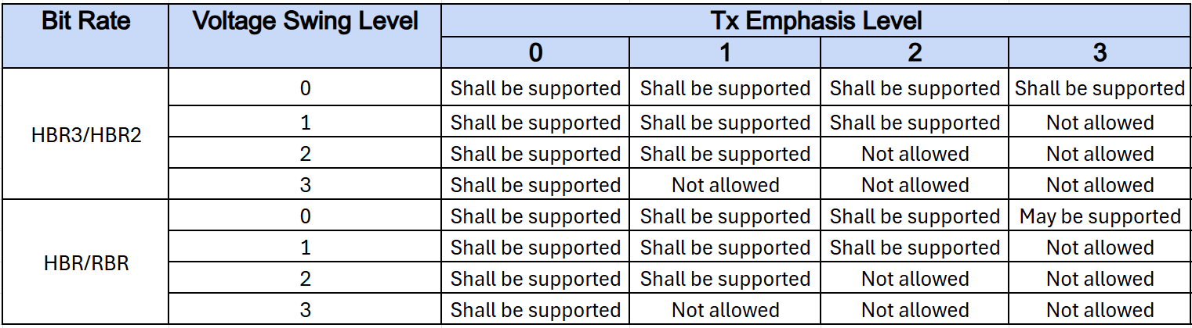
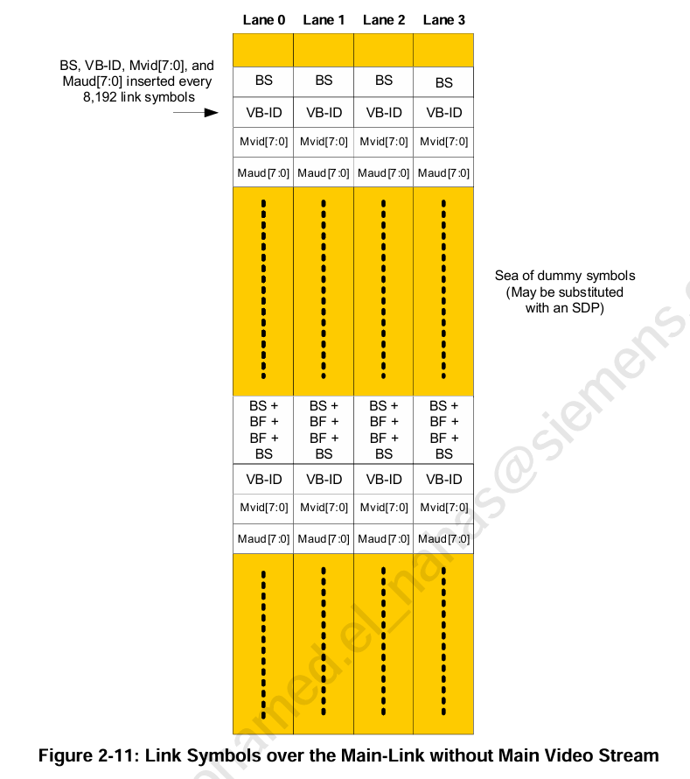
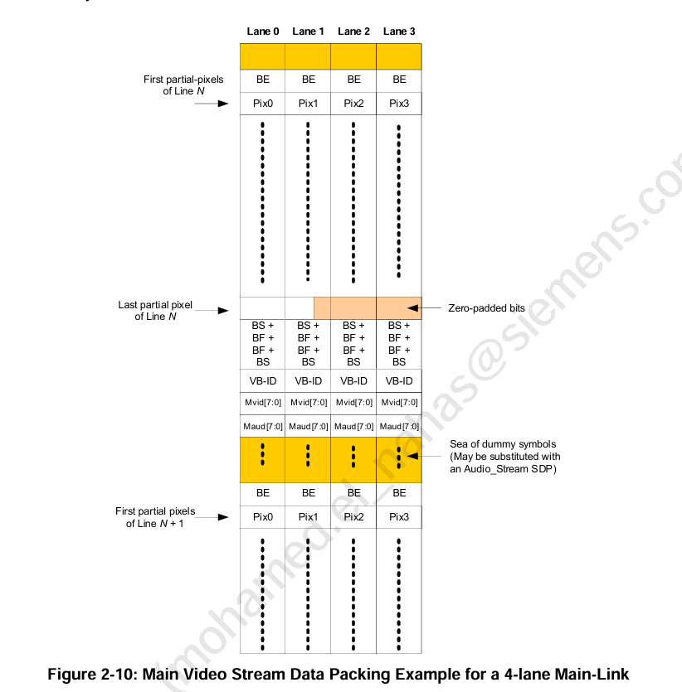
- SST Main Link data:

More Complex Tests:
- Handling of HPD Interrupts & Link Recovery:
  - Simulate loss of synchronization and verify retraining behavior.
  - Check if the system correctly handles fluctuations in lane quality.
- Handling of Clock Drift & Jitter:
  - Introduce controlled timing deviations and validate that the stream remains synchronized.

Advanced / Negative Testing:
- Corrupting AUX Transactions & Data Packets:
  - Inject invalid AUX messages and observe error handling mechanisms.
  - Simulate data corruption at different phases (startup, runtime).
- Unexpected Link Parameter Changes:
  - Alter link parameters mid-stream and observe system recovery.
  - Force incorrect lane counts or invalid link rates.

Verification Environment:
