**Synchronous FIFO – SV**

**Amira Atef Ismaeil El Komy**

Table of Contents

1. Verification Plan 4

2. Code Snippets 5

2.1. Design 5

2.1.1. Bugs Found 6

2.2. Top Module 8

2.3. SVAs 9

2.4. Test Bench Module 10

2.5. Interface 11

2.6. Transaction Package 12

2.7. Monitor Module 13

2.8. Coverage Package 14

2.9. Scoreboard Package 15

2.10. Shared Package 17

3. Source Files List 18

4. Do File 18

5. Coverage Report Snippets 18

5.1. Branch Coverage Snippet 18

5.2. Toggle Coverage Snippet 18

5.3. Statement Coverage Snippet 19

5.4. Condition Coverage Snippet 19

5.5. Directive Coverage Snippet 19

5.6. Total Coverage Snippet 19

6. Functional Coverage Report Snippet 19

7. Assertions Report Snippet 20

8. Cover Directives Snippet 20

List of Figures

Figure 1: Sync. FIFO Verification Plan 4

Figure 2: Fixed Design Code 5

Figure 3: Fixed Design Code (Cont.) 6

Figure 4: Bugs Found 1 6

Figure 5: Bugs Found 2 6

Figure 6: Bugs Found 3 7

Figure 7: Bugs Found 4 7

Figure 8: Bugs Found 5 7

Figure 9: Top Module Code 8

Figure 10: Properties Code 9

Figure 11: Assertions and Covers Code 9

Figure 12: Test Bench Module Code 10

Figure 13: Test Bench Module Code (Cont.) 11

Figure 14: Interface Code 11

Figure 15: Transaction Package Code 12

Figure 16: Monitor Module Code 13

Figure 17: Coverage Package Code 14

Figure 18: Coverage Package Code (Cont.) 14

Figure 19: Scoreboard Package Code 1 15

Figure 20: Scoreboard Package Code 2 16

Figure 21: Scoreboard Package Code 3 17

Figure 22: Shared Package Code 17

Figure 23: List of Source Files 18

Figure 24: The Do File 18

Figure 25: Total Branch Coverage 18

Figure 26: Total Toggle Coverage 18

Figure 27: Total Statement Coverage 19

Figure 28: Total Condition Coverage 19

Figure 29: Total Directive Coverage 19

Figure 30: Total Coverage 19

Figure 31: Total Functional Coverage 19

Figure 32: Assertions 20

Figure 33: Cover Directives 20

# Verification Plan

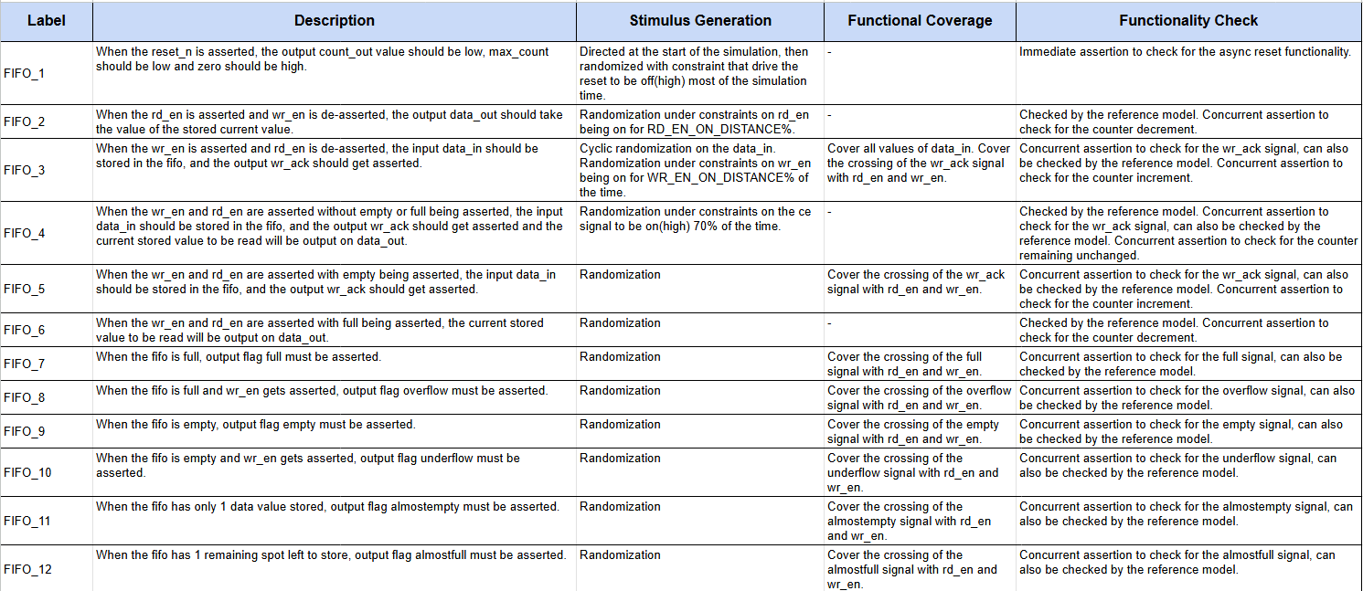

Figure 1: Sync. FIFO Verification Plan

# Code Snippets

## Design

Figure 2: Fixed Design Code

Figure 3: Fixed Design Code (Cont.)

### Bugs Found

Figure 4: Bugs Found 1

Figure 5: Bugs Found 2

Figure 6: Bugs Found 3

Figure 7: Bugs Found 4



Figure 8: Bugs Found 5

## Top Module

Figure 9: Top Module Code

## SVAs

Figure 10: Properties Code

Figure 11: Assertions and Covers Code

## Test Bench Module

Figure 12: Test Bench Module Code

Figure 13: Test Bench Module Code (Cont.)

## Interface

Figure 14: Interface Code

## Transaction Package

Figure 15: Transaction Package Code

## Monitor Module

Figure 16: Monitor Module Code

## Coverage Package

Figure 17: Coverage Package Code

Figure 18: Coverage Package Code (Cont.)

## Scoreboard Package

Figure 19: Scoreboard Package Code 1

Figure 20: Scoreboard Package Code 2

Figure 21: Scoreboard Package Code 3

## Shared Package

Figure 22: Shared Package Code

# Source Files List

Figure 23: List of Source Files

# Do File

Figure 24: The Do File

# Coverage Report Snippets



## Branch Coverage Snippet

Figure 25: Total Branch Coverage

## Toggle Coverage Snippet

Figure 26: Total Toggle Coverage

## Statement Coverage Snippet

Figure 27: Total Statement Coverage

## Condition Coverage Snippet

Figure 28: Total Condition Coverage

## Directive Coverage Snippet



Figure 29: Total Directive Coverage

## Total Coverage Snippet



Figure 30: Total Coverage

# Functional Coverage Report Snippet

Figure 31: Total Functional Coverage

# Assertions Report Snippet

Figure 32: Assertions

# Cover Directives Snippet

Figure 33: Cover Directives