**Synchronous FIFO – UVM**

**Amira Atef Ismaeil El Komy**

Table of Contents

1. Verification Plan 4

2. UVM Testbench Structure 5

3. Bugs Found 7

4. Source Files List 8

5. Do File 8

6. Coverage Report Snippets 8

5.1. Branch Coverage Snippet 8

5.2. Toggle Coverage Snippet 9

5.3. Statement Coverage Snippet 9

5.4. Condition Coverage Snippet 9

7. Functional Coverage Report Snippet 10

8. Assertions Report Snippet 10

9. Cover Directives Snippet 11

10. Waveform Snippets 12

11. Transcript Snippets 13

List of Figures

Figure 1: Sync. FIFO Verification Plan 4

Figure 2: FIFO UVM Environment Architecture 5

Figure 3: Bugs Found 1 7

Figure 4: Bugs Found 2 7

Figure 5: Bugs Found 3 7

Figure 6: Bugs Found 4 7

Figure 7: Bugs Found 5 7

Figure 8: List of Source Files 8

Figure 9: The Do File 8

Figure 10: Total Branch Coverage 8

Figure 11: Total Toggle Coverage 9

Figure 12: Total Statement Coverage 9

Figure 13: Total Condition Coverage 9

Figure 14: Total Functional Coverage 10

Figure 15: Assertions 10

Figure 16: Cover Directives 11

Figure 17: Reset Sequence Waveform 12

Figure 18: Write Only Sequence Waveform 12

Figure 19: Read Only Sequence Waveform 12

Figure 20: Write + Read Sequence Waveform 12

Figure 21: Transcript Snippet 13

Figure 22: Transcript Snippet (Cont.) 13

List of Tables

Table 1: Assertions 11

# Verification Plan

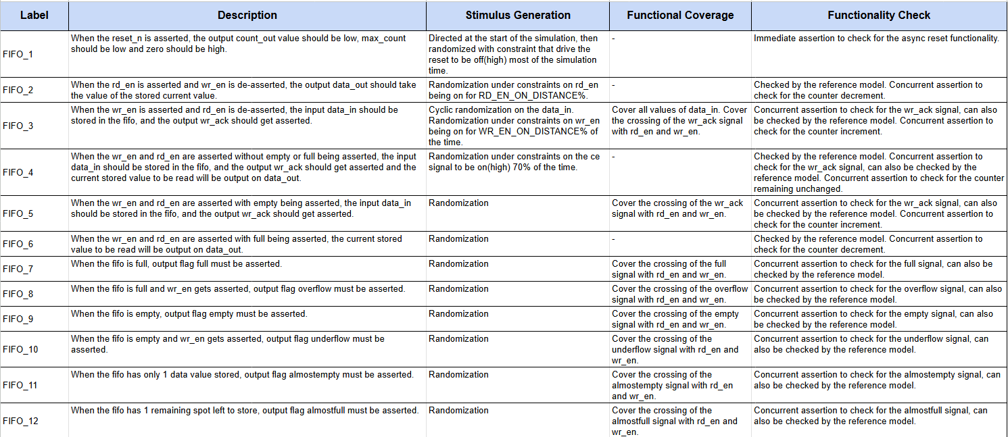

Figure 1: Sync. FIFO Verification Plan

# UVM Testbench Structure

Figure 2: FIFO UVM Environment Architecture

The UVM testbench flow:

* The top module generates the clock and instantiates the test, interface and FIFO, our design under test.
* The interface supplies the DUT with the input stimulus and receives the output from it, so the interface carries all the signals.
* The test class, which extends uvm_test, instantiates all sequence classes and the environment. It also runs all the sequences.
* The sequence item class, which extends uvm_seq_item, contains all the variables for all the signals passing through the environment whether these signals are DUT input signals that get randomized or not. In addition, it contains all constraint blocks for randomized signals.
* The sequence class, which extends uvm_sequence, is a base class that contains tasks for all different sequences, which are then called in child classes of the base class to run different sequences.
* The environment class, which extends uvm_env, instantiates the coverage collector, scoreboard and the agent.
* The agent class, which extends uvm_agent, instantiates the monitor, driver and sequencer, as well as creates the connections using uvm_tlm_ports and uvm_analysis_ports, between the monitor and classes outside the agent or between the driver and sequencer, respectively.
* The driver class, which extends uvm_driver, instantiates a seq_item, as it drives the input stimulus to the interface given to it by the sequence in a seq_item through the sequencer.
* The monitor class, which extends uvm_monitor, instantiates a seq_item, and writes all the signals in the interface to a uvm_fifo every negative edge clock.
* The coverage class, which extends uvm_component, instantiates a seq_item, to be able to get the sequence item from the monitor and applies coverpoints inside covergroups to its signals and samples the covergroups.
* The scoreboard class, which extends uvm_scoreboard, instantiates a seq_item, and compares every output using a reference model task written inside it, incrementing counters for every correct and incorrect comparison.
* An SVA class was also written containing all assertions and was bound to the DUT inside the top.

# Bugs Found

Figure 3: Bugs Found 1

Figure 4: Bugs Found 2

Figure 5: Bugs Found 3

Figure 6: Bugs Found 4



Figure 7: Bugs Found 5

# Source Files List

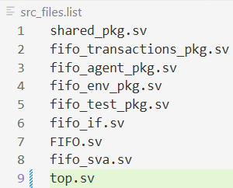

Figure 8: List of Source Files

# Do File

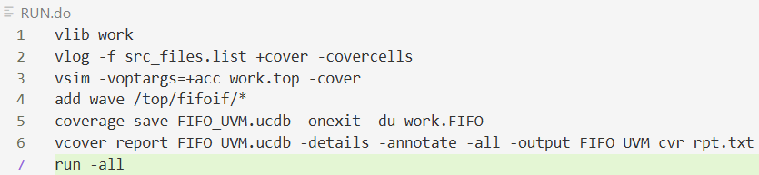

Figure 9: The Do File

# Coverage Report Snippets



## Branch Coverage Snippet

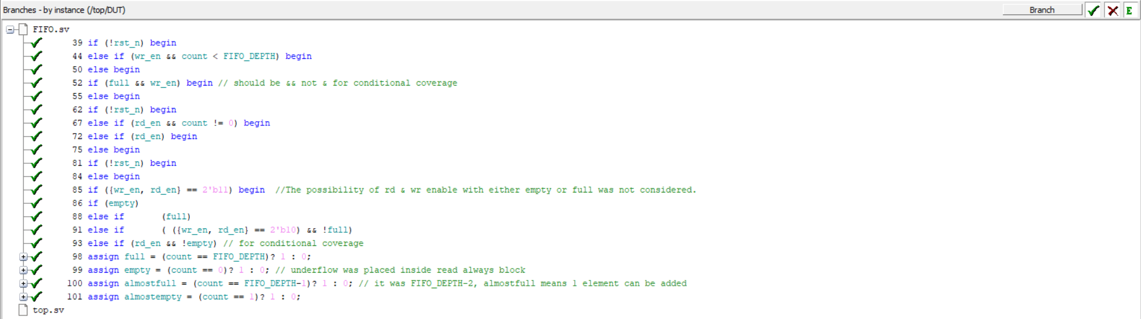

Figure 10: Total Branch Coverage

## Toggle Coverage Snippet

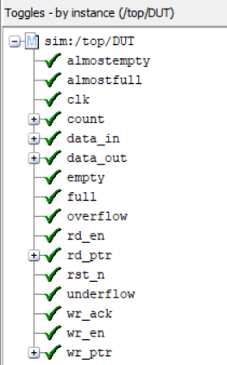

Figure 11: Total Toggle Coverage

## Statement Coverage Snippet

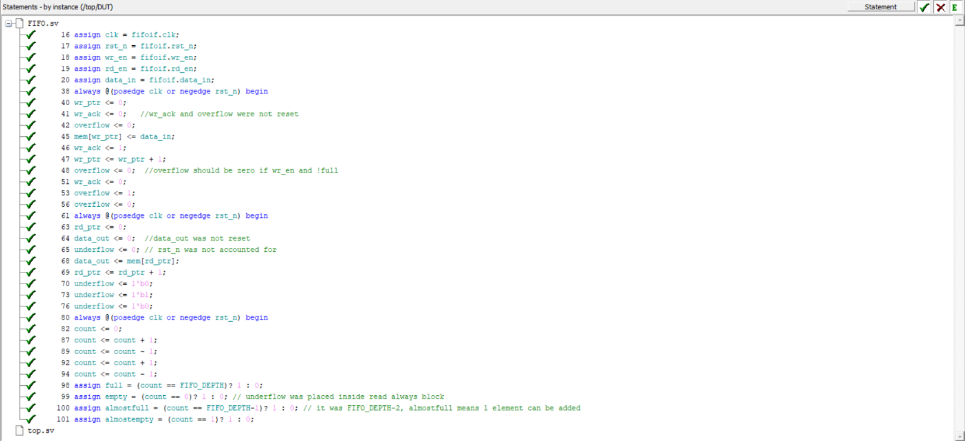

Figure 12: Total Statement Coverage

## Condition Coverage Snippet

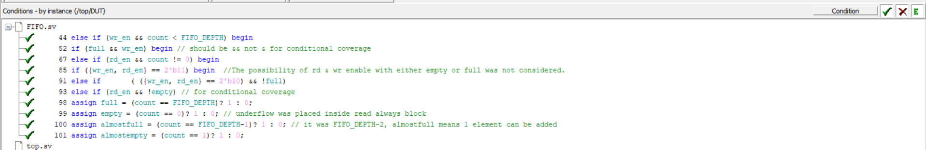

Figure 13: Total Condition Coverage

# Functional Coverage Report Snippet

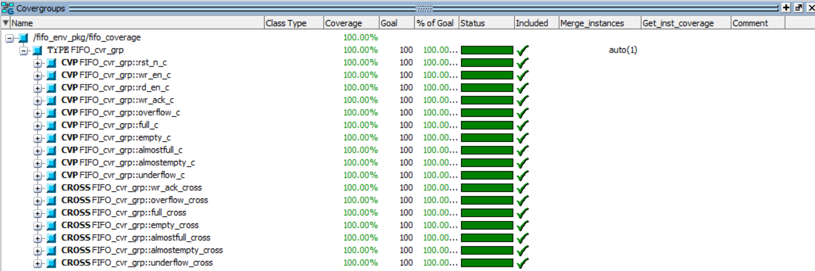

Figure 14: Total Functional Coverage

# Assertions Report Snippet

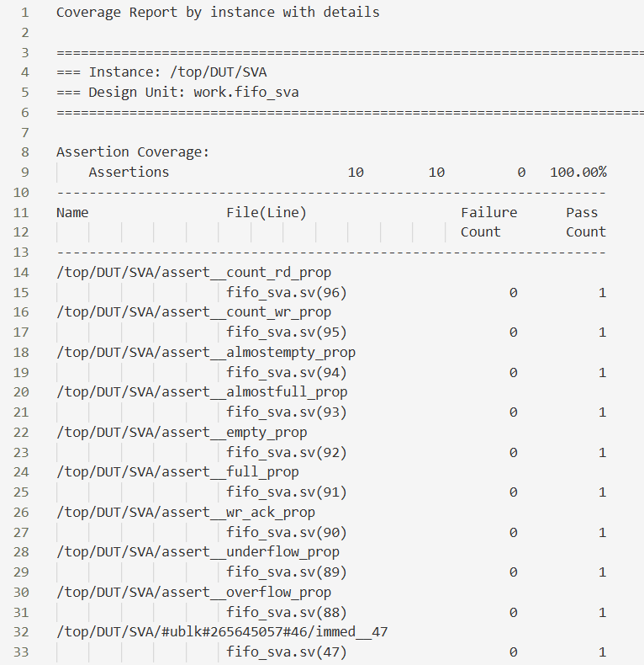

Figure 15: Assertions

Table 1: Assertions

|  |  |
| --- | --- |
| Feature | Assertion |
| When rst_n is zero all outputs must be zero and only empty is 1. | always @(posedge clk) begin          if (!rst_deasserted)  **assert** (data_out == 0 && empty && !almostfull && !almostempty && !underflow && !overflow && !full && !wr_ack && count == 0)      end |
| When FIFO is full and wr_en gets asserted, overflow gets asserted. | @(posedge clk) disable iff (~rst_n) (wr_en && full) |=> overflow; |
| When FIFO is empty and rd_en gets asserted, overflow gets asserted. | @(posedge clk) disable iff (~rst_n) (rd_en && empty) |=> underflow; |
| When FIFO is not full and wr_en gets asserted, wr_ack gets asserted. | @(posedge clk) disable iff (~rst_n) (wr_en && count < FIFO_DEPTH) |=> wr_ack; |
| When FIFO is full, as indicated by the counter, Full gets asserted. | @(posedge clk) disable iff (~rst_n) (count == FIFO_DEPTH) |-> full; |
| When FIFO is empty, as indicated by the counter, empty gets asserted. | @(posedge clk) disable iff (~rst_n) (count == 0) |-> empty; |
| When only 1 place is empty in FIFO, almostfull gets asserted. | @(posedge clk) disable iff (~rst_n) (count == FIFO_DEPTH-1) |-> almostfull; |
| When only 1 place is full in FIFO, almostempty gets asserted. | @(posedge clk) disable iff (~rst_n) (count == 1) |-> almostempty; |
| Counter must get incremented when wr_en is asserted, fifo is not full and rd_en is de-asserted or when wr_en is asserted, fifo is empty and rd_en is asserted. | @(posedge clk) disable iff (~rst_n) ((wr_en && !full && !rd_en) || (wr_en && rd_en && empty)) |=> (count == **$past**(count) + 1); |
| Counter must get decremented when rd_en is asserted, fifo is not empty and wr_en is de-asserted or when rd_en is asserted, fifo is full and wr_en is asserted. | @(posedge clk) disable iff (~rst_n) ((rd_en && !empty && !wr_en) || (wr_en && rd_en && full)) |=> (count == **$past**(count) - 1); |

# Cover Directives Snippet

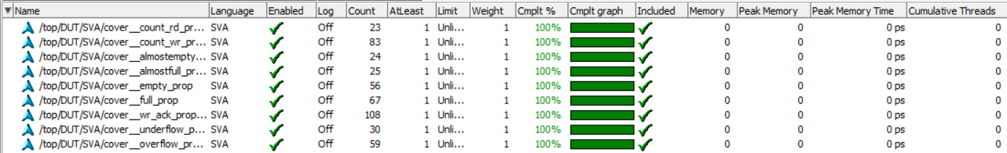

Figure 16: Cover Directives

# Waveform Snippets

Figure 17: Reset Sequence Waveform

Figure 18: Write Only Sequence Waveform

Figure 19: Read Only Sequence Waveform

Figure 20: Write + Read Sequence Waveform

# Transcript Snippets

Figure 21: Transcript Snippet

Figure 22: Transcript Snippet (Cont.)