* Name: Amira Ehab Mohamed Refai
* B.N.:211
* *Groub : 2*
* *Section: 9*
* *Topic : covid-19*
* *Githup link :*
* *Application brief :* On March 13, 2020, the National Science and Technology Advisors from a dozen countries, including the United States, called on publishers to voluntarily make their COVID-19 and coronavirus-related publications, and the available data supporting them, immediately accessible in PubMed Central (PMC) and other appropriate public repositories to support the ongoing public health emergency response efforts.  
    
  To date, more than fifty publishers (see [Collaborators](https://www.ncbi.nlm.nih.gov/pmc/about/covid-19/#collab) to the right) have responded to the call and volunteered to make their coronavirus-related articles accessible in PMC in formats and under license terms that facilitate text mining and secondary analysis. In addition, many other PMC journals and publishers make their coronavirus-related articles available the same way.
* *Screen shots: 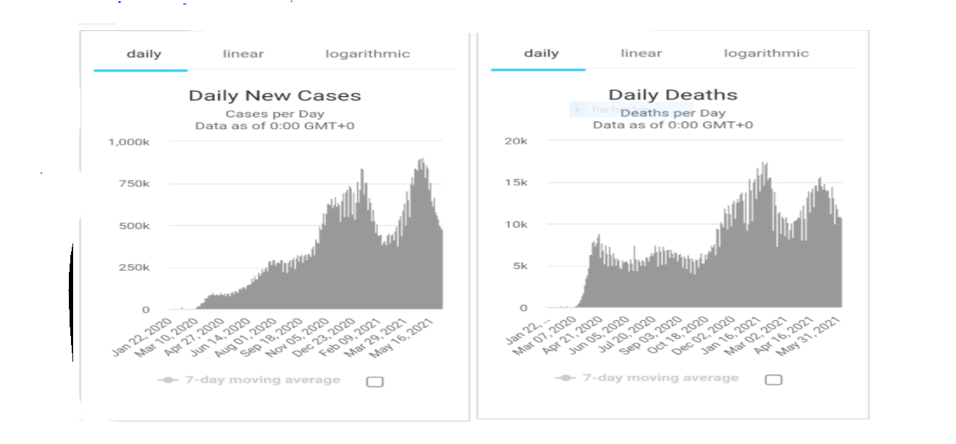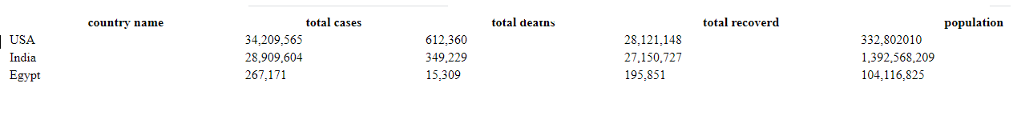*

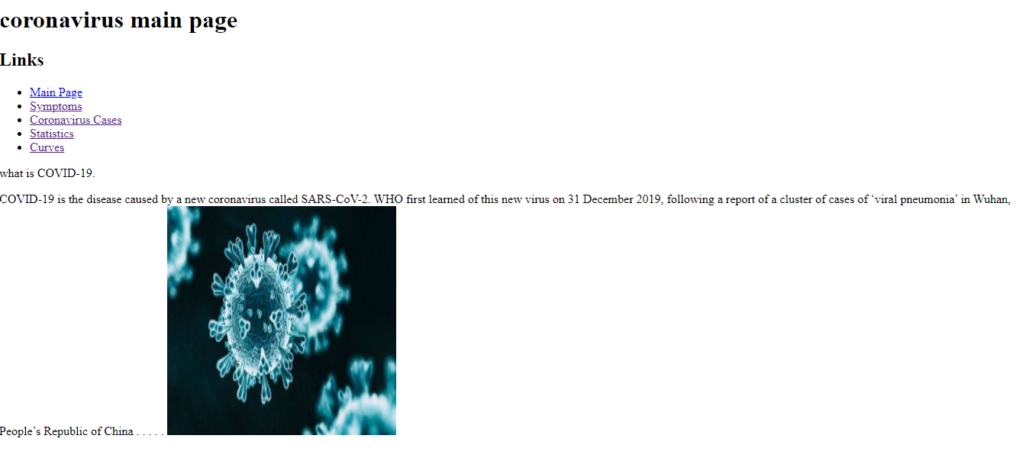

* Source code : 