Cairo University  
Faculty of Computers and Information



**CS251**

**Software Engineering I**

Knowledge Plus

Software Design

Team Names

Amira Shawky Amen

Amira Elsayed Ahmed

Esraa Mohamed Rabee

Yusr tarek zaki

December 2016

Contents

Instructions [To be removed] 3

Team 3

Document Purpose and Audience 3

System Models 3

I. Class diagrams 3

Important Algorithm 5

II. Sequence diagrams 5

Class - Sequence Usage Table 7

Ownership Report 8

Policy Regarding Plagiarism: 8

References 8

Authors 8

# Team

|  |  |  |  |
| --- | --- | --- | --- |
| **ID** | **Name** | **Email** | **Mobile** |
| 20140073 | Amira elsayed Ahmed | Amira.elsayed558@gmail.com | 01111914785 |
| 20140077 | Amira Shawky amen | amirashawky20140077@yahoo.com | 01142534127 |
| 20140338 | Esraa Mohamed rabe3 | esraamohamed7846@yahoo.com | 01116225340 |
| 20110425 | Yusr tarek zaki |  | 01004456152 |

# Document Purpose and Audience

-This document to describe our software design, class Diagram, sequence diagram

-This is like a contract between us and the client; we can go back to it when we argue about something or any detail.

Our audience:

-Customer.

-Project Managers

# 

# System Models

## Class diagrams

## 

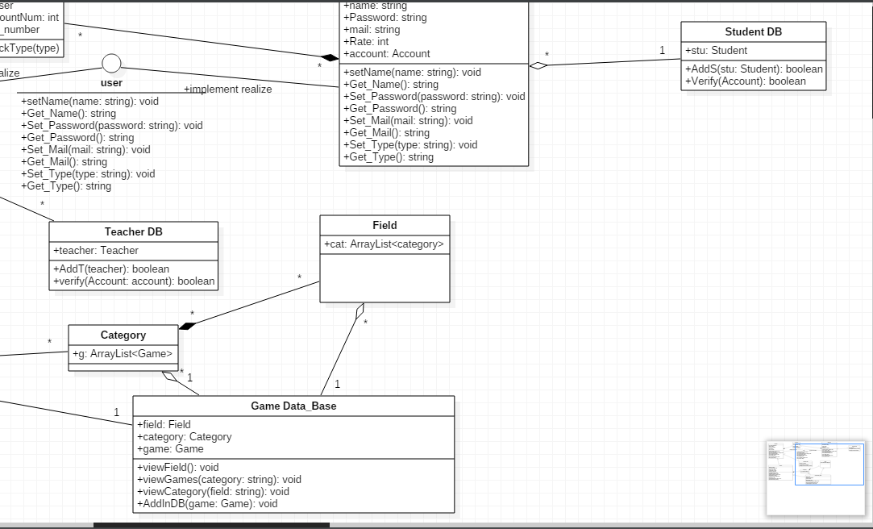

| **Class ID** | **Class Name** | **Description & Responsibility** |
| --- | --- | --- |
| 1 | User | Interface class its what the user see when he enters the website |
| 2 | Teacher | Type of users contain teacher data and save the data that get from the user |
| 3 | Student | Type of users contain student data and save the data that get from the user |
| 4 | TeacherDB | This class is responsible about the teacher data and save it in the database and add new teacher user and verify their data |
| 5 | studentDB | This class is responsible about the student data and save it in the database and add new student user and verify their data |
| 6 | Game | This class is responsible to take the each game from each user as file and send it to the game to game database, define the game name,num of questions, author name |
| 7 | Category | This class is responsible to define the category of the game (T&F,MCQ) |
| 8 | field | This class is responsible to define the field of the game(cs,math,science,English) |
| 9 | GameDB | This class is responsible for view the fields(show the fields that we have) and take the choice from the user, view the categories(show the category that we have) and take the choice from the user,load the game to the DB and from |
| 10 | Account | This class responsible for checking for the accounts if exist in student DB or teacher DB |

### 

## 

## II. Sequence diagrams

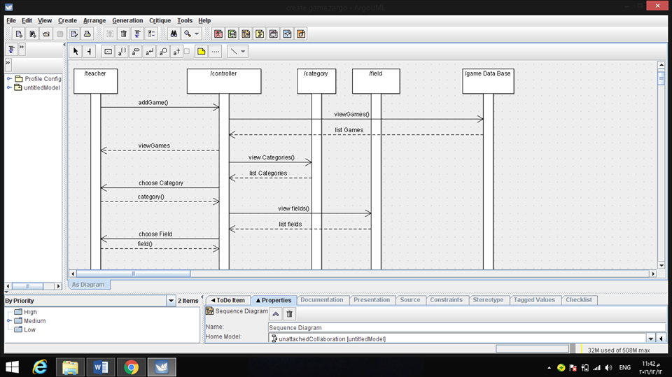

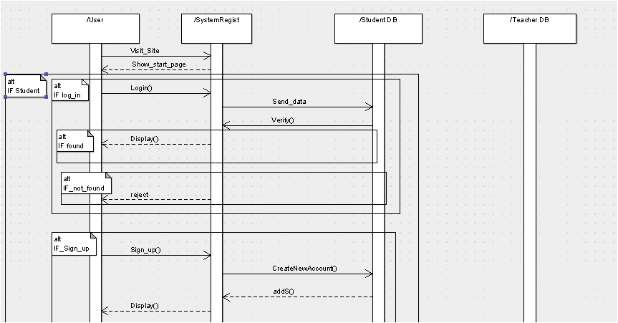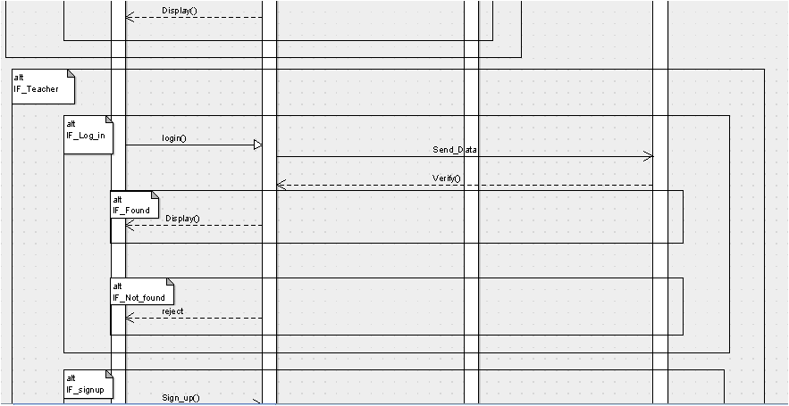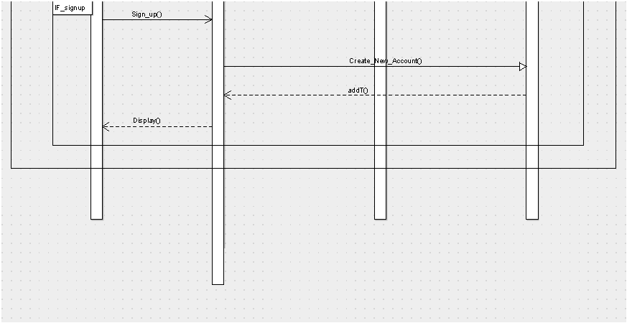

### Class - Sequence Usage Table

| **Class Name** | **Sequence Diagrams** | **Overall used methods** |
| --- | --- | --- |
| User | 1 | add game, choose category, choose field |
| Game |  |  |
| Account |  |  |
| category | 1 | Send categories to DB |
| field | 1 | Send field to DB |
| Teacher DB |  |  |
| Student DB |  |  |
| Game DB | 1 | Show list of categories to the user, show list of filed to the use, load game to the DB |

# 

# Ownership Report

|  |  |
| --- | --- |
| **Item** | **Owners** |
| Class Diagram | *Amira,Esraa,Amira* |
| Class Diagram description Table | *Yusr* |
| Sequence Diagram Register | *Amira,Esraa,Amira* |
| Sequence Diagram Create game | *Amira,Esraa,Amira* |
| Sequence Diagram play Game | *Amira,Esraa,Amira* |
| Sequence Diagram Table | *Yusr* |

# 

# Policy Regarding Plagiarism:

**Students have collective ownership and responsibility of their project. Any violation of academic honesty will have severe consequences and punishment for ALL team members.**

1. تشجع الكلية على مناقشة الأفكار و تبادل المعلومات و مناقشات الطلاب حيث يعتبر هذا جوهريا لعملية تعليمية سليمة
2. ساعد زملاءك على قدر ما تستطيع و حل لهم مشاكلهم فى الكود و لكن تبادل الحلول غير مقبول و يعتبر غشا.
3. أى حل يتشابه مع أى حل آخر بدرجة تقطع بأنهما منقولان من نفس المصدر سيعتبر أن صاحبيهما قد قاما بالغش.
4. قد توجد على النت برامج مشابهة لما نكتبه هنا أى نسخ من على النت يعتبر غشا يحاسب عليه صاحبه.
5. إذا لم تكن متأكدا أن فعلا ما يعد غشا فلتسأل المعيد أو أستاذ المادة.
6. فى حالة ثبوت الغش سيأخذ الطالب سالب درجة المسألة ، و فى حالة تكرار الغش سيرسب الطالب فى المقرر.

# References

* http://www.mhhe.com/engcs/compsci/pressman/graphics/Pressman5sepa/common/cs1/design.pdf

# Authors

* Mostafa Saad and Mohammad El-Ramly (Edited by Mohamed Samir)