***Defining a Network***

* A group of devices (pc, mobile, etc.) connecting to share resources

[network audio](https://fcihelwanedu-my.sharepoint.com/personal/amira_20210185_fci_helwan_edu_eg/Documents/Transcribed%20Files/Your%20Recording%202.wav)

***# Devices #***

***Repeater (extender)***

* By entering a signal (wired or wireless) on it and it is stronger
* To link distance between LANs
* strengthens the network in the place where the Wi-Fi is connected to it with difficulty
* Use of distance limitation in local area networks

[Repeater audio](https://fcihelwanedu-my.sharepoint.com/personal/amira_20210185_fci_helwan_edu_eg/Documents/Transcribed%20Files/Your%20Recording%201.wav)

***Hubs (physical layer)***

* A device in the form of a square and the number of interfaces expresses the number of devices
* Every opening reaches the device through a cable
* as device call another device it sends data to Hub, so Hub is central device
* disadvantages ->
  + but when device sends data to Hub, the Hub sends data to all devices (not secure).
  + When two devices send data at the same time, a collision will occur.
  + Collision -> makes the network slower.

[Hubs audio](https://fcihelwanedu-my.sharepoint.com/personal/amira_20210185_fci_helwan_edu_eg/Documents/Transcribed%20Files/Your%20Recording%203.wav)

***Bridges (link layer)***

* To link LANs together
* When two Hubs connect without a bridge, a loop will occur
  + Loop -> cause network throttling (اختناق).

[Bridge audio](https://fcihelwanedu-my.sharepoint.com/personal/amira_20210185_fci_helwan_edu_eg/Documents/Transcribed%20Files/Your%20Recording%204.wav)

***Switches (link layer)***

* To link LANs together
* It contains a table containing the MAC addresses of all devices.
  + MAC address -> is unique to each device.
* If a device (A) wants to send data to device (B), it is sent to the switch, then the switch searches for MAC address of (B) device, then sends data through it.
* Advantages -> it avoids the collision problem because it has a full duplex.
  + Full Duplex -> more than device can send data at the same time.

[Switch Audio](https://fcihelwanedu-my.sharepoint.com/personal/amira_20210185_fci_helwan_edu_eg/Documents/Transcribed%20Files/Your%20Recording%206.wav)

***Router (Network layer) -> (to big medium)***

* To link LANs or WANs together
* The router is an exit gateway to the internet.
* Every network has a unique Ip
* It has a routing table
* It determines the pest path for the data to flow
* It reaches me to ISP
* Very expensive

[Router Audio](https://fcihelwanedu-my.sharepoint.com/personal/amira_20210185_fci_helwan_edu_eg/Documents/Transcribed%20Files/Your%20Recording%208.wav)

***ADSL Modum (minimum Router) -> (to small medium)***

* Dealing with rg11

[ADSL Modum Audio](https://fcihelwanedu-my.sharepoint.com/personal/amira_20210185_fci_helwan_edu_eg/Documents/Transcribed%20Files/Your%20Recording%2010.wav)

***Access Points (Link layer)***

* Wireless (radio waves)
* Look like switch
* it makes internal network without cables
* Wireless router -> router has access points services
* Use repeater to strength the network

[Access Points Audio](https://fcihelwanedu-my.sharepoint.com/personal/amira_20210185_fci_helwan_edu_eg/Documents/Transcribed%20Files/Your%20Recording%209.wav)

***Firewalls -> can be (hardware or software)***

* + DMZ -> isolate area (put on server)
  + It can prevent devices from reaching external or vice versa
    - External -> router
    - internal -> group of switches

[Firewalls Audio](https://fcihelwanedu-my.sharepoint.com/personal/amira_20210185_fci_helwan_edu_eg/Documents/Transcribed%20Files/Your%20Recording%2011.wav)

***Types of Firewalls***

* + IDS -> A passive security solution (not prevent hackers. it only tells network administrator)
    - Update need -> intrusion signature / attack signature
  + IPS -> prevent hackers

[Types of firewalls Audio](https://fcihelwanedu-my.sharepoint.com/personal/amira_20210185_fci_helwan_edu_eg/Documents/Transcribed%20Files/Your%20Recording%2012.wav)

* + Content filtering ( URL filtering) -> it can prevent to access on some webs like Facebook

[content filtering audio](https://fcihelwanedu-my.sharepoint.com/personal/amira_20210185_fci_helwan_edu_eg/Documents/Transcribed%20Files/Your%20Recording%2013.wav)

* + VPN Concentrator (Virtual Private Network)-> to link two companies away from each other
    - Every company have public Ip
    - secure

[VPN Concentrator Audio](https://fcihelwanedu-my.sharepoint.com/personal/amira_20210185_fci_helwan_edu_eg/Documents/Transcribed%20Files/Your%20Recording%2014.wav)

* Load Balancer (توزيع احمال) -> enhance network performance
  + Use of web or mail server
  + hardware

[load balancer Audio](https://fcihelwanedu-my.sharepoint.com/personal/amira_20210185_fci_helwan_edu_eg/Documents/Transcribed%20Files/Your%20Recording%2015.wav)

***Packet Shaper***

* + Application performance monitoring
  + Manage to data in network
  + It controls the bandwidth of the user
  + Blue Coat -> the best company to offer packet shaper

[Pcket Shaper Audio](https://fcihelwanedu-my.sharepoint.com/personal/amira_20210185_fci_helwan_edu_eg/Documents/Transcribed%20Files/Your%20Recording%2016.wav)

***Rack Unit***

* + Store (switch , router , server , etc)
  + Measured by unit

-------------------------------------------------------------------------------------------------------------------------------

***# Network Topology#***

***Bus Topology***

* Each device is connected to a single cable or backbone
* Terminator -> end and start cable
  + Killed data to prevent loop
* Type of cables
  + 10BASE2
    - Speed -> 10 mbit/s
    - thin
* 10BASE5
  + Thick
  + Vampire tap

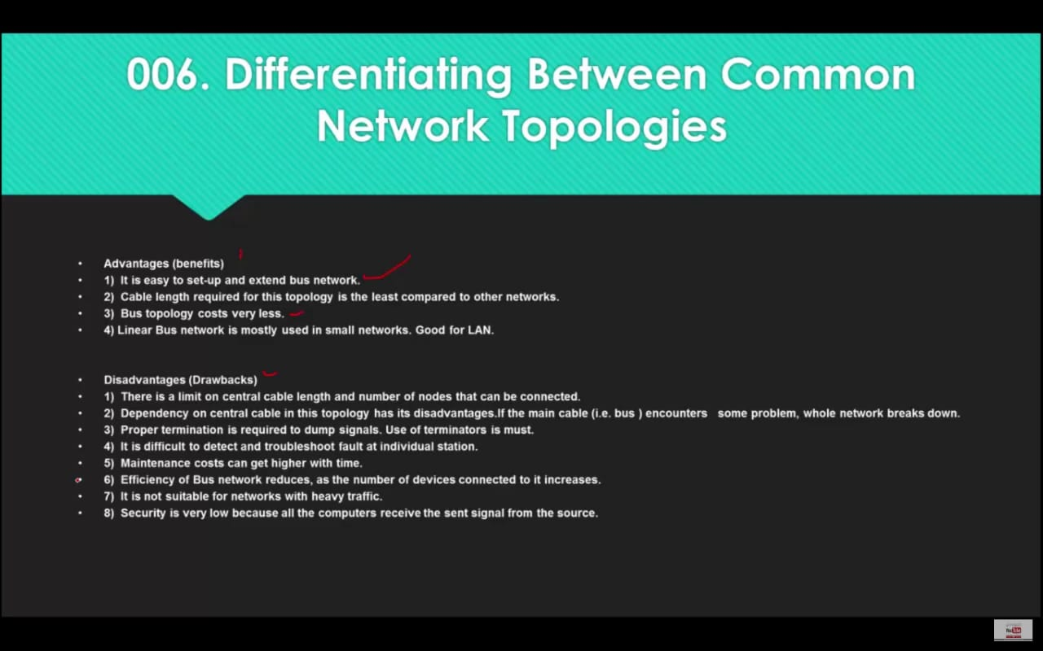

***Star Topology***

* Each device connected to the central device (hup or switch)

***Ring Topology***

* Closed loop
* unidirectional