# Lab 2 - Command Line

## Instructions

1. Answer the below question in the boxes if needed.
2. Code on your computer and zip all your code before submission.
3. Please submit the assignment through TalentLabs Learning System.

## 

## Part 0 Open up Command Line

In this part, we are going to try opening up the terminal on your computer and try running the first command in your terminal.

#### Windows

**Steps**

1. First open up the Powershell on your computer. (Make sure that you are opening the “Windows PowerShell”, not the ISE or x86 version.

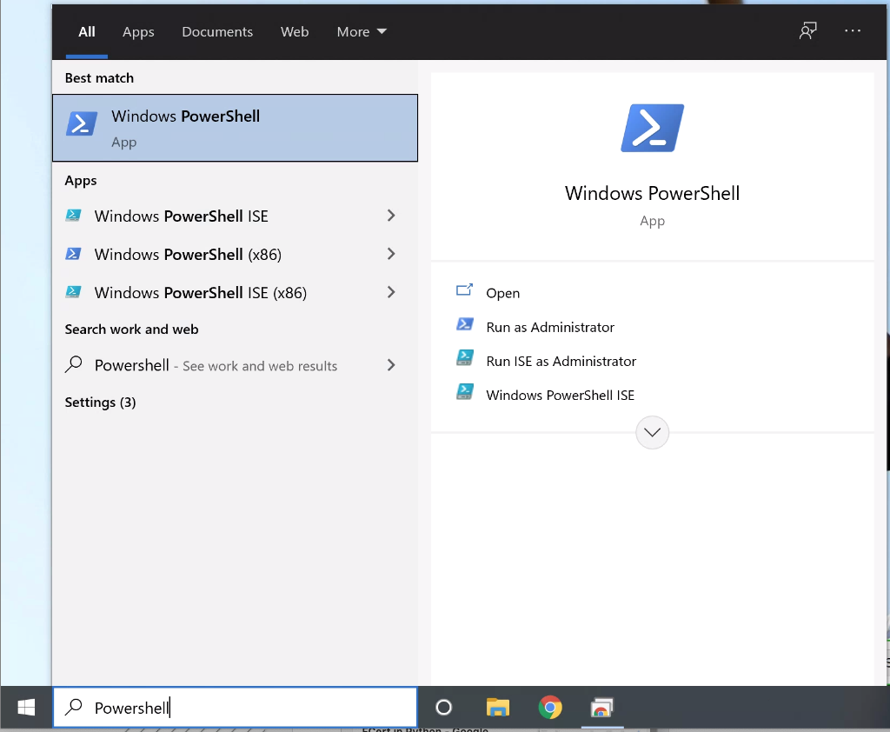

1. If you successfully started up the PowerShell, you should see a windows pop up similar to this one:

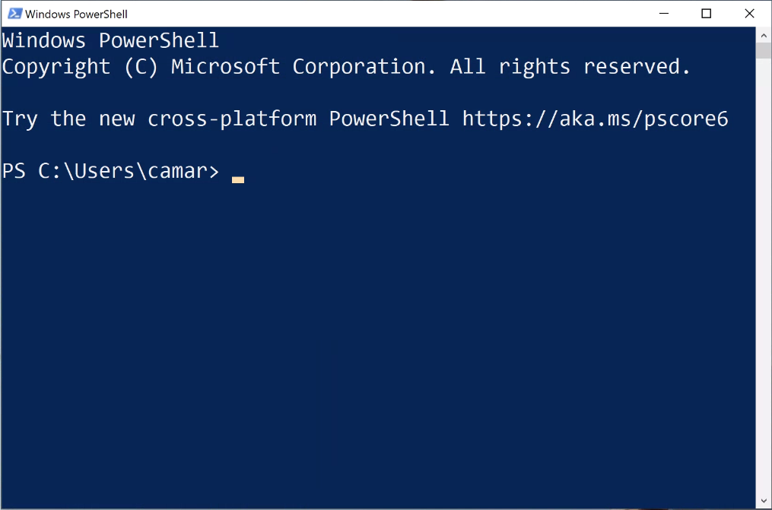

1. Try to type your first command “whoami” in the command prompt and press “Enter” key on your keyboard. You should see it print out your username in the result.

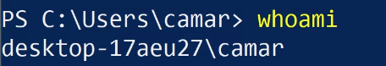

#### Mac

**Steps:**

1. Go to your application folder -> Utilities folder, and open up your “Terminal” app in the folder. (Alternatively, you can search for “Terminal” in Spotlight)

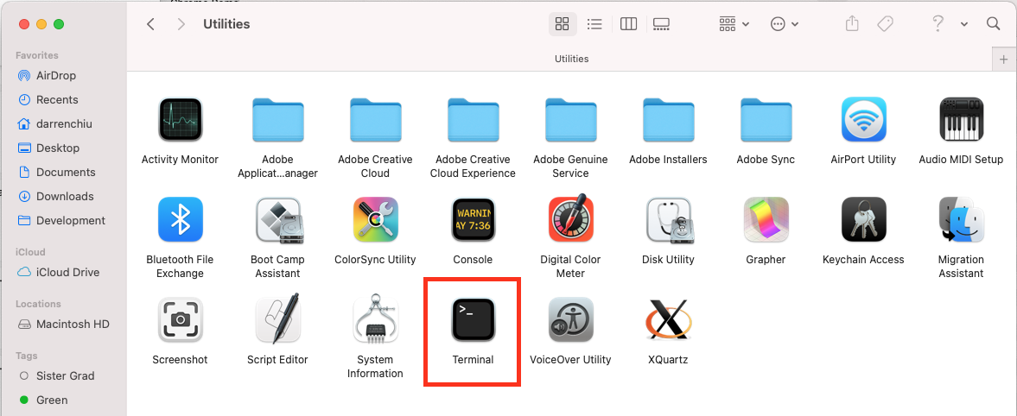

1. If you successfully started up the Terminal, you should see a windows pop up similar to this one:

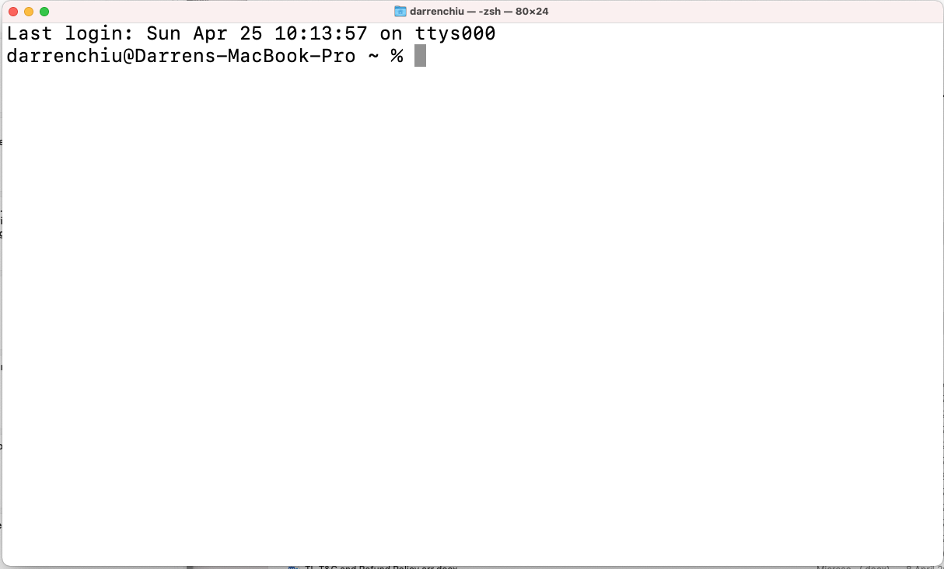

1. Try to type your first command “whoami” in the command prompt and press “Enter” key on your keyboard. You should see it print out your username in the result.



## 

## Part 1 Getting Familiar with the Interface

### 1.1 Print out something in command prompt

We are going to try to print out a line in the command prompt using echo command.

**Steps**

1. Type echo Hello in the command prompt and press “Enter”. You should see that the command line is outputting “Hello” like below.

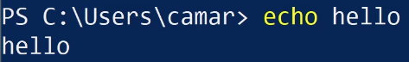 (Windows PowerShell)

 (Mac)

### 1.2 Getting out of trouble

Sometimes, if we typed some wrong command into the terminal, or some error occurred, the terminal will get stuck. Beginners will easily get panic at this point as no mouse is available. In this part, we are going to teach you how to leave the trouble.

Steps

1. First, let’s get into the trouble by typing a wrong command echo ‘hello (no closing quote) and press enter. You should find that your command line is not returning anything and doesn’t look like the usual interface (get stuck). Also, you are not able to type another command and run it.

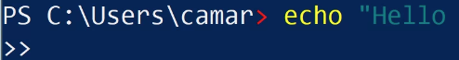

1. At this point, even if you try to type the correct command again, it won’t run. At this point, you will need the magic cure for a situation like this: Ctrl + C. Try pressing Ctrl + C, and your command line will back to normal again (Sometimes it would require pressing the shortcut twice). This shortcut key will save you from most of the troubles when using the command line.

### 

### 1.3 Reusing the previous command

You can quick re-type the previous commands by “pressing the up arrow”. Press once means the previous command. Press twice means getting the previous previous command.

Now try:

Using the up arrow, print to the screen the strings “fee”, “fie”, “foe”, and “fum” without retyping echo each time.

Answer (Put down your key sequences in the box):

|  |
| --- |

### 1.3 Reusing the previous command

Sometimes after working for a while, the command line interface is full of commands, results and mess. You can clean it up using the clear command.

Now try:

Clean up your command line interface by typing clear and press enter.

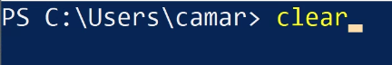

## 

## Part 2 Manipulating Files

We are going to try navigating the file system and try to play around with files and folders a bit in this part. Please reference the lecture notes on the command that you should use and follow the steps. Remember to put down the command you used in the box below.

### 2.1 Setting up the Scene

2.1.1 First, we would like to find out where we are in the command line. What is the command?

|  |
| --- |

2.1.2 We are going to work in the Desktop folder. Let’s first check what is inside our current folder (supposingly, you should have the “Desktop” folder under your current Folder)

|  |
| --- |

2.1.3 Now, we want to navigate to our Desktop from our current location (current folder). What is the command?

|  |
| --- |

2.1.4 You should be in your Desktop folder now. Before we create a folder, let’s try to check what are the folders and files in your Desktop. What is the command?

|  |
| --- |

2.1.5 Let’s create a new folder name “testcommand” on your Desktop. What is the command?

|  |
| --- |

2.1.6 We want to navigate to the “testcommand” folder. What is the command?

|  |
| --- |

2.1.7 We are now in the “testcommand” folder and let’s create a new file named “file1.txt” in it. What is the command?

|  |
| --- |

2.1.8 You should have the “file1.txt” file in the “testcommand” folder now. Please make a copy of “file1.txt” and name it “file2.txt”. What is the command?

|  |
| --- |

2.1.9 Please help me to move the newly created “file2.txt” to your Desktop (one level up). What is the command?

|  |
| --- |

2.1.10 I would like to go back to Desktop from my current position (testcommand folder). What is the command?

|  |
| --- |

2.1.11 To verify that I have successfully moved the “file2.txt” to Desktop, I will need to list out all the files on Desktop and check if “file2.txt” exists. What is the command that I should use?

|  |
| --- |

2.1.12 It’s time to clean things up. What is the command for deleting the “file2.txt”?

|  |
| --- |

2.1.13 Also, don’t forget to delete the “testcommand folder”. What is the command for that? (Hint: You might need to Google for the right command for deleting a folder recursively)

|  |
| --- |

## Part 3 Turn in your assignment

Please turn in your assignment to TalentLabs Learning Management System.