Lab 6 Functions Revisited

## Instructions

1. Answer the below question in the boxes if needed.
2. Code on your computer and zip all your code before submission.
3. Please submit the assignment through TalentLabs Learning System.

## Part 1 Functions

### 1.1 Code Dry-running

In this section, you don’t need to write any code. Just try to run the code in your mind or on a piece of paper. DO NOT test the code with your computer.

Question 1.1 What’s the console output of the following statements? (Hint: the results might be more than 1 line)

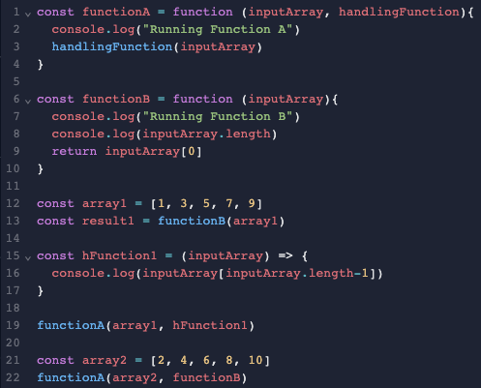

Answer 1.1

|  |
| --- |
| Running Function B  5  Running Function A  9  Running Function A  Running Function B  5 |

Question 1.2 What’s the console output of the following statements? (Hint: the results might be more than 1 line)

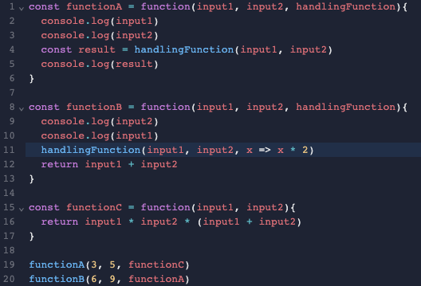

Answer 1.2

|  |
| --- |
| 3  5  120  9  6  6  12 |

## Part 2 Rewriting Functions into Arrow Functions

### 2.1 Code Rewriting

Please rewrite the code block below by using Arrow Functions. Then test it with [repl.it](https://replit.com/languages/javascript).

You can paste a screenshot or type the code in the answer box.

Question 2.1.1

|  |
| --- |
| **Original Code:** |
|  |
| **Rewritten Code:** |
| const functionA = () => console.log(“Hello World”);  functionA();  // Hello World |

Question 2.1.2

|  |
| --- |
| **Original Code:** |
|  |
| **Rewritten Code:** |
| const functionB = input => {  let result = 1;  for (i = 1; i<=input; i++) {  result = result * i;  }  return result;  }  console.log(functionB(3)); // 6 |

Question 2.1.3

|  |
| --- |
| **Original Code:** |
|  |
| **Rewritten Code:** |
| const functionC = (width, height) => {  return width * height;  }  console.log(functionC(5, 2)); // 10 |

Question 2.1.4

|  |
| --- |
| **Original Code:** |
|  |
| **Rewritten Code:** |
| const greeting = (name, greetingFunction) => greetingFunction(name);  const sayHello = name => console.log(“Hello, ” + name);  const sayGoodMorning = name => console.log(“Good Morning, ” + name);  greeting(“Darren”, sayHello); // Hello, Darren  greeting(“Darren”, sayGoodMorning); // Good Morning, Darren |