Lab Assignment 5 - SELECT Queries with Conditions

## Instructions

1. Answer the below question in the boxes.
2. Please submit the assignment through TalentLabs Learning System.

## Open the Movies database

Follow the step illustrated in Chapter 3 to open the Movies database using DB Browser for SQLite. You should see 5 tables in the database.

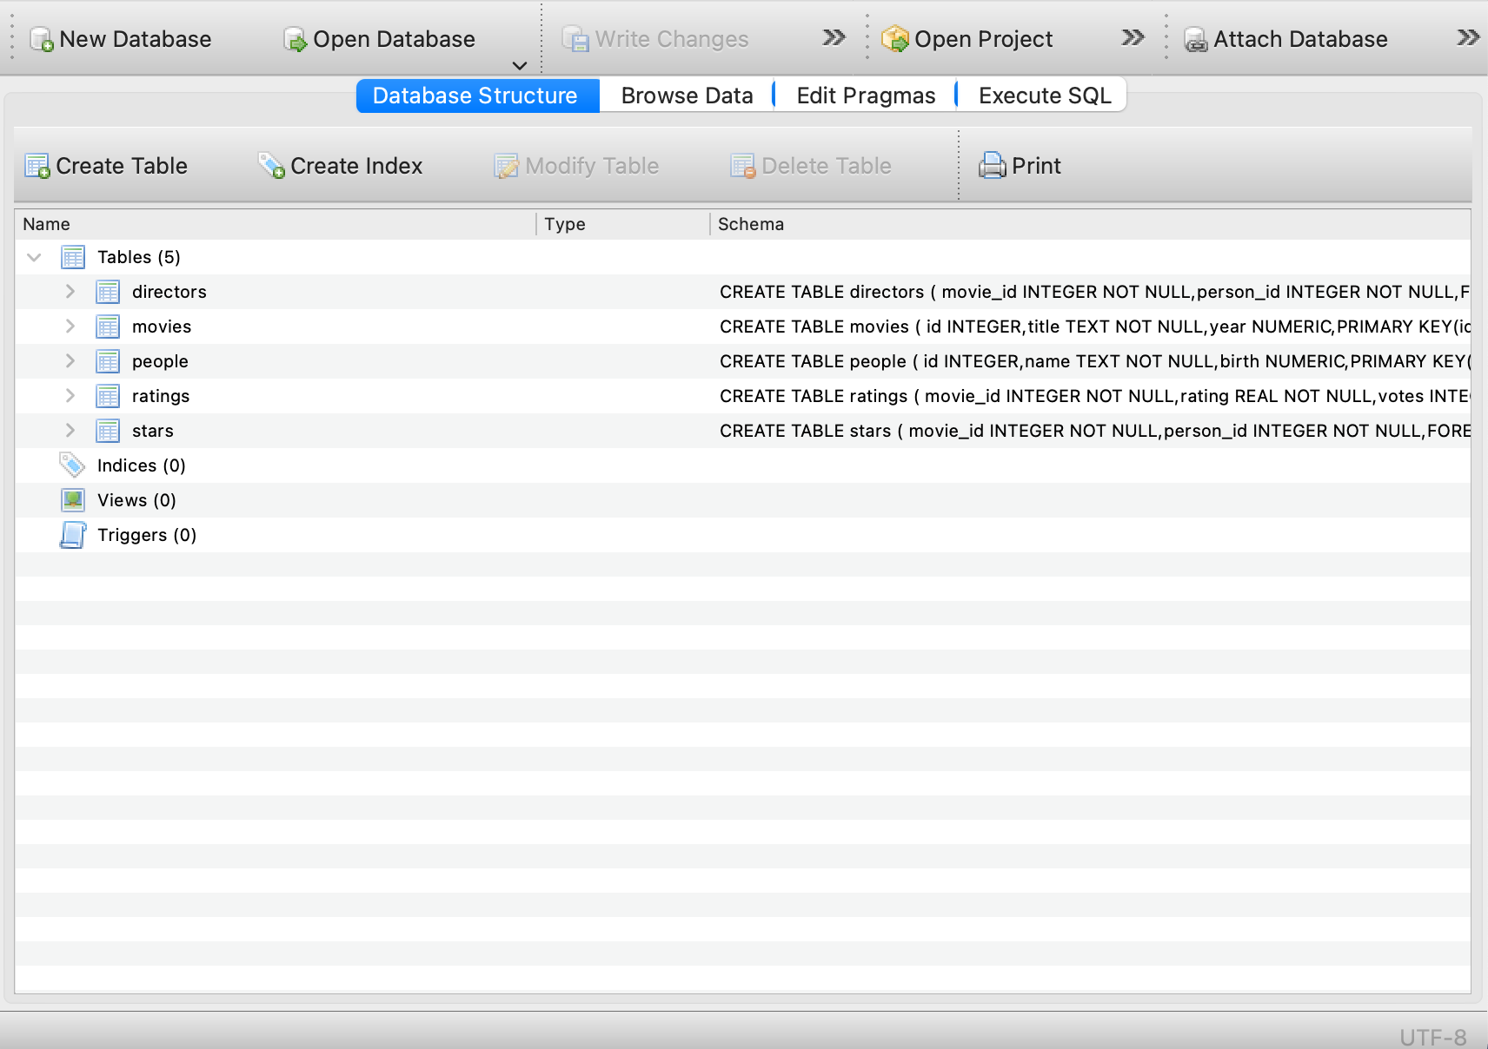

## 

## 

## Query Exercises

For the exercises below, please write the required query and **test in DB Browser for SQLite**. When you succeed, please copy and paste the query you used in the answer box. You can reference the “Expected Output” for what is expected to come out from your query execution.

1. Write a SQL query to list the titles of all movies released in 1990.

**Expected Output:** a table with a single column for the title of each movie.

|  |
| --- |
|  |

1. Write a SQL query to determine the birth year of Benedict Cumberbatch.

You may assume that there is only one person in the database with the name Benedict Cumberbatch.

**Expected Output:** a table with a single column and a single row (plus optional header) containing Benedict Cumberbatch’s birth year.

|  |
| --- |
|  |

1. Write a SQL query to list the titles of all movies with a release date on or after 2000, in alphabetical order.

**Expected Output:** a table with a single column for the title of each movie.

|  |
| --- |
|  |

1. Write a SQL query to determine the number of movies with an IMDb rating > 9.8.

**Expected Output:** a table with a single column and a single row (plus optional header) containing the number of movies higher than 9.8 rating.

|  |
| --- |
|  |

1. Write a SQL query to list the titles and release years of all Captain America movies, in chronological order.

You may assume that the title of all Captain America movies will begin with the words “Captain America”, and that if a movie title begins with the words “Captain America”, it is a Captain America movie.

**Expected Output:** a table with two columns, one for the title of each movie and one for the release year of each movie.

|  |
| --- |
|  |

**- End of Assignment -**