Lab 1 - Moving Your Projects to GitHub

## Instructions

1. Answer the below question in the boxes.
2. Please submit the assignment through TalentLabs Learning System.

## Part 1 Setting up your GitHub Profile

### 1.1 Sign up an account

In this part, you are going to set up your GitHub account, so you can start browsing all the open-source software code on Github and store your own projects there.

If you already have a GitHub account, feel free to skip this part and use your existing GitHub account.

1. Go to [github.com](https://github.com/)
2. At the top right hand corner, press “Sign Up” button, and follow the instructions

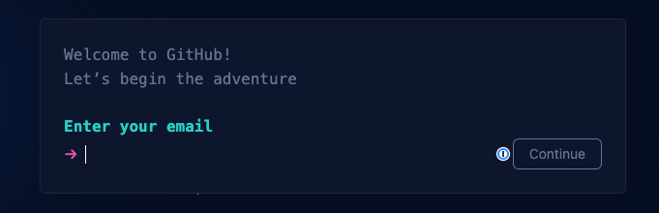

1. Once your account is set up successfully, you should be able to login to the site.

### 1.2 Creating your first git repository

Steps:

1. On Github.com, at the top right hand corner, press the “+” sign and click “New Repository”.

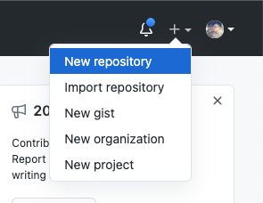

1. Fill in the page with the repository details. You can reference the one below:

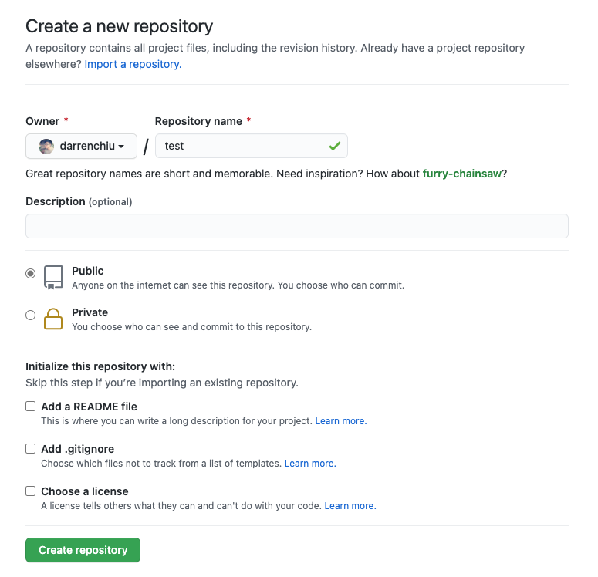

1. When you see a page like this, then you have successfully created the new repo.

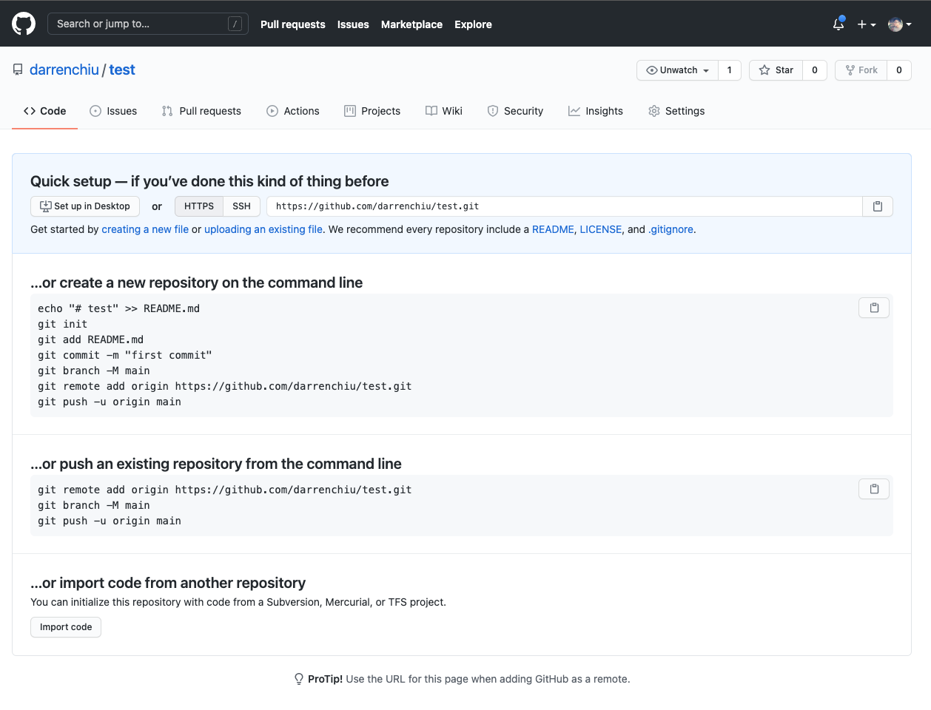

1. Create a project folder locally and name it as “test”
2. Navigate to the project folder in terminal
3. Run the code below one by one. Try to understand the meaning of the line of code before running it. (This should be the same as the code on the GitHub repo page)
   1. echo "# test" >> README.md
   2. git init
   3. git add README.md
   4. git commit -m "first commit"
   5. git branch -M main
   6. git remote add origin <github project path>
   7. git push -u origin main
4. Verify if you have successfully linked up your local project folder with the repo on GitHub by refreshing the GitHub repo page. You should see the screen below (branch = main, and there is one file there - README.md)

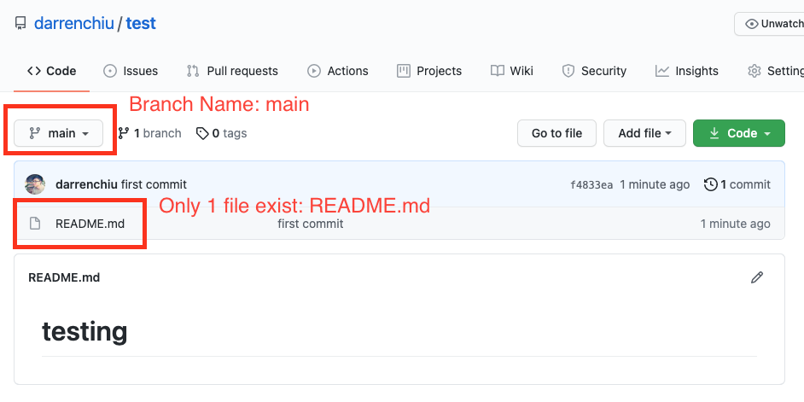

## 

## Part 2 Creating a Pull Request using Visual Studio Code

In this part, you are going to try to simulate in a work environment, where you work on some code changes, then push to GitHub and create a Pull Request (PR) for your manager’s review.

We have included the steps in the Visual Studio Code user interface for you. But **you can achieve the same by using the git commands** that we taught you in the lecture videos. Using Visual Studio Code is usually easier for beginners.

We have also included the command in the title of each part. **You are encouraged to try using the command line as well.**

### 2.1 Making Changes (git branch)

1. Open the project you created in Part 1 in Visual Studio Code.
2. Create a new branch by switching to the “Version Control” tab on the left.

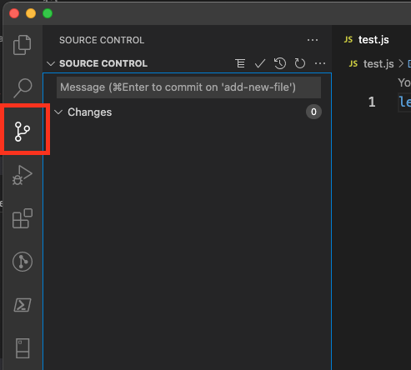

1. Then create a new branch by pressing the “...” -> Branch -> “Create Branch”

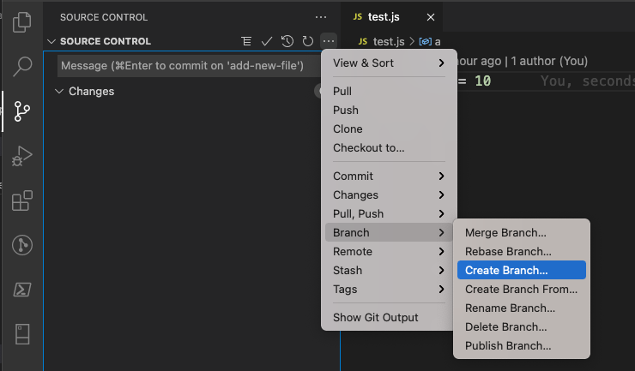

1. In the popup, enter the new branch name as “test-add-file”
2. Now try to create a new js file “testing.js” in your repository (project folder) as usual. Put some js code in it.
3. Switch back to the “Version Control” tab on the left hand side. If you have done it correctly, you should be able to see your “testing.js” file in the changelist.

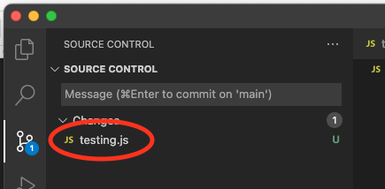

### 

### 2.2 Making Changes (git commit and git push)

1. Press the “+” sign next to “testing.js” to add it to staging, which means about to commit. (Note: In reality, everytime you make changes, the staging usually have multiple files instead of 1).

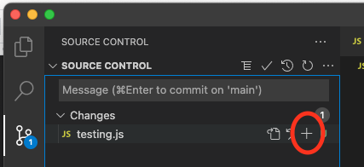

1. If you can see your testing.js file in the staging list, then we can commit and push the change (new file) to GitHub. Let’s commit the changes now by clicking the “...” -> Commit -> Commit Staged. You will be prompted to put a commit message. The message should describe what you changed in this commit.

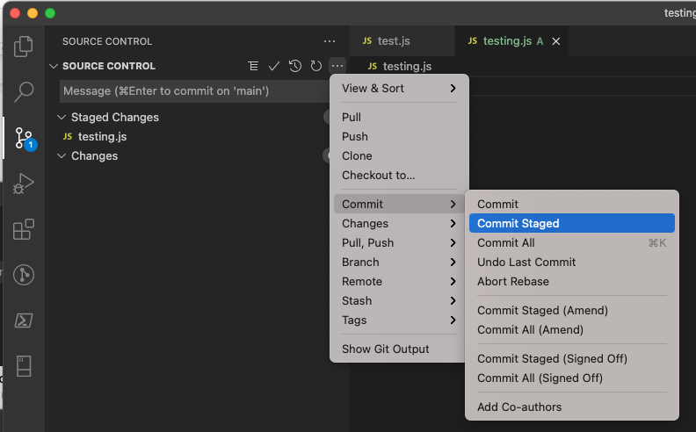

1. We can finally push the changes to GitHub for others to review. Please click “...” -> Push

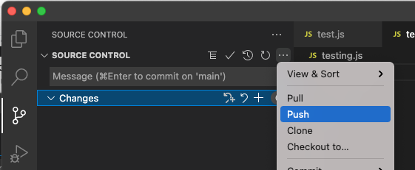

1. Now you can go to GitHub, and refresh your repository page, and see if you have successfully pushed the change.

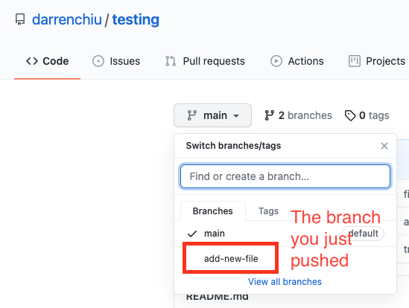

### 

### 2.3 Creating a Pull Request

1. Go to your GitHub repository page and create a Pull Request.

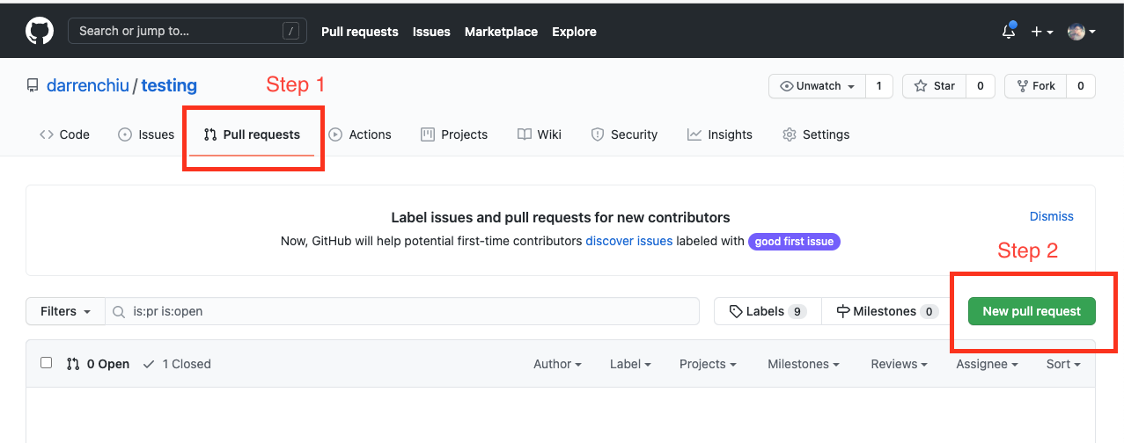

1. Pick the branch you just pushed under “Compare” and the base should be “main. Make sure you pick the right one.

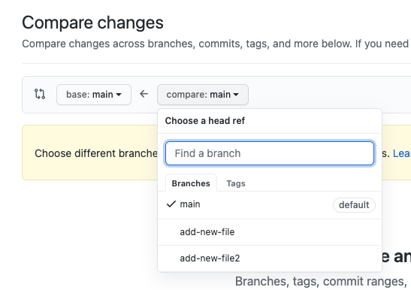

1. After checking the PR (e.g. confirming the changes are what you are expecting, press the “Create pull request” button. Then put in some comments for this PR if you want to. Then confirm this pull request.

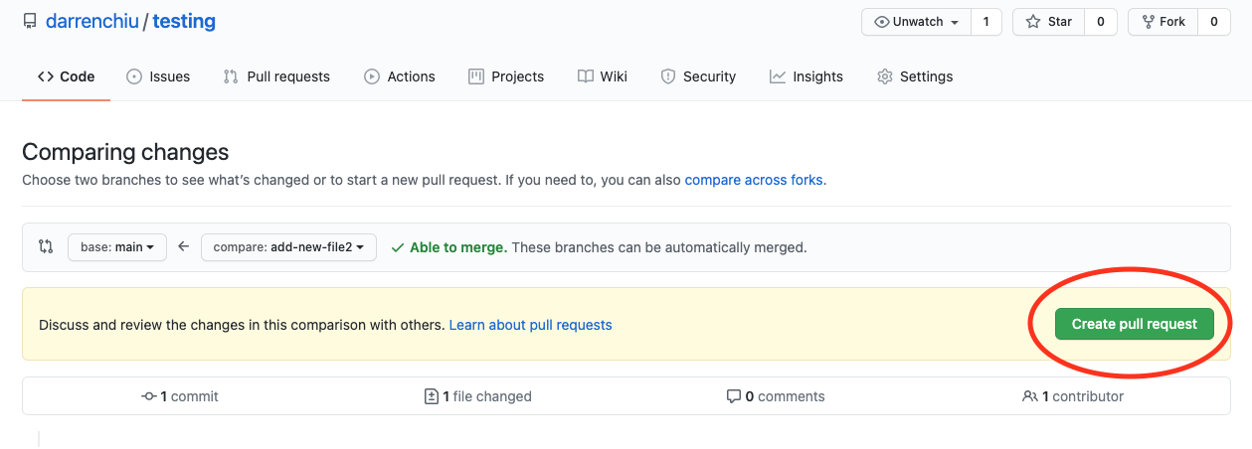

1. If you have done it correctly, you would be seeing a screen like this one:

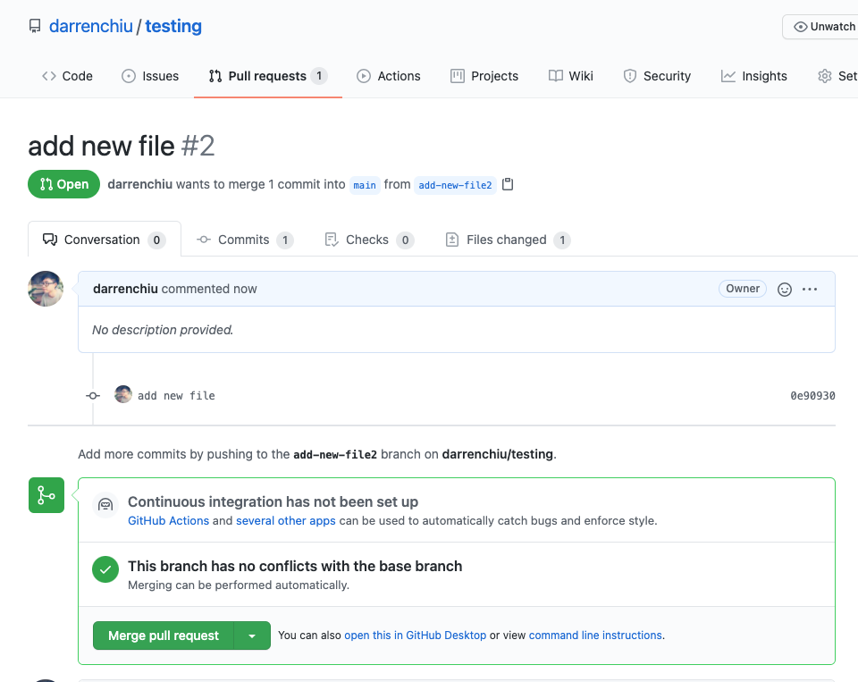

## Part 3 Migrate one of your projects to GitHub

This part is for you to try out migrating one of your projects to GitHub. Feel free to pick any one (or all) projects in this course, and move it to GitHub. In the future, you can easily showcase your project with future employers or friends by sharing the repository or GitHub profile link.

## Part 4 Submission

### List out the repository address you created in Part 1, 2 and 3 below. Then upload this document to TalentLabs Learning Management System.

| Parts | Repository Address |
| --- | --- |
| 1 and 2 |  |
| 3 |  |