Lab 3 - Trying AWS

## Instruction

## Follow the instructions and answer the below question in the boxes.

1. Please submit the assignment through TalentLabs Learning System.

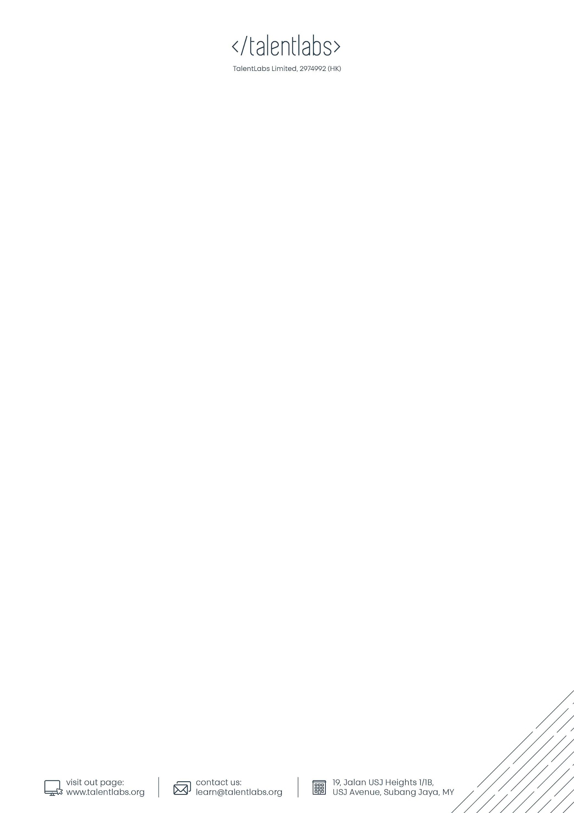

## Part 1 Setting up AWS Account

### 1.1 Sign up an account

In this part, you are going to set up your AWS account, so you can start using all the free tier services.

1. Go to <https://aws.amazon.com/>
2. At the top right hand corner, press the “Create an AWS Account” button, and follow the instructions. Prepare a mobile phone that could receive SMS as you will need to use that to verify your account.

If you are asked to enter a credit/debit card for billing, please do. You may be charged for a very small amount to verify your card (e.g. USD0.01).

After the successful setup, you WILL NOT be charged for the usage below AWS Free Tier limits. (If you are following our instructions, then you should not exceed the limit).

There are some cases where the bank might stop you from using the card on AWS. In these cases, please call up the bank and tell them your situation.

1. Once your account is set up successfully, you should be able to login to the site.

## Part 2 Spin up a virtual machine

### 2.1 Spin up a EC2 Machine

Steps:

1. On the AWS console, search for EC2 in the search bar. Pick “EC2” in the result.

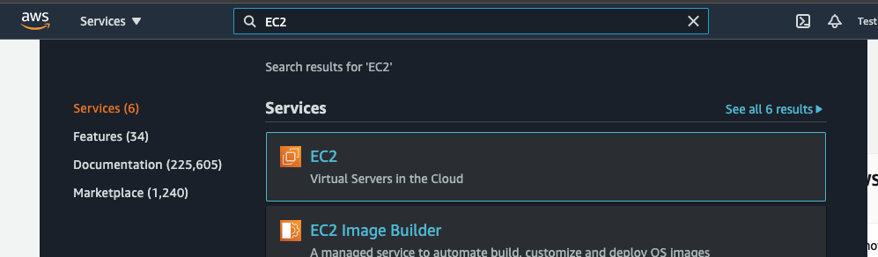

1. You will then reach the EC2 management page. (Your page might look a bit different from the screenshot). Please find the button for “Launch Instance”.

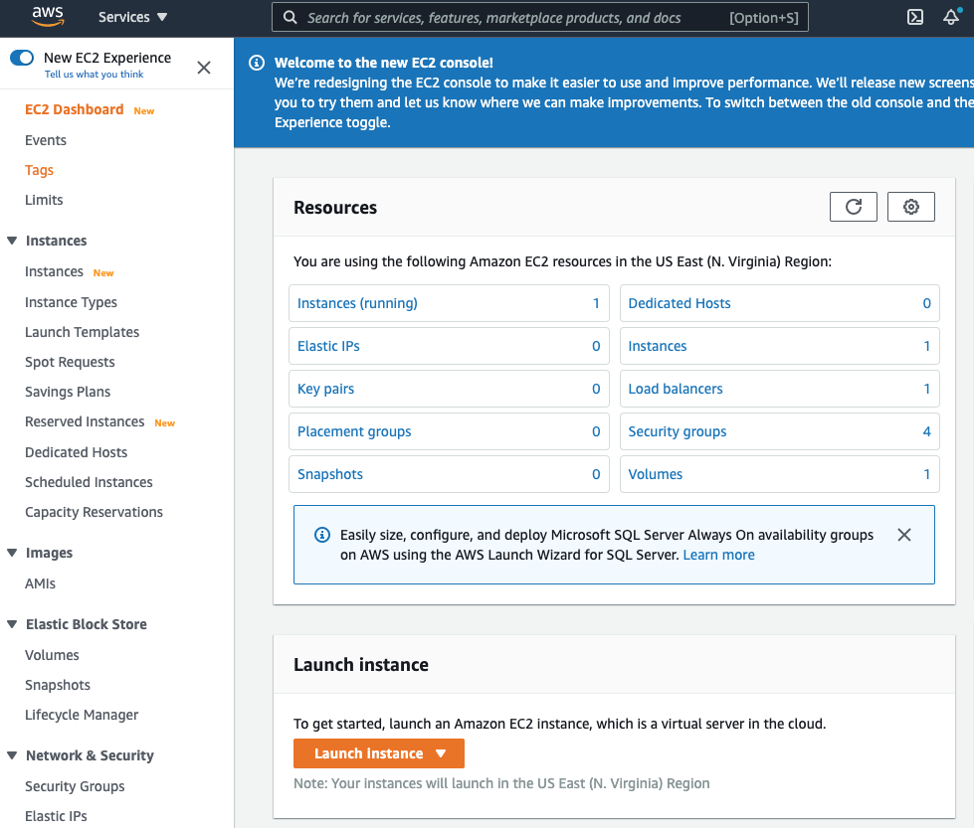

1. You will then see a list of Operating system and server that you can pick from. Please pick the “Amazon Linux 2 AMI”.

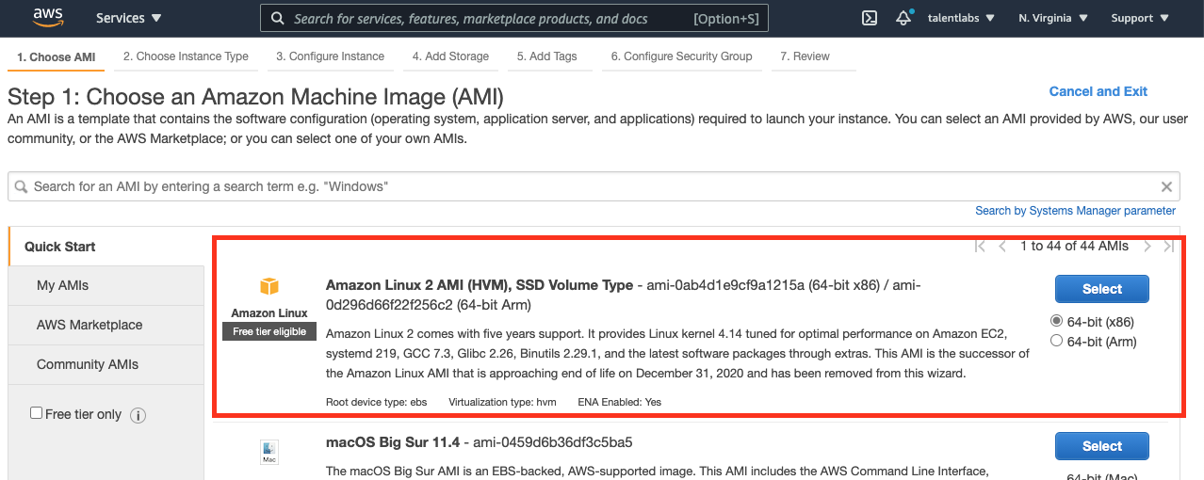

1. In the next page, then you will see that you can pick from a list of different machines. Pick the one that’s “Free tier eligible”, which should be “t2.micro” type.
2. Then press “Review and Launch”. Then you will be seeing Step 7 like the page below:

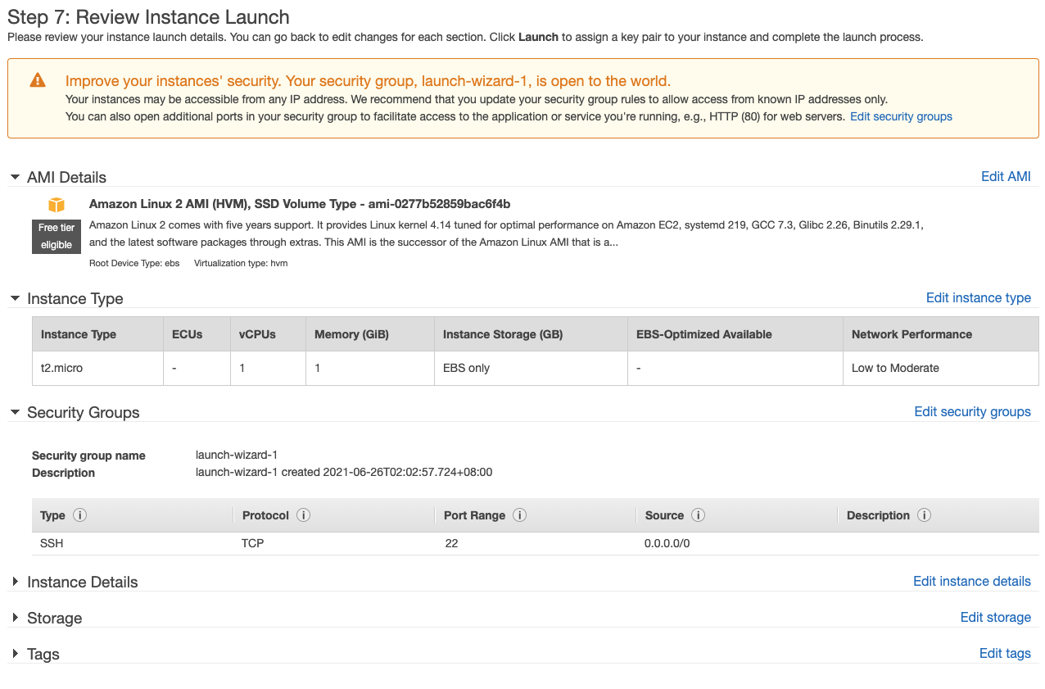

1. On this Step 7 page, just press “Launch” at the bottom right corner. Then you would see a pop up like this one:

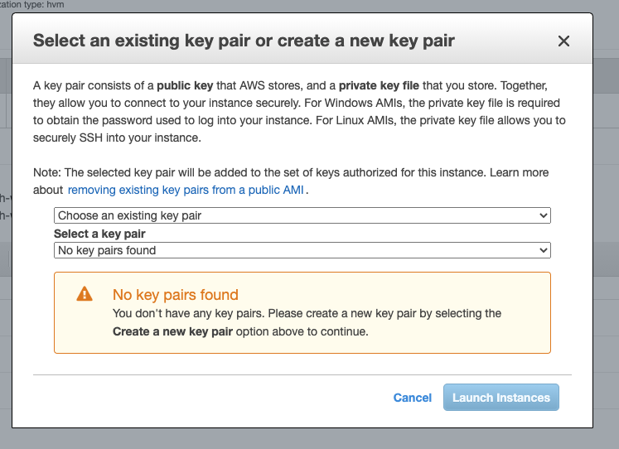

1. In the pop-up, in the first drop down list, pick “Create a new key pair”. Give the key a name in the “key pair name”. Then press the “Download Key Pair”. Keep the file you downloaded. Then press “Launch Instances”. **(Make sure you have downloaded the key and save it properly on your computer before you click “Launch Instances”. There is no way back.)**

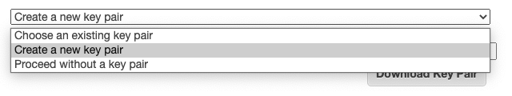

1. After a while, you should see a page like this one, showing that you have successfully created an EC2 virtual machine on AWS.

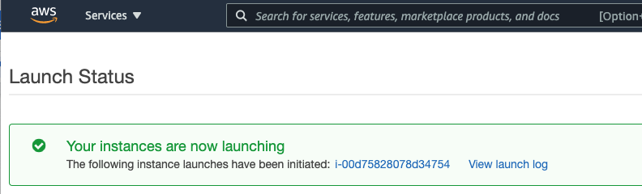

1. Press the “View Instances” button at the bottom right corner. You will the be directed to a page like this:

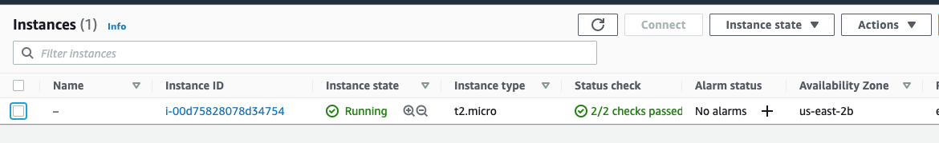

1. Select your new VM by checking the checkbox for the only EC2 VM. Then press “Actions” -> “Connect”. You should now see this on your screen:

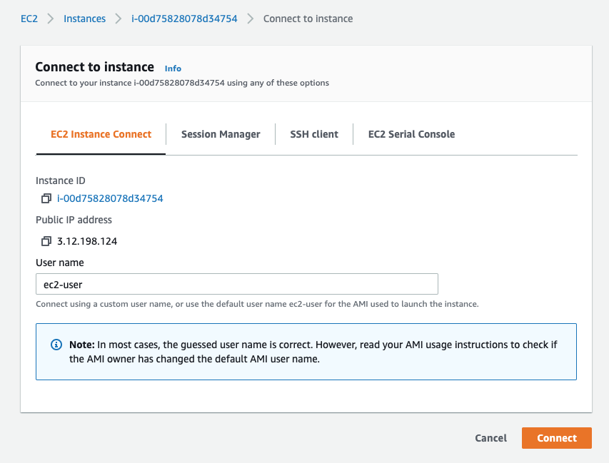

1. Make no change and just press the “Connect” button at the bottom right. A new window or tab should pop up and you should see a black screen like below. Does it look similar to the Terminal or PowerShell on your machine? This is the reason why we need to learn about those terminal commands before. There are no graphical interfaces for remote machines!

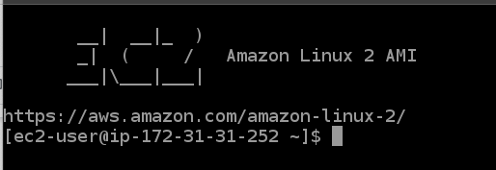

1. Try some terminal commands that you usually use in this “remote computer”. Some commands that you can try included:

| **Commands** |
| --- |
| whoami |
| mkdir test |
| cd test |
| touch test1.txt |
| ls -l |

1. Do a screenshot of what you tried and paste it in Part 4 (end of the assignment) to show that you have successfully created a EC2 virtual machine and tried using it.
2. After you are done with trying, and playing, just close the tab in the browser.

## 

## Part 3 Creating a S3 Storage Folder

In this part, you are going to try to create a “bucket” (similar to a folder) in your AWS account and get a link for people to download an image.

### 3.1 Create a S3 bucket

1. Go back to your AWS Console. In the search bar, type “S3” and pick “S3” to enter the S3 management panel.

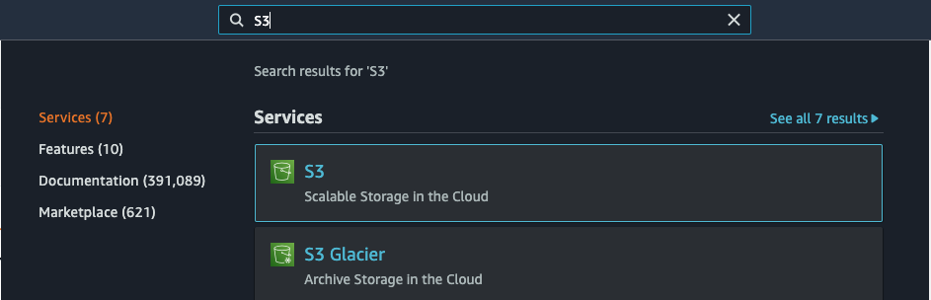

1. You will then be directed to the S3 panel. Click the orange “Create bucket” button on the right.

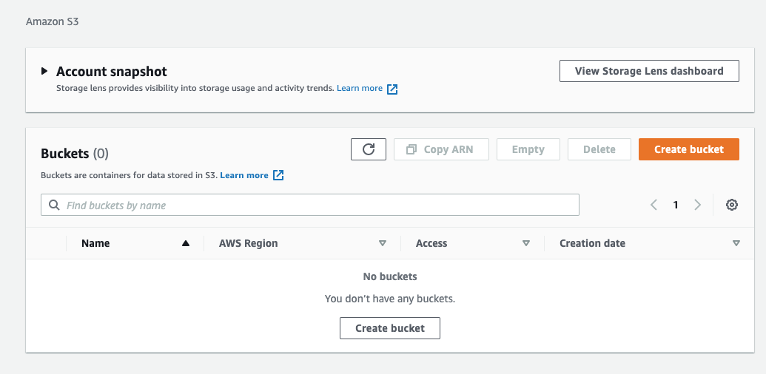

1. On the bucket setup page, you will need to fill in some information. For fields not specified below, just leave it as-is.

| Field | Value |
| --- | --- |
| Bucket Name | Pick any name you like |
| Block all public access | Uncheck the box, and acknowledge.  **(This is only for our testing purpose. For an actual project in reality, DO NOT do this as this would be sharing all the files in this bucket with the public, i.e. no security at all.)** |

1. You will then be redirected to the S3 console again. Click into your newly created bucket.

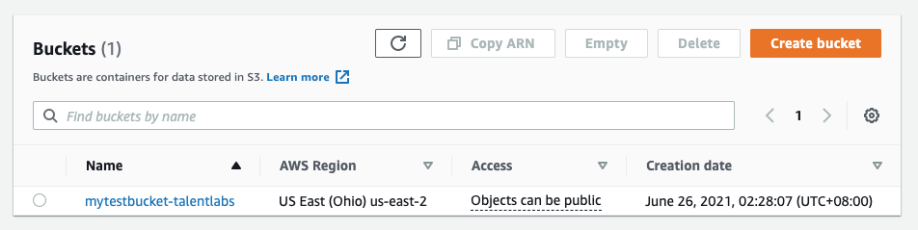

### 3.2 Upload a file to your S3 bucket

1. After getting into the bucket, just upload a random image to the bucket by clicking the “Upload Files” button. Any image will do. In the “Upload” page, make sure you pick “Grant public-read access” in the “Permissions” panel. This would enable the public to access your file without logging in.

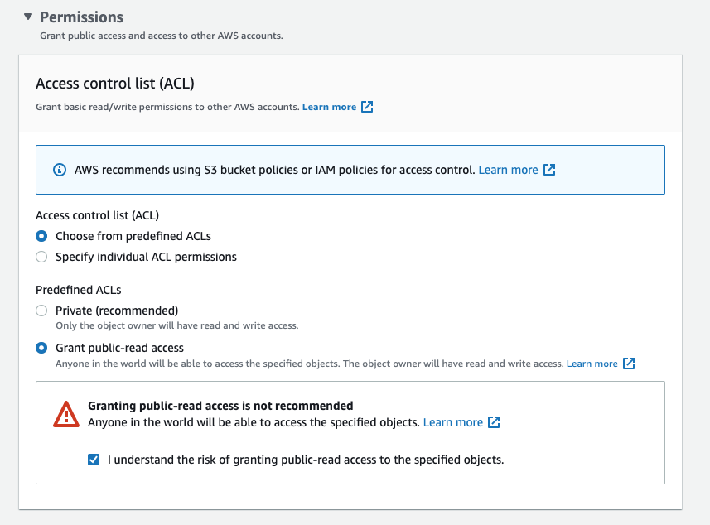

1. Wait for the upload to complete. Then you can click on the file name that you just uploaded.

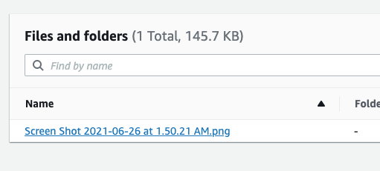

1. In the pop-up page, copy the Object URL and paste in the Part 4 (end of the assignment) below.

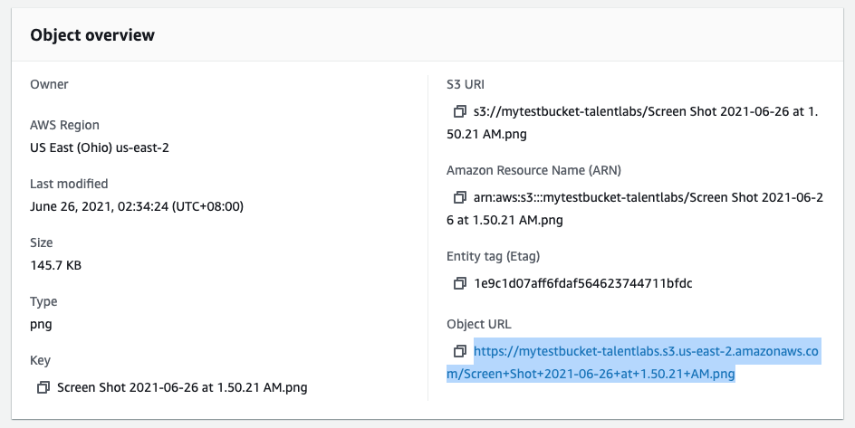

1. Send this URL to your mobile phone (by using whatsapp, messenger or any messaging method). Open it on your mobile phone. You should be able to open up the image. (If there is an error about the access of the file, that means you didn’t enable public access to your file properly)

## Part 4 Submission

### Fill in the boxes below with the results from Part 2 and 3. Then upload the completed document to TalentLabs Learning Management System.

| Part 2 (Screenshot) |  |
| --- | --- |
| Part 3 (Object URL) |  |

## Part 5 Clean Up

AWS Free Tier only last for 1 year. You will need to terminate everything that you set up within 1 year or AWS will start charging your card.

Please make a reminder to yourself to delete everything or shut down the whole AWS account **once you have finished studying the module**.

To shut down your AWS account, you can refer to this link: <https://aws.amazon.com/premiumsupport/knowledge-center/close-aws-account/>