Lab 4 - Deploying Your Projects to AWS

## Instruction

## Follow the instructions and answer the below question in the boxes.

1. Please submit the assignment through TalentLabs Learning System.

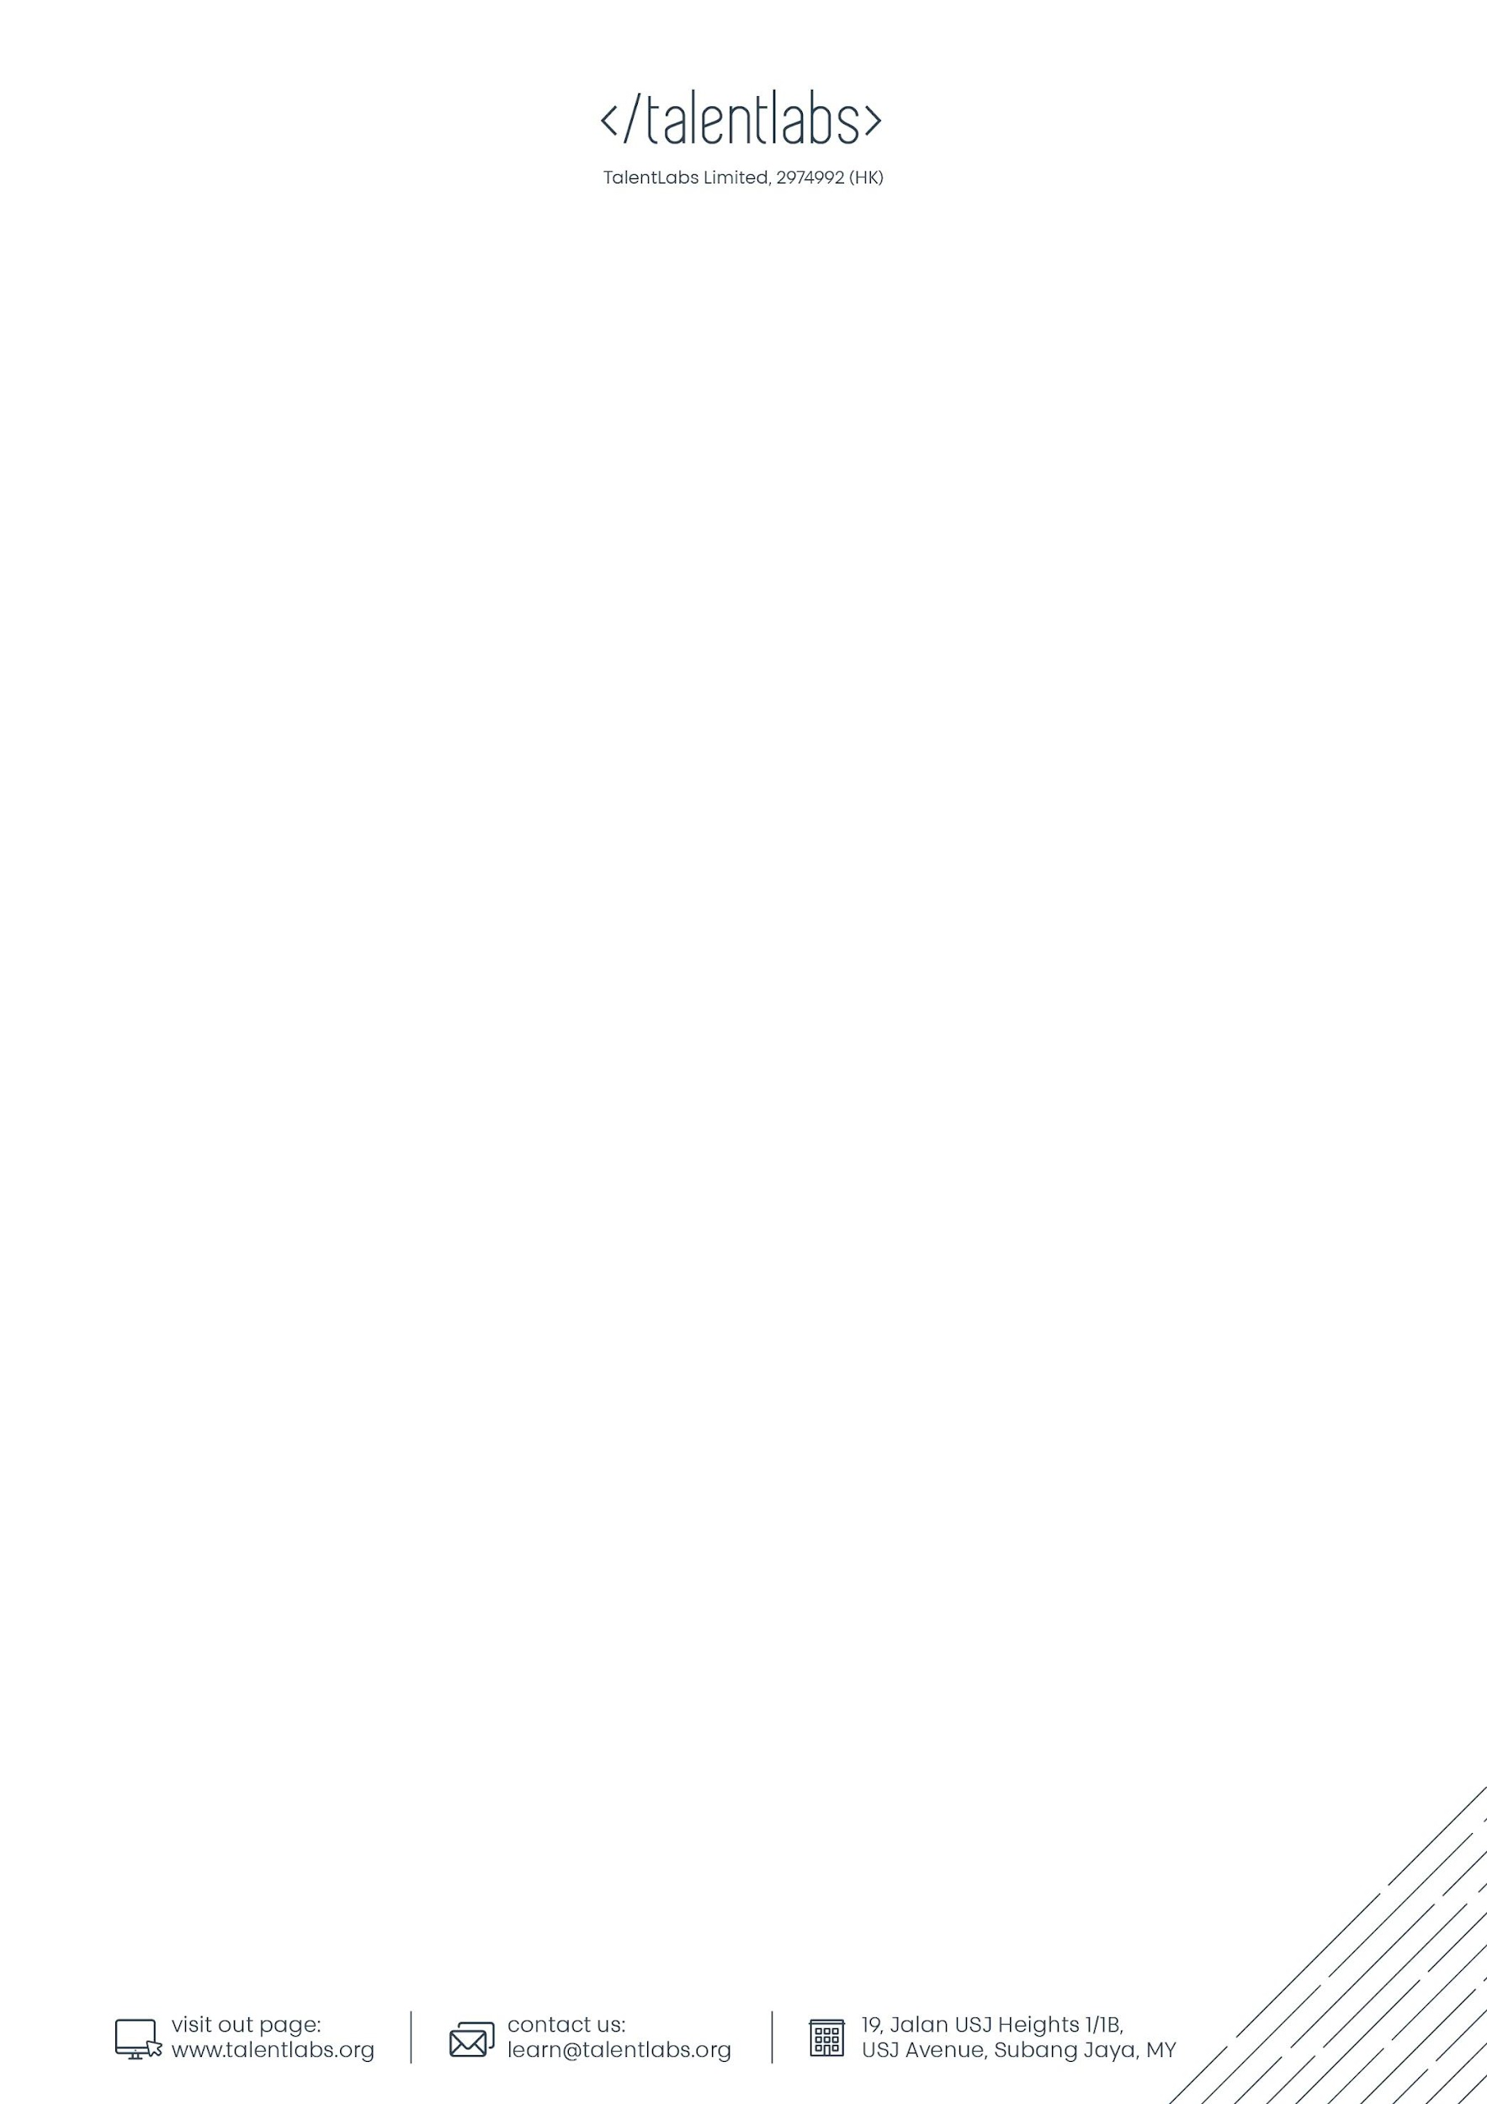

## Note: In this assignment, you are only required to complete the relevant parts for your study programme. Please pick the parts that are relevant to your study programme.

## You can also refer to the table below to help you in picking the part for your assignment.

|  |  |
| --- | --- |
| Type of application you built in previous modules | Part(s) to complete the assignment |
| React | Part 1 |
| ExpressJS | Part 2 |
| Static HTML webpage | Both Part 3 and Part 4 |

## Part 1 Deploying React App you AWS Amplify

### 1.1 Move your project to GitHub

In this part, please move one of your React projects to GitHub. If you have already done it in the lab before, then you can skip this part.

If you haven’t done it yet, please refer to the GitHub lab manual to move one of your React projects to GitHub.

### 1.2 Deploy your React App to AWS Amplify

Follow the steps in the lecture notes (Part 4.1) or the official documentation on AWS, deploy your React App to AWS Amplify.

Official Documentation:

<https://aws.amazon.com/getting-started/hands-on/build-react-app-amplify-graphql/module-one/>

After completing the step, copy the application URL to Part 5 of this document.

## Part 2 Deploy Express App to AWS Elastic Beanstalk

Follow the steps in the lecture notes (Part 4.2), deploy your ExpressJS App to AWS Elastic Beanstalk.

After completing the step, copy the application URL to Part 5 of this document.

## Part 3 Deploy Static HTML Webpage on AWS S3

Follow the Step-by-step guide of hosting static website on AWS S3: <https://docs.aws.amazon.com/AmazonS3/latest/userguide/HostingWebsiteOnS3Setup.html>, deploy your static HTML site to AWS S3.

After completing the step, copy the webpage URL to Part 5 of this document.

## Part 4 Deploy Static HTML Webpage on GitHub

Follow the Step-by-step guide in the lecture note (Part 4.4) and deploy your static HTML website to GitHub.

After completing the step, copy the webpage URL to Part 5 of this document.

## Part 5 Submission

### Fill in the table below with the link that you created in Part 1 and 2. Then press the “Turn in” button on the top right hand corner.

|  |  |
| --- | --- |
| **Part** | **URL** |
| Part 1 |  |
| Part 2 |  |
| Part 3 |  |
| Part 4 |  |

## Part 6 Clean Up

AWS Free Tier only last for 1 year. You will need to terminate everything that you set up within 1 year or AWS will start charging your card.

Please make a reminder to yourself to delete everything or shut down the whole AWS account **once you have finished studying the module**.

To shut down your AWS account, you can refer to this link: <https://aws.amazon.com/premiumsupport/knowledge-center/close-aws-account/>

**- End of Assignment -**