Code-Fix.R
User
2025-11-25
library(tidyverse)
## ── Attaching core tidyverse packages ──────────────────────── tidyverse 2.0.0 ──
## ✔ dplyr 1.1.4 ✔ readr 2.1.5
## ✔ forcats 1.0.0 ✔ stringr 1.5.1
## ✔ ggplot2 3.5.1 ✔ tibble 3.2.1
## ✔ lubridate 1.9.3 ✔ tidyr 1.3.1
## ✔ purrr 1.0.2
## ── Conflicts ────────────────────────────────────────── tidyverse_conflicts() ──
## ✖ dplyr::filter() masks stats::filter()
## ✖ dplyr::lag() masks stats::lag()
## ℹ Use the conflicted package (<http://conflicted.r-lib.org/>) to force all conflicts to become errors
library(lubridate)
library(dplyr)
library(forecast)
## Registered S3 method overwritten by 'quantmod':
## method from
## as.zoo.data.frame zoo
library(scales)
##
## Attaching package: 'scales'
##
## The following object is masked from 'package:purrr':
##
## discard
##
## The following object is masked from 'package:readr':
##
## col_factor
options(scipen = 999)
options(warn = -1)
data<- "ICAOctober25cleaned.csv"
catastrophe_data <- read_csv(data)
## Rows: 340 Columns: 23
## ── Column specification ────────────────────────────────────────────────────────
## Delimiter: ","
## chr (10): CAT Name, Event Name, Event Start, Event Finish, Financial Year, S...
## dbl (13): Year, ORIGINAL LOSS VALUE, NORMALISED LOSS VALUE (2022), TOTAL CLA...
##
## ℹ Use `spec()` to retrieve the full column specification for this data.
## ℹ Specify the column types or set `show_col_types = FALSE` to quiet this message.
CLAIM_COLS <- c(
"TOTAL CLAIMS RECEIVED", "Domestic Building Claims",
"Domestic Content Claims", "Domestic Motor Claims",
"Domestic Other Claims", "Commercial Property Claims",
"Commercial motor", "Commercial BI Claims",
"Commercial Other Claims", "Commercial Crop Claims"
)
clean_numeric <- function(x) {
as.numeric(gsub("[$,]", "", x))
}
cleaned_data <- catastrophe_data %>%
select(
`Event Name`, Type, `Event Start`,`Event Finish`, Year,
Original_Loss = `ORIGINAL LOSS VALUE`,
Normalized_Loss = `NORMALISED LOSS VALUE (2022)`,
all_of(CLAIM_COLS)
) %>%
mutate(
Original_Loss = clean_numeric(Original_Loss),
Normalized_Loss = clean_numeric(Normalized_Loss),
across(all_of(CLAIM_COLS), ~replace_na(clean_numeric(.), 0)),
Event_Start = dmy(`Event Start`),
Year = year(Event_Start)
) %>%
filter(!is.na(Normalized_Loss) & Normalized_Loss > 0)
# Analysis Part 1: Trends in Frequency and Severity
yearly_trends <- cleaned_data %>%
# Group by Year and summarize
group_by(Year) %>%
summarise(
Frequency = n(),
Total_Severity_Billion_AUD = sum(Normalized_Loss) / 1e9
) %>%
ungroup() %>%
filter(Year <= 2024) # Exclude the partial 2025 entry for cleaner trends
# Plot Frequency
freq_plot <- yearly_trends %>%
ggplot(aes(x = Year, y = Frequency)) +
geom_line(color = "blue", linewidth = 1) +
geom_point(color = "darkblue") +
geom_smooth(method = "loess", color = "lightblue", se = FALSE) +
labs(
title = "A. Catastrophe Event Frequency Over Time",
subtitle = "Count of events per year (1967-2024)",
x = "Year",
y = "Number of Catastrophes Declared"
) +
theme_minimal() +
scale_x_continuous(breaks = seq(min(yearly_trends$Year), max(yearly_trends$Year), by = 10))
# Plot Severity
severity_plot <- yearly_trends %>%
ggplot(aes(x = Year, y = Total_Severity_Billion_AUD)) +
geom_bar(stat = "identity", fill = "red3") +
geom_smooth(method = "loess", color = "darkred", linewidth = 1, se = FALSE) +
labs(
title = "B. Total Annual Normalized Severity Over Time",
subtitle = "Total Normalized Loss Value (in billions AUD 2022) per year (1967-2024)",
x = "Year",
y = "Total Normalized Loss (AUD Billion)"
) +
theme_minimal() +
scale_x_continuous(breaks = seq(min(yearly_trends$Year), max(yearly_trends$Year), by = 10)) +
scale_y_continuous(labels = dollar_format(prefix = "$"))
print(freq_plot)
## `geom_smooth()` using formula = 'y ~ x'
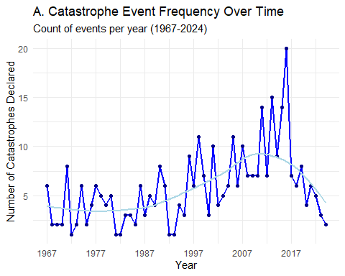
print(severity_plot)
## `geom_smooth()` using formula = 'y ~ x'
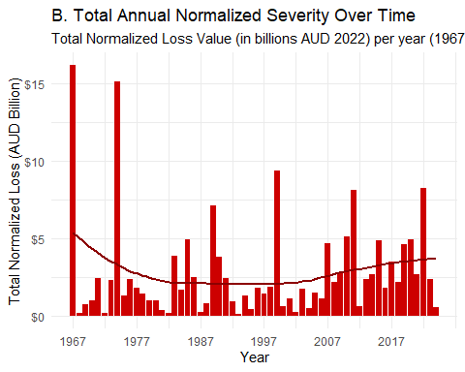
#Analysis Part 2: Correlations between Catastrophe Type and Claims
claims_by_type <- cleaned_data %>%
group_by(Type) %>%
summarise(
Total_Claims = sum(`TOTAL CLAIMS RECEIVED`),
across(all_of(CLAIM_COLS[-1]), sum) # Sum all other claim types
) %>%
filter(Total_Claims > 1000) %>%
mutate(across(all_of(CLAIM_COLS[-1]), ~./Total_Claims)) %>%
select(Type, all_of(CLAIM_COLS[-1])) %>%
pivot_longer(
cols = -Type,
names_to = "Claim_Category",
values_to = "Proportion"
)
# Plot the distribution of claim categories by Catastrophe Type
claims_plot <- claims_by_type %>%
ggplot(aes(x = Type, y = Proportion, fill = Claim_Category)) +
geom_bar(stat = "identity", position = "fill") +
scale_y_continuous(labels = percent) +
labs(
title = "Claim Composition by Catastrophe Type",
subtitle = "Proportion of total claims received per event type",
x = "Catastrophe Type",
y = "Proportion of Total Claims",
fill = "Claim Category"
) +
coord_flip() + # Flip coordinates for readability
theme_minimal() +
scale_fill_brewer(palette = "Paired") # Use a colorblind-friendly palette
print(claims_plot)
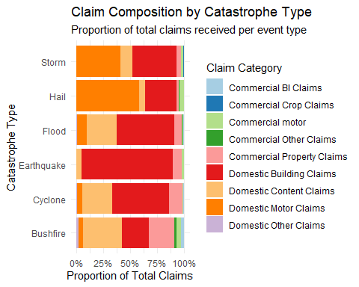
# Prepare data for correlation:
# Group by Catastrophe Type and sum all claims and losses for each type
claims_correlation_data <- cleaned_data %>%
group_by(Type) %>%
summarise(
Total_Normalized_Loss = sum(Normalized_Loss),
across(all_of(CLAIM_COLS), sum) # Sum all claim types
) %>%
ungroup() %>%
# Filter out event types that have very low total claims for stability
filter(`TOTAL CLAIMS RECEIVED` > 50000)
# Extract only the numeric columns needed for the matrix
# We will use Total Normalized Loss as the proxy for event 'Magnitude'
corr_matrix_data <- claims_correlation_data %>%
select(-Type, -`TOTAL CLAIMS RECEIVED`) # Remove Type and the redundant Total Claims column
# Calculate the Correlation Matrix (using Pearson correlation)
R_matrix <- cor(corr_matrix_data, method = "pearson")
# Visualize the Correlation Matrix
# We'll use a specific plot type (color pie chart) for visualization with values
# This requires a function to display the correlation matrix plot
plot_corr_matrix <- function(R) {
# Rename columns for better readability on the plot
colnames(R) <- gsub(" Claims", "", colnames(R))
colnames(R) <- gsub(" Claims", "", colnames(R))
colnames(R)[1] <- "Norm. Loss"
# Plot using corrplot
corrplot(R,
method = "color", # Use color intensity
type = "full", # Show full matrix
addCoef.col = "black", # Add correlation coefficients as text
tl.col = "black", # Text label color
tl.srt = 45, # Text label rotation
diag = FALSE, # Remove diagonal correlation (always 1)
cl.pos = "r", # Color legend position
title = "C. Correlation Matrix: Catastrophe Magnitude vs. Claim Type (Pearson)",
mar = c(0,0,1,0) # Adjust margins
)
}
print(round(R_matrix, 2))
## Total_Normalized_Loss Domestic Building Claims
## Total_Normalized_Loss 1.00 0.15
## Domestic Building Claims 0.15 1.00
## Domestic Content Claims 0.15 0.98
## Domestic Motor Claims 0.13 -0.06
## Domestic Other Claims 0.17 0.99
## Commercial Property Claims 0.25 0.96
## Commercial motor 0.26 0.21
## Commercial BI Claims 0.24 0.97
## Commercial Other Claims 0.10 0.99
## Commercial Crop Claims -0.95 0.03
## Domestic Content Claims Domestic Motor Claims
## Total_Normalized_Loss 0.15 0.13
## Domestic Building Claims 0.98 -0.06
## Domestic Content Claims 1.00 -0.27
## Domestic Motor Claims -0.27 1.00
## Domestic Other Claims 1.00 -0.22
## Commercial Property Claims 0.99 -0.31
## Commercial motor 0.01 0.96
## Commercial BI Claims 0.99 -0.27
## Commercial Other Claims 1.00 -0.21
## Commercial Crop Claims 0.09 -0.39
## Domestic Other Claims Commercial Property Claims
## Total_Normalized_Loss 0.17 0.25
## Domestic Building Claims 0.99 0.96
## Domestic Content Claims 1.00 0.99
## Domestic Motor Claims -0.22 -0.31
## Domestic Other Claims 1.00 0.99
## Commercial Property Claims 0.99 1.00
## Commercial motor 0.06 -0.04
## Commercial BI Claims 1.00 1.00
## Commercial Other Claims 1.00 0.98
## Commercial Crop Claims 0.06 0.00
## Commercial motor Commercial BI Claims
## Total_Normalized_Loss 0.26 0.24
## Domestic Building Claims 0.21 0.97
## Domestic Content Claims 0.01 0.99
## Domestic Motor Claims 0.96 -0.27
## Domestic Other Claims 0.06 1.00
## Commercial Property Claims -0.04 1.00
## Commercial motor 1.00 0.02
## Commercial BI Claims 0.02 1.00
## Commercial Other Claims 0.05 0.99
## Commercial Crop Claims -0.46 -0.01
## Commercial Other Claims Commercial Crop Claims
## Total_Normalized_Loss 0.10 -0.95
## Domestic Building Claims 0.99 0.03
## Domestic Content Claims 1.00 0.09
## Domestic Motor Claims -0.21 -0.39
## Domestic Other Claims 1.00 0.06
## Commercial Property Claims 0.98 0.00
## Commercial motor 0.05 -0.46
## Commercial BI Claims 0.99 -0.01
## Commercial Other Claims 1.00 0.12
## Commercial Crop Claims 0.12 1.00
#Analysis Part 3: Loss Value Explanation and Forecasting to 2026
# Time Series Data Preparation: Aggregate normalized loss by year
ts_data <- yearly_trends %>%
select(Year, Total_Severity_Billion_AUD) %>%
# Ensure all years from 1967 to 2024 are present (fill with 0 if no event)
complete(Year = seq(min(Year), 2024, by = 1), fill = list(Total_Severity_Billion_AUD = 0)) %>%
# Convert to Time Series object (start year is 1967, frequency is 1/year)
pull(Total_Severity_Billion_AUD) %>%
ts(start = 1967, frequency = 1)
# Methodology: Auto ARIMA Forecasting
# auto.arima selects the best ARIMA model based on AIC/BIC scores.
# This model is suitable for data with trend and non-seasonal randomness.
fit_arima <- auto.arima(ts_data, stepwise = FALSE, approximation = FALSE)
# Forecast 3 years into the future (2024 + 3 = 2027, so we get 2025, 2026)
forecast_2026 <- forecast(fit_arima, h = 3)
# Plot the forecast
forecast_plot <- autoplot(forecast_2026) +
labs(
title = "C. Normalized Annual Loss Value Forecast to 2027",
subtitle = "Historical data (1967-2024) and ARIMA(p,d,q) forecast",
x = "Year",
y = "Total Normalized Loss (AUD Billion)",
caption = "Dark blue area: 80% confidence interval | Light blue area: 95% confidence interval"
) +
theme_minimal() +
scale_y_continuous(labels = dollar_format(prefix = "$"))
print(forecast_plot)
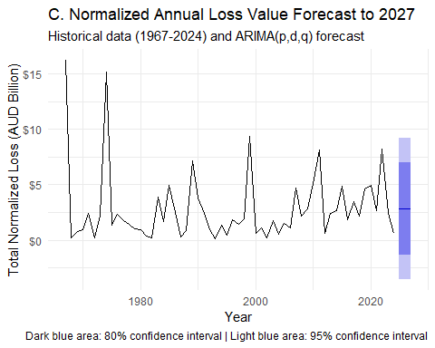
# Analysis Part 4: Climate Change Notion (Based on Severity Trend)
# We'll use the severity data
# Check the number of high-loss events in two 30-year periods (proxy for climate change impact)
# Period 1: 1967 - 1996 (30 years)
# Period 2: 1997 - 2026 (projected 30 years)
# Calculate the average annual loss value in the first 30 years of available data
avg_loss_early <- yearly_trends %>%
filter(Year >= 1967 & Year <= 1996) %>%
summarise(Avg_Loss = mean(Total_Severity_Billion_AUD)) %>%
pull(Avg_Loss)
# Calculate the average annual loss value in the most recent 27 years of data (1997-2024)
avg_loss_recent <- yearly_trends %>%
filter(Year >= 1997 & Year <= 2024) %>%
summarise(Avg_Loss = mean(Total_Severity_Billion_AUD)) %>%
pull(Avg_Loss)
message("\n--- Climate Change Notion Metrics (Normalized Loss AUD Billion) ---")
##
## --- Climate Change Notion Metrics (Normalized Loss AUD Billion) ---
message(paste("Average Annual Loss (1967-1996): $", round(avg_loss_early, 2), "B"))
## Average Annual Loss (1967-1996): $ 2.66 B
message(paste("Average Annual Loss (1997-2024): $", round(avg_loss_recent, 2), "B"))
## Average Annual Loss (1997-2024): $ 3 B
message(paste("Percentage Increase in Average Annual Loss:",
round(((avg_loss_recent - avg_loss_early) / avg_loss_early) * 100, 1), "%"))
## Percentage Increase in Average Annual Loss: 12.9 %

