Sudo a2enmod rewrite
sudo nano /etc/apache2/sites-available/000-default.conf
you will get
Add follwing code after DocumentRoot /var/www/html
<Directory /var/www/html/>
Options Indexes FollowSymLinks
AllowOverride All
Require all granted
</Directory>
sudo service apache2 restart

SHOW DATABASES;
CREATE DATABASE tesla_db;
CREATE USER 'admin'@'localhost' IDENTIFIED BY ‘password’;
grant select, insert, delete, update on tesla_db.* to admin@'localhost'
mysql> use db_name;
mysql> source file_name.sql;

To get the application up and running, you’re going to need a LAMP stack. This stack consists out of 4 layers: an Ubuntu server which everything will be running on, an Apache web server to deliver content to the web, MYSQL as our database interpreter, and after all PHP to act as our server side scripting language. We’ll set up a virtual environment using Virtual Box, on which we’re going to install all of the 4 LAMP layers.
To install Virtual Box, navigate to https://www.virtualbox.org/wiki/Downloads. Download the most recent release for Windows, which will be version 6.0.0 for now. Once opened, just click next on all tabs, as default values are fine. At some point you’ll get asked to confirm your actions, after clicking Finish Virtual Box will get installed. While installing, you’ll get two pop-ups asking for permission to install certain requirements, click on Yes/Install on both of them to successfully install Virtual Box.
Before creating the virtual environment within Virtual Box, you’ll have to install an Ubuntu server. Navigate to https://www.ubuntu.com/download/server, and download the long term support version (LTS). Which will be version 18.04.1 for now. When finished, navigate back to Virtual Box and hit the blue New button.

1. Choose a relevant name and use Linux as your type in combination with Ubuntu.
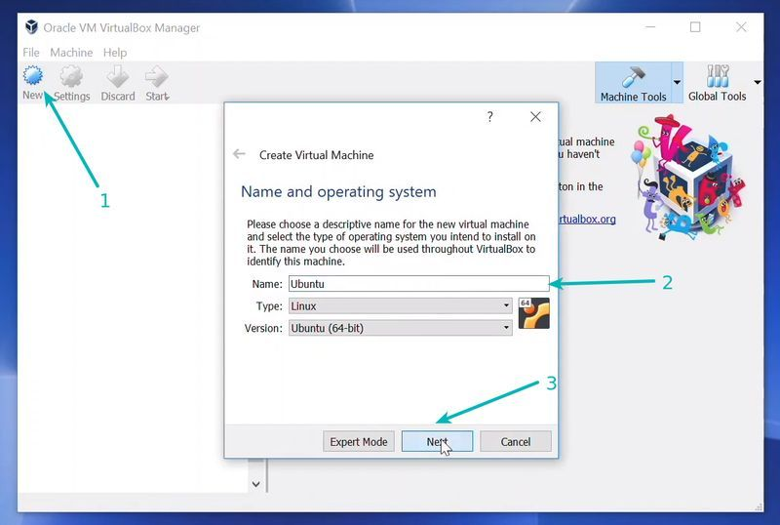
2. The following tab will let you select your preferred memory size (RAM) for the virtual machine, just click on next as the default size (1024 MB) will do for this project.
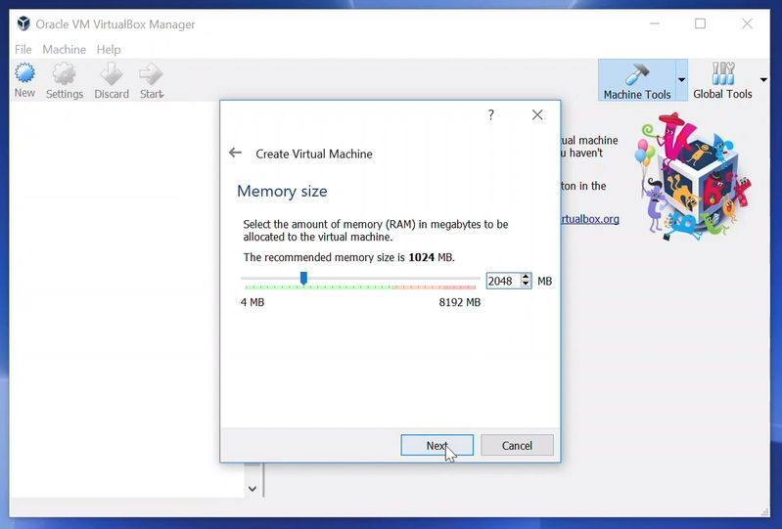
3. You’ll get the option to add a virtual hard disk, select the option to create one.
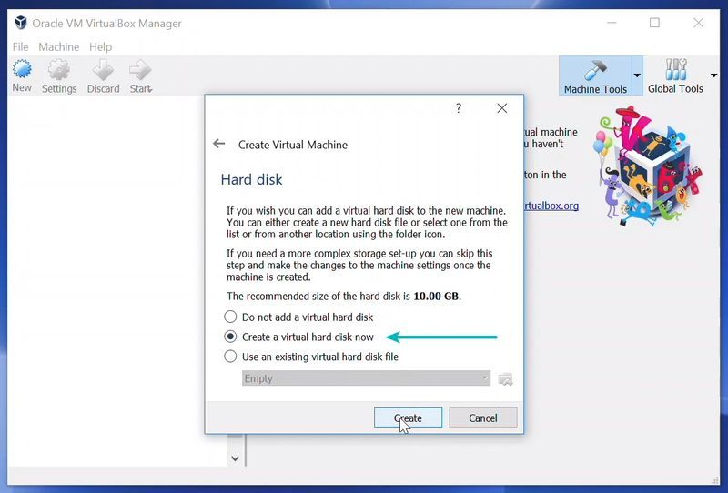
4. Now you’re going to have to choose the filetype for this virtual hard disk, we need a Virtual Disk Image (VDI) , so select it and click on next.
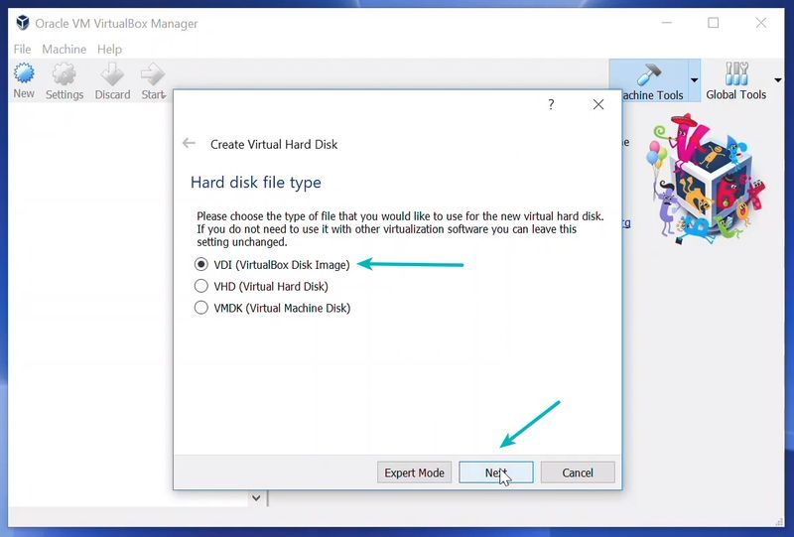
5. Now you’ll be asked to select whether the new virtual hard disk file should grow as it is used (dynamically allocated) or if it should be created at it’s maximum size (fixed size). Choose for dynamically allocated.
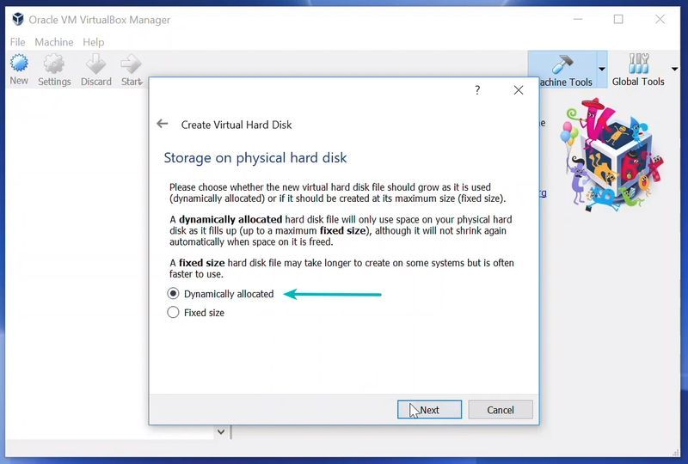
6. Now you’re able to set a name for the virtual hard disk and select the size in megabytes, just leave it at default and click on Create.
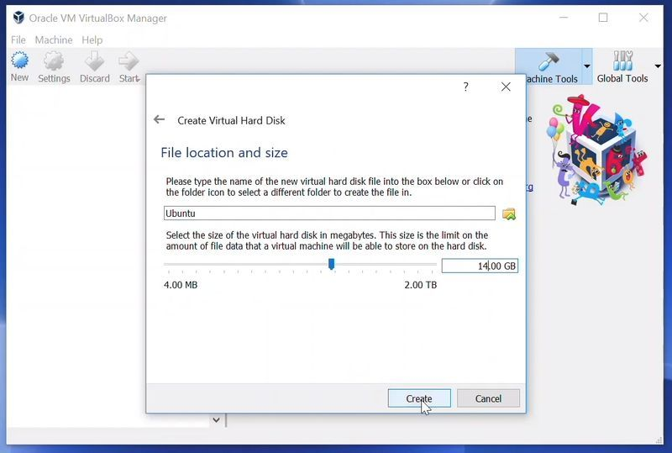
7. The pop-up will close now, and you’ll see your first virtual environment item listed. Select it and click on the green Start arrow.
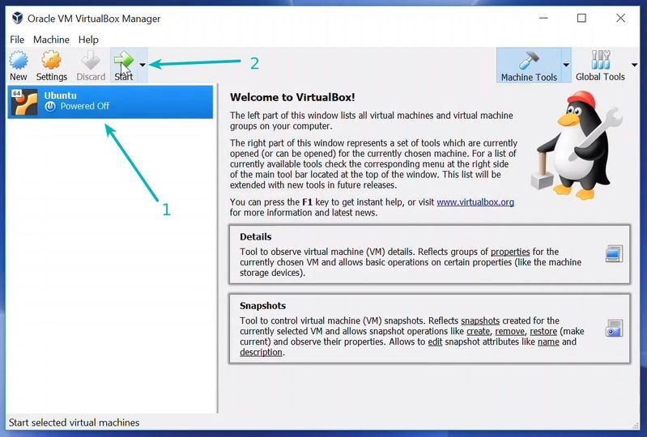
8. When first starting your virtual environment, you’ll be prompted to select your start up disk. This will be the Ubuntu .ISO. Click on the directory icon and select the .ISO file from your local computer, which we downloaded previously.
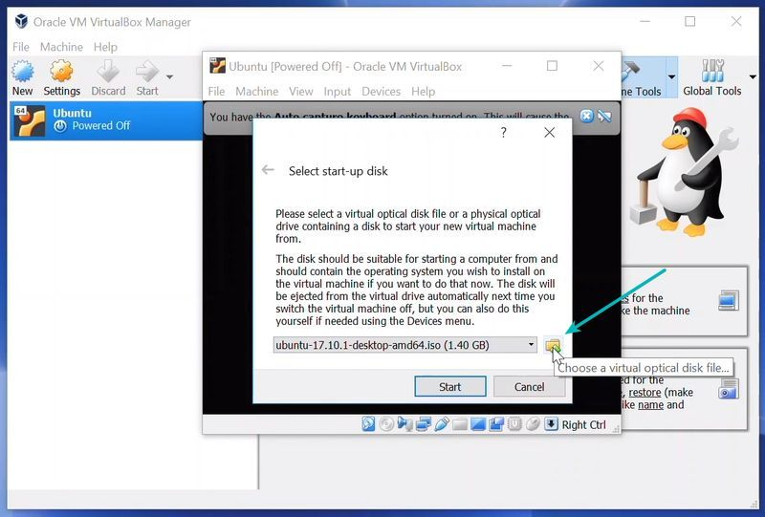
9. Once booted up, you’ll be able to select your preferred system language using your arrows and Enter to click. We’ll be choosing English for this implementation.
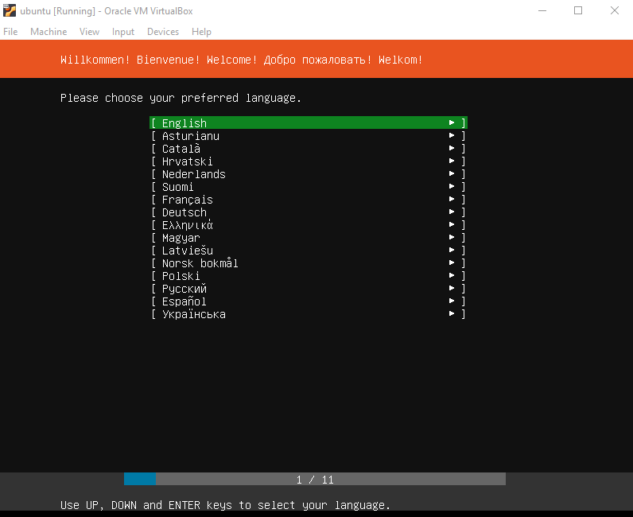
10. Now you have to select your keyboard layout. If the default layout isn’t the correct one, you can click on Identify Keyboard and follow the instructions, else click on Done using Enter again.
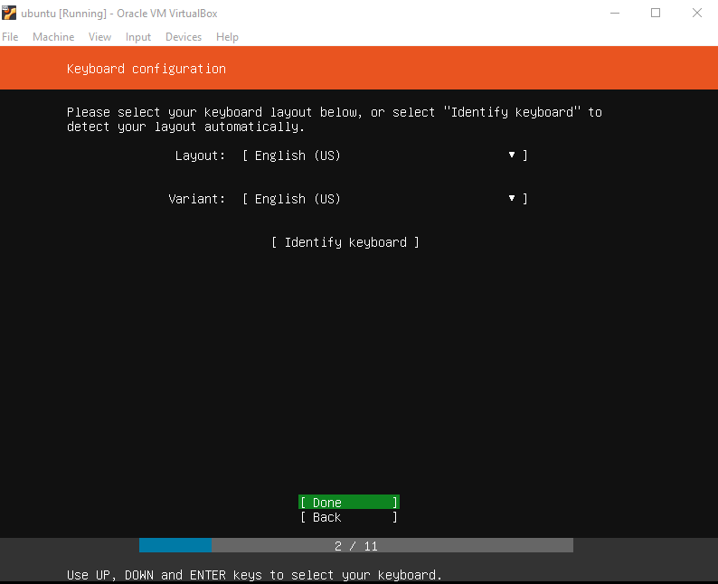

11. Now you’ll see Ubuntu’s welcome message and the options to choose your installation. Select Install Ubuntu by hitting Enter.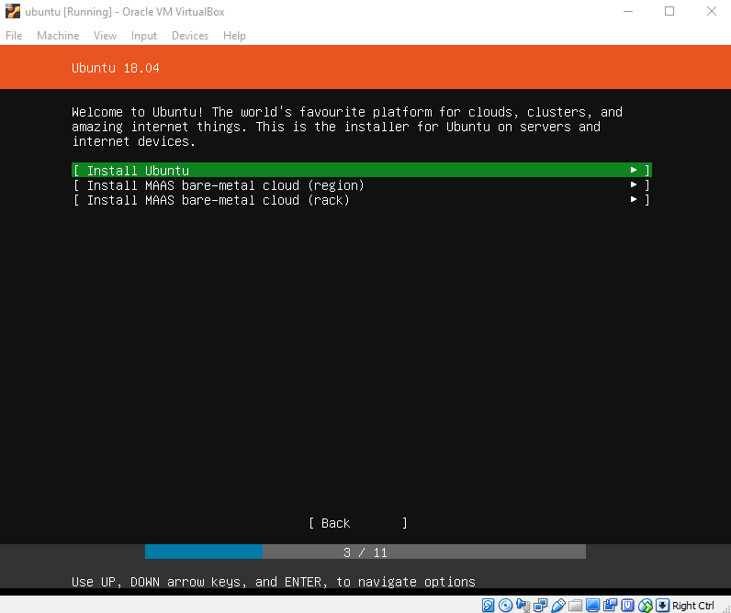

12. On the screen that follows, you’ll be able to configure an interface to talk to other machines, there is no need to change anything, so click on Done to navigate to the next screen.
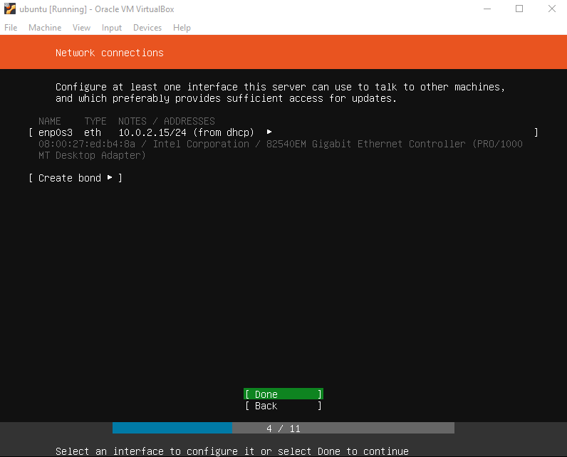
13. Now you’ll be able to configure a proxy, which we don’t need. Just select Done again.
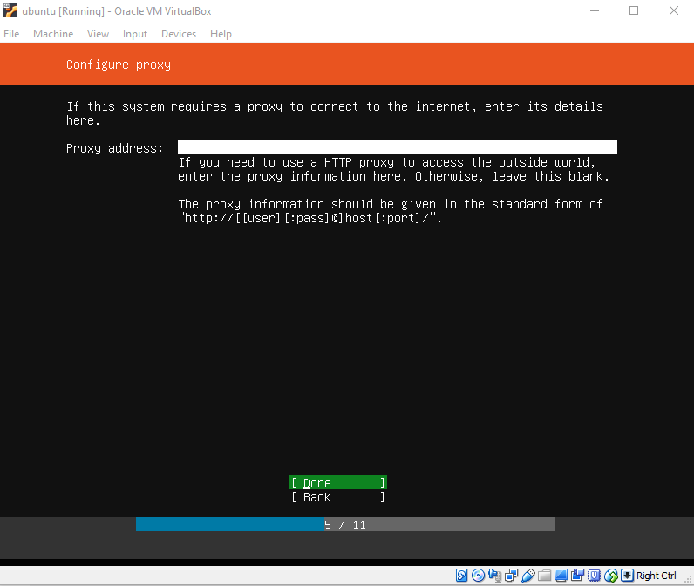

14. Now it lets you change the default Mirror address, again no need to change anything, click Enter.
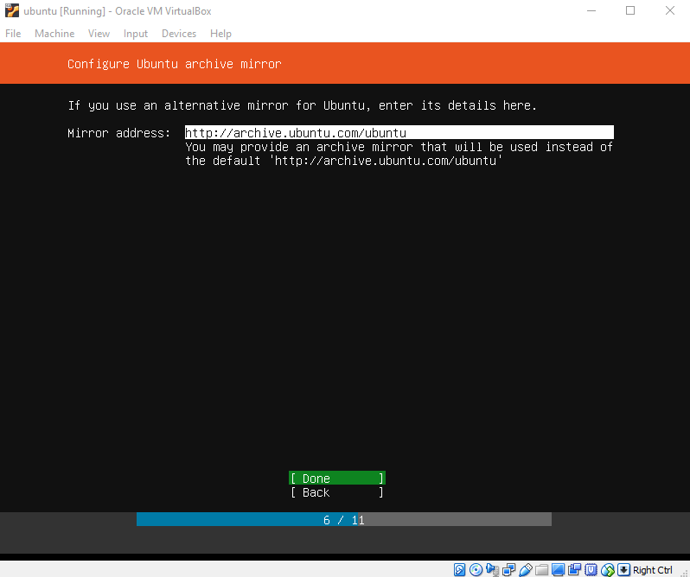
15. Now you’ll be prompted to choose to use an entire disk either directly or using something else, select “Use An Entire Disk” and confirm using Enter.
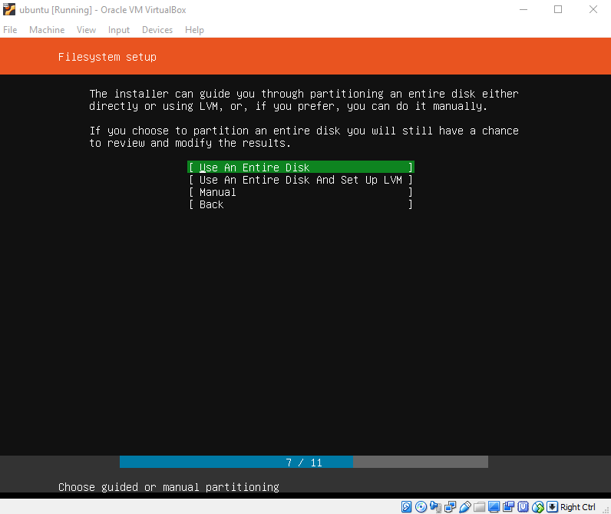

16. Now you’ll have to select a disk to use, Click Enter on the one we made earlier on, most likely it will be the only option.
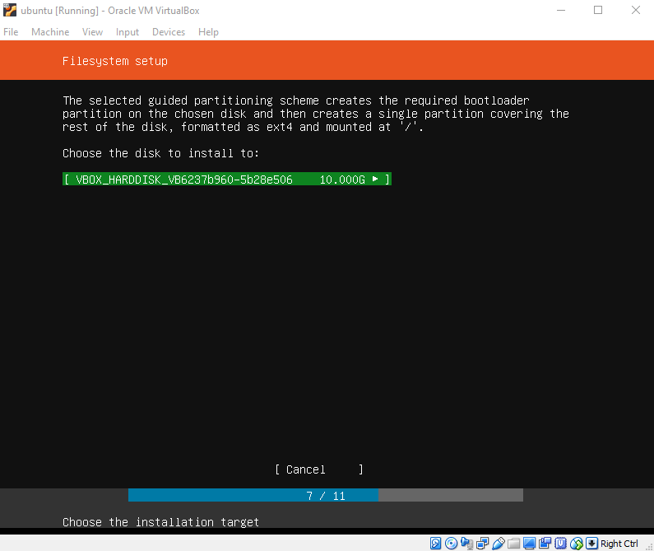
17. You’ll see some some info regarding devices now, no need to touch anything just click on Done.
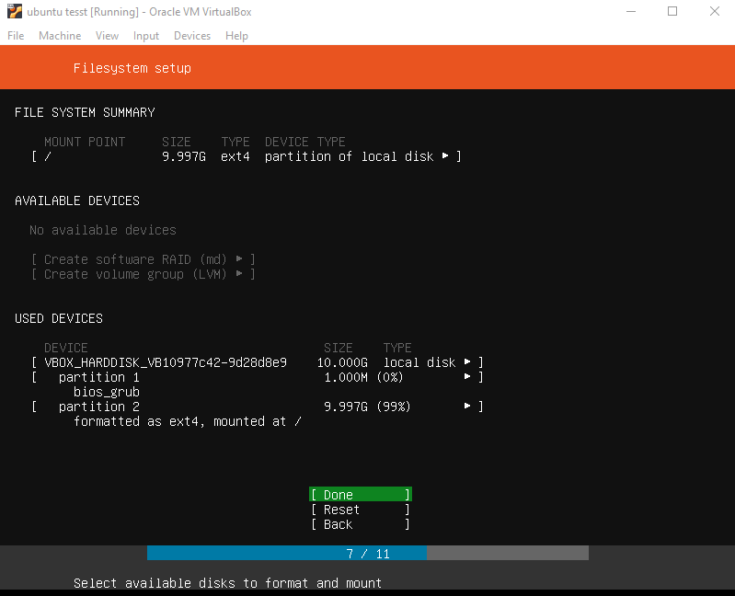

18. Now you’ll be prompted to confirm all of your actions, press Enter to start the installation process. In the meanwhile you’ll be able to set up your system profile. Enter your full name, server’s name (which will be used when it talks to other computers), username and password. You’ll need the username and password to login into the server after completion. Make sure you save them locally to prevent losing them. You can leave the SSH identity selection on No, click on Done when you’re finished.
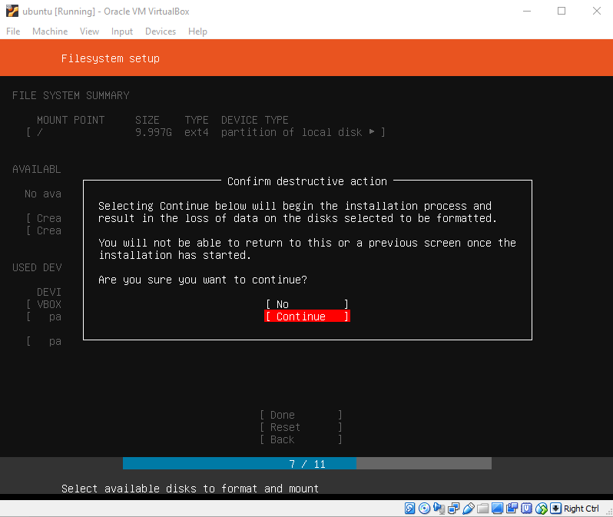
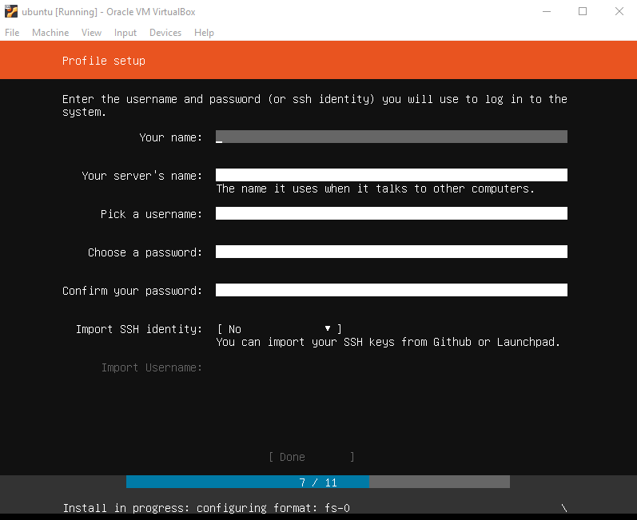
19. Now you’re able to select some popular packages to be installed on your server automatically. We don’t need any of them so just navigate to Done and click Enter.
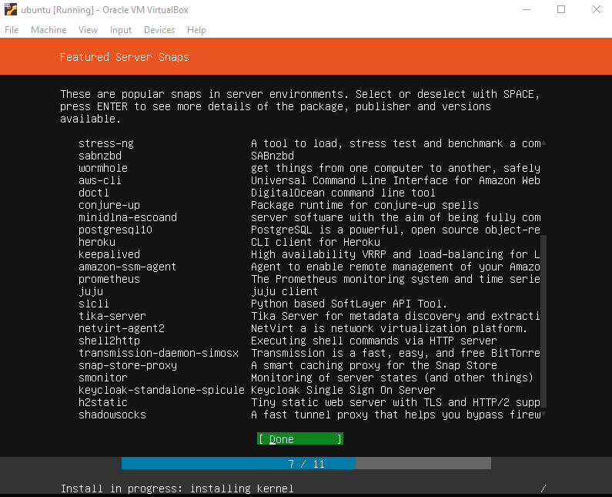
You’ll see some logs now and the option to Reboot the virtual environment, click on it using Enter to have your environment restart itself.
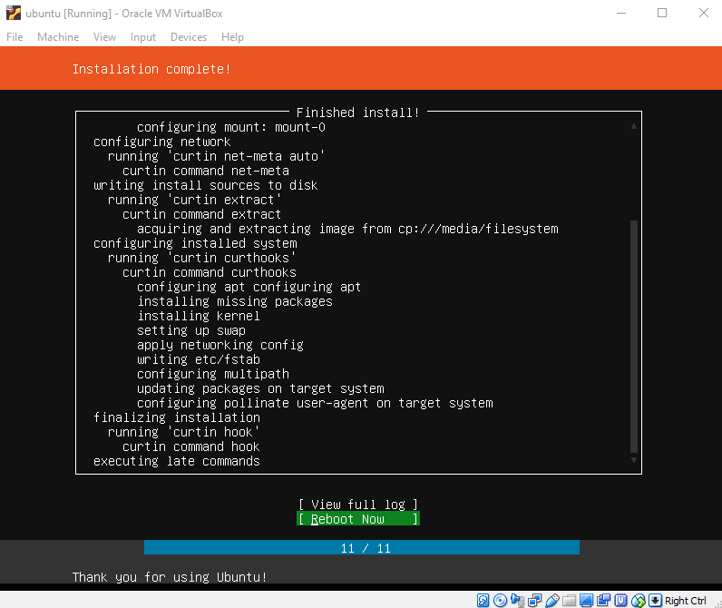
Once rebooted, you’ll be prompted to log in using the credentials you chose during the installation process. After putting in the correct credentials, you’ll be logged into the server. Now we have correctly set up the first layer of the LAMP stack, mentioned at the beginning.
Instead of installing the other 3 layers (Apache, MYSQL, PHP) separately, Tasksel offers a convenient way to get a LAMP stack running quickly. Before we install Tasksel, make sure our server is up to date by writing the following line and clicking Enter:
Sudo apt update && sudo apt upgrade
You’ll be prompted to enter your password. After doing so, it will start the operation and tell you how much disk space it will take, when asked if you want to continue, agree by writing Y or just click Enter. After the operation, all of the packages our server included, are installed and updated. Now we can install Tasksel by writing the following command line and clicking Enter:
Sudo apt install tasksel
It will again show you the amount of disk space it will take and ask if want to continue, write Y or just click Enter. After the operation, we have installed Tasksel onto our server, we can use it now to install the remaining layers of our LAMP stack by writing the following command line and clicking on Enter:
Sudo tasksel install lamp-server
That’s it. Instead of installing Apache, MYSQL and PHP separately, we now have everything installed with just one command line.
First, we’re going to set up our database first by creating a user and database within MYSQL. To do so, use the follow command lines in the root directory (var/www/html):
Sudo mysql
Create database tesla_db;
Create user 'admin'@'localhost' identified by ‘password’;
Grant select, insert, delete, update on tesla_db.* to ‘admin’@'localhost'
Use tesla_db;
Source db.sql;

Now our database is correctly set up, so we have to move our local application onto the server. To do that, we need FileZilla, which is a FTP client that lets us connect to our server and manage files. To install FileZilla, navigate to https://filezilla-project.org/download.php?type=client and click on the large green button which says Download FTP client, this will open a pop up which lets you choose between the regular or pro version, just download the regular one.
Once you opened the downloaded file, you’ll have to agree on the terms and privacy policy. After doing so, you’ll be asked wether you want the application to be available for anyone on your computer or just your current user account, you can choose your preferred option and click Next to navigate to the following tab. Here you’ll be able to choose which components to install. Make sure at least FileZilla Client, Shell Extension and Desktop Icon are checked, the other ones are optional. After clicking Next, you’ll be able to choose an install location, choose where ever you’d like and hit Next again. You’ll have to option now to choose a start menu folder, you don’t have to change anything just click on Next to finally start the installation of Filezilla. After installation, check Start Filezilla now and hit the Finish button.

