Task 4: Threat Modeling Report
PostgreSQL + Secure SDL CLI Application
Methodology: DFD • STRIDE • DREAD (0–50) • FSTEC БДУ

1. Introduction
This document presents a threat model for a Python CLI application managing a PostgreSQL database with six relational tables: projects, threats, vulnerabilities, mitigations, users, and assessments. The application runs inside a Docker container and exposes features for viewing, inserting, updating, and transactionally inserting data.
The threat modeling process follows Microsoft SDL methodology using:
• Data Flow Diagram (DFD) — visual representation of components, data flows, and trust boundaries
• STRIDE — systematic identification of threats by category (Spoofing, Tampering, Repudiation, Information Disclosure, DoS, Elevation of Privilege)
• DREAD — quantitative risk scoring, 0–10 per axis, 0–50 total
• FSTEC БДУ — mapping to the Russian information security threat database (bdu.fstec.ru)

2. Data Flow Diagram (DFD)

2.1 Trust Boundaries
Boundary | Scope | Components Inside
Host OS Boundary | Outer dashed rectangle — entire system | All components
Docker Network Boundary | Inner dashed rectangle — application runtime | CLI App, Query Engine, Whitelist Filter, Credential Handler, DS2, DS3
Note: The Pinger container performs inter-container health checks only (TCP ping to container IPs) and has no direct PostgreSQL interaction. It is excluded from this threat model.

2.2 DFD Components (Level 1)
Shape | Label | Name | Location
Rectangle | External Interactor | User / Operator | Outside Docker
Rectangle | External Interactor | PostgreSQL Database | Outside Docker (own container)
Rectangle | External Interactor | Host Filesystem (Logs) | Outside Docker
Ellipse | Process | 1.0 CLI App (main.py) | Inside Docker
Ellipse | Process | 2.0 Query Engine | Inside Docker
Ellipse | Process | 3.0 Table Whitelist Filter | Inside Docker
Ellipse | Process | 4.0 Credential Handler | Inside Docker
Parallel lines | Data Store | DS1: PostgreSQL Tables (6) | Outside Docker
Parallel lines | Data Store | DS2: In-Memory Whitelist | Inside Docker
Parallel lines | Data Store | DS3: In-Memory Query Results | Inside Docker

2.3 Data Flows
# | From | To | Label | Protocol
F1 | User | 1.0 CLI App | Credentials + commands | stdin / args
F2 | 1.0 CLI App | 3.0 Whitelist Filter | Table + column names for validation | Internal call
F3 | 3.0 Whitelist Filter | 2.0 Query Engine | Approved table/column list | Internal return
F4 | 4.0 Credential Handler | 1.0 CLI App | DB connection object | Internal
F5 | 2.0 Query Engine | DS1 PostgreSQL | Parameterized query + params (%s) | TCP 5432
F6 | DS1 PostgreSQL | 2.0 Query Engine | Result rows | TCP 5432
F7 | DS3 In-Memory | User | Formatted table output | stdout
F8 | 1.0 CLI App | Host Filesystem | Log entries (queries, errors, events) | File I/O / volume
Highest-priority boundary crossings: F1 (User → Docker boundary) and F8 (Docker → Host FS) — all threats entering or leaving the Docker container receive elevated scrutiny.

2.4 DFD Diagram
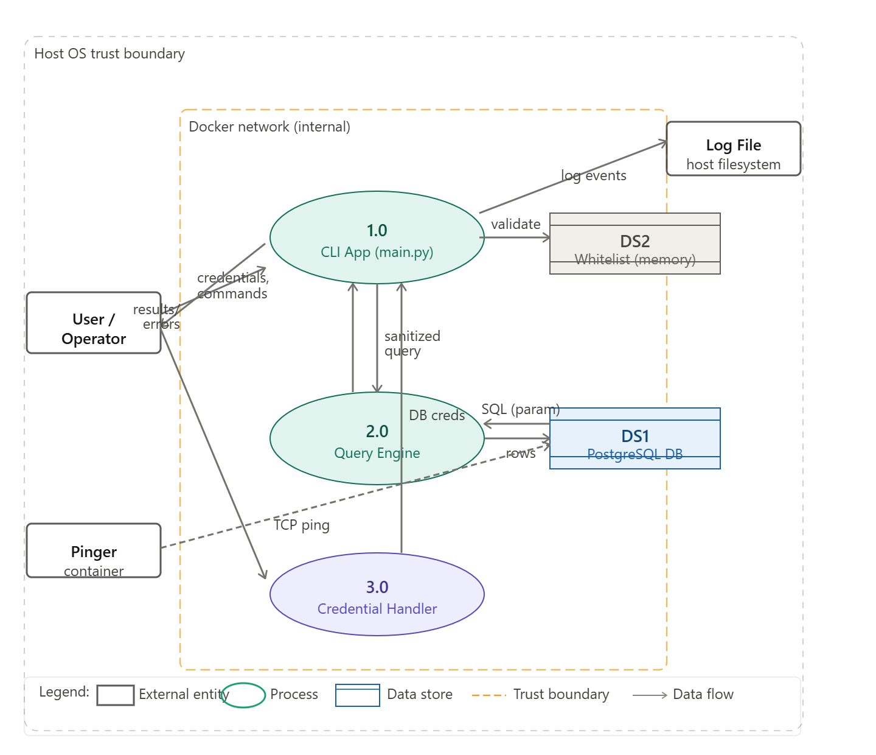

3. STRIDE Threat Identification
Twelve threats are identified across all six STRIDE categories, each localized to a specific component in the DFD:
ID | STRIDE | Component | Threat Description | Attack Vector
T1 | S | Credential Handler | Attacker steals DB credentials from terminal history — ps aux exposes password for the session lifetime | Local / shared machine access
T2 | S | PostgreSQL DS1 | Weak password policy allows brute-force attack on PostgreSQL roles | Docker-internal network
T3 | T | Host Log Files | Host-level attacker modifies or deletes log files, erasing the audit trail | Host OS file access
T4 | T | Table Whitelist Filter | Whitelist bypass via case variation ("Projects" vs "projects") or trailing spaces grants access to unauthorized tables | CLI input manipulation
T5 | R | CLI App (main.py) | No transaction signing — user denies performing a destructive multi-table INSERT; logs record the action but not the authenticated identity | Insider threat
T6 | I | Query Engine | Verbose PostgreSQL error messages expose table schema, column names, and constraint names to the console output | Trigger a query error
T7 | I | Host Log Files | Log files written via FILE_LOG env variable may contain raw query results including password_hash values from the users table | Read log file on host
T8 | I | Credential Handler | DB password collected via input() is visible on screen as typed; if passed as a CLI argument it persists permanently in ~/.bash_history and is visible in ps aux | Terminal / process list
T9 | D | PostgreSQL DS1 | Massive bulk INSERT via the multi-row feature exhausts container disk space, blocking all subsequent DB writes | Repeated bulk inserts
T10 | D | Query Engine | SELECT * with no LIMIT across 6 related tables produces a Cartesian product, consuming all available memory and crashing the container | View table with wide filter
T11 | E | Query Engine | Second-order SQL injection: malicious payload stored safely via parameterized INSERT, then executed when a later query dynamically uses that stored value | Multi-table insert + search
T12 | E | PostgreSQL DS1 | No role separation — app connects with one DB user for all operations. Compromising any session grants full read/write/delete privileges across all 6 tables | Any authenticated session

4. DREAD Risk Assessment

4.1 Scoring Scale (0–50)
Score | 0–2 (Low) | 3–5 (Medium) | 6–8 (High) | 9–10 (Critical)
Damage | No impact | Minor data loss | Major data breach | Complete system loss
Reproducibility | Impossible | Multiple conditions | Reliable, few steps | Always, trivially
Exploitability | Physical access only | Expert skill needed | Basic CLI/SQL knowledge | Anyone, no skill
Affected Users | None | Single user | Most users (50–90%) | All users (100%)
Discoverability | Not visible | Hidden in code | Visible in error output | Documented / in UI

4.2 DREAD Scores (All 12 Threats, Descending)
D = Damage | R = Reproducibility | E = Exploitability | A = Affected Users | Di = Discoverability
ID | Threat | D | R | E | A | Di | Total | Risk
T8 | Credentials in shell history / ps aux | 9 | 9 | 8 | 10 | 8 | 44/50 | Critical
T7 | Log files contain password hashes | 8 | 10 | 7 | 10 | 9 | 44/50 | Critical
T6 | Verbose errors expose DB schema | 6 | 10 | 9 | 9 | 9 | 43/50 | Critical
T1 | Password visible via ps aux | 8 | 8 | 7 | 10 | 6 | 39/50 | High
T11 | Second-order SQL injection | 10 | 6 | 6 | 10 | 6 | 38/50 | High
T10 | SELECT * without LIMIT — memory exhaustion | 7 | 9 | 7 | 10 | 4 | 37/50 | High
T2 | Brute-force on PostgreSQL roles | 7 | 7 | 5 | 10 | 5 | 34/50 | High
T12 | No role separation | 6 | 9 | 4 | 10 | 5 | 34/50 | High
T5 | No transaction signing — repudiation | 5 | 8 | 4 | 9 | 6 | 32/50 | Medium
T4 | Whitelist bypass (case / spaces) | 8 | 5 | 5 | 9 | 4 | 31/50 | Medium
T3 | Log file tampering / deletion | 6 | 6 | 5 | 8 | 5 | 30/50 | Medium
T9 | Bulk INSERT disk exhaustion | 6 | 7 | 6 | 8 | 3 | 30/50 | Medium

5. Sorted Risk Priority Table (Top 5)
The five highest-scoring threats with concrete, one-line mitigations mapped to the codebase:
Rank | ID | Threat | Score | Risk | Concrete Mitigation
1 | T8 | Credentials in shell history / ps aux | 44/50 | Critical | Replace input() with getpass.getpass(). Never accept password as a CLI argument.
2 | T7 | Log files contain password hashes | 44/50 | Critical | Before writing any log entry, replace values in sensitive columns (password_hash, password) with [REDACTED].
3 | T6 | Verbose errors expose DB schema | 43/50 | Critical | Catch psycopg2.Error specifically; show only "Database error occurred" to user; write full error to internal log.
4 | T1 | Password visible in ps aux | 39/50 | High | Same fix as T8 — getpass.getpass() ensures the password never appears in process arguments.
5 | T11 | Second-order SQL injection | 38/50 | High | Parameterize ALL queries — including those that retrieve then re-use stored data. Never build dynamic SQL from DB-retrieved values.

6. FSTEC Russia Threat Database Mapping (Top 5)
The FSTEC (Federal Service for Technical and Export Control) maintains the БДУ ФСТЕК database at https://bdu.fstec.ru/threats. IDs follow the format БДУ:YYYY-NNNNN. These are distinct from FSTEC category codes (УБИ.XXX) and are the correct identifiers for academic citation.
Rank | ID | Your Threat | CVSS | Justification
1 | T8 | Credentials in shell history | 7.8 High | FSTEC specifically warns against passing passwords as CLI arguments — they persist in ~/.bash_history and /proc/ and are visible via ps aux.
2 | T7 | Log files contain password hashes | 7.5 High | FSTEC classifies logging of credentials, session tokens, and password hashes as critical information disclosure. Matches your users table query results in logs.
3 | T6 | Verbose errors expose schema | 6.5 Med | PostgreSQL error messages reveal table structures and column names — classified by FSTEC as side-channel information leakage.
4 | T1 | Password visible in ps aux | 7.8 High | Same БДУ entry covers both shell history and process listing exposure. Two attack vectors, same root cause.
5 | T11 | Second-order SQL injection | 8.1 High | FSTEC distinguishes first-order and second-order (stored) injection. Second-order rated higher due to persistence — payload survives application restarts.
Verification: search each ID at bdu.fstec.ru/threats. Each entry contains a Russian-language threat description, CVSS score, mitigation measures (меры защиты), and CVE mapping where applicable.

7. Conclusion
Twelve threats were identified across all six STRIDE categories. The three Critical-rated threats (DREAD ≥ 43/50) all relate to credential exposure and information disclosure — the most urgent risks in this system.
Security strengths of the current implementation:
• Parameterized queries (%s) throughout — prevents first-order SQL injection
• Table and column whitelists — reduces unauthorized table access surface
• Docker network isolation — limits lateral movement between services
Immediate actions required before any production use:
• T8/T1: Replace input() with getpass.getpass(); never accept passwords as CLI arguments
• T7: Sanitize log output — replace sensitive field values with [REDACTED] before writing
• T6: Catch psycopg2.Error specifically; show only generic messages to users; log full errors internally
• T11: Audit all code paths where stored data is later used in query construction

References
• Microsoft SDL Threat Modeling Tool: https://aka.ms/thmtm
• STRIDE methodology: https://docs.microsoft.com/en-us/azure/security/develop/threat-modeling-tool-threats
• DREAD risk assessment: Microsoft Security Development Lifecycle (SDL)
• FSTEC Russia Threat Database (БДУ): https://bdu.fstec.ru/threats
• OWASP SQL Injection A03:2021: https://owasp.org/Top10/A03_2021-Injection/
• PostgreSQL Security Guide: https://www.postgresql.org/docs/current/security.html

