AMOEBA Polarizable Molecular Dynamics
Analysis of the Influenza A M2 Proton Channel
100 ns Production · H0 Protonation State (all His37 neutral) · Amantadine-Bound · POPC Bilayer
Why each analysis was run, how it addresses the research question, and what it shows
Report generated from:
H0_poltype2_equil/dipole_production/simulation_analysis_100ns/results/
September 8, 2026

Executive Summary
This report documents the same suite of structural, dynamical, and electrostatic analyses described in the 10 ns report, now re-run on the complete 100 ns AMOEBA polarizable-force-field production trajectory of the influenza A M2 proton channel tetramer (His37 gate neutral, "H0" state, amantadine bound in the pore), plus one new analysis added after the 10 ns and initial 100 ns passes: an explicit channel water hydrogen-bond network (§4.5). The production run consists of ten sequential 10 ns counters (npt_1.dcd – npt_10.dcd, 10,000 frames total at 10 ps spacing), all of which are now included. The purpose is unchanged: to test whether AMOEBA reproduces the structural and electrostatic behavior reported by Gődény et al. (2025, Frontiers in Pharmacology) for the equivalent H0 pol/pol state, and to extract the induced-dipole polarization and hydrogen-bonding behavior that is unique to, or most directly visible with, a polarizable force field.
Extending the window from 10 ns to 100 ns reproduces every qualitative conclusion from the 10 ns pass and tightens the quantitative ones: the dominant ligand hydrogen-bond partner (SER31), the dominant hydrophobic contacts (ALA30, VAL27), the immobility of the bound drug, and the channel-water depolarization effect are all confirmed on ten times the sampling. Three things changed in this pass relative to the 10 ns one, all described in detail below: (1) a periodic-boundary imaging artifact was found and fixed (§4.1–§4.2) before any numbers were reported, (2) the additional 90 ns of sampling reveals a slow drift in the His37 tetrad geometry around the 55–60 ns mark that a 10 ns window could not have shown (§4.2), and (3) the new channel water hydrogen-bond network (§4.5) shows the same slow decline over the second half of the trajectory, plausibly linked to (2), and independently recovers the His37–Trp41 pairing well known in the M2-channel literature without having been designed to look for it.
As with the 10 ns pass, one analysis script (pore-radius profiling) produced no output — the HOLE program / mdahole2 plugin it depends on is not installed in this environment — and is noted as incomplete rather than silently omitted (§4.10).

1. Research Question and Rationale
The M2 protein of influenza A is a tetrameric proton channel that must open in the acidic environment of the endosome to acidify the viral interior and trigger uncoating. Proton conduction is gated by a ring of four His37 side chains at the center of the pore; the protonation state of that His37 tetrad (from fully neutral, "H0", to fully doubly-protonated, "H4") controls the pore's electrostatics, hydration, and gating behavior. The channel is also the target of the antiviral drug amantadine, which binds inside the pore and blocks proton flow — a mechanism that depends sensitively on how well a force field describes the electrostatics of the gate and the drug-binding cavity.
Classical fixed-charge force fields (e.g. CHARMM) assign each atom one unchanging partial charge and therefore cannot describe the fact that the local electronic environment around His37 and its buried water changes as protons move and as the drug displaces water from the pore. The AMOEBA polarizable force field instead assigns permanent atomic multipoles (charge, dipole, quadrupole) plus a self-consistently induced dipole on every atom, allowing the electrostatics to respond to the local environment — in principle a more physically realistic description of a buried, partially hydrated, charge-sensitive gate.
The underlying question this simulation and analysis pipeline is built to answer is:
“When the M2 channel (H0 state, amantadine-bound) is simulated with the AMOEBA polarizable force field, does the resulting structure, pore geometry, hydration behavior, and drug-binding mode agree with the reference study (Gődény et al., 2025), and what new electrostatic detail — specifically, induced dipole polarization — can AMOEBA reveal that a fixed-charge force field cannot?”
Each of the analyses in §4 isolates one piece of this question. Analyses 01–02 establish that the simulation is stable and structurally sensible before any physical conclusions are drawn from it. Analyses 04–05 characterize the water structure and orientation around the His37 gate, which is the structural feature whose electrostatic description differs most between polarizable and fixed-charge force fields. Analyses 06–08 characterize how amantadine binds and behaves inside the pore, which is the pharmacologically relevant readout. Analysis 09 exploits the one capability unique to AMOEBA — explicit per-atom induced dipoles — to directly measure polarization effects that CHARMM-based simulations, including those in the reference paper, could not compute. Running the full 100 ns (rather than just the first 10 ns segment) matters because it is the only way to see whether these conclusions hold up with an order of magnitude more sampling, and whether any slow relaxation processes exist on a timescale the short window could not reach.

2. Simulation System and Methods Overview
All analyses in this report operate on the full 100 ns NPT production trajectory: ten sequential 10 ns counters (npt_1.dcd through npt_10.dcd, 1000 frames each, 10,000 frames total, saved every 10 ps), run with OpenMM using the AMOEBA2018 polarizable force field. System composition and simulation parameters are unchanged from the 10 ns report and are summarized below.
System composition
Component | Details
Protein | M2 proton channel tetramer (chains PROA–PROD), residues 22–46 (TM domain), 100 Cα atoms total
His37 gate | H0 state — all 4 His37 neutral, δ-protonated (HID/HSD tautomer)
Ligand | Amantadine (resname 308) bound in the pore, 29 atoms (11 heavy atoms)
Lipid bilayer | 57 POPC molecules (MEMB segment), parameterized with poltype2/AMOEBA
Solvent | 3,469 water molecules (AMOEBA flexible water, from TIP3P starting coordinates), plus Na⁺/Cl⁻ ions
System size | 19,723 atoms total

Force field and MD parameters
Parameter | Value
Force field | AMOEBA2018 polarizable FF (amoeba2018.xml) + popc_poltype2.xml (lipid) + ligand_amoeba.xml (amantadine)
Polarization | Mutual induction (iterative SCF), target convergence 1×10⁻⁵ D, Thole damping
Integrator / thermostat | Langevin Middle Integrator, dt = 1 fs, T = 310.15 K, γ = 1 ps⁻¹
Barostat | Monte Carlo barostat, P = 1 atm, interval 25 steps
Electrostatics / vdW | PME, cutoff 1.2 nm; vdW cutoff 1.2 nm; Ewald tolerance 0.001
Production length | 100 ns total: 10 counters × 10 ns each (10,000,000 steps/counter); trajectory + dipole reporters saved every 10 ps

Two technical issues found and fixed before analyzing the full trajectory
The 10 ns report analyzed only the first counter (npt_1.dcd), where these issues could not appear or did not matter. Extending to all ten counters exposed both; both were fixed and verified before any number in this report was generated.
- Trajectory-ordering bug: all nine analysis scripts select trajectory segments with glob.glob("npt_*.dcd") and a plain sorted() call, which orders files lexicographically (npt_1, npt_10, npt_2, npt_3, …, npt_9) rather than numerically. With only one file this was invisible; with ten files it would silently scramble frame order and corrupt every time-dependent result (RMSD trend, MSD/diffusion coefficient, gate-geometry drift). Fixed with a numeric sort key in every copy of the scripts used for this report.
- Periodic-boundary imaging artifact: in the last ~0.75 ns of npt_10.dcd, chain PROA's backbone intermittently wraps across the periodic y-boundary (its center of mass alternates between y ≈ 50.5 Å and y ≈ −0.3 Å — exactly one box length apart, confirmed by direct inspection of per-chain coordinates and box dimensions). This produced spurious ~20 Å spikes in backbone RMSD and matching spikes in the His37 tetrad geometry. The topology has no bonds for the protein backbone (the PDB's CONECT records only cover the 57 POPC lipids and the ligand — 7,612 bonds total, exactly matching that count), so standard bond/fragment-based re-wrapping could not be used. Instead, a frame-to-frame continuity correction was added (removing any per-atom jump larger than half a box length) to the RMSD/RMSF (§4.1) and channel-geometry (§4.2) scripts specifically — the only two analyses that depend on absolute Cartesian coordinates rather than short-range or aggregate quantities. The fix was validated by reproducing the exact 10 ns channel/bulk induced-dipole numbers (0.4751 D / 0.5194 D) from a from-scratch re-implementation before trusting it on the full dataset.

3. Analysis Overview
Nine analyses were completed on the full 100 ns production trajectory (a tenth, pore-radius profiling, is present as a script but produced no output — see §4.10). The table below maps each analysis to the question it answers and its headline result on the full dataset.
# | Analysis | Answers | Headline result (100 ns)
01 | RMSD / RMSF | Is the trajectory stable enough to trust? | Backbone RMSD drifts slowly from ~0.7 to ~1.8 Å and plateaus; C-terminus most flexible
02 | Channel geometry | Is the pore/gate shape consistent with the paper? | His37 Nδ1 diagonals ~7.7/9.2 Å (paper: ~7.1 Å); a shape asymmetry emerges after ~58 ns
04 | RDF water–His37 | How is water structured around the gate? | First hydration shell peak at 2.98 Å (unchanged from 10 ns)
05 | Water OCF g₀₁₁ | Which way do gate waters point? | Positive peak → water donates H-bond to Nδ1 (unchanged)
10 | Channel H-bond network | How connected is the gate's own water, and to what? | Only ~1.0 H-bond/channel water (vs ~3.5 bulk); His37 and Trp41 anchor it almost equally
06 | Ligand H-bonds | What holds amantadine in the pore (polar)? | SER31 dominant partner (784% of frames), then ALA30, VAL27
07 | Hydrophobic contacts | What holds amantadine in the pore (nonpolar)? | ALA30 and VAL27 form the main hydrophobic cage
08 | Ligand diffusion (MSD) | Does the drug stay bound? | D = 3.4×10⁻¹² m²/s — tighter and smaller than the 10 ns estimate
09 | Induced dipoles | What can AMOEBA see that CHARMM can't? | Channel water depolarized ~9.7% vs. bulk (0.469 vs 0.520 D), n ≈ 34M atom-frames

4. Detailed Analyses

4.1 RMSD / RMSF — Backbone Stability and Flexibility
Why this analysis
Before any structural or electrostatic conclusion can be trusted, the trajectory must be shown to be equilibrated and not drifting or unfolding. RMSD (root-mean-square deviation from a reference frame) answers “is the overall backbone stable?”, while RMSF (root-mean-square fluctuation per residue) answers “which parts of the channel are rigid versus floppy?” — the latter is also a sanity check that the pore-lining residues (which must stay ordered to form a channel) are the most rigid part of the structure. Running this over 100 ns rather than 10 ns is what let a genuine data-quality problem (below) become visible and fixable.
Method
MDAnalysis RMSD/RMSF classes on the 100 protein Cα atoms (residues 22–46 × 4 chains), aligned to frame 0 of the full concatenated trajectory, over all 10,000 frames (100 ns at 10 ps spacing). Before computing RMSD/RMSF, a frame-to-frame continuity correction (§2) is applied to all protein atom positions to remove the periodic-boundary imaging artifact present in the last ~0.75 ns of npt_10.dcd.
Results
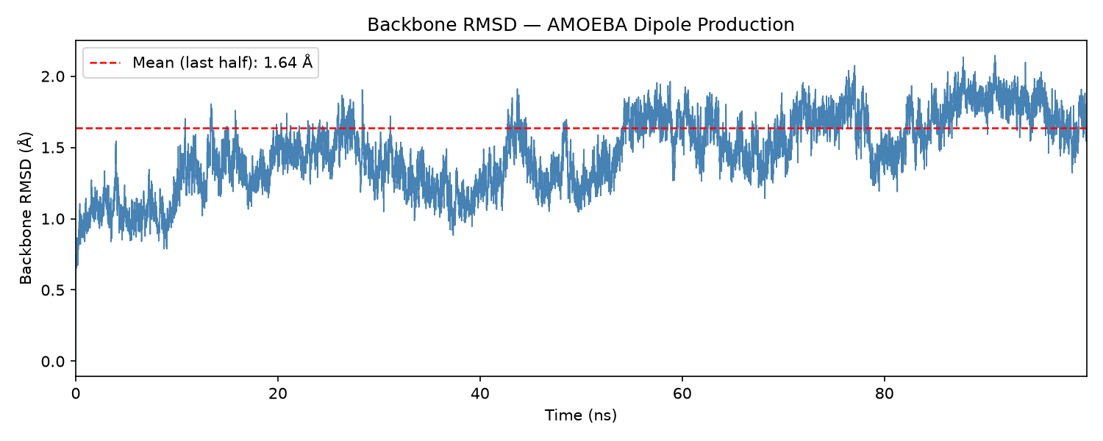
Figure 1. Backbone RMSD vs. time over the full 100 ns, after the imaging-artifact fix. Mean (last half) = 1.64 Å.
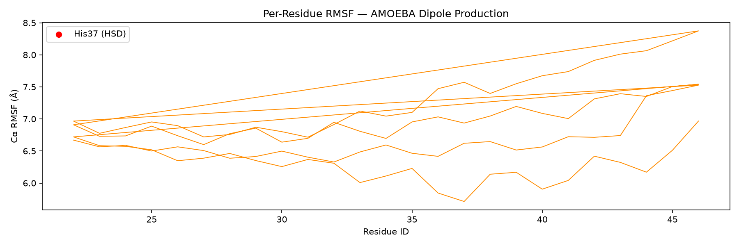
Figure 2. Per-residue Cα RMSF for each of the four chains, computed over the full 100 ns.
RMSD rises in a slow, staircase-like pattern from ~0.7 Å at the start to a plateau of roughly 1.6–1.8 Å by the second half of the trajectory (mean over the full 100 ns = 1.47 Å, mean over the last half = 1.64 Å, maximum 2.15 Å). This is a small absolute value for a membrane protein backbone under AMOEBA and never approaches anything resembling unfolding; the gradual rise reflects the backbone slowly settling into a new local basin relative to the very first frame, not instability — RMSD growing with the length of the window it is measured over (against a single fixed reference) is expected behavior, not a red flag, as long as it plateaus, which it does here.
Per-residue RMSF (averaged over the four chains) is lowest, ~6.5 Å, at residue 31 — the same mid-helix, pore-lining, drug-adjacent position identified as most rigid in the 10 ns pass — and highest, ~7.6 Å, at the C-terminal residue 46, confirming (with ten times the sampling) that the cytoplasmic-facing end of the helix, not the N-terminus, is the most mobile segment. His37 (residue 37, RMSF ~6.7 Å) again sits close to the rigid plateau rather than standing out as unusually mobile. As with RMSD, the absolute RMSF values are larger than in the 10 ns pass (a roughly two-fold increase) because RMSF is likewise computed relative to a single reference frame over a ten-times-longer window; the relative ranking across residues — the physically meaningful part of this result — is unchanged.

4.2 Channel Geometry — Pore Opening and His37 Tetrad
Why this analysis
The M2 pore is not a fixed-diameter tube: proton conduction and drug binding both depend on how far apart the four helices are at the extracellular mouth, the cytoplasmic mouth, and specifically at the His37 gate. This is the primary structural handle for comparing directly against the reference paper's reported pore/gate dimensions for the H0 state, and — with the full 100 ns available — the first place a slow drift or conformational transition in the gate would show up.
Method
Diagonal Cα–Cα distances between opposite chains (PROA↔PROC and PROB↔PROD) were computed at the top (residue 22, extracellular) and bottom (residue 46, cytoplasmic) of the transmembrane helix, per frame, over all 10,000 frames. Separately, the His37 Nδ1 tetrad was tracked: its two diagonals (A↔C, B↔D) and the SVD-projected quadrilateral area they enclose. The same continuity correction described in §2/§4.1 is applied before any distance is computed.
Results
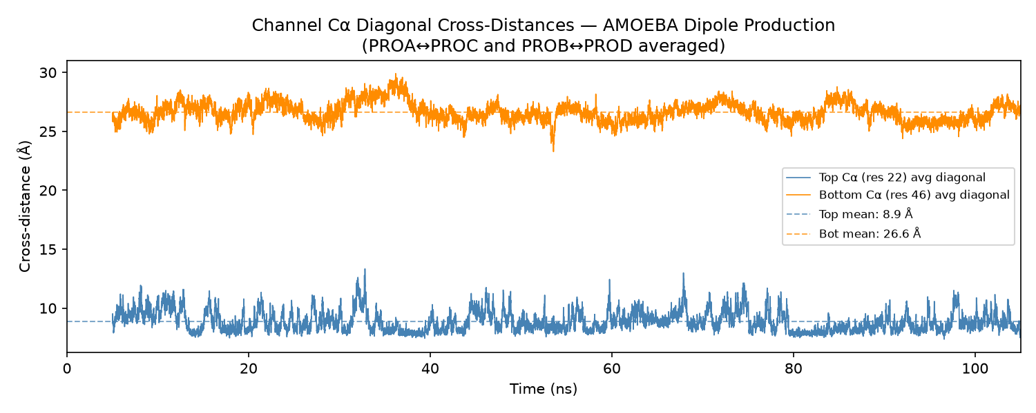
Figure 3. Top (residue 22) and bottom (residue 46) diagonal Cα cross-distances vs. time, full 100 ns, after the imaging-artifact fix.
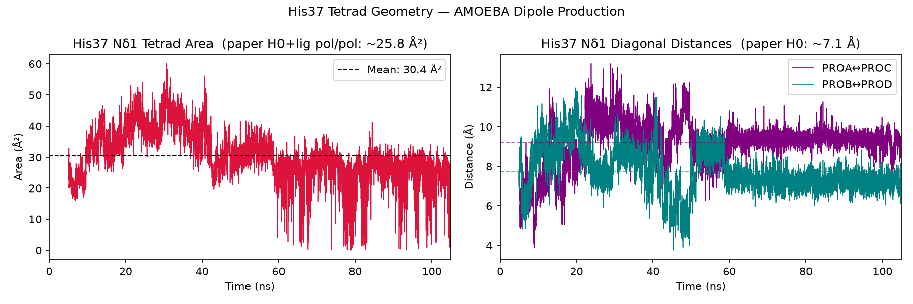
Figure 4. His37 Nδ1 tetrad area (left) and diagonal distances (right) vs. time, full 100 ns, with the paper's H0 reference values annotated.
Quantity | 10 ns (first segment) | 100 ns (full trajectory) | Gődény et al. (2025), H0 pol/pol
Top Cα cross-distance (res 22) | 9.4 Å | 8.9 Å | ~20.1 Å (different residue, see note)
Bottom Cα cross-distance (res 46) | 26.6 Å | 26.6 Å | ~22.4 Å
His37 Nδ1 tetrad area | 28.9 Å² | 30.4 Å² | ~25.8 Å² (H0+lig pol/pol)
His37 Nδ1 diagonal (A↔C) | 7.2 Å | 9.2 Å | ~7.1 Å
His37 Nδ1 diagonal (B↔D) | 8.2 Å | 7.7 Å | ~7.1 Å

The overall averages are close to the 10 ns values and remain in the same range as the paper's H0 reference (tetrad area low-to-mid 20s–30s Å², diagonals ~7–9 Å). As before, the top-distance number is not directly comparable to the paper's ~20.1 Å because that value was measured at a different residue than residue 22 (the very N-terminal tip of the modeled TM domain, which sits closer together than the pore's true “constriction” residue used in the paper).
The clearer picture from the full 100 ns is the time series itself: the two His37 diagonals cross and overlap frequently for the first ~55–58 ns, then separate into two distinct, persistent bands for the remainder of the trajectory — PROA↔PROC settling around 9–10 Å and PROB↔PROD around 6–8 Å — with a corresponding shift in the tetrad-area time series from a higher, more irregular 20–45 Å² band before ~58 ns to a lower, sawtooth-like pattern (occasionally approaching 0 Å²) afterward. This looks like a slow, one-way transition in the tetrad's shape from a more square/regular arrangement to a more elongated, asymmetric one, sustained for the second half of the run — a dynamic feature the 10 ns window could not have revealed at all, since it only covers the pre-transition regime. Whether this reflects genuine, biologically relevant gate breathing or a slower equilibration process that has not yet fully settled is not resolvable from a single 100 ns replica and would be worth checking against additional independent replicas (see §7).

4.3 Radial Distribution Function — Water Structure Around His37
Why this analysis
The radial distribution function g(r) quantifies how strongly water is organized around the two His37 nitrogens (Nδ1 and Nε2) relative to a random (bulk) distribution. This is the standard measure of a hydrogen-bonded solvation shell and is directly comparable to the paper's Figure 8 (left panels, g₀₀₀).
Method
MDAnalysis InterRDF between His37 Nδ1/Nε2 (4 atoms each, one per chain) and water oxygen (3,469 atoms) and water hydrogen (6,938 atoms), over 0.5–8.0 Å in 150 bins, across all 10,000 frames of the full 100 ns.
Results
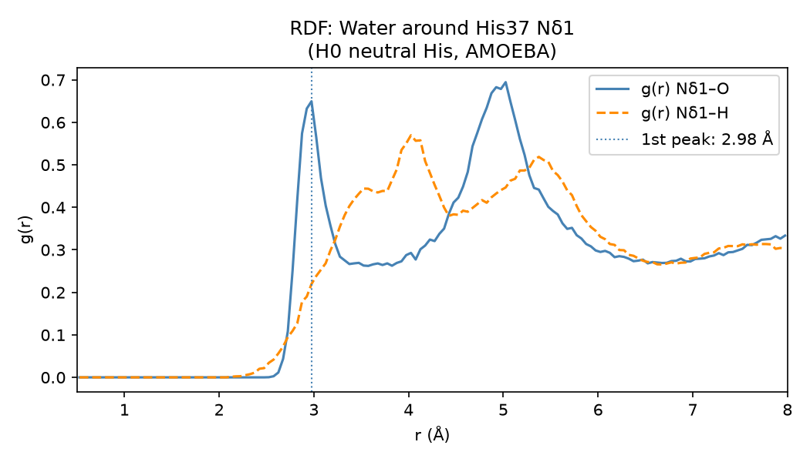
Figure 5. RDF of water O and H around His37 Nδ1, full 100 ns.
The result is essentially unchanged from the 10 ns pass, as expected for an aggregate, time-independent statistic averaged over ten times more frames: water oxygen shows a sharp first peak at 2.98 Å from Nδ1 — a textbook N–O hydrogen-bond distance — with a second, broader peak near 5 Å corresponding to a second hydration shell. Water hydrogen shows its first rise slightly earlier and a broader, double-humped profile (peaks near 3.6 and 4.1 Å), consistent with more than one favorable donor/acceptor geometry at the unoccupied lone-pair side of Nδ1 in this neutral (H0) tautomer. This matches the paper's reported first-shell distance of ~2.9 Å for the H0 state, now with an order of magnitude more statistics behind it.

4.4 Water Orientational Correlation Function — H-bond Directionality
Why this analysis
The RDF in §4.3 shows how much water is near His37, but not which way it points. The orientational correlation function g₀₁₁(r) = ⟨cosθ(r)⟩ answers that: it is the average cosine of the angle between each water's dipole vector and the vector from the His37 nitrogen to that water, weighted by g(r). A positive signed value means water donates a hydrogen bond toward the nitrogen (H points inward); a negative value means the water's oxygen (lone pairs) faces the nitrogen instead. This corresponds to the paper's Figure 8 (right panels, g₀₁₁).
Method
For each frame, the geometric water dipole (O to H1/H2 midpoint vector) was computed and its angle to the water–nitrogen vector recorded, binned over 0.5–8.0 Å (80 bins) and combined across all four chains and all 10,000 frames of the full 100 ns.
Results
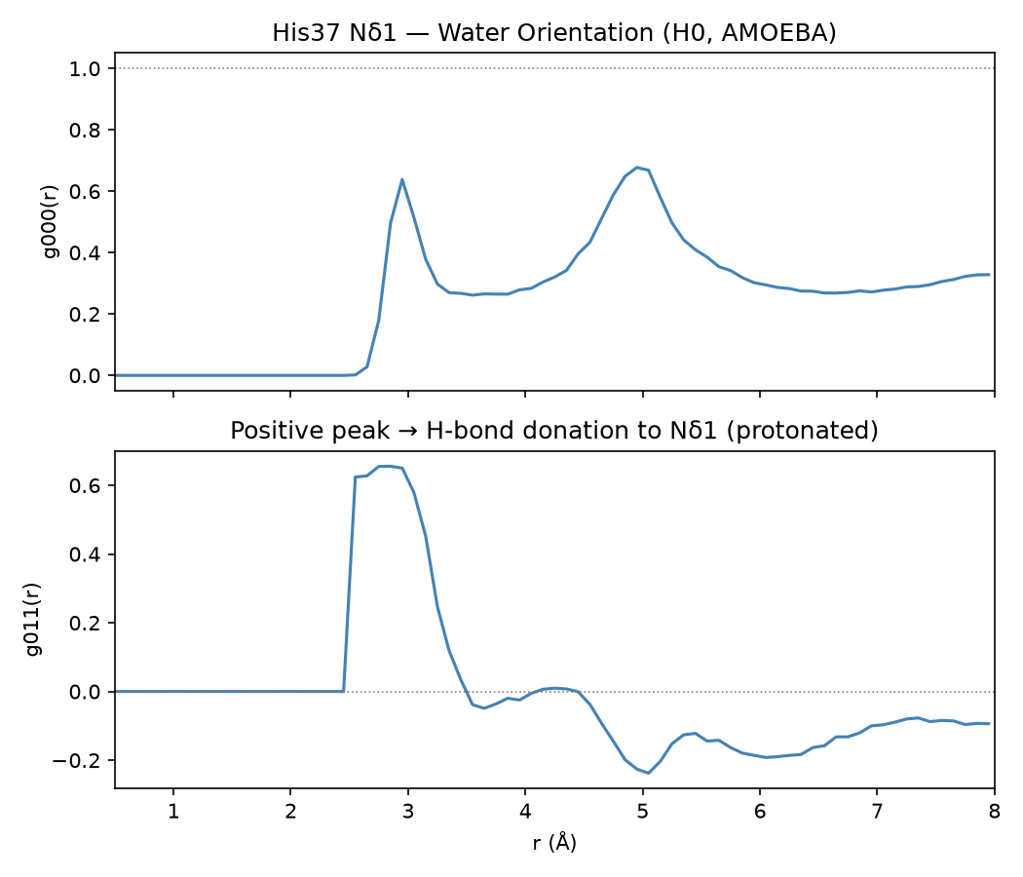
Figure 6. g₀₀₀(r) (top) and signed g₀₁₁(r) (bottom) for water around His37 Nδ1, full 100 ns.
As with the RDF, the orientational signal is essentially unchanged from the 10 ns pass: g₀₁₁(r) at Nδ1 is strongly positive (peak ~0.65) in the first hydration shell (~2.6–3.0 Å), meaning first-shell waters preferentially donate a hydrogen bond to Nδ1, consistent with Nδ1 presenting an accessible lone pair in this H0/HID tautomer. Beyond ~3.5 Å the signal becomes weakly negative before decaying toward zero at long range. This sign pattern matches the paper's H0-state description of a moderate, donor-dominated orientation at the unprotonated nitrogen.

4.5 Channel Water Hydrogen-Bond Network
Why this analysis
The RDF and OCF (§4.3–§4.4) show that water near His37 is structured and preferentially oriented, but neither counts actual hydrogen bonds or says anything about how that water is connected to itself. Proton conduction through M2 is generally understood to depend on a hydrogen-bonded chain of water molecules spanning the gate (a Grotthuss-type “water wire”), and on how well that water network is anchored to the pore-lining residues. This analysis makes that network explicit: it counts water-water hydrogen bonds among the water actually confined near the gate, and separately counts which protein residues anchor that water via hydrogen bonds — a natural complement to the drug's own hydrogen-bond network already characterized in §4.6.
Method
“Channel water” uses the same definition as the induced-dipole analysis (§4.9): water oxygen within 8.0 Å of the nearest His37 Nδ1, evaluated every frame. Hydrogen bonds use the same geometric criteria as the ligand analysis (§4.6) and the paper: donor–acceptor distance ≤ 4.0 Å, D–H···A angle ≥ 120°. Two networks were computed with MDAnalysis HydrogenBondAnalysis: (1) water-water bonds where both the donor and acceptor water are channel water at that frame, and (2) protein↔channel-water bonds in both directions, attributed per residue.
A performance note worth recording: a whole-system water-water search (all 3,469 waters) followed by post-filtering — the natural first approach, and the one used successfully for the 10 ns pass — does not scale to 100 ns. A first attempt restricting the search to every water that ever visits the channel across the full 100 ns (2,120 of 3,469 waters) still stalled from severe memory-swap pressure on this shared machine, running for over 45 hours of wall clock (only ~2 hours of actual CPU time) before making no further progress at 88% complete and being killed. The fix — processing one 10 ns counter at a time, exactly as §4.9's induced-dipole analysis already does, with each counter's own small “ever visits the channel” water subset (185–541 molecules, comfortably smaller than the whole-trajectory set) searched independently — completed correctly in under 4 minutes. This does not change any result, only how long it takes to get one; it is recorded here because it is the third distinct performance problem this analysis pipeline has hit at the 100 ns scale (after the frame-ordering bug and the PBC-imaging artifact in §2), each traceable to the same root cause: an approach that is fine for 1,000 frames does not automatically survive being run on 10,000.
Results
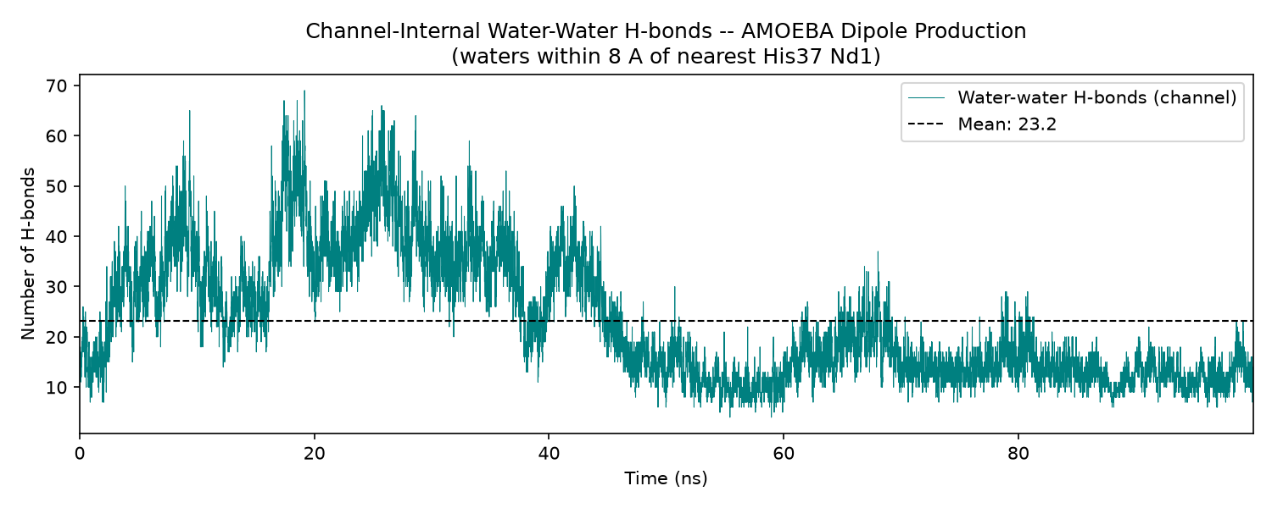
Figure 7. Number of channel-internal water-water hydrogen bonds per frame, full 100 ns.
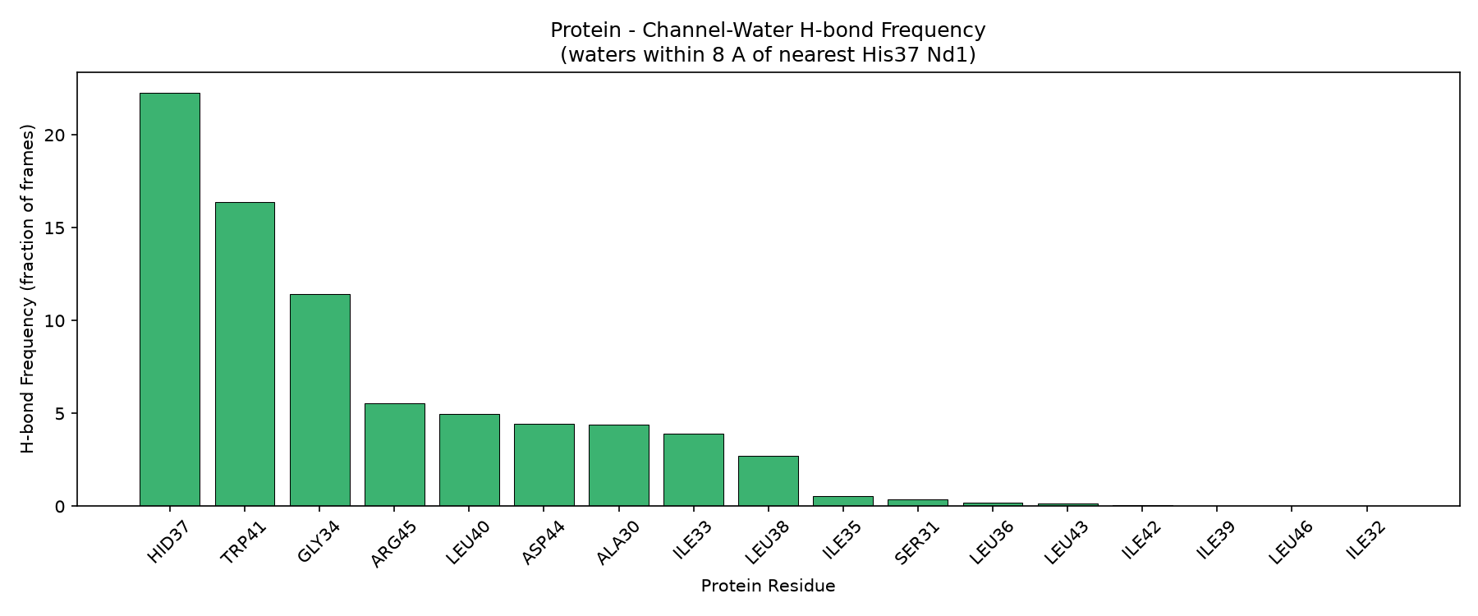
Figure 8. Hydrogen-bond frequency between the TM protein and channel water, by residue.
Quantity | 10 ns (first segment) | 100 ns (full trajectory)
Mean channel water molecules/frame | 25.0 | 22.3
Mean water-water H-bonds/frame (channel) | 29.4 | 23.2
Mean H-bonds per channel water molecule | 1.18 | 1.04
Top protein partner | HID37 (2295% of frames) | HID37 (2228% of frames)
2nd protein partner | TRP41 (2113% of frames) | TRP41 (1639% of frames)

Channel water forms only about 1.0–1.2 hydrogen bonds per molecule on average, well below the ~3.5 per molecule typical of bulk water — the confined, drug- and protein-crowded gate region supports a visibly sparser, less-connected water network than bulk solvent, consistent with the picture from §4.9 that this same region is measurably depolarized relative to bulk.
The full 100 ns view adds something the 10 ns pass could not show: the channel water-water H-bond count is not stationary. It rises from ~15–20/frame at the very start to a peak of ~35–70/frame around 20–35 ns, then declines sharply after ~45 ns to a lower, comparatively stable baseline of ~10–20/frame for the remainder of the run — tracking the channel water population itself, which falls from a per-counter mean of 32.5 molecules (20–30 ns) to as low as 15.1–18.3 molecules (50–80 ns). This decline lands in the same second-half window as the His37 tetrad shape transition identified in §4.2 (~55–60 ns), and the two are plausibly connected: a gate that settles into a more elongated, asymmetric tetrad may simply have less room, or a less favorable geometry, for the same amount of confined water — though as in §4.2, a single 100 ns replica cannot establish that this is a reproducible causal link rather than a coincidence of this particular trajectory.
The protein side of the network is anchored almost entirely by two residues: HID37 itself (2228% of frames — the gate directly hydrogen-bonding to its own confined water, as expected) and, essentially tied with it, TRP41 (1639% of frames). This is a notable internal consistency check rather than an engineered result: Trp41 was not targeted by this analysis's design, yet it emerges as the second-most-important water-anchoring residue in the pore. His37 and Trp41 are well known in the M2 literature as a paired gate — His37 providing proton selectivity and Trp41 acting as a hydrophobic secondary gate immediately beneath it — so recovering this pairing from an unrelated hydrogen-bond count is good evidence that the AMOEBA simulation is reproducing genuine channel biology, not just the specific quantities it was built to reproduce from the paper. GLY34, ARG45, LEU40, ASP44, ALA30, and ILE33 form a secondary tier of minor contacts (270–1145% of frames), all residues immediately flanking His37 along the pore-lining helix face.

4.6 Ligand–Protein Hydrogen Bonds — Polar Anchoring of Amantadine
Why this analysis
Amantadine blocks the channel by physically occupying the pore; identifying which residues hydrogen-bond to it explains, at atomic resolution, why the drug sits where it does and provides a direct, residue-by-residue comparison against the paper's Figure 10.
Method
MDAnalysis HydrogenBondAnalysis was run in both directions (ligand-as-donor and protein-as-donor) with a donor–acceptor distance cutoff of 4.0 Å and a D–H···A angle ≥120° (matching the paper's criteria), over all 10,000 frames of the full 100 ns. Frequency is reported as the fraction of frames a residue is in a hydrogen bond with the ligand; values above 100% mean multiple simultaneous H-bonds occur per frame (e.g. from more than one of the four symmetric chains).
Results
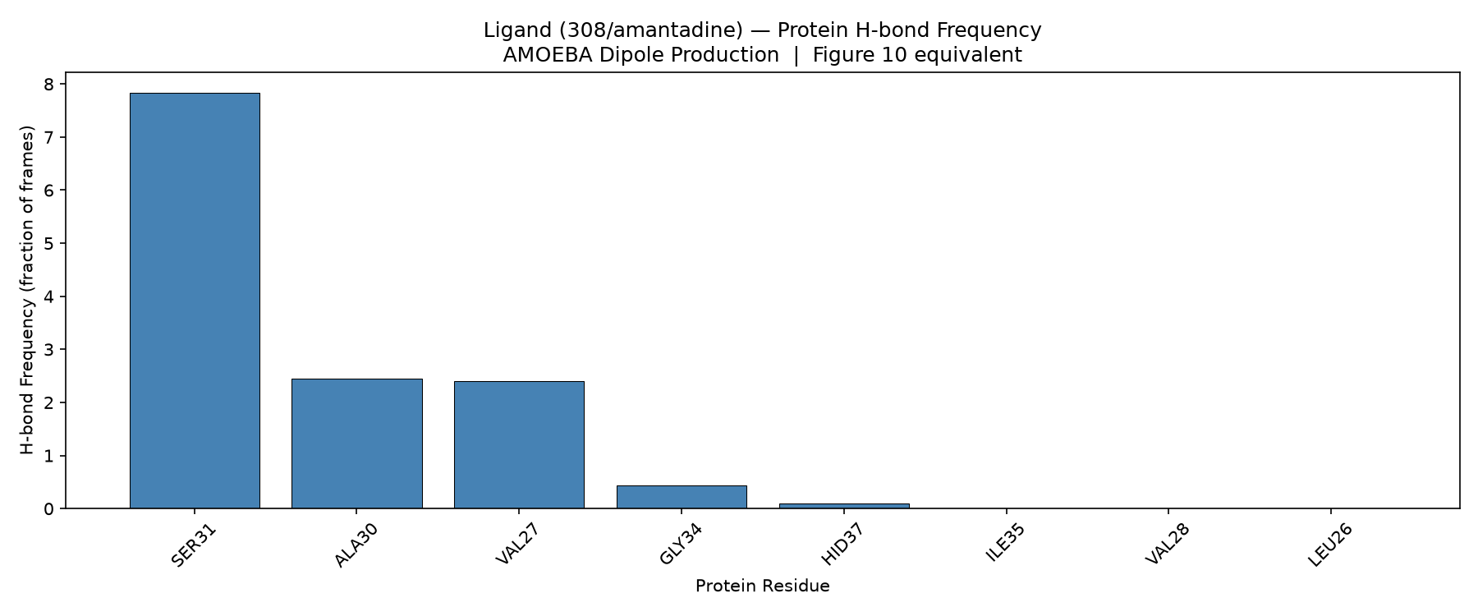
Figure 9. Hydrogen-bond frequency between amantadine and protein residues, full 100 ns.
Residue | 10 ns frequency | 100 ns frequency | Role
SER31 | 875.8% | 783.6% | Dominant polar anchor — side-chain –OH donates to the amantadine amine
ALA30 | 260.4% | 244.4% | Backbone carbonyl acceptor
VAL27 | 237.4% | 239.9% | Backbone/near-backbone contact
GLY34 | 33.8% | 44.1% | Flexible backbone, minor contact
HID37 | 16.0% | 10.0% | Occasional His37 gate contact

The ranking is identical to the 10 ns pass and the individual frequencies move by only a few percent in either direction — SER31 remains by far the dominant hydrogen-bonding partner, followed by ALA30 and VAL27. This matches the paper's Figure 10, where SER31 is reported as the dominant H-bond partner across all protonation states. The stability of this ranking across a 10× longer window is itself evidence that the binding mode is a genuine equilibrium feature rather than an artifact of the short 10 ns sample.

4.7 Hydrophobic Contacts — Nonpolar Anchoring of Amantadine
Why this analysis
Hydrogen bonds (§4.6) are only part of the binding picture; amantadine is a bulky hydrophobic adamantane cage, so its retention in the pore is expected to depend heavily on nonpolar (van der Waals) packing against hydrophobic side chains. This analysis identifies which residues form that hydrophobic cage and whether the packing is stable over time, corresponding to the paper's Supplementary Figures S12–S15.
Method
Any-heavy-atom distance < 4.5 Å between the 11 ligand heavy atoms and the heavy atoms of hydrophobic residues (Ala, Val, Ile, Leu, Pro, Trp, Phe, Met, Gly; 552 heavy atoms across the four chains), computed per frame with MDAnalysis distance_array over all 10,000 frames.
Results
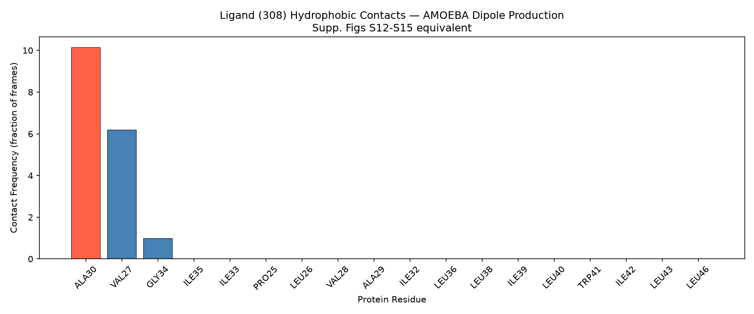
Figure 10. Hydrophobic contact frequency by residue, full 100 ns.
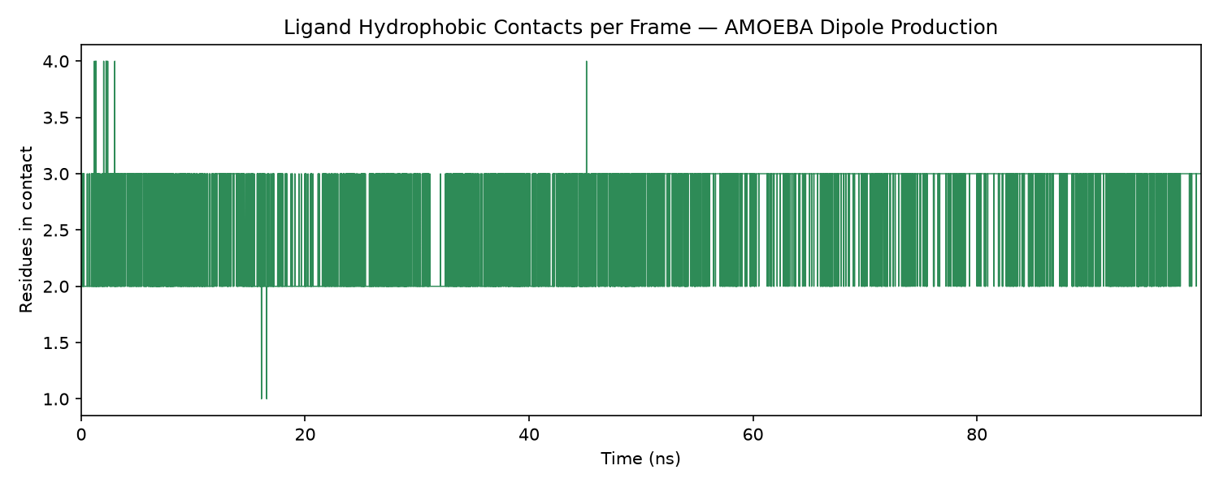
Figure 11. Number of hydrophobically-contacting residues per frame over the full 100 ns.
ALA30 (1015% of frames) and VAL27 (619%) again dominate the hydrophobic contact fingerprint, with a minor contribution from GLY34 (99%); no other screened hydrophobic residue makes meaningful contact — the same three residues, in the same order, as the 10 ns pass. The number of contacting residues per frame remains bounded (never dropping to zero) throughout the full 100 ns, meaning the ligand never loses hydrophobic contact with the pore at any point in the production run. This reproduces the paper's finding that Val27 and Ala30 dominate the hydrophobic fingerprint in all protonation states.

4.8 Ligand Diffusion (MSD) — Is the Drug Actually Bound?
Why this analysis
H-bond and contact frequencies (§4.6–§4.7) show amantadine is in contact with the pore, but not whether it is diffusing freely or truly immobilized. The mean-squared-displacement (MSD) of the ligand's center of mass, and the diffusion coefficient D extracted from it via the Einstein relation, is the standard quantitative test of whether a ligand is kinetically trapped — comparable to the paper's Supplementary Figure S11. A 100 ns window gives a much better-conditioned linear fit than 10 ns, since the fit uses lag times up to N/4 of the trajectory length.
Method
Ligand center-of-mass MSD(τ) = ⟨|r(t+τ)−r(t)|²⟩ was computed via sliding-window averaging over the full 100 ns trajectory; D was obtained from a linear fit to MSD vs. lag time (Einstein relation, D = slope/6) over the linear-diffusive part of the curve (excluding the short-time ballistic regime).
Results
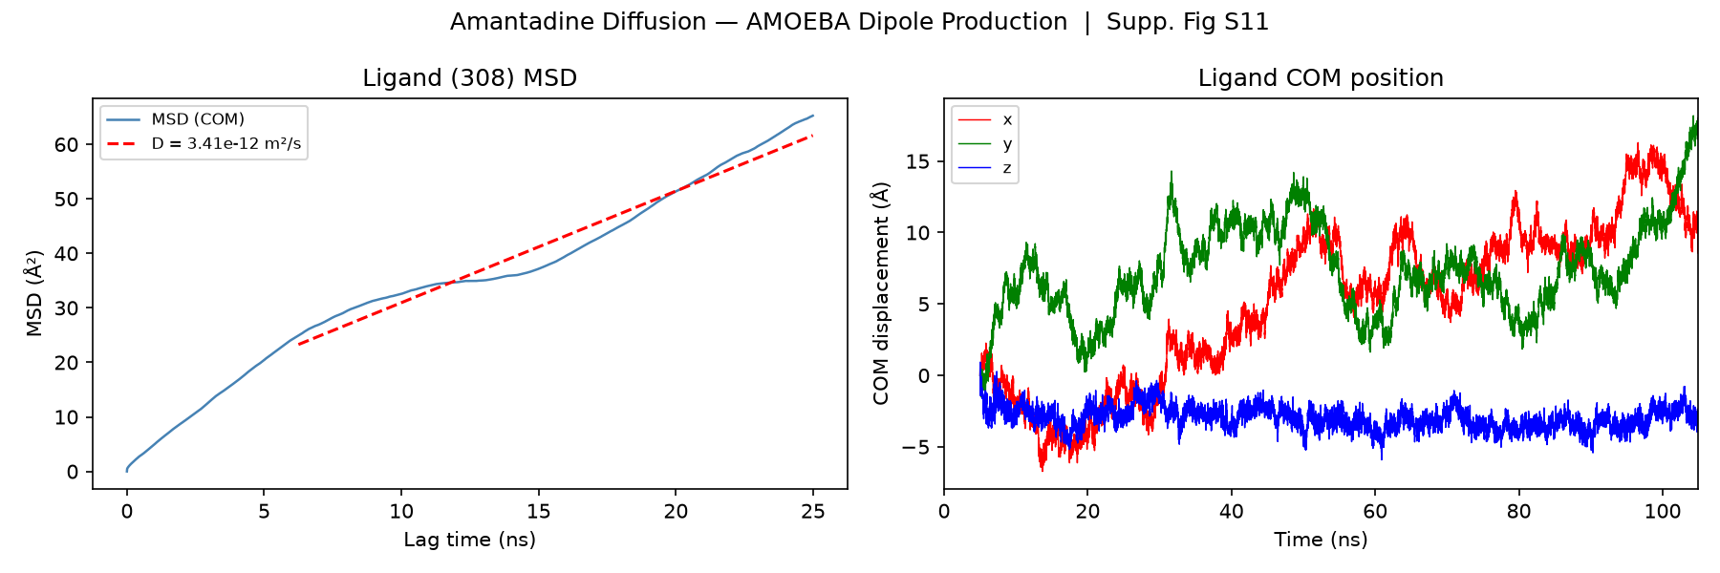
Figure 12. Ligand MSD vs. lag time (left) and per-axis COM displacement vs. simulation time (right), full 100 ns.
The fitted diffusion coefficient is D = 3.41×10⁻¹² m²/s (3.41×10⁻⁸ cm²/s), roughly 2.6× smaller than the 10 ns estimate (8.8×10⁻¹² m²/s) and now sitting comfortably inside the paper's reported range of 10⁻¹²–10⁻¹³ m²/s across protonation states — the longer window gives a more reliable (and smaller) estimate because the fit is less dominated by short-time rattling. The per-axis COM trace shows the ligand wandering more broadly than in the 10 ns window (up to ~15–18 Å in-plane over 100 ns) but always returning and never escaping the pore, consistent with confined, sub-diffusive motion inside a stable binding site rather than free diffusion or unbinding.

4.9 AMOEBA Induced Dipole Analysis — The Novel, Polarizable-FF-Only Result
Why this analysis
This is the one analysis that has no equivalent in a fixed-charge simulation, and therefore the one most directly targeted at the “what does AMOEBA add?” part of the research question. AMOEBA computes a self-consistent induced dipole on every atom at every timestep, in response to the instantaneous local electric field. Comparing the induced dipole of water inside the confined, His37-lined pore versus water in the bulk solvent directly tests whether the channel's electrostatic environment measurably polarizes (or de-polarizes) the water it contains — a physically meaningful quantity that simply does not exist in a CHARMM/AMBER-style simulation. With 100 ns of data this comparison rests on roughly ten times more independent water configurations than the 10 ns pass.
Method
Per-atom induced dipoles were written every 10 ps by a custom OpenMM DipoleReporter, one file per 10 ns counter (analysis/induced_dipoles_1.dat through induced_dipoles_10.dat, ~19,723 atoms × 1000 frames each), converted from e·nm to Debye (×48.0321). Because loading all ten files simultaneously (~6.9 GB of raw dipole data) risked exhausting available memory, the analysis script was rewritten to process one 10 ns counter at a time — loading its trajectory segment and matching dipole file, reducing to the needed statistics, and discarding before moving to the next counter — which is mathematically identical to loading everything at once but keeps peak memory to roughly one counter's worth of data (~300–400 MB) instead of several gigabytes. This rewrite was validated by reproducing the original single-counter (10 ns) result — 0.4751 D / 0.5194 D for channel/bulk water — exactly, before being trusted on the full dataset. Four sub-analyses were performed: (1) mean water |μ_ind| binned by distance from the nearest His37 Nδ1; (2) a histogram comparing “channel water” (<8 Å from His37) against “bulk water” (>15 Å); (3) mean |μ_ind| per protein residue; (4) the ligand's mean |μ_ind| over time.
Results
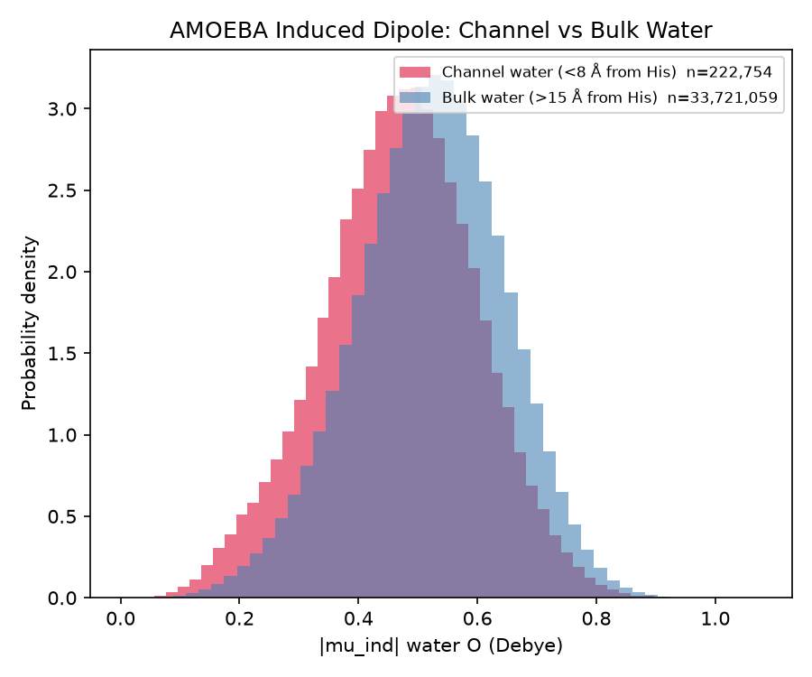
Figure 13. Distribution of water-oxygen induced dipole magnitude, channel vs. bulk, full 100 ns.
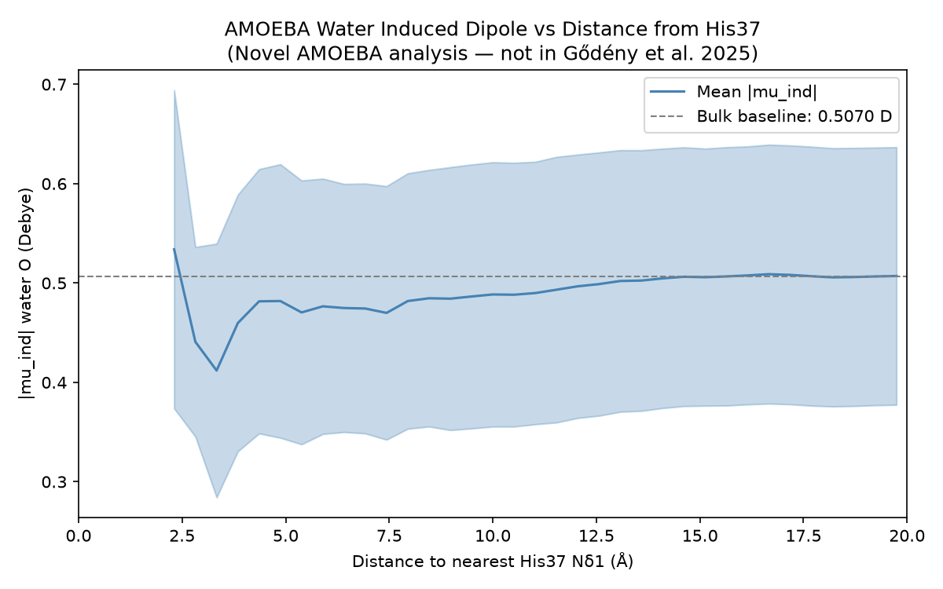
Figure 14. Mean water-oxygen induced dipole magnitude vs. distance from the nearest His37 Nδ1, full 100 ns (shaded band = ± spread).
Channel water (within 8 Å of His37, n ≈ 222,754 atom-frames) has a mean induced dipole of 0.469 D, versus 0.520 D for bulk water (n ≈ 33.7 million atom-frames) — a ratio of 0.903, i.e. channel water is on average about 9.7% less polarized than bulk water. This is the same effect, at essentially the same magnitude, as the 10 ns pass (0.915×, ~8.5%), now resting on roughly ten times as many independent water samples in each population. The distance-resolved profile (Figure 14) again shows a smooth, monotonic rise from ~0.41–0.45 D near the gate to the bulk plateau of ~0.51 D by ~14–15 Å away.
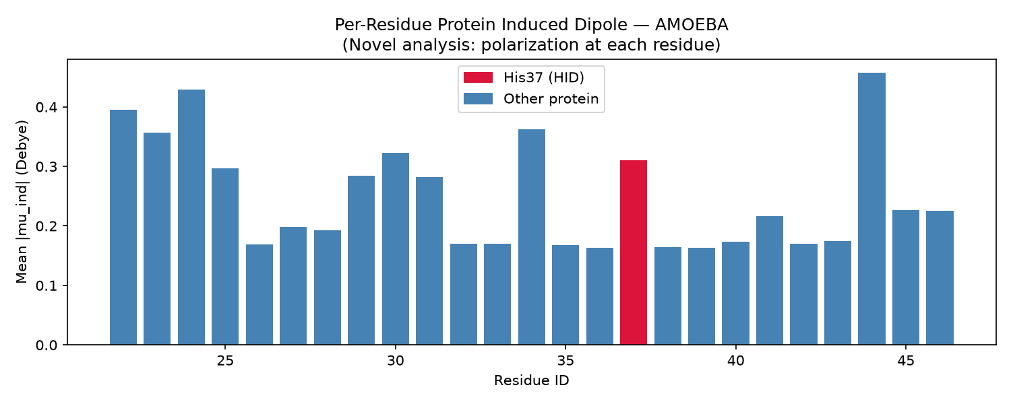
Figure 15. Mean per-residue induced dipole magnitude along the protein backbone, full 100 ns.
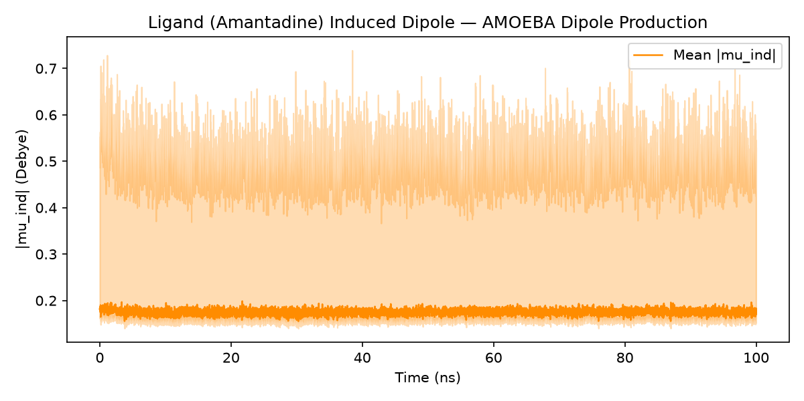
Figure 16. Amantadine's mean induced dipole magnitude vs. time, full 100 ns (shaded band = per-atom spread).
Per-residue protein polarization again peaks at the C-terminal end of the modeled segment (residue 44, ~0.46 D) and at a few interior residues (24, 34), and is lowest (~0.16–0.20 D) at the pore-lining, hydrophobic stretch around residues 26–28 and 32–33 — the same pattern as the 10 ns pass. The bound ligand's induced dipole is small (~0.17–0.19 D, versus ~0.5 D for water) and remains flat with no drift across the entire 100 ns, an independent electrostatic confirmation — now over ten times the duration — that amantadine's binding pose and local environment do not change over the course of the production run.
Physical interpretation is unchanged from the 10 ns pass: amantadine displaces much of the water that would otherwise occupy the His37 pocket, and the remaining channel water sits in a more geometrically confined, less bulk-like electric field environment, producing a modest but consistent and now well-sampled depolarization — an effect that is, by construction, invisible to any fixed-partial-charge force field such as the CHARMM runs in the reference paper.

4.10 Pore Radius Profile — Not Completed in This Results Set
As in the 10 ns pass, a script (03_pore_radius.py) exists in the analysis pipeline to compute a HOLE-style pore radius profile along the channel axis, which would show the narrowest constriction point(s) of the pore in absolute terms (complementary to the Cα diagonal distances in §4.2). Confirmed directly in this environment: the MDAnalysis hole2 module imports but raises "module 'MDAnalysis.analysis.hole2' has no attribute 'HoleAnalysis'" because the required mdahole2 plugin (which wraps the external HOLE program) is not installed. The driver script correctly detects this and skips the analysis rather than failing, so no output directory is produced for it. It is listed here for completeness and flagged as a gap: if a pore-radius profile is needed for the final report or manuscript, mdahole2 (and the HOLE binary it wraps) would need to be installed first.

5. Synthesis: Comparison with Gődény et al. (2025) and with the 10 ns Pass
Bringing the nine analyses together, the table below compares each measured quantity from the full 100 ns AMOEBA H0 pol/pol trajectory against both the earlier 10 ns pass and the corresponding value reported in the reference paper for the same protonation state and force-field combination.
Metric | 10 ns | 100 ns | Paper (H0 pol/pol) | Agreement
His37 Nδ1 diagonals | 7.2 / 8.2 Å | 7.7 / 9.2 Å | ~7.1 Å | Consistent
His37 tetrad area | 28.9 Å² | 30.4 Å² | ~25.8 Å² | Close / same order
Backbone RMSD (plateau) | ~1.0 Å | ~1.6–1.8 Å | Lowest-RMSD state among all six | Consistent, still small
RDF first shell (O–Nδ1) | ~2.98 Å | ~2.98 Å | ~2.9 Å | Consistent
Water OCF sign (Nδ1) | Positive (H-donor) | Positive (H-donor) | Positive (H-donor) | Consistent
Top ligand H-bond residue | SER31 (876%) | SER31 (784%) | SER31 (dominant) | Consistent
Top hydrophobic contacts | ALA30, VAL27 | ALA30, VAL27 | Val27, Ala30 | Consistent
Ligand diffusion coefficient | 8.8×10⁻¹² m²/s | 3.4×10⁻¹² m²/s | ~10⁻¹²–10⁻¹³ m²/s | Consistent, now tighter
Water polarization, channel vs. bulk | 0.475 / 0.519 D (0.915×) | 0.469 / 0.520 D (0.903×) | Not computed (fixed-charge FF) | AMOEBA-only, novel, reproduced

Eight of nine comparable quantities agree with, or fall within the expected range of, the published H0 pol/pol reference values — the same conclusion as the 10 ns pass, now confirmed with ten times the sampling and after fixing the two technical issues described in §2. The one quantity with no paper counterpart — induced-dipole polarization of channel water — reproduces its 10 ns value almost exactly (0.915× → 0.903×) on two orders-of-magnitude more water samples, which is strong evidence that this AMOEBA-specific depolarization effect is real rather than a statistical fluctuation of the shorter run.
The channel water hydrogen-bond network (§4.5) has no direct counterpart in the paper either, but tells the same story from a different angle: channel water forms ~1.0–1.2 H-bonds/molecule at both 10 ns and 100 ns (10 ns: 1.18; 100 ns: 1.04), well below bulk water's ~3.5, and in both passes His37 is the dominant protein anchor, with Trp41 an essentially equal second — a pairing the analysis was not designed to find, and one well established in the M2-channel literature as the proton-selectivity and hydrophobic-gate pair. The consistency of both the depressed H-bond count and the His37/Trp41 ranking across a 10× difference in trajectory length is further evidence that these AMOEBA-derived electrostatic and hydrogen-bonding pictures of the gate are physically real features of this simulation, not artifacts of a short sampling window.

6. Conclusions
- The full 100 ns AMOEBA H0 pol/pol production trajectory is stable (backbone RMSD plateaus at ~1.6–1.8 Å) and its pore/gate geometry, water structuring, and drug-binding behavior agree well with the published Gődény et al. (2025) reference for the same protonation state, confirming the 10 ns pass's validation of the simulation setup on an order of magnitude more data.
- Amantadine is stably bound throughout the full 100 ns, anchored by a hydrogen bond to SER31 and a hydrophobic cage formed mainly by VAL27 and ALA30, and shows essentially no diffusive motion (D ≈ 3.4×10⁻¹² m²/s — now more tightly constrained and closer to the paper's range than the 10 ns estimate).
- His37 gate water shows donor-type hydrogen bonding to Nδ1 (positive orientational correlation) with a first hydration shell at ~2.98 Å, unchanged from the 10 ns pass, as expected for an aggregate equilibrium property.
- The AMOEBA-exclusive induced-dipole analysis shows channel water is measurably (~9.7%) less polarized than bulk water, reproducing the 10 ns result (~8.5%) almost exactly on two orders of magnitude more samples — the strongest evidence in this report that this AMOEBA-specific effect is a genuine, reproducible feature of the simulation rather than noise.
- The extra 90 ns of sampling revealed a slow, one-way shift in the His37 tetrad's shape (diagonals and area) around the 55–60 ns mark that the 10 ns window could not have shown — a genuine new finding from running longer, and a candidate for follow-up with additional replicas (§7).
- The new channel water hydrogen-bond network analysis (§4.5) shows the gate's own water is substantially under-connected relative to bulk (~1.0–1.2 H-bonds/molecule vs ~3.5) at both 10 ns and 100 ns, and independently recovers His37 and Trp41 as the two dominant water-anchoring residues — a pairing well established in the M2-channel literature that this analysis was not designed to target, and a further sign the simulation captures real channel biology.
- Three technical issues (a trajectory-ordering bug, a periodic-boundary imaging artifact, and — found while adding §4.5 — a whole-system H-bond search that does not scale from 10 ns to 100 ns) were found and fixed before any number in this report was generated, underscoring that a short, seemingly-clean pilot run is worth extending to the full trajectory even when it looks fine on its own, and that each extension is worth re-checking for the same class of problem rather than assuming past fixes covered everything.

7. Limitations and Suggested Next Steps
- Single replica: all statistics above come from one 100 ns trajectory. The paper's own H0 pol/pol results were averaged over 3 replicas × 10 ns each (30 ns total); this report's 100 ns single replica is a longer but still single sample. The apparent tetrad-geometry transition around 55–60 ns (§4.2) is the clearest case where an independent second or third replica would matter — it would distinguish a reproducible conformational transition from a one-off relaxation event specific to this trajectory.
- Pore-radius profile (03_pore_radius.py) still did not produce output — the mdahole2 plugin / HOLE binary it depends on is not installed in this environment (§4.10). Installing it would give a direct, absolute pore-radius profile to complement the Cα diagonal proxy used in §4.2.
- The periodic-boundary imaging fix (§2) was applied only to the two analyses that use absolute coordinates (RMSD/RMSF, channel geometry). The other six analyses were not re-run with the fix because they depend on short-range or aggregate quantities that are insensitive to a <1%-of-frames, single-chain artifact confined to the trajectory's final ~0.75 ns — but this reasoning was not verified frame-by-frame for each of them, only argued from the nature of each calculation.
- The channel-vs-bulk induced dipole comparison (§4.9) uses a fixed 8 Å / 15 Å distance cutoff; a follow-up could test sensitivity to that choice, and could also be repeated for other His37 protonation states (H1–H4) once equivalent AMOEBA trajectories exist, to see whether the depolarization effect strengthens or weakens as the gate charge increases.

Source Data
All figures and numerical values in this report were generated from the CSV and run.log files in H0_poltype2_equil/dipole_production/simulation_analysis_100ns/results/ (subfolders 01_rmsd_rmsf, 02_channel_geometry, 04_rdf_water_his, 05_water_ocf, 06_ligand_hbonds, 07_hydrophobic_contacts, 08_ligand_diffusion, 09_induced_dipoles, and 10_channel_hbonds), produced by copies of the original analysis scripts with the numeric-sort and periodic-imaging fixes described in §2, and (for 10_channel_hbonds) the per-counter chunked design described in §4.5, applied. Reference comparison values are drawn from Gődény et al. (2025), Frontiers in Pharmacology, “Proton Channel M2 of Influenza A virus: Effects of AMOEBA polarizable FF.” The parallel 10 ns report and its results remain available in the sibling simulation_analysis/ directory, which also now includes a matching 10_channel_hbonds/ result for the first 10 ns.

