**GAMINDUSTRI**

**BALOO’S BANANA**

**Version 1.01**

All work Copyright © 2018 by Gamindustri Gaming Studio

All rights reserved

**Amit Kumar  
RanjanaKalra  
ArunBharath  
Amarender Reddy  
RonnellanVillarino  
Julian Giraldo**

**Table of Contents**

Game Overview 4

Game Play Mechanics 4

Camera 4

Controls 4

Saving & Loading 4

Interface Sketch 5

Menu and Screen Descriptions 6

Game World 6

Levels 6

Game Progression 6

Characters 6

Non-Player Character 6

Enemies 6

Weapons 7

Items 7

Abilities 7

Vehicles 7

Script 7

Scoring 7

Puzzles/Mini Games 7

Bonuses 7

Cheat Codes 8

Sound Index 8

Story Index 8

Art / Multimedia Index 8

Design Notes 8

Future Features 8

Plan for the team 8

* **Game Overview**In this game there are a lots of banana’s that is to be collected because the Player**(A Monkey)** has to collect the banana’s as he is hungry but he has to do so without getting noticed by other monkey’s who are near to banana’s.

There are many levels in the game where 1st level is the easiest one, In the next level, the player will be chased by enemies and the last level has to be played against the boss who is **A Big Monkey.**

* **Game Play Mechanics**The player is provided with 3 lives. Each time the player is caught, game will be continued from same point up to 3 chances and at final caught, the score at that moment will be declared as final score.   
    
  The more banana’s player collect’s, more points will be gained. Escaping from normal enemies is easy but escaping from boss will require long run and more banana’s.
* **Camera**The camera used in game is Orthographic.
* **Controls**Game uses the A(left) D(right) Keys for standard movement, S Key for jumping and CTRL key for attacking on enemies.
* **Saving and Loading**The game has no auto-save feature I.e. at any point if you end the game, next time when you open it, it will open from the start.
* **Interface Sketch**

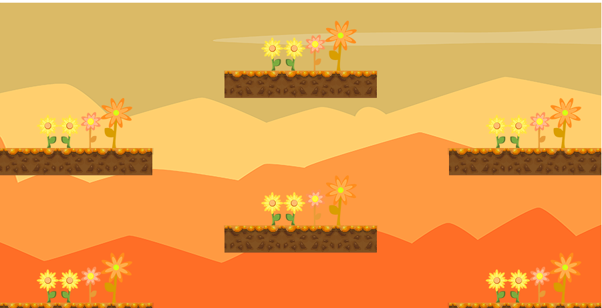 Basic Interface of Whole Game



Platform



Collectibles   
   
 Player

* **Menu and Screen Descriptions  
  \*** One is menu screen where player will have basic options like Start Game.   
  * Other is game play screen where the main game will be played
* **Game World**Jungle is the game world where the player has to run and play the game while jumping on the platforms.
* **Levels**The game has 3 levels. In 1st level, player needs to collect the banana’s.  
  In 2nd level, player will be chased by enemies  
  In 3rd/last level, the player will be attacked by the boss.
* **Game Progression**The game starts with a short intro and then the main game starts. The arrows will come in start to direct the gameplay concept to the player. New level will come every time once the current level is passed.  
  **NOTE:** There is no option to skip a level.  
  There will be a total of 3 levels that player has to pass in order to win the game.
* **Characters**Main Player: Monkey  
  Medial-Enemy: Money  
  Boss Enemy: Big Monkey
* **Non-player Characters  
  Banana’s:** Isn’t a character but an item that the main player has to collect in order to increase game score and win.
* **Enemies**There will be **Medial Enemy’s** who itself will be **monkey’s** like as the main player but in the last level, the **Boss Enemy** will be a **Monkey**.
* **Weapons**The player has to collect banana’s and throw it on enemy, hence banana is the only weapon.
* **Items**Power-up and jet-packs will be made avail at specific times and at boss level.
* **Abilities**Player can control the movement and also the throw intensity and timing when to throw.
* **Vehicles**No vehicles are included, it’s an On-foot locomotion game.
* **Script**It’s a battle between the main player monkey with other monkeys of the jungle in search of food while he’s starving for food and at same time the boss evil of the game and also known as the King of the Jungle, The Lion who might come in between as a barrier for him.
* **Scoring**The farther the player runs and more banana’s it collects, the score will increase.
* **Bonuses**There will be bonus banana’s also available ha will give extra points when collected but it will be more difficult more difficult for collecting them than that of collecting the normal banana’s.
* **Cheat Codes**No cheat codes.
* **Sound Index**The sound is a bell-jungle style sound which shows variation according to difficulty of the game.
* **Story Index**Collect bananas for time when player is hungry and use them also as a weapon against the enemy’s. Defeat them all including the boss and escape from trouble to win the game.
* **Art / Multimedia Index**The graphics and multimedia index of the game is basically based on Jungle theme with sound and voices giving a real feel of jungle life style.
* **Design Notes**The design is simple Jungle based concept oriented.
* **Future Features**This game can also be presented in a 3D variant with new weapons and levels and more enemies with more difficulties.