**MathTicTac** - A Mathematics Learning Website

**MathTicTac**- is primarily designed for middle school students, especially those in the 8th grade.

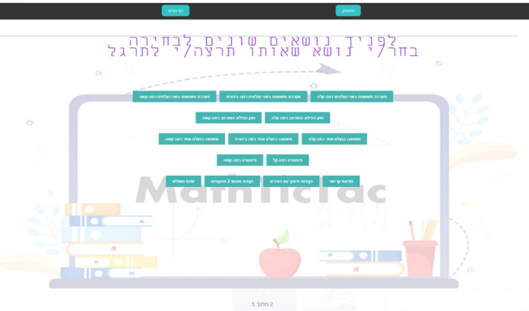The website provides explanations through short videos on a variety of study materials. Following each video, there's an opportunity to practice the subject and take a test on it. Each topic is presented at three levels of study: easy, medium, and hard.

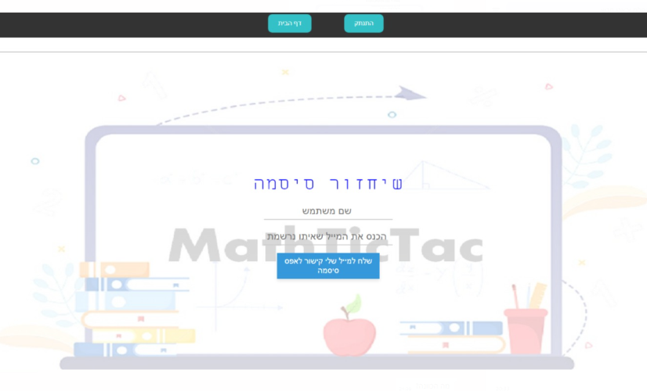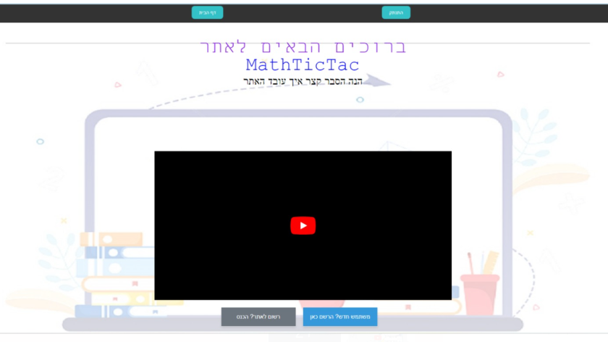To access the website, users must register and set a password. If a user forgets their password, there's an option to retrieve or reset it. The website remembers the exercises the user has already solved.

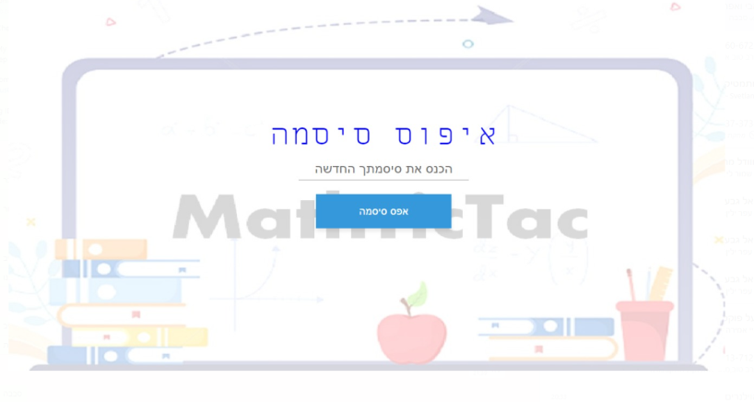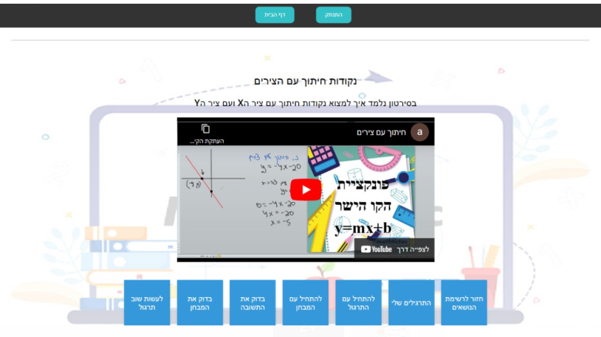

A great user experience is guaranteed on the site

: To install the website, download from the following two links

Technologies Used:

Django

sqlite3

Python

TypeScript

Angular

Gmail