**13-08-2024**

**1] IMAGE INSERTION IN JAVAFX**

package javafxapplication8;

import javafx.application.Application;

import javafx.scene.Scene;

import javafx.scene.image.Image;

import javafx.scene.image.ImageView;

import javafx.scene.layout.StackPane;

import javafx.stage.Stage;

public class JavaFXApplication8 extends Application {

@Override

public void start(Stage primaryStage) {

Image image = new Image("file:C:\\Users\\oviya\\Downloads\\images (1).jpeg");

ImageView imageView = new ImageView(image);

imageView.setFitWidth(290);

imageView.setFitHeight(350);

imageView.setPreserveRatio(true);

StackPane root = new StackPane();

root.getChildren().add(imageView);

Scene scene = new Scene(root, 300, 250);

primaryStage.setTitle("Display Image");

primaryStage.setScene(scene);

primaryStage.show();

}

public static void main(String[] args) {

launch(args);

}

}

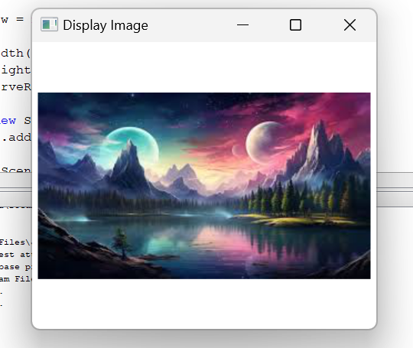

**2] AUDIO INSERTION**

package javafxapplication9;

import javafx.application.Application;

import javafx.event.ActionEvent;

import javafx.event.EventHandler;

import javafx.scene.Scene;

import javafx.scene.control.Button;

import javafx.scene.layout.StackPane;

import javafx.stage.Stage;

import javafx.scene.media.Media;

import javafx.scene.media.MediaPlayer;

import java.io.File;

public class JavaFXApplication9 extends Application {

@Override

public void start(Stage primaryStage) {

String audioFilePath = "C:\\Users\\oviya\\Downloads\\chin-tapak-dum-dum-made-with-Voicemod.mp3";

Media audio = new Media(new File(audioFilePath).toURI().toString());

MediaPlayer mediaPlayer = new MediaPlayer(audio);

Button btn = new Button();

btn.setText("Play Audio");

btn.setOnAction(new EventHandler<ActionEvent>() {

@Override

public void handle(ActionEvent event) {

mediaPlayer.play();

System.out.println("Playing audio...");

}

});

StackPane root = new StackPane();

root.getChildren().add(btn);

Scene scene = new Scene(root, 300, 250);

primaryStage.setTitle("Audio Player");

primaryStage.setScene(scene);

primaryStage.show();

}

public static void main(String[] args) {

launch(args);

}

}

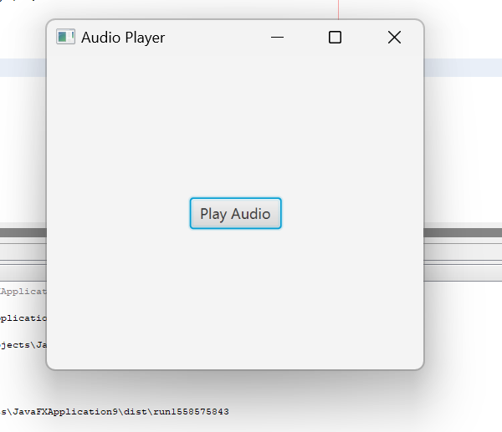

**3] KEYBOARD EVENT HANDLING**

package javafxapplication10;

import javafx.application.Application;

import javafx.event.EventHandler;

import javafx.scene.Group;

import javafx.scene.Scene;

import javafx.scene.control.TextField;

import javafx.scene.input.KeyEvent;

import javafx.scene.paint.Color;

import javafx.stage.Stage;

public class JavaFXApplication10 extends Application{

@Override

public void start(Stage primaryStage) throws Exception {

TextField tf1 = new TextField();

TextField tf2 = new TextField();

tf1.setTranslateX(100);

tf1.setTranslateY(100);

tf2.setTranslateX(300);

tf2.setTranslateY(100);

tf1.setOnKeyPressed(new EventHandler<KeyEvent>() {

@Override

public void handle(KeyEvent key) {

tf2.setText("Key Pressed :"+" "+key.getText());

}

});

Group root = new Group();

root.getChildren().addAll(tf2,tf1);

Scene scene = new Scene(root,500,200,Color.WHEAT);

primaryStage.setScene(scene);

primaryStage.setTitle("Handling KeyEvent");

primaryStage.show();

}

public static void main(String[] args) {

launch(args);

}

}

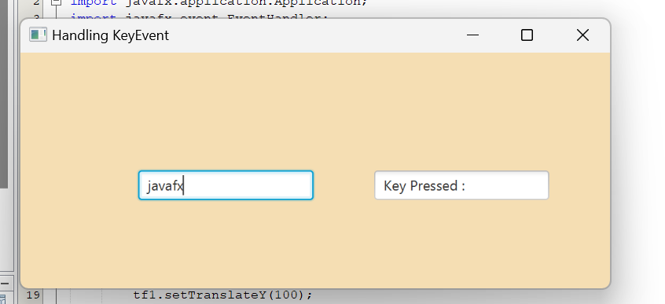

**4] MOUSE EVENT HANDLIND**

package javafxapplication11;

import javafx.animation.TranslateTransition;

import javafx.application.Application;

import javafx.event.EventHandler;

import javafx.scene.Group;

import javafx.scene.Scene;

import javafx.scene.control.Button;

import javafx.scene.input.MouseEvent;

import javafx.scene.paint.Color;

import javafx.scene.shape.Circle;

import javafx.stage.Stage;

import javafx.util.Duration;

public class JavaFXApplication11 extends Application{

@Override

public void start(Stage primaryStage) throws Exception {

Circle c = new Circle(100,100,50);

c.setFill(Color.GREEN);

c.setStroke(Color.BLACK);

Button btn = new Button("Play");

btn.setTranslateX(125);

btn.setTranslateY(200);

Button btn1 = new Button("Pause");

btn1.setTranslateX(175);

btn1.setTranslateY(200);

TranslateTransition trans = new TranslateTransition();

trans.setAutoReverse(true);

trans.setByX(200);

trans.setCycleCount(100);

trans.setDuration(Duration.millis(500));

trans.setNode(c);

EventHandler<MouseEvent> handler = new EventHandler<MouseEvent>() {

@Override

public void handle(MouseEvent event) {

if(event.getSource()==btn)

{

trans.play();

}

if(event.getSource()==btn1)

{

trans.pause();

}

event.consume();

}

};

btn.setOnMouseClicked(handler);

btn1.setOnMouseClicked(handler);

Group root = new Group();

root.getChildren().addAll(c,btn,btn1);

Scene scene = new Scene(root,420,300,Color.WHEAT);

primaryStage.setScene(scene);

primaryStage.setTitle("EventHandler example");

primaryStage.show();

}

public static void main(String[] args) {

launch(args);

}

}

