الجلسة الخامسة
شبكة Perceptron
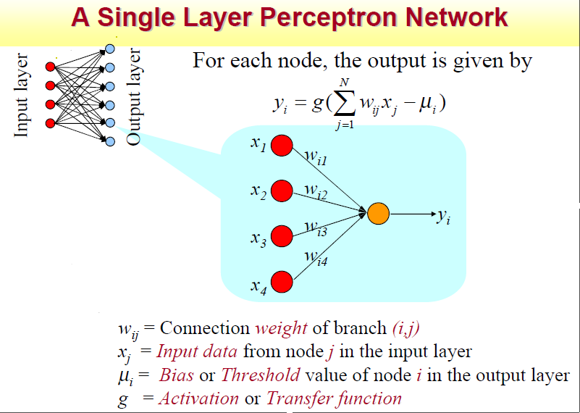

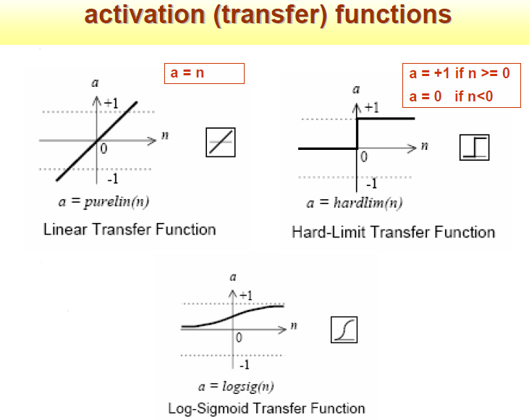
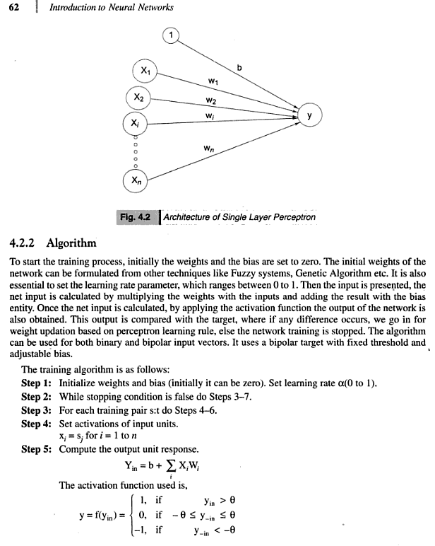

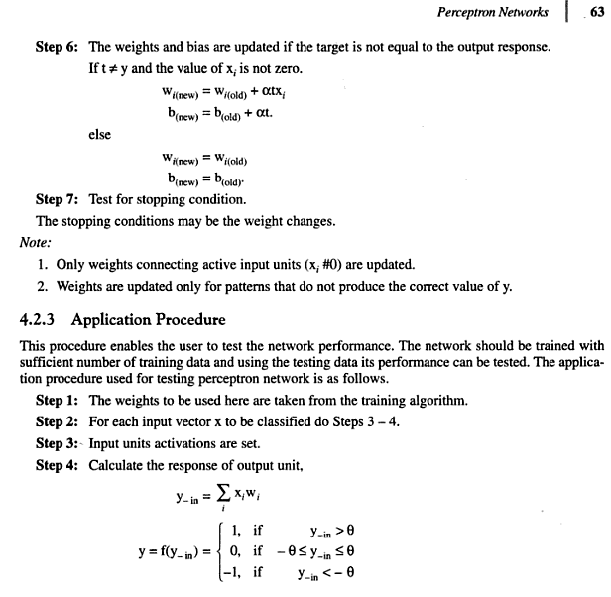
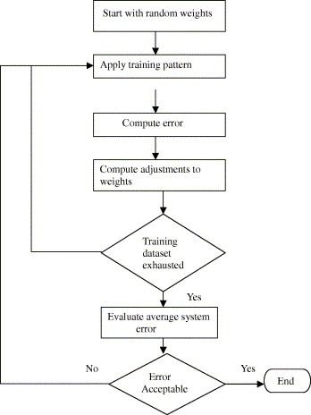
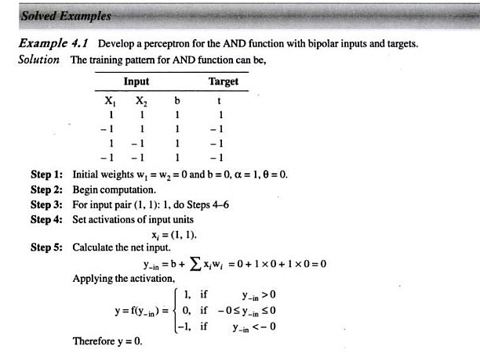
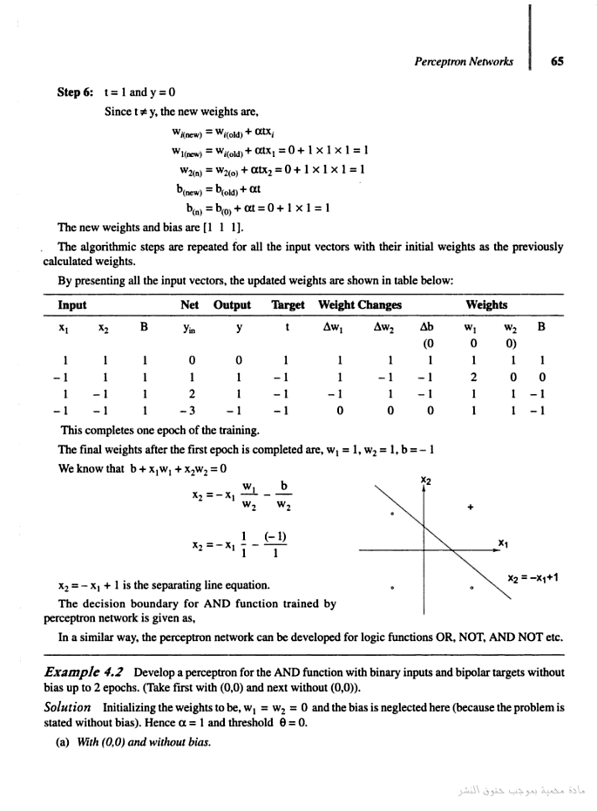

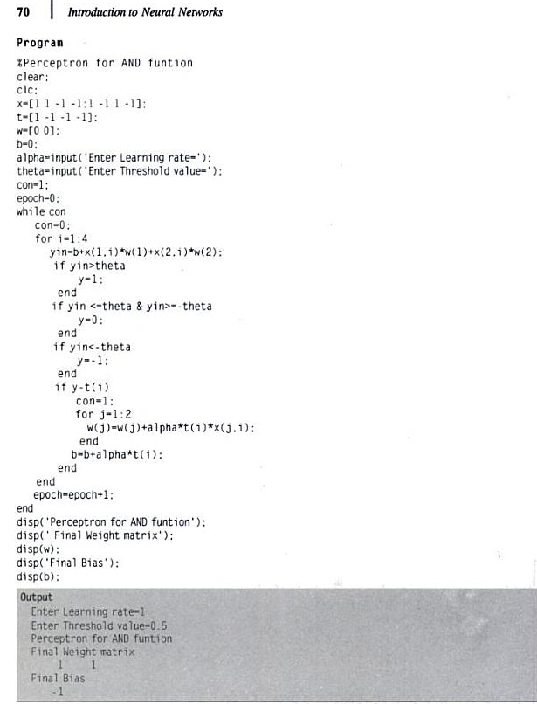

Example 4.5 Write a MATLAB program for perceptron net for an AND function with bipolar inputs and targets.
Solution The truth table for the AND function is given as
X1 X2 Y
– 1 – 1 – 1
– 1 1 – 1
1 – 1 – 1
1 1 1
The MATLAB program for the above table is given as follows.
Program
%Perceptron for AND funtion
clear;
clc;
x=[1 1 -1 -1;1 -1 1 -1];
t=[1 -1 -1 -1];
w=[0 0];
b=0;
alpha=input('Enter Learning rate=');
theta=input('Enter Threshold value=');
con=1;
epoch=0;
while con
con=0;
for i=1:4
yin=b+x(1,i)*w(1)+x(2,i)*w(2);
if yin>theta
y=1;
end
if yin <=theta & yin>=-theta
y=0;
end
if yin<-theta
y=-1;
end
if y-t(i)
con=1;
for j=1:2
w(j)=w(j)+alpha*t(i)*x(j,i);
end
b=b+alpha*t(i);
end
end
epoch=epoch+1;
end
disp('Perceptron for AND funtion');
disp(' Final Weight matrix');
disp(w);
disp('Final Bias');
disp(b);

Example 2.1 Write a MATLAB program to generate a few activation functions that are being used in neural networks.
Solution The activation functions play a major role in determining the output of the functions. One such program for generating the activation functions is as given below.
Program
% Illustration of various activation functions used in NN's
x = -10:0.1:10;
tmp = exp(-x);
y1 = 1./(1+tmp);
y2 = (1-tmp)./(1+tmp);
y3 = x;
subplot(231); plot(x, y1); grid on;
axis([min(x) max(x) -2 2]);
title('Logistic Function');
xlabel('(a)');
axis('square');
subplot(232); plot(x, y2); grid on;
axis([min(x) max(x) -2 2]);
title('Hyperbolic Tangent Function');
xlabel('(b)');
axis('square');
subplot(233); plot(x, y3); grid on;
axis([min(x) max(x) min(x) max(x)]);
title('Identity Function');
xlabel('(c)');
axis('square');

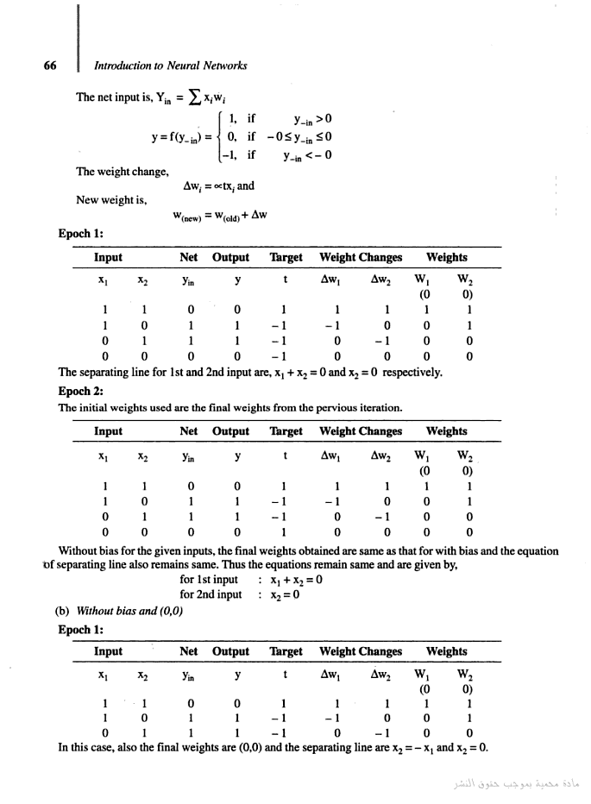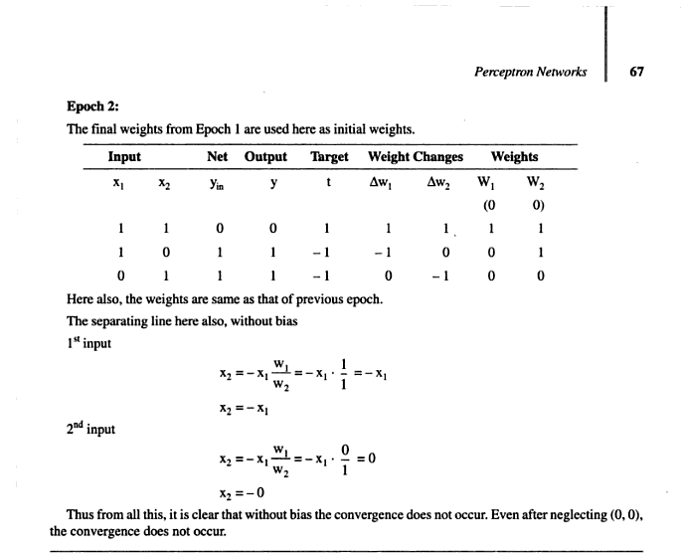
تمرين1: يطلب كتابة البرنامج السابق
تمرين2: يطلب كتابة البرنامج السابق من أجل OR
تمرين3: يطلب كتابة البرنامج السابق من أجل XOR
************************

