الجلسة السادسة والسابعة
شبكة Perceptron
newp:

Creating a Perceptron (newp)
A perceptron can be created with the newp function:
net = newp(P,T)
where input arguments are as follows:
- P is an R-by-Q matrix of Q input vectors of R elements each.
- T is an S-by-Q matrix of Q target vectors of S elements each.
Commonly, the hardlim function is used in perceptrons, so it is the default.
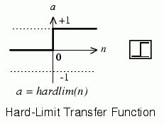
The following commands create a perceptron network with a single one-element input vector with the values 0 and 2, and one neuron with outputs that can be either 0 or 1:
P = [0 2];
T = [0 1];
net = newp(P,T);
You can see what network has been created by executing the following command:
inputweights = net.inputweights{1,1}
which yields
inputweights =
delays: 0
initFcn: 'initzero'
learn: 1
learnFcn: 'learnp'
learnParam: []
size: [1 1]
userdata: [1x1 struct]
weightFcn: 'dotprod'
weightParam: [1x1 struct]
The default learning function is learnp, which is discussed in Perceptron Learning Rule (learnp). The net input to the hardlim transfer function is dotprod, which generates the product of the input vector and weight matrix and adds the bias to compute the net input.
The default initialization function initzero is used to set the initial values of the weights to zero.
Similarly,
biases = net.biases{1}
gives
biases =
initFcn: 'initzero'
learn: 1
learnFcn: 'learnp'
learnParam: []
size: 1
userdata: [1x1 struct]
You can see that the default initialization for the bias is also 0.
Now try a simple example. Start with a single neuron having an input vector with just two elements. Here are input vectors with the values −2 and 2, and outputs with values 0 and 1.
net = newp([-2 2;-2 2],[0 1]);
To simplify matters, set the bias equal to 0 and the weights to 1 and -0.8:
net.b{1} = [0];
w = [1 -0.8];
net.IW{1,1} = w;
The input target pair is given by
p = [1; 2];
t = [1];
You can compute the output and error with
a = sim(net,p)
a =
0
e = t-a
e =
1
and use the function learnp to find the change in the weights.
dw = learnp(w,p,[],[],[],[],e,[],[],[])
dw =
1 2
The new weights, then, are obtained as
w = w + dw
w =
2.0000 1.2000
The process of finding new weights (and biases) can be repeated until there are no errors. Recall that the perceptron learning rule is guaranteed to converge in a finite number of steps for all problems that can be solved by a perceptron. These include all classification problems that are linearly separable. The objects to be classified in such cases can be separated by a single line.
تطبيق عملي1 (شبكة P):
- تتألف المشكلة من دخل p وهدف T يتم حلها باستخدام شبكة P .
P = [0 1 2 3 4 5 6 7 8 9 10];
T = [0 1 2 3 4 3 2 1 2 3 4];
- حيث يتم استخدام شبكة من طبقة خرج واحدة.
net = newp(P,T);
- يتم محاكاة الشبكة ويطبع خرجها مقابل الهدف.
Y = sim(net,P);
plot(P,T,P,Y,'o')
- يتم تدريب الشبكة من أجل 50 دور. ثم يطبع الخرج.
net.trainParam.epochs = 50;
net = train(net,P,T);
Y = sim(net,P);
plot(P,T,P,Y,'o')
تطبيق عملي2:
بناء شبكة عصبية للتعرف على أحرف الأبجدية الانكليزية التي تتألف من 26 حرف حيث يتم تمثيل كل حرف بمصفوفة منطقية بأبعاد 5×7 قيم كل منها (0 أو 1).
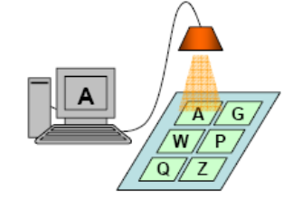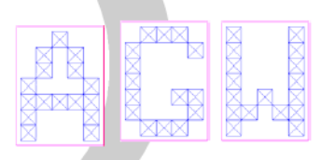
شعاع الدخل:
من أجل كل حرف ننشئ شعاع دخل من 1×35 بقيم صفر أو واحد تمثل الحرف كما يلي .
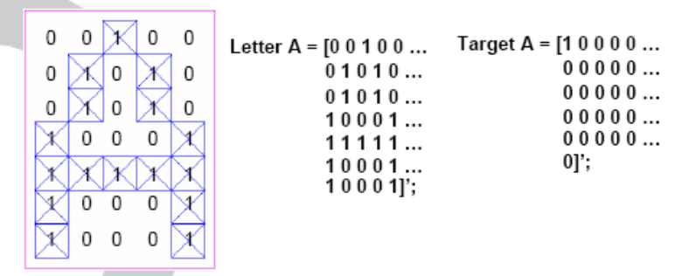
شعاع الخرج:
الخرج هو شعاع من 1×26 . ونعين القيمة 1 لموقع تسلسل الحرف الصحيح في الأبجدية .
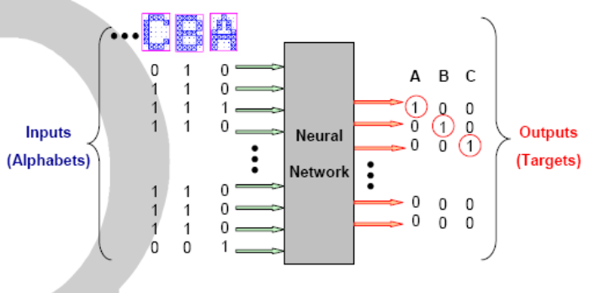
البنية الهندسية للشبكة :
شبكة تتألف من 35 عصبون دخل و26 عصبون في طبقة الخرج ,
بيانات التدريب والهدف يتم تعيينها باستخدام تابع prprob الذي يقوم بتعريف مشكلة التعرف على الأحرف الهجائية الانكليزية ويعيد المتحولين:
alphabets - 35x26 matrix of 5x7 bit maps for each letter.
targets - 26x26 target vectors..
الحـــــــل :
- تحميل معطيات التدريب :
% Load the training data into MATLAB→ Workspace
[alphabets, targets] = prprob;

- إنشاء شبكة perceptron من أجل rms= 0.001 ومن أجل 500 دورة :
% Create the perceptron network
net = newp(minmax(alphabets), targets);
net.trainParam.epochs = 500;
net.trainParam.show = 1;
net.trainParam.goal = 0.001;
- تدريب الشبكة :
% Training the neural network
[net, tr] = train(net, alphabets, targets);

- اختبار الشبكة للتعرف على حرف من بيانات التدريب نفسها.
% First, we create a normal ‘J’ to test the network performance
J = alphabets(:,10);
figure, plotchar(J);
output = sim(net, J);
output = compet(output) % change the largest values to 1, the rest 0s
answer = find(compet(output) == 1); % find the index (out of 26) of network output
figure, plotchar(alphabets(:, answer));
- اختبار الشبكة للتعرف على حرف مشوه من البيانات المدخلة:
% Next, we create a noisy ‘J’ to test the network can still identify it correctly…
noisyJ = alphabets(:,10)+randn(35,1)*0.2;
figure; plotchar(noisyJ);
output2 = sim(net, noisyJ);
output2 = compet(output2);
answer2 = find(compet(output2) == 1);
figure; plotchar(alphabets(:,answer2));

************************

