الجلسة 7
تطبيق عملي3: يطلب كتابة برنامج Matlab للتعرف على الأعداد من 0-9 وفق المصفوفة 5*3
الحل:
Example 4.6 Write a MATLAB program to recognize the number 0, 1, 2, 3…,9. A 5  3 matrix forms the numbers. For any valid point it is taken as 1 and invalid point it is taken as 0. The net has to be trained to recognize all the numbers and when the test data is given, the network has to recognize the particular numbers.
Solution The numbers are formed from the 5  3 matrix and the input data file is determined. The input data files and the test data files are given. The data are stored in a file called ‘reg.mat’. When the test data is given, if the pattern is recognized then it is + 1, and if the pattern is not recognized, it is – 1.
Data - reg.mat
input_data=[1 0 1 1 1 1 1 1 1 1;
1 1 1 1 0 1 1 1 1 1;
1 0 1 1 1 1 1 1 1 1;
1 1 0 0 1 1 1 0 1 1;
0 1 0 0 0 0 0 0 0 0;
1 0 1 1 1 0 0 1 1 1;
1 0 1 1 1 1 1 0 1 1;
0 1 1 1 1 1 1 0 1 1;
1 0 1 1 1 1 1 1 1 1;
1 0 1 0 0 0 1 0 1 0;
0 1 0 0 0 0 0 0 0 0;
1 0 0 1 1 1 1 1 1 1;
1 1 1 1 0 1 1 0 1 1;
1 1 1 1 0 1 1 0 1 1;
1 1 1 1 1 1 1 1 1 1;]
output_data=[1 0 0 0 0 0 0 0 0 0;
0 1 0 0 0 0 0 0 0 0;
0 0 1 0 0 0 0 0 0 0;
0 0 0 1 0 0 0 0 0 0;
0 0 0 0 1 0 0 0 0 0;
0 0 0 0 0 1 0 0 0 0;
0 0 0 0 0 0 1 0 0 0;
0 0 0 0 0 0 0 1 0 0;
0 0 0 0 0 0 0 0 1 0;
0 0 0 0 0 0 0 0 0 1;]
test_data=[1 0 1 1 1;
1 1 1 1 0;
1 1 1 1 1;
1 1 0 0 1;
0 1 0 0 1;
1 1 1 1 1;
1 0 1 1 1;
0 1 1 1 1;
1 0 1 1 1;
1 1 1 0 0;
0 1 0 1 0;
1 0 0 1 1;
1 1 1 1 1;
1 1 1 1 0;
1 1 1 1 1;]
Program
clear;
clc;
cd=open('reg.mat');
input=[cd.input_data(:,1)';cd.input_data(:,2)';cd.input_data(:,3)'; cd.input_data(:,4)'; cd.input_data(:,5)'; cd.input_data(:,6)'; cd.input_data(:,7)'; cd.input_data(:,8)'; cd.input_data(:,9)'; cd.input_data(:,10)']';
for i=1:10
for j=1:10
if i==j
output(i,j)=1;
else
output(i,j)=0;
end
end
end
for i=1:15
for j=1:2
if j==1
aw(i,j)=0;
else
aw(i,j)=1;
end
end
end
test=[cd.test_data(:,1)';cd.test_data(:,2)';cd.test_data(:,3)';cd.test_data(:,4)';cd.test_data(:,5)']';
net=newp(aw,10,'hardlim');
net.trainparam.epochs=1000;
net.trainparam.goal=0;
net=train(net,input,output);
y=sim(net,test);
x=y';

for i=1:5
k=0;
l=0;
for j=1:10
if x(i,j)==1
k=k+1;
l=j;
end
end
if k==1
s=sprintf('Test Pattern %d is Recognised as %d',i,l-1);
disp(s);
else
s=sprintf('Test Pattern %d is Not Recognised',i);
disp(s);
end
end
Output
TRAINC, Epoch 0/1000
TRAINC, Epoch 25/1000
TRAINC, Epoch 50/1000
TRAINC, Epoch 54/1000
TRAINC, Performance goal met.
Test Pattern 1 is Recognised as 0
Test Pattern 2 is Not Recognised
Test Pattern 3 is Recognised as 2
Test Pattern 4 is Recognised as 3
Test Pattern 5 is Recognised as 4

تطبيق عملي4: يطلب كتابة برنامج Matlab للتعرف على بعض الأحرف الانكليزية وفق المصفوفة 5*3
الحل:

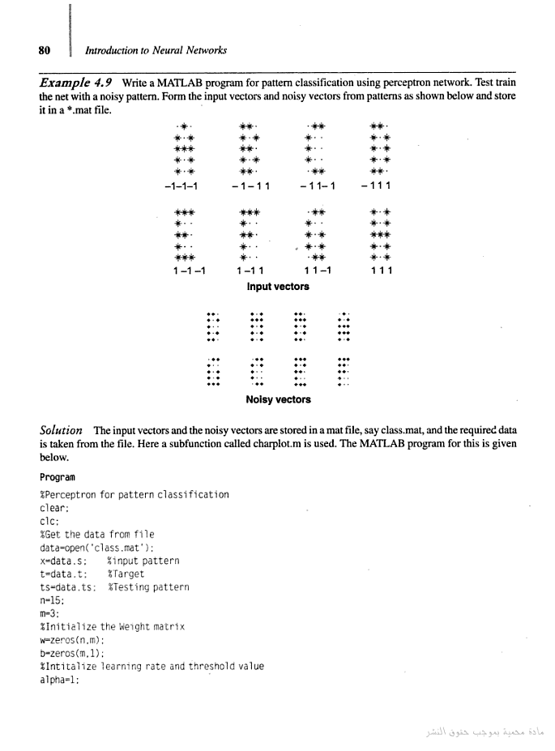
Program
%Perceptron for pattern classification
clear;
clc;
%Get the data from file
data=open('class.mat');
x=data.x; %input pattern
t=data.t; %Target
ts=data.ts; %Testing pattern
n=15;
m=3;
%Initialize the Weight matrix
w=zeros(n,m);
b=zeros(m,1);
%Intitalize learning rate and threshold value
alpha=1;
theta=0;
%Plot for Input Pattern
figure(1);
k=1;
for i=1:2
for j=1:4
charplot (x(k,:),10+(j-1)*10,20-(i-1)*10,5,3);
k=k+1;
end
end
axis([0 55 0 25]);
title('Input Pattern for Training');
con=1;
epoch=0;
while con
con=0;
for I=1:8
for j=1:m
yin(j)=b(j,1);
for i=1:n
yin(j)=yin(j)+w(i,j)*x(I,i);
end
if yin(j)>theta
y(j)=1;
end
if yin(j) <=theta & yin(j)>=-theta
y(j)=0;
end
if yin(j)<-theta
y(j)=-1;
end
end
if y(1,:)==t(I,:)
w=w;b=b;
else
con=1;
for j=1:m
b(j,1)=b(j,1)+alpha*t(I,j);
for i=1:n
w(i,j)=w(i,j)+alpha*t(I,j)*x(I,i);
end
end
end
end
epoch=epoch+1;
end
disp('Number of Epochs:');
disp(epoch);
%Testing the network with test pattern
%Plot for test pattern
figure(2);
k=1;
for i=1:2
for j=1:4
charplot(ts(k,:),10+(j-1)*10,20-(i-1)*10,5,3);
k=k+1;
end
end
axis([0 55 0 25]);
title('Noisy Input Pattern for Testing');
for I=1:8
for j=1:m
yin(j)=b(j,1);
for i=1:n
yin(j)=yin(j)+w(i,j)*ts(I,i);
end
if yin(j)>theta
y(j)=1;
end
if yin(j) <=theta & yin(j)>=-theta
y(j)=0;
end
if yin(j)<-theta
y(j)=-1;
end
end
for i=1:8
if t(i,:)==y(1,:)
or(I)=i;
end
end
end
%Plot for test output pattern
figure(3);
k=1;
for i=1:2
for j=1:4
charplot(x(or(k),:),10+(j-1)*10,20-(i-1)*10,5,3);
k=k+1;
end
end
axis([0 55 0 25]);
title('Classified Output Pattern');
Subprogram used:
function charplot(x,xs,ys,row,col)
k=1;
for i=1:row
for j=1:col
xl(i,j)=x(k);
k=k+1;
end
end
for i=1:row
for j=1:col
if xl(i,j)==-1
plot(j+xs-1,ys-i+1,'r');
hold on
else
plot(j+xs-1,ys-i+1,'k*');
hold on
end
end
end
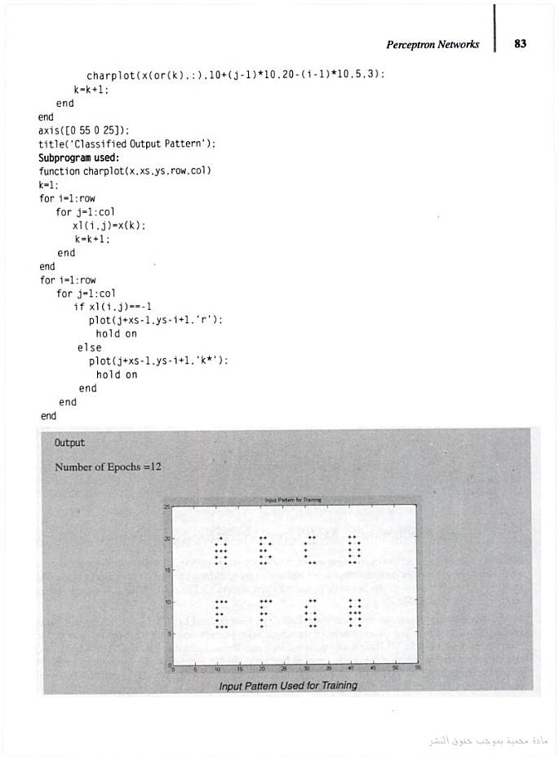
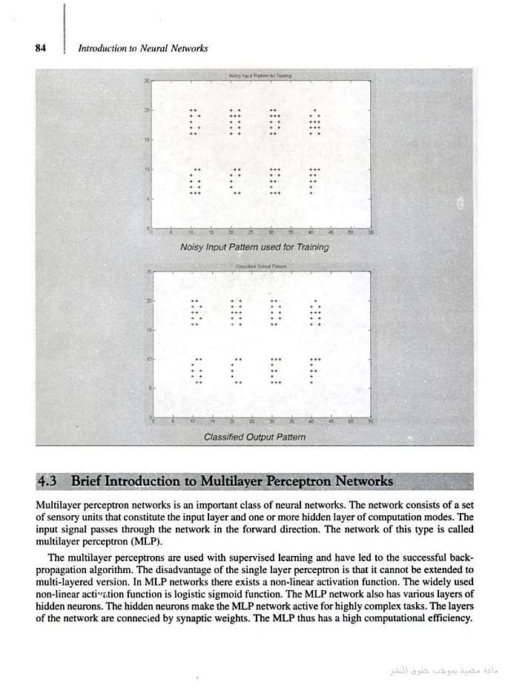


تطبيق عملي5: يطلب كتابة برنامج Matlab للتابع AND وفق الأداة nntool
الحل:
- تجهيز المعطيات:
x=[1 1 0 0;1 0 1 0];
t=[1 0 0 0];

- بناء الشبكة :
nntool
import (x, t)
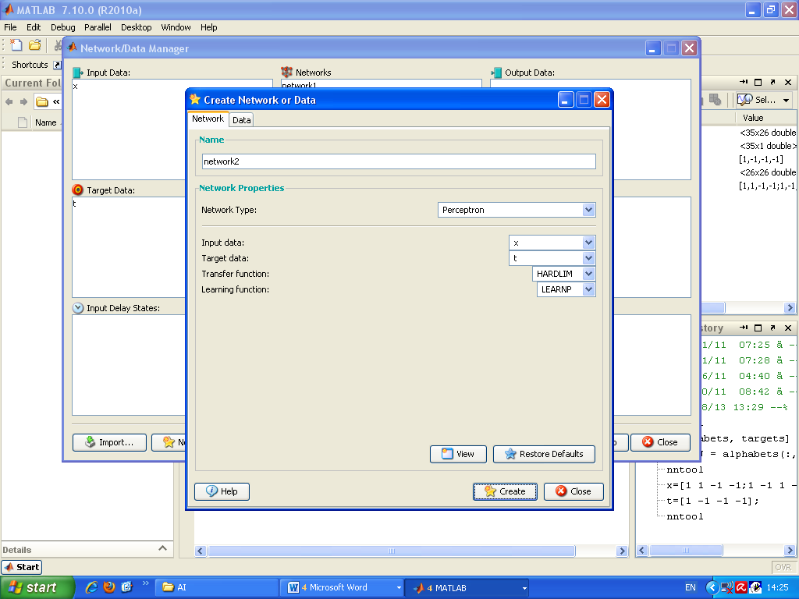

- تدريب الشبكة:

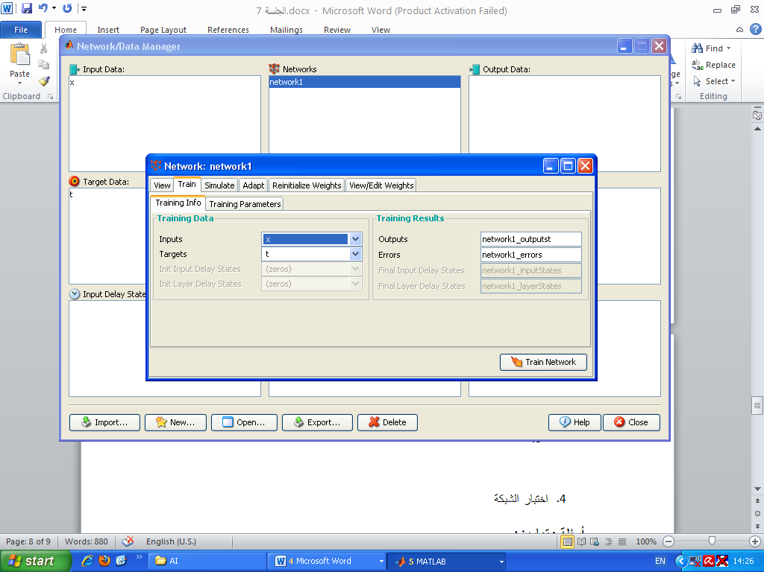
- اختبار الشبكة (Simulate)
أسئلة وتمارين:
