ParFit How-To Manual

6/30/2016

Contents

Introduction 3

Selecting a set of molecules to fit parameters using ParFit 3

Generating PESs 4

Parameter fitting tips 4

Testing ParFit parameter transferability 5

Other considerations 5

# Introduction

Users wanting to run MM calculations on molecules that are not well represented by the standard MM3 or Merk force field parameters, may be able to generate more accurate results by using ParFit to improve parameters. ParFit fits parameters to a library of small representative molecules. This How-To manual is designed to give practical information on using ParFit to improve the MM3 or Merk force field parameters.

The document will first guide the user in how to select a group of representative molecules and how to prepare the data necessary to achieve good parameter fitting. Running ParFit is briefly described, but more detailed information is found in the ParFit Manual. The method by which to test the transferability of the parameters is also explained. The last section includes additional tips and information.

# Selecting a set of molecules to fit parameters using ParFit

In order to improve the accuracy of MM calculations, the user should select molecules that include the atom to atom connectivity and atom types in the model system. That is, the molecules selected for fitting parameters should be representative of the model system. If the model system has sulfur-carbon bonds, for example, the user should select small molecules that include S-R groups, where the R is a series organic functional groups such as methyl, ethyl, isopropyl, t-butyl, vinyl, and phenyl groups, for example.

In some cases, it may be convenient to modify the parameters of an existing atom type by replacing its parameters with parameters that better suite the model systems of interest. For example, if the model system contains hydroxamic acid (Fig. 1a), and no amides (Fig. 1b), one may choose to modify the parameters that affect the nitrogen atom type found in amide such that the MM PES fits the hydroxamic acid PES rather than the PES of the amide. Then, when running the MM calculations use the modified atom types and parameters for the system.

a.)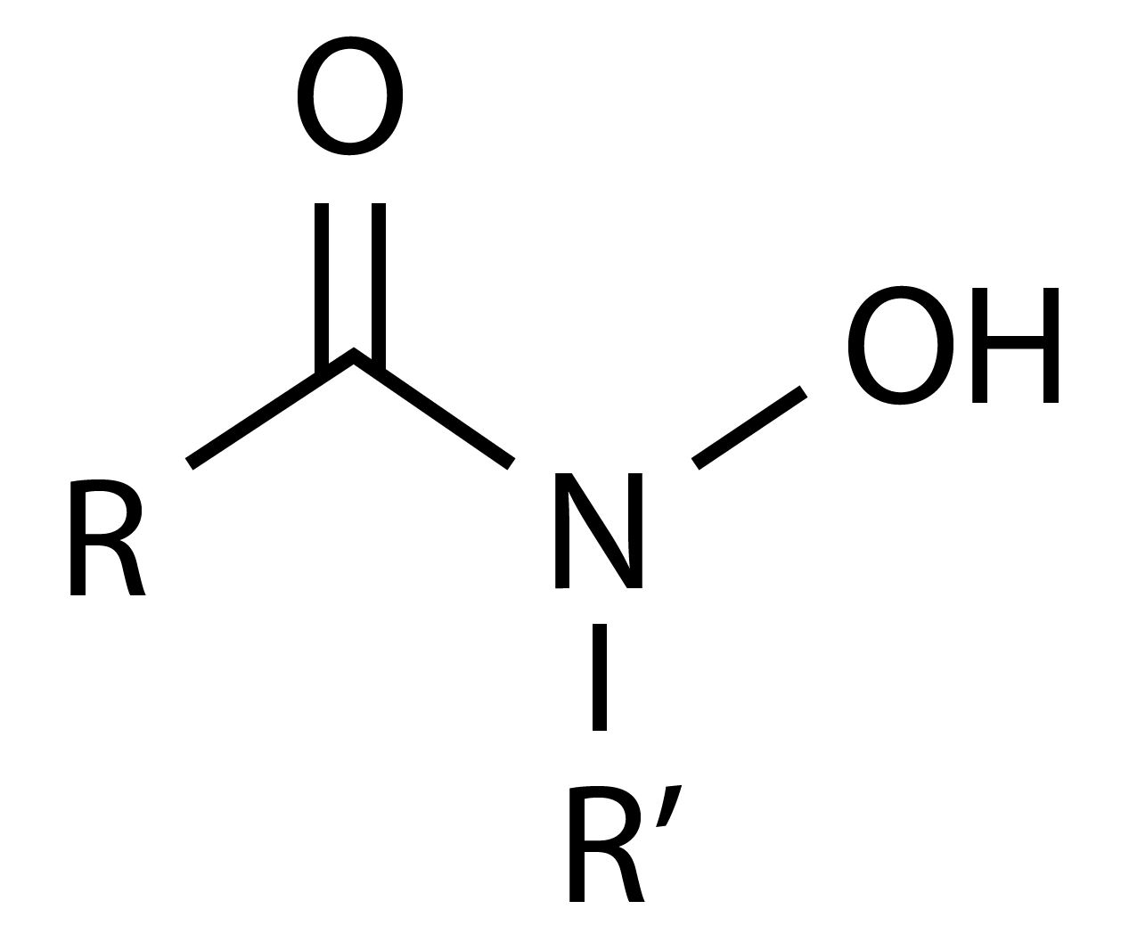 b.)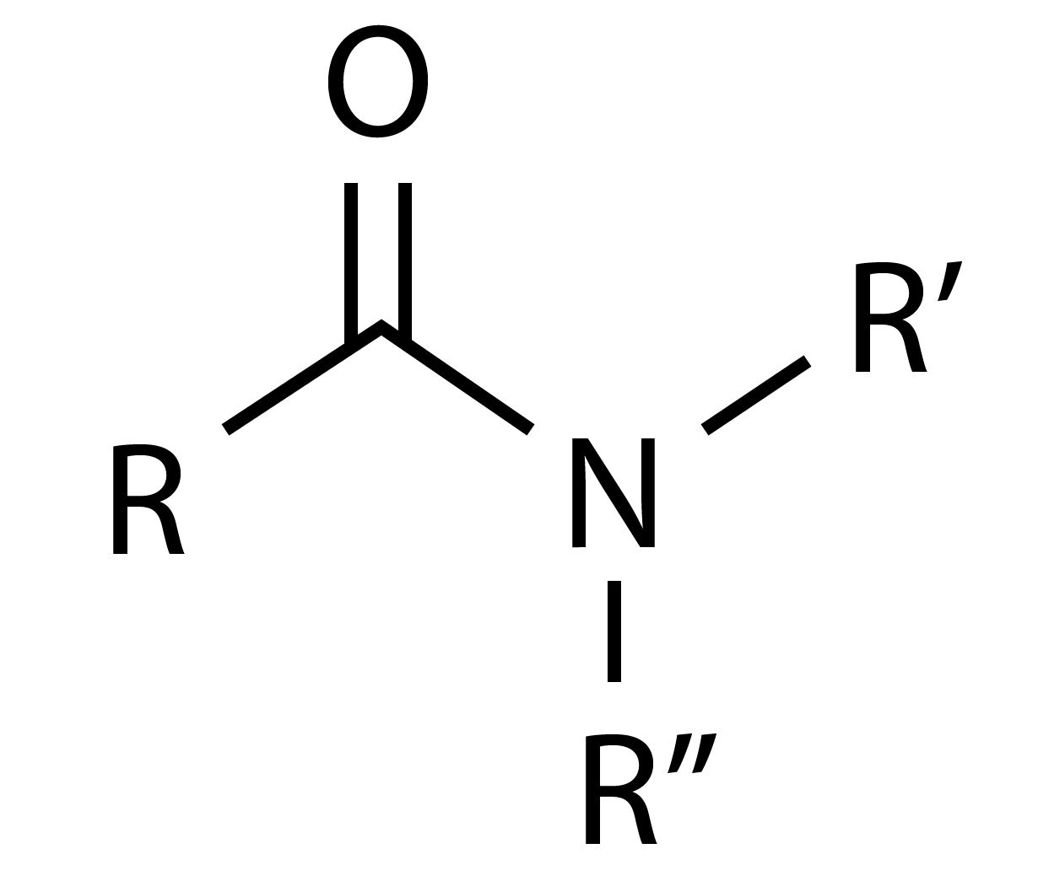

**Figure 1. General structure for a.) hydroxamic acid, and b.) amide.**

The molecules should be as small as is reasonable while remaining representative of the system of interest. For example, reasonable molecules to fit the torsional parameters for rotation along the P-R bond (where R is an alkyl group) in phosphine oxide HCPO, HCPC, CCPO, and CCPC dihedral angles would be: trimethylphosphine oxide, dimethyl t*-*butylphosphine oxide, dimethylethylphosphine oxide.

Any bond length and bond angle parameters will need to be fit if the system contains bonds between atoms that are not included in the default atom parameter list

# Generating PESs

ParFit adjusts parameters such that an MM PES fits a PES calculated at a higher level of theory. The user must supply the PESs for each fixed bond length, bond angle, and torsion angle value that will be used for parameter fitting and transferability (see Section V). GAMESS is the prefered electronic structure code for generating PESs as ParFit has a built in function to generate the GAMESS input files and extract the energy information from the output. The user may choose to use a different electronic structure code and generate a condensed file containing the energy and coordinates for each structure with a fixed length or angle. The condensed file format are found in the ParFit Manual.

For bond length parameter fitting, optimize the geometry of the small molecule system without constraints. Then run calculations for fixed lengths for a range of lengths greater than and less than the equilibrium bond length. A reasonable range may be from x ± 0.3-0.4 Å, where x is the equilibrium bond length. A similar method can be used for a bond angles: optimize the geometry of the molecule containing the atom connectivity for which a bond angle PES will be fit, then choose a range of angles above and below the equilibrium value. Generate the PES for fixed angle geometries by calculate the energy of the optimized structures for the range of constrained angles.

To calculate torsional PESs, calculate the energy of structures optimized at constrained torsion angles between 0° and 360°. It may not be necessary to calculate the full rotation if there is symmetry in the R group being rotated. For example, if the R group is a phenyl group, one would only need to calculate energies for fixed torsions from 0° to 180°.

# Parameter fitting tips

ParFit can be used to fit the torsion parameters for torsions in multiple molecules. It cannot, however, use different molecules to calculate the parameters for one torsion type. Thus, in some cases, it is necessary to calculate stepwise. For example, torsion A1RA2RPO, where AR are atoms that are part of an R group, can exist in multiple molecules but the PES from molecules with C3 symmetric R groups are sensitive to parameter V3 but not V1 and V2. PESs from lower symmetry R groups can be sensitive to parameters V1, V2, in addition to V3, thus different molecules are necessary to fit all three parameters for the same torsion. To calculate parameters stepwise, it is good practice to calculate V3 with a C3 symmetric R-group, such as a methyl or t-butyl group, first because V1 and V2 do not greatly affect the PES derived from the rotation of a C3 symmetric R group. The V1, and V2 parameters corresponding to the previous V3 torsional parameter may be calculated using the PES from the rotation of a lower symmetry groups, such as an ethyl R group.

Once the torsions of the simplest most symmetric case molecules are fitted, one can move on to larger molecules to continue parameterizing the torsions that do not exist in the small molecules. For example, a CCPO and CCPC torsion does not exist in trimethylphosphine oxide, thus in order to fit the parameters for these torsions, a new molecule would need to be used. dimethylethylphospine oxide contains those torsions and is only slightly larger and more complicated than the trimethylphosphine oxide. For the asymmetric molecules, there is no particular order in which the parameters V1, V2, and V3 need to be fit.

When parameters are coupled, the parameters may be fit simultaneously and to the same value. Parameters are coupled when there is a second torsion that is rotated as a consequence of the first. For example, for trimethylphosphine oxide, Fig. 2, the HCPO torsion is coupled with the HCPC torsion. In this case, V3 can be set equal and calculated simultaneously.

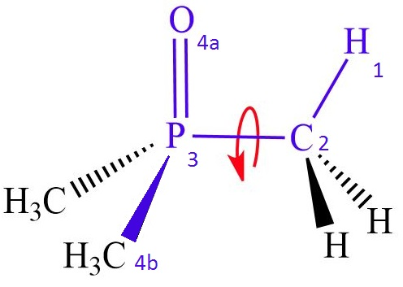

**Figure 2. Trimethylphosphine oxide with two coupled torsions, 1234a and 1234b.**

The order in which bond lengths and angles are fit is not critical. Fit each bond length and bond angle in any order before attempting to calculate torsion parameters.

# Testing ParFit parameter transferability

Parameter transferability refers to how a set of parameters that were fitted to a library of small molecules are able to accurately produce the PESs of molecules that were not included in the library. To test the transferability, one needs to have the PES of molecules that are not included in the training set of molecules. Then, the input file should be generated as usual but the parameters should all be set to constants such that the code does not modify the parameters. This will generate the MM PESs for the new molecules. The transferability can be tested by running ParFit with all of the parameters set to “c” or constant.

The parameters are transferable if the MM PESs calculated with the new parameters agree with the higher level of theory PESs. It is especially important that the minima calculated using MM agree with the minima calculated using a higher level of theory.

Some suggestions for testing transferability are using slightly more complex molecules from the ones that were used to fit parameters, such as going from ethyl to t-butyl groups, and vinyl to phenyl groups and combinations of groups.

# Other considerations

Sensitivity analysis: Running a sensitivity analysis, generating a series of PES in which each of the three parameters per torsion is varied one at a time to have the value of +1 or -1, can help determine which parameters should be fit with a particular set of molecules. The parameters may be changed in the /Data/Engine/add_MM3 (or MMFF94).prm file and the sensitivity checked by running a test with the same method as for checking transferability in section V. Calculate parameters using the molecules where high sensitivity is observed.