**Hammad Hassan** 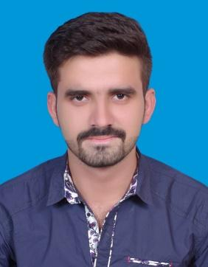

Mobile: 0306-7051251 Email: hamad.pixiders@gmail.com.

**Address**: CHAK No.92 N.B Sargodha ,Punjab Pakistan.

**Skype**: +923067051251

**Career Objective**

To achieve an opportunity in such a reputed organization where I can enhance and utilize my challenging and hardworking capabilities in the field of **Information Technology** to full extent and that can provide me a gate for learning and career development.

**Education**

* **BSCS (BCS) (3.1 CGPA)**

[2016] University of Sargodha. Sargodha, Punjab.

* **FSc (IST Div.)**

[2012] Dar-E-Arqam College. Sargodha, Punjab.

* **Matric (IST Div.)**

[2010] GOVT. High School No.1. Sargodha, Punjab.

**Experiences**

1. Now Working as a **Freelancer** as Full time (**Can show profiles if required**)
2. Worked as a senior Web developer at TECHLEADZ since FEB-2017 to May-2017.
3. Worked as a senior Web developer at Pixiders since Nov-2014 - FEB-2017.

**Projects**

* + - Final year Project OCR using java.
    - DATAWARE HOUSE USE THE TARADATA DATA UPLODING; DATA CLEANSING; DATA DECISION MAKING.

**Key Strengths**

* Eager to learn new technologies.
* Strive for excellence in everything I do.
* A thinker with strong analytical skills.
* Get on well with people at all levels, easily making good working relationships.
* Good organizational skills developed in a variety of deadline orientated situations.
* Have good presentation skills combining sound analytical research and clear verbal explanation.
* Self-motivated graduate with well-developed Management and IT skills combined with a flexible attitude to work.

**Skills**

* PHP (Structured,OOP)
* PHP MVC frameworks e.g.

i. Laravel (Expert)

ii. CodeIgniter (Expert)

iii. Symfony

* HTML /CSS / Bootstrap.
* JAVASCRIPT.
* J-Query
* Ajax
* NODEJS (EXPRESS JS)
* AngularJS
* MongoDB
* Git

**Personal Information**

Name : Hammad Hassan

Father Name : Muhammad Mumtaz

Date of Birth : 15-Mar -1995

Cell # : 0306-7051251

N.I.C : 38403-2650234-9

Marital Status : Single

Domicile : Punjab (Dist. Sargodha)

Nationality : Pakistani

Religion : Islam

Address : CHAK No.92 N.B Sargodha , Sargodha.

**Languages**

* English
* URDU
* Punjabi

**References**

Reference will be furnished as required.